INDOOR AIR QUALITY ASSESSMENT

MassHealth Office
529 Main Street (Schrafft's City Center)
2nd floor
Charlestown

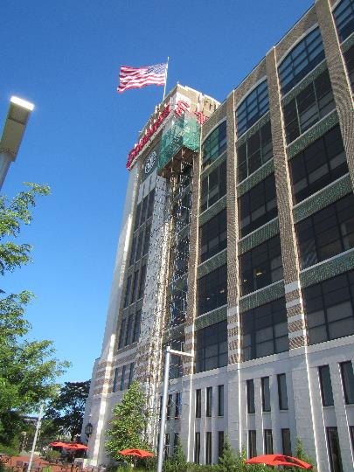

Prepared by:
Massachusetts Department of Public Health
Bureau of Environmental Health
Indoor Air Quality Program
September 2019

Background
Building: | MassHealth offices
Address: | 529 Main Street, 2nd floor, Charlestown
Assessment Requested by: | Pedro Batista, Facilities Resource Coordinator, Executive Office of Health and Human Services (EOHHS)
Reason for Request: | Concerns about indoor air quality (IAQ)
Date of Assessment: | September 13, 2019
Massachusetts Department of Public Health/Bureau of Environmental Health (MDPH/BEH) Staff Conducting Assessment: | Ruth Alfasso, Environmental Engineer, IAQ Program
Building Description: | MassHealth occupies a portion of the 2nd floor of Schrafft's City Center which was originally built in 1928 as a candy factory/warehouse on the Charlestown waterfront. It currently houses a number of state agencies and private businesses.
Windows: | Not openable

Methods
Please refer to the IAQ Manual for methods, sampling procedures, and interpretation of results (MDPH, 2015).

IAQ Testing Results
The following is a summary of indoor air testing results (Table 1).
- Carbon dioxide levels were below the MDPH guideline of 800 parts per million (ppm) in most of the areas surveyed, and slightly above in rooms in one area of the building. This is discussed further below.
- Temperature was within the MDPH recommended range of 70°F to 78°F in all areas tested.
- Relative humidity was within the MDPH recommended range of 40 to 60%.
- Carbon monoxide levels were non-detectable (ND) in all areas tested.
- Fine particulate matter (PM2.5) concentrations measured were below the National Ambient Air Quality Standard (NAAQS) limit of 35 μg/m³ in all areas tested.

Ventilation
A heating, ventilating, and air conditioning (HVAC) system has several functions. First it provides heating and, if equipped, cooling. Second, it is a source of fresh air. Finally, an HVAC system will dilute and remove normally-occurring indoor environmental pollutants by not only introducing fresh air, but by filtering the airstream and ejecting stale air to the outdoors via exhaust ventilation. Even if an HVAC system is operating as designed, point sources of respiratory irritation may exist and cause symptoms in sensitive individuals.
The HVAC system consists of air handling units (AHUs) located on the roof, which draw in outside air and heat/cool it. Air from the rooftop is ducted to multiple AHUs located in closets in the office (Picture 1). Tempered air is then delivered to spaces via ceiling-mounted supply vents (Picture 2). Slots in the door of each closet return air to the AHU (Picture 3) so these closets act as small mixing rooms. Each AHU has a slot for a filter, which appeared to be of a pleated type. Filters with a Minimum Efficiency Reporting Value (MERV) rating of 8 or better is recommended to remove particles such as pollen and mold spores.
As noted above, levels of carbon dioxide were slightly above the MDPH recommended levels of 800 ppm in offices and open areas in one part of the floor (Table 1). It was reported that supply vents in this part of the office had been closed because of concerns regarding drafts. As shown by the carbon dioxide levels, obstructing or reducing airflow to parts of the office can lead to higher levels of carbon dioxide, which may lead to an increase in complaints about IAQ. It was also noted that airflow in an adjacent area of the office had a high enough velocity to blow the window shades around (Table 1). Supply of fresh air should not be obstructed; concerns about drafts can be addressed with a change to the design of supply vents, supply vent location, or occupant locations.
In order to have proper ventilation with a mechanical ventilation system, the systems must be balanced after installation to provide an adequate amount of fresh air to the interior of a room while removing stale air from the room. It is recommended that HVAC systems be re-balanced every five years to ensure adequate air systems function (SMACNA, 1994). It is not known when the systems were last balanced.

Microbial/Moisture Concerns
Light water stains were noted in the conference room ceiling (Picture 4; Table 1). This likely is the result of a leak/condensation in the plumbing or sprinkler system. The area above this ceiling tile should be examined for the source of the leak and for any additional water-damaged materials. Once the leak is repaired, the affected ceiling tiles should be replaced.
Water dispensers were found in carpeted areas (Picture 5). These appliances can spill or leak and moisten carpeting. The unit shown in Picture 5 had developed a small leak in the water tubing and had been shut off pending repairs. These should be placed in areas with non-porous flooring where possible or on a waterproof mat to protect carpeting.
The AHUs have condensation drains with pumps to remove condensate (Picture 6). These pumps and associated piping should be checked periodically for function and cleaned/repaired to prevent or mitigate leaks.
Plants were noted in many areas (Picture 7; Table 1). Plants should be properly maintained and equipped with drip pans and should be located away from airflow to prevent the aerosolization of dirt, pollen, and mold.

Other Concerns
Exposure to low levels of total volatile organic compounds (TVOCs) may produce eye, nose, throat, and/or respiratory irritation in some sensitive individuals. BEH/IAQ examined spaces for products containing VOCs. BEH/IAQ staff noted hand sanitizers, cleaners, and dry erase materials in the office space (Picture 8; Table 1). All of these products have the potential to be irritants to the eyes, nose, throat, and respiratory system of sensitive individuals. This office reportedly has a scent-free policy which will help in reducing exposure to VOCs.
A comprehensive cleaning program, including carpet and surface cleaning, was in process at the time of the visit. Supply vents were dusty in some areas (Picture 2; Table 1) and were reportedly scheduled for cleaning. Occupants expressed concern that dust had built up on pipes and light fixtures in the exposed ceiling (Picture 9) and that these were not part of the original cleaning plan/schedule. Dust on surfaces such as exposed fixtures, as well as personal fans, decorative items and other surfaces, can be reaerosolized and cause irritation. This becomes more likely when the relative humidity is low or air velocity increases. In addition, during periods of higher humidity or if building envelope or plumbing leaks occur, accumulated dust can become a mold growth medium. Dust should be cleaned from surfaces periodically including those that are difficult to access. This includes the AHU closets, particularly, as they act as mixing rooms, and the door to one was found dusty on the inside (Picture 10).
In some offices and common areas, accumulated items were on the floor or surfaces such as desks and windowsills (Picture 11; Table 1). These items make it more difficult for custodial staff to clean, provide a source for dusts to accumulate and may also provide harborage to pests. Items should be relocated and/or be cleaned periodically to avoid excessive dust build up.
Exposed insulation or similar material was noted in an area of the ceiling on top of a light fixture (Picture 11). This appeared to be fiberglass, which can release irritating fibers if disturbed. This material should be checked and trimmed/contained in an appropriate manner to prevent release of fibers.
Food (Picture 12) and food preparation equipment, including microwaves and toasters were observed in offices and common areas. Food should be kept tightly sealed to prevent pest access and food preparation equipment should be kept clean to prevent smoke, odors and pests. Pest issues have been reported in this building in the past. Removal of sources of food, including crumbs and residues, is very important to prevent pest issues in the future.
Most of the offices are carpeted. Carpets should be cleaned annually (or semi-annually in soiled/high traffic areas) in accordance with Institute of Inspection, Cleaning and Restoration Certification (IICRC) recommendations, (IICRC, 2012).

Conclusions/Recommendations
Based on observations at the time of assessment, the following is recommended:
- Operate supply and exhaust ventilation continuously in all areas during occupied periods. Ensure all HVAC equipment is cleaned/maintained in accordance with manufacturer’s instructions.
- Change filters for HVAC equipment 2-4 times a year. If possible in current equipment, use pleated filters of MERV 8 (or higher), which are adequate in filtering out pollen and mold spores (ASHRAE, 2012).
- Avoid turning off or obstructing fresh air supply for areas of the building; work with facility staff and occupants to adjust diffuser style or locations to prevent drafts.
- Balance the HVAC system every 5 years in accordance with Sheet Metal and Air Conditioning Contractors’ National Association (SMACNA) recommendations (SMACNA, 1994).
- Replace water-damaged ceiling tiles. Examine spaces above/behind areas of water damage to determine if any hidden damage or odors have occurred.
- Consider placing refrigerators and water dispensers in areas without carpeting, or use a waterproof mat to protect carpeting.
- Regularly inspect HVAC condensate piping and pumps for clogs and leaks and repair as needed.
- Keep plants and flowers in good condition, avoid overwatering, and remove from the airstream of heating and ventilation equipment.
- Reduce the use of cleaning products, sanitizers, and other items that contain VOCs.
- For buildings in New England, periods of low relative humidity during the winter are often unavoidable. Therefore, scrupulous cleaning practices should be adopted to minimize common indoor air contaminants whose irritant effects can be enhanced when the relative humidity is low. To control for dusts, a high efficiency particulate arrestance (HEPA) filter equipped vacuum cleaner in conjunction with wet wiping of all surfaces is recommended. Avoid the use of feather dusters. Drinking water during the day can help ease some symptoms associated with a dry environment (throat and sinus irritations).
- Ensure all dusty surfaces are cleaned periodically, including less accessible areas such as supply vents, mixing room vents, and exposed piping.
- Reduce the amount of items stored in offices and on surfaces. Use file cabinets, shelving, or storage totes to contain papers and other items for ease of cleaning.
- Check exposed material shown in Picture 11 and trim, contain or remove/replace as necessary to prevent the distribution of irritating fiberglass or other dust.
- Keep food preparation equipment clean, and clean out refrigerators, including the gaskets, regularly.
- Use the services of a licensed pest contractor to control pests as needed. Increase cleaning in areas where pests were present to remove allergens.
- Clean carpeting in accordance with IICRC recommendations (IICRC, 2012).
- Refer to resource manual and other related IAQ documents located on the MDPH’s website for further building-wide evaluations and advice on maintaining public buildings. These documents are available at: http://mass.gov/dph/iaq.

References
ASHRAE. 2012. American Society of Heating, Refrigeration and Air Conditioning Engineers (ASHRAE) Standard 52.2-2012 -- Method of Testing General Ventilation Air-Cleaning Devices for Removal Efficiency by Particle Size (ANSI Approved). 2012.
IICRC. 2012. Institute of Inspection, Cleaning and Restoration Certification. Carpet Cleaning: FAQ.
MDPH. 2015. Massachusetts Department of Public Health. Indoor Air Quality Manual: Chapters I-III. Available at: http://www.mass.gov/eohhs/gov/departments/dph/programs/environmental-health/exposure-topics/iaq/iaq-manual/.
SMACNA. 1994. HVAC Systems Commissioning Manual. 1st ed. Sheet Metal and Air Conditioning Contractors’ National Association, Inc., Chantilly, VA.
Picture 1
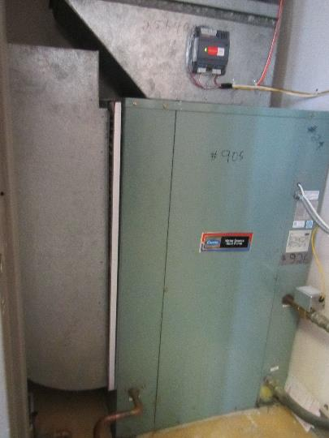
AHU in closet, note filter in unit (arrow)
Picture 2
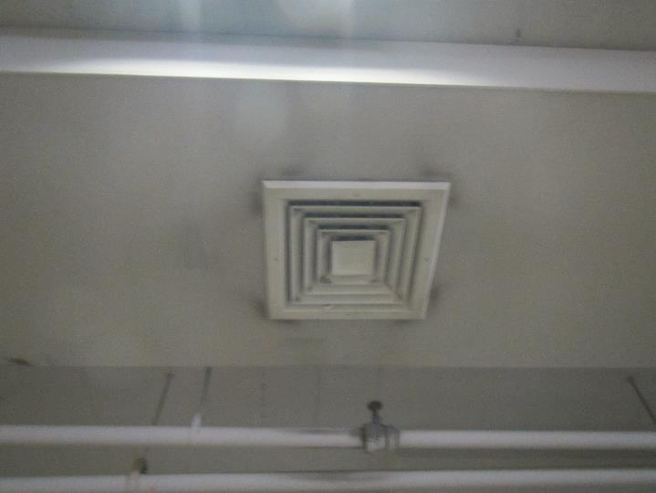
Typical supply vent, note dust
Picture 3
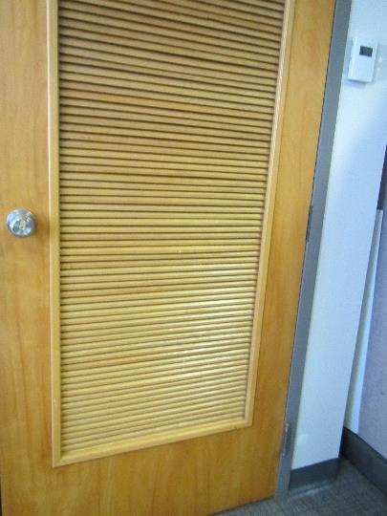
AHU closet door with slots
Picture 4
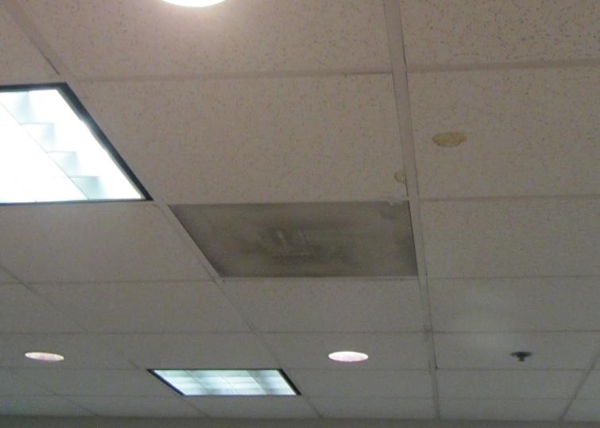
Light water stains on ceiling tile
Picture 5
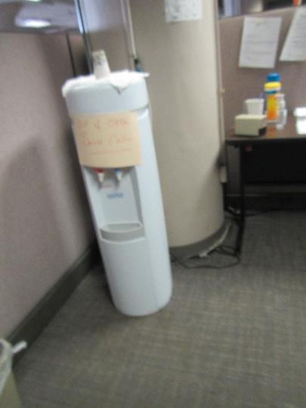
Water dispenser on carpeting – note sign saying “out of order”
Picture 6
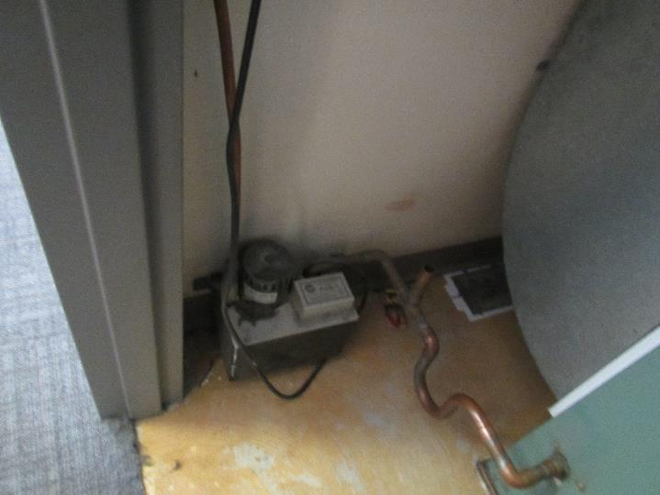
Condensate drain pump
Picture 7
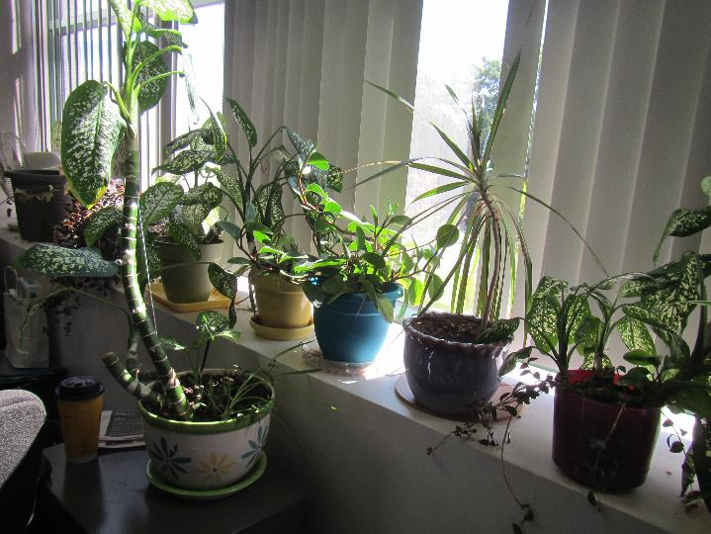
Plants on a windowsill
Picture 8
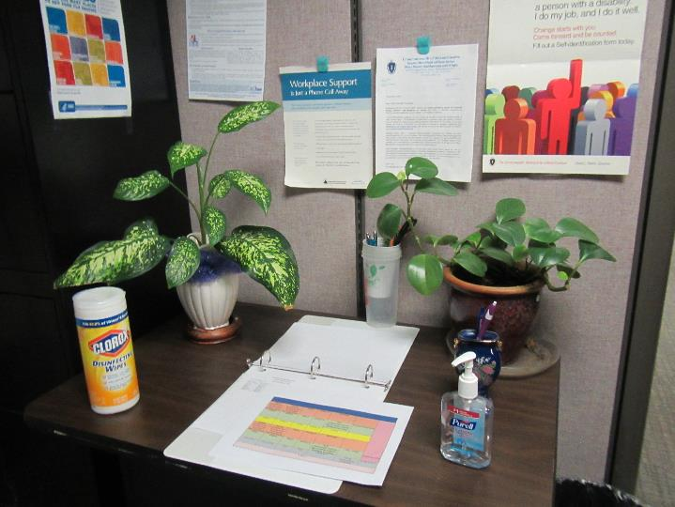
Hand sanitizer and cleaning wipes
Picture 9
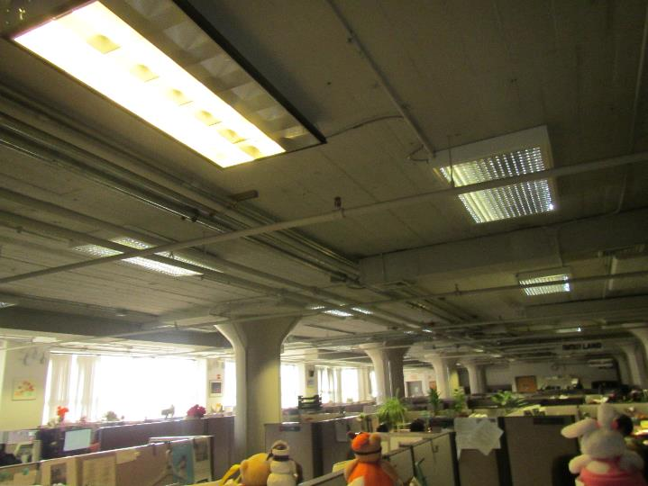
Ceiling showing exposed pipes and hanging light fixtures
Picture 10
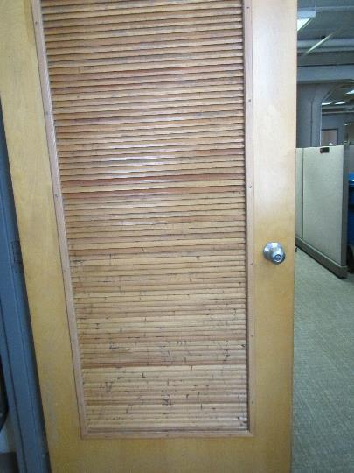
Interior of AHU room door showing dust
Picture 11
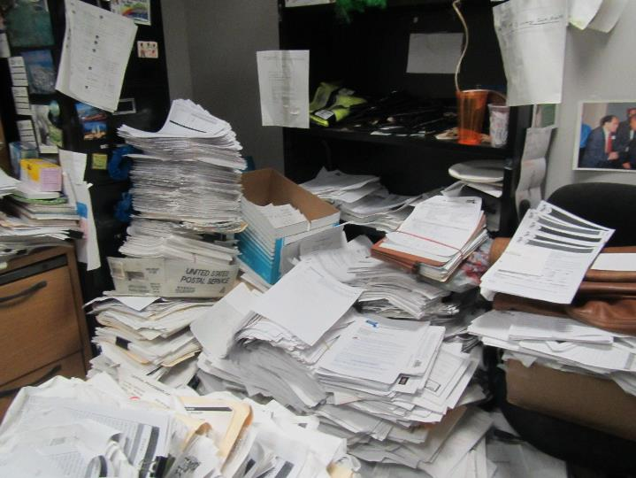
Accumulated papers in an office
Picture 12
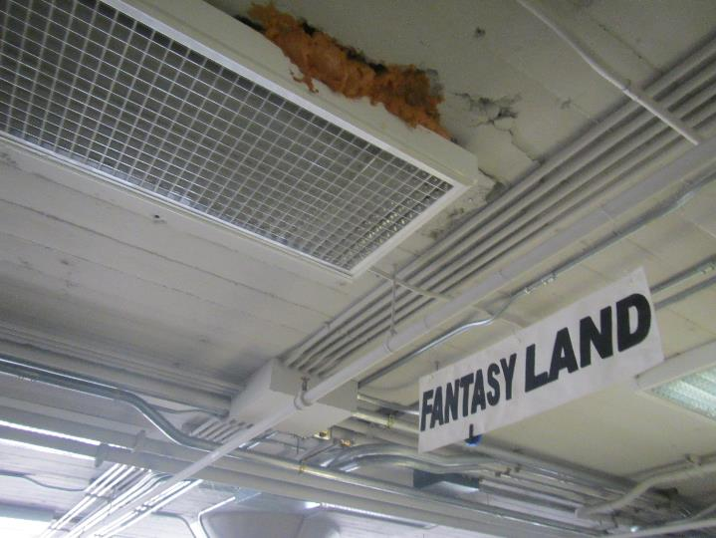
Possible exposed fiberglass insulation
Picture 13
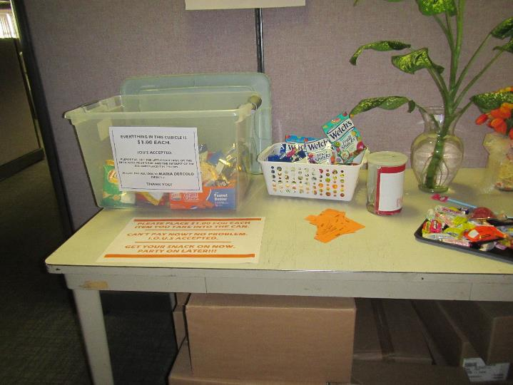
Food in a common area, note sealable tote

Location | Carbon  Dioxide  (ppm) | Carbon Monoxide  (ppm) | Temp  (°F) | Relative  Humidity  (%) | PM2.5  (µg/m³) | Occupants  in Room | Windows  Openable | Ventilation |  | Remarks
 |  |  |  |  |  |  |  | Supply | Exhaust
Background | 412 | ND | 75 | 40 | 9 |  |  |  |  | Sunny and cool, near high-traffic rotary
Conference room | 790 | ND | 73 | 45 | 1 | 4 | N | Y | Y | Vents dusty, DEM, CP, microwave, small area of water damage to ceiling tile
Chair storage area | 622 | ND | 73 | 45 | 1 | 0 | N | Y | Y
1016 | 658 | ND | 73 | 45 | 1 | 0 | N | Y | Y | DEM, sunlight, old unused microwave
1013 | 660 | ND | 74 | 44 | 1 | 0 | N | Y | Y | HS, plants
1005 | 674 | ND | 74 | 43 | 1 | 1 | N | Y | Y | DEM, PF – on
1022 | 680 | ND | 76 | 43 | 2 | 2 | N | Y | Y | Plants
1019 | 685 | ND | 76 | 42 | 1 | 2 | N | Y | Y | Plants, HS
1033 | 678 | ND | 76 | 41 | 1 | 2 | N | Y | Y | CP/AF, PF, AI, plants
1041 | 699 | ND | 74 | 41 | 1 | 1 | N | Y | Y | Exposed fiberglass overhead
Mailroom area | 701 | ND | 76 | 41 | 1 | 1 | N | Y | Y | PFs
1050 | 771 | ND | 76 | 46 | 1 | 4 | N | Y | Y | Plants
1047 | 771 | ND | 76 | 39 | 1 | 3 | N | Y | Y | PFs, plants
1077 | 738 | ND | 75 | 37 | 1 | 1 | N | Y | Y | High air velocity – shades moving
1080 | 735 | ND | 74 | 39 | 1 | 1 | N | Y | Y | AI
Scanning room | 748 | ND | 73 | 39 | 1 | 1 | N | Y | Y | DEM, old humidifier – unplugged
1103 | 780 | ND | 74 | 45 | 1 | 1 | N | Y | Y | ½ wall office
1092 | 880 | ND | 75 | 47 | 1 | 8 | N | Y | Y
1107 | 863 | ND | 76 | 47 | 2 | 2 | N | Y | Y
1112 | 883 | ND | 76 | 46 | 1 | 0 | N | Y | Y | Lots of furniture, food, DEM
Kitchen | 859 | ND | 76 | 46 | 1 | 0 | N | Y | Y | Non-carpeted with runners, broken wood under sink
1088 | 837 | ND | 77 | 42 | 2 | 0 | N | Y | Y | Piles of papers, CP
1070 | 818 | ND | 77 | 42 | 1 | 1 | N | Y | Y
Computer room | 786 | ND |  | 46 |  | 0 | N | Y | Y | Separate air conditioning system
Waiting room | 686 | ND | 75 | 41 | 2 | 1 | N | Y | Y
1000 (interview) | 665 | ND | 75 | 41 | 2 | 0 | N | Y | Y
1002bB(interview) | 629 | ND | 75 | 41 | 2 | 0 | N | Y | Y
1003 (interview) | 595 | ND | 75 | 40 | 2 | 0 | N | Y | Y
1004 (lactation) |  | ND | 75 | 41 |  | 0 | N | Y | Y

