# MassHealth Delivery System Restructuring: 2022 Update Report

Executive Office of Health & Human Services

December 2024

## Executive Summary

* In 2018, Massachusetts implemented its most significant Medicaid restructuring[1] in 20 years to move away from a fee-for-service model by creating:
  + Accountable Care Organizations (ACOs)
  + Community Partners (CPs), serving members with complex needs
  + Delivery System Reform Incentive Payment (DSRIP) Program, investing in statewide infrastructure
* This is the fifth public report on the MassHealth delivery system restructuring—this report covers the program’s fifth calendar year (2022) through the first quarter of 2023 which marked the end of that ACO contract period.[2]
* During 2022, MassHealth had 17 ACOs providing care for ~1.2M members with a composite expense of ~$6.9B.
  + When including Q1 2023, through the end of the ACO contract, and additional ~$1.8B was spent for a total five-quarter period expense of $8.7B
* The COVID-19 pandemic began to wane with a decline in case counts and severity of illness, yet the residual effects of the pandemic continued to challenge the health care delivery system and to have an impact on health needs and outcomes.
  + MassHealth caseload and ACO enrollment significantly increased due to Medicaid coverage protections during the federal Public Health Emergency (PHE), and as a result total spend increased.
  + In response to concerns over the pandemic’s impact on individual quality measures, MassHealth and CMS agreed to certain benchmark reductions for ACO/CP measures.
* This report is focused on the 2017-2022 1115 demonstration's performance data. At the time of this report’s release, MassHealth is implementing the 2022-2027 1115 demonstration. This report does not cover this extension.
* By 2022, ACOs were showing early signs of impact.
  + MassHealth members in ACO plans had **higher primary care utilization** relative to other plans, even during the pandemic when access was an issue. PCP visits were 14% higher for members in ACOs than for members not in ACOs on average from 2019 to 2022.
  + ACOs had the structure to **respond to growing challenges with behavioral health (BH) emergency department (ED) boarding and better support members with high BH risk during a time with limited access to BH inpatient beds.** 
    - **ACOs were able to effectively partner with MassHealth to improve engagement on high impact interventions for these members.**
* In 2022, quality measures rebounded after declines in 2020, **though some measures did not reach their pre-pandemic performance levels**. The confounding effects of the pandemic made cost and quality outcomes difficult to interpret.
* Community Partners (CPs), which provide community-based care coordination for members with significant behavioral health and long-term services and supports (LTSS) needs, engaged with 44,000 unique members in 2022.
* The **Flexible Services Program,**which provides housing and nutrition support to certain members, had **rapid and substantial growth,** and provided >51K services in 2022 (more than doubled compared to the previous year).

## Context

#### Slide 5: Context for Delivery System Restructuring Efforts: 1115 Waiver Renewal

* This report covers the final year of the 2017-2022 1115 demonstration. The Period of performance was January 1, 2022 through March 31, 2023.
* MassHealth collaborated with the Center for Medicare & Medicaid Services (CMS), its ACOs, CPs, and other providers involved in the restructuring efforts on the design of the subsequent 1115 waiver (2022-2027).
* 2022 was also the last full year of the Delivery System Reform Incentive Payment (DSRIP) Program:
  + ACOs identified which high-impact programs should continue in whole or in part beyond DSRIP, and accordingly developed sustainability plans and identified funding sources
  + ACOs also identified which programs were less impactful and should be discontinued.
* The 2022-2017 1115 waiver was approved on September 28, 2022 effective October 1, 2022 through December 31, 2027. Among many broad authorities, the 1115 extension authorized the continuation of the ACO program.
* The ACO contracts that began in 2018 ended on March 31, 2023. During 2022, the ACO program was being re-procured.
  + ACOs spent time throughout 2022 preparing their bids and setting strategy for the next contract period, including changes in partnerships and/or models.

#### Slide 6: Context for Delivery System Restructuring Efforts: the COVID-19 Pandemic

In 2022, the Massachusetts health care delivery system continued to experience the effects of the COVID-19 pandemic on health care delivery, utilization, and access.

* The pandemic placed **a strain on the healthcare workforce** and resulted in **significant workforce shortages**, leading to system-wide capacity strains and barriers to healthcare access.
* **Behavioral and mental health needs rose** as a result of the pandemic while service capacity was limited particularly for inpatient BH beds. This led to a large volume of members waiting in the ED for extended periods for a BH inpatient placement.
* The **use of telehealth declined** although it remained higher than pre-pandemic; most telehealth utilization was BH-related.
* **Utilization remained lower** in most areas compared to pre-pandemic, including acute care utilization (inpatient and ED)
* **Clinical quality performance** improved for ACOs, and all 5 measures with declines during the pandemic showed a partial or full recovery
* **Per member spend increased** by 2% compared to 2021 among ACO members, with increases concentrated in the child population, **Total spend increased** in part due to increases in caseload.
* **Caseload and ACO enrollment continued to increase significantly.** MassHealth paused routine redeterminations of members’ eligibility in accordance with federal guidance starting in March 2020, leading caseload to increase by 10% in 2020, 13.5% in 2021, and 7% in 2022.

#### Slide 7: Context for Delivery System Restructuring: ACO Caseload

Graph 1:

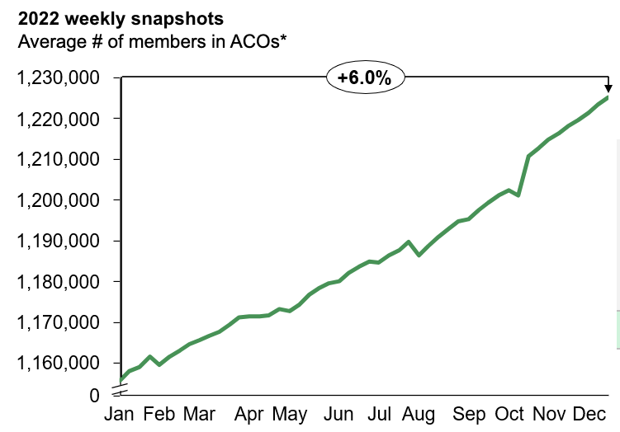

Table 1:

|  |  |  |
| --- | --- | --- |
|  | **Average Members** | **% Change** |
| **2019** | **888,421** |  |
| **2020** | **974,558** | **9.7%** |
| **2021** | **1,105,665** | **13.5%** |
| **2022** | **1,183,050** | **7%** |

**Notes for the graphics:**

Graph 1: Includes 13 Accountable Care Partnership Plans (ACPPs), which are partnerships between ACOs and managed care plans, and three Primary Care ACOs (PCACOs), which are provider ACOs contracted directly with MassHealth. Excludes MCO-Administered ACOs. See appendix for more information about ACOs.

Table 1: January – December 2022 average member months for ACPP and PCACO models. Year-over-year % change is restricted to the ACPP and PCACO population.

**Key Takeaways:**

* Redeterminations paused in March 2020 and remained paused throughout 2022 due to the federal PHE
* Growth of 6% from January 2022 to December 2022
* Average annual membership growth of 7% over 2022
* ACO caseload was 52% of total MassHealth caseload in 2022

#### Slide 8: MassHealth’s Restructuring Efforts Were Already Showing Early Promising Results in 2022

**Key Examples of Progress**

* **ACOs retained strong member connection to primary care**. PCP visits were 14% higher for ACOs than non ACOs on average from 2019 to 2022
* **ACO members saw greater declines in inpatient admissions**[3] from 2019 to 2022 where ACOs saw a 21% decline versus a 14% decline for non-ACO members.
* **ACOs improved clinical quality.** In 2022, all ACOs showed a partial or full recovery of quality metrics from their respective previous declines during the pandemic. **Overall clinical quality performance improved for ACOs** from 2021.
* **CPs succeeded at engaging members** with complex BH and LTSS needs. In 2022, CPs served ~44,000 unique members, increased engagement rated over pre-pandemic levels, and sustained improvement on members’ cost and outcomes including trends that pre-dated the pandemic’s impact on care patterns.
* The **Flexible Services Program,** which provides nutrition and housing support to certain members, saw rapid and substantial growth **increasing the number of unique members served by 60% from 2021.**

## Delivery System Reform Updates

### ACOs

#### Slide 10: Delivery System Reform: ACOs

**In 2022[4], the Covid-19 pandemic was waning however residual effects continued including ongoing enrollment increases and capacity constraints particularly in behavioral health. This also marked the last full year of DSRIP funding for ACOs. A few** themes emerged during this period:

1. ACOs retained members and **increased enrollment over the course of 2022,** growing to a total average enrollment of **1,196,381** (7% growth over year-end 2021).
2. The ACO program **saw utilization declines from 2019 to 2022** driven by ongoing impacts of the pandemic. However, from 2021-2022 the pediatric population saw increases in acute services likely due to a surge of pediatric respiratory illnesses.
3. ACOs collaborated with MassHealth to **address BH ED boarding and better support members with high BH risk** during a time with limited access to BH inpatient bends resulting in a large volume of members waiting in the ED for extended periods for a BH inpatient placement.
4. 2022 was the last year of DSRIP funding during which ACOs made **ongoing funding decisions based on demonstrated outcomes and experience of their DSRIP programs.** This included sustaining programs with clear impact, while discontinuing other efforts.
5. ACOs continued **rapid and substantial growth in the third year of the Flexible Services Program.** Flexible Services **grew faster in 2022 than in 2021** with services provided more than doubling from 2021 *(see next section of this report for detail)*

#### Slide 11: ACOs Retained Members and Increased Enrollment from 2021 to 2022

Table below shows enrollment as of 12/31/22, data pulled on 08/09/2024; MCO-administered ACO data pulled on 07/15/2024

*Note this reflects average members enrolled; see appendix (p. 64) for total unique members enrolled by managed care option.

Table 2:

|  |  |  |  |  |  |  |
| --- | --- | --- | --- | --- | --- | --- |
| ACO Type | Health Plan | ACO Name | % of ACO Total | # of Average Members* | % Adults | % Children |
| Accountable Care Partnership Plans (ACPP) | BMC Health Net Plan | Boston Accountable Community Alliance | 12.7% | 151,685 | 64% | 36% |
| ACPP | BMC Health Net Plan | Mercy Medical Center | 2.8% | 33,901 | 60% | 40% |
| ACPP | BMC Health Net Plan | Signature Healthcare | 2.0% | 24,218 | 65% | 35% |
| ACPP | BMC Health Net Plan | Southcoast Health | 1.8% | 21,138 | 74% | 26% |
| ACPP | Fallon Health | Health Collaborative of the Berkshires | 1.8% | 21,015 | 75% | 25% |
| ACPP | Fallon Health | Reliant Medical Group | 3.4% | 40,904 | 48% | 52% |
| ACPP | Fallon Health | Wellforce | 5.2% | 61,670 | 58% | 42% |
| ACPP | Health New England | Baystate Health Care Alliance | 4.0% | 47,973 | 58% | 42% |
| ACPP | Always Health Plan | Merrimack Valley ACO | 3.7% | 43,893 | 57% | 43% |
| ACPP | Tufts Public Plans | Atrius Health | 3.6% | 43,293 | 56% | 44% |
| ACPP | Tufts Public Plans | Boston Children’s Health ACO | 11.0% | 131,283 | 5% | 95% |
| ACPP | Tufts Public Plans | Beth Israel Deaconess Care Organization | 3.9% | 47,066 | 76% | 24% |
| ACPP | Tufts Public Plans | Cambridge Health Alliance | 3.2% | 38,003 | 56% | 44% |
| Primary Care ACOs (PCACO) |  | Community Care Cooperative (C3) | 14.5% | 173,967 | 60% | 40% |
| PCACO |  | Mass General Brigham | 12.9% | 154,228 | 56% | 44% |
| PCACO |  | Steward Health Choice | 12.6% | 150,789 | 57% | 43% |
| MCO-Administered ACO |  | Lahey Health | 0.9% | 11,355 | 93% | 7% |
| ACO Total |  |  | 100% | 1,196,381* | 50% | 50% |

Key Takeaway:

* 7% growth over year-end 2021 ACO enrollment (11,115,230)

#### Slide 12: In 2022, Most Utilization Rates Were Still Below 2019 (Pre-COVID) Levels

Graph 2: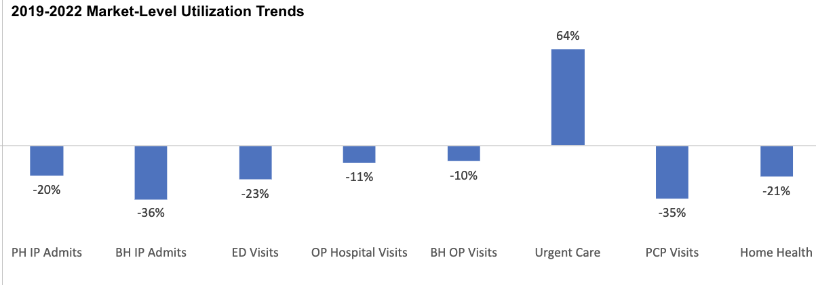Note for Graph 2: PCP Visits includes in-person visits and visits delivered via telehealth. Includes ACO, MCO and PCC Plan utilization.

Note: Utilization trends do not reflect the impact of temporary rate increases implemented in response to the COVID-19 PHE

**Key Takeaways:**

* Compared to 2019, the last full year before the COVID-19 pandemic, utilization was down for most services in 2022 **ranging from –10% to –36%.**
  + Urgent Care saw a 64% increase when comparing 2022 to 2019 due to the removal of referral requirements for certain plans at the start of the COVID pandemic and overall changes in patterns of care.
* The utilization rates continue to reflect **ongoing pandemic impacts** in 2022 (e.g. holds on elective procedures during COVID spikes and overall lower acuity of the population)
* Behavioral Health Inpatient Admissions saw the largest declines of –36%, at least partially due to statewide system capacity issues including staffing shortages and limited bed availability.

#### Slide 13: From 2021 to 2022, Utilization Declined for Most Services While Hospital, Urgent Care, and Primary Care Use Increased for Pediatrics

Graph 3:

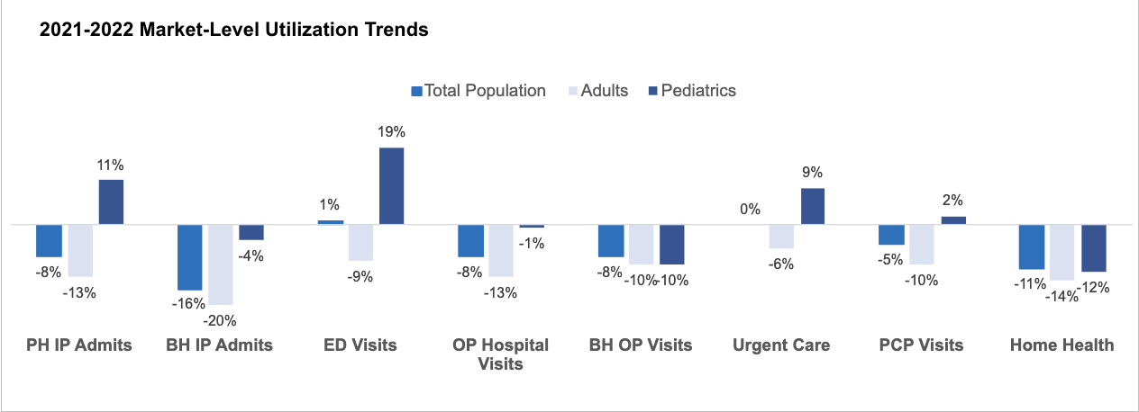Note for Graph 3: PCP Visits includes in-person visits and visits delivered via telehealth. Includes ACO, MCO, and PCC Plan utilization.

**Note:** Utilization trends do **not** reflect the impact of temporary rate increases implemented in response to the COVID-19 PHE.

**Key Takeaways:**

* Comparing 2021 to 2022, **most services continued to see flat or declining utilization** ranging from a 1% increase to -16% decrease. These overall trends were driven by declining utilization in the adult population.
* However, the **pediatric population experienced increases** in a few acute services as well as primary care. These services included an 11% increase in P**hysical Health Inpatient Admissions,** 19% increase in **Emergency Department Visits,** 9% increase in **Urgent Care,** and a 2% increase in **Primary Care.** 
  + The winter of 2022-2023 saw increases in respiratory infections driven by influenza, respiratory syncytial virus (RSV), and COVID-19 impacting the pediatric population. This may explain some of these trends.

#### Slide 14: Members in ACOs Continued to Retain Higher Rates of Primary Care and Lower Rates of Physical Health Inpatient Admissions

Graph 4:

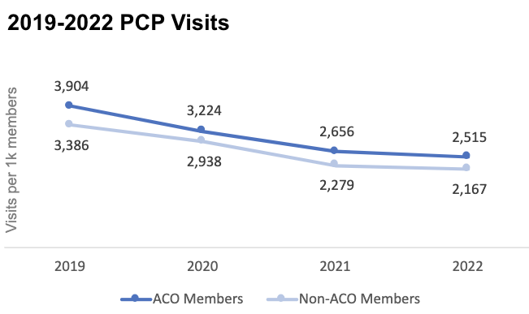

Key Takeaways:

* From 2019 to 2022, PCP visits remained higher among ACO members than non-ACO members.
  + **PCP visits were higher among ACO members by 14% on average.**

Graph 5:

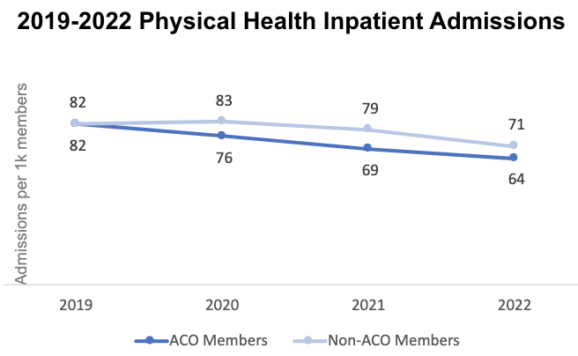

Key Takeaways:

* ACO members saw sharper declines in Physical Health (PH) Inpatient Admissions from 2019 to 2021 than non-ACO members and have maintained lower rates into 2022.
  + **From 2019 to 2022, ACOs saw a 21% decline in PH inpatient admissions versus a 14% decline for non-ACO plans.**

#### Slide 15: Telehealth Utilization Declined from 2021 to 2022[5] for ACO and Non-ACO Members, with Behavioral Health the most used Telehealth Service.

Graph 6:

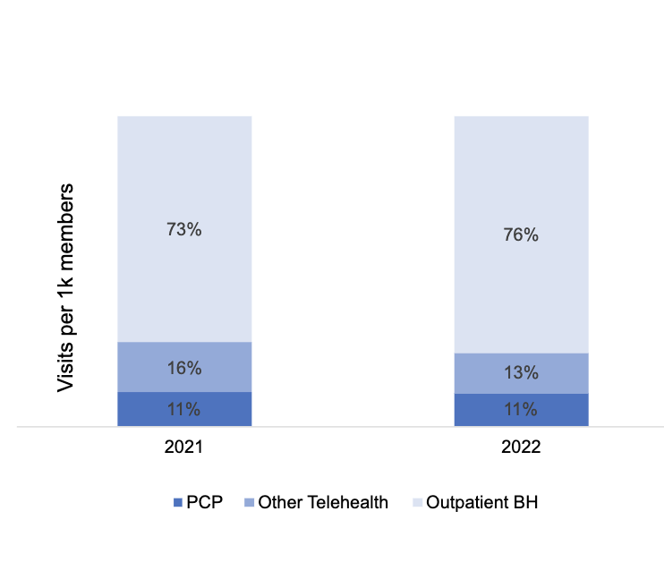

Key Takeaways:

* Telehealth utilization surged during the pandemic. While telehealth rates declined in 2022 as the pandemic waned, rates remained higher than pre-pandemic.
* Telehealth utilization did not vary significantly between members enrolled in ACOs and those enrolled in other managed care plans.
* **Outpatient BH services** remained the most common telehealth service, accounting for ~75% of total telehealth visits in both 2021 and 2022.

#### Slide 16: ACOs Collaborated with MassHealth to Adress BH ED Boarding and Better Support Members with High BH Risk

* In 2022, Massachusetts **continues to experience a large volume of members presenting in EDs seeking inpatient BH care** and waiting extended periods for placement
* To address this ongoing concern, MassHealth **implemented a performance and reporting program** with ACOs to improve engagement in high impact interventions for members with high BH risk. High BH risk was defined by the number of BH ED visits and BH IP admissions a member had during a 3-month period.
* ACOs were asked to report on which four high impact interventions they had engaged members with high BH risk in during the previous quarter. The results, including a market comparison, were shared with ACOs.

**Performance Engagement Findings:**

* Performance engagements were held with 9 ACOs in 2022 to better understand best practices, barriers, and facilitators for high BH risk population health management, identifying innovative and successful approaches to managing high BH risk members, including the following:
  + **Fallon 365** utilized separate, tailored adult and youth risk stratification dashboards. They included a variety of variables such as difficulty of engagement, SDOH, preferred language of care, and chronic conditions in addition to the typical total cost of care and hospitalization rates.
  + **Tufts Together with Cambridge Health Alliance** had an intensive care management program that was provider facing to ensure seamless care coordination between the care team. Community Health Workers focused on member facing care and coordination and reducing barriers to access.
  + **Boston Medical Center Community Plan** had shelter and ED-based liaisons to meet members where they were at to engage them in care management services.

**2023 Strategy:**

* **Contract Requirements** 
  + Separate risk stratification criteria for adults and youth identified as a best practice and was incorporated into the ACO contracts in 2023.
* **Information Sharing** 
  + A summary of findings and best practices identified in the first 3 rounds of reporting and engagements was disseminated to the plans in October 2023.
* **Updates to Reporting Program** 
  + The following rounds of reporting and engagement beginning in December 2023 focused on facilitating adoption of best practices from previous rounds and problem-solving barriers.
  + Reporting process updates included requiring plans to self-identify members who met the high BH risk criteria and comparing their identified members to those reported to the Massachusetts Behavioral Health Access (MABHA). Plans began to be held to greater accountability for accurately reporting their high-risk members who are waiting for placement on the state portal.

#### Slide 17: ACOs Reviewed Effectiveness of DSRIP Funded Programs to Make Ongoing Investment Decisions

* As time-limited DSRIP funding declined in this final year of the DSRIP program, ACOs evaluated and compared their DSRIP-funded investments to make data-driven choices about which to scale/sustain and which to sunset.
* ACO DSRIP spending was at its highest in 2018 ($189.3M) and continually decreased in the subsequent years ($173.7M in 2019, $135.7M in 2020, $87.5M in 2021, $69M in 2022 through Q1 2023) as ACOs decreased spending on Integration Projects and Data Analytics, Population Health, and HIT Projects.
* In 2022, as in prior years, ACOs made decisions about which programs to fund through DSRIP and which to sunset or move to other funding sources given lower levels of DSRIP funding.
* **Example: In 2022, FLN-Berkshire continued DSRIP investment in their Hospital Based Community Health Worker (CHW) program based on demonstrated reductions in avoidable ED visits, inpatient admissions, and behavioral health hospital days** 
  + The Hospital Based CHW at Berkshire visits or contacts members when they are in the ED/inpatient setting to engage the member and provide a warm handoff to the care team for ongoing care management and engagement
  + The program was evaluated and showed positive outcomes on three measures compared to benchmarks: 1) avoidable ED visits decreased by 24%, 2) inpatient admissions decreased by 23%, 3) residential behavioral health / SUD hospital days decreased 18%.

### Flexible Services

#### Slide 19: Flexible Services Program: Summary of 2022 Progress

* The Flexible Services Program enables ACOs to provide nutritional and housing supports to certain members, with the goal of improving overall member health and outcomes
* The Flexible Services Program was **one of 2022’s key successes.** In its third year, the program continued to experience **rapid and substantial growth, became more efficient**, and demonstrated **promising early outcomes**
* The Flexible Services Program **grew faster in 2022 than in 2021, providing more services to more members:** 
  + **Overall services[6] delivered more than doubled:**
    - 2021: 21,051
    - 2022[7]: 51,281 (2022 total annualized: 41,0247)
* **Unique members served increased by 60%** 
  + 10,229 members served in 2021; 20,475 in 2022 (16,380 annualized7)
* **Dollars spent on Flexible Services supports doubled** 
  + $22.6M in 2021 to $52.4M ($41.9M annualized7) in 2022
* While Flexible Services remained a relatively nascent program in 2022, preliminary analyses already began to show **improvements for members with diabetes (reductions in A1c) and total cost of care**

#### Slide 20: ACOs Partnered with SSOs to Offer 85 Flexible Services Programs in 2022

* In 2022, ACOs partnered with community-based Social Services Organizations (SSOs) to offer 85 **Flexible Services programs** focused on nutrition and housing support services and goods.
* Compared to 2021, both the number of available programs and partnerships between ACOs and SSOs **increased by approximately 12%.**
* **ACOs and SSOs launched 85 programs** in the following domains in 2022:
  + 41 Housing
  + 43 Nutrition
  + 1 Housing/Nutrition
* ACOs partnered with **39 SSO partners** to deliver Flexible Services in 2022, including:
  + 23 Housing SSOs
  + 13 Nutrition SSOs
  + 3 Housing/Nutrition SSOs
* All **17 ACOs offered at least 1 Flexible Services program** in calendar year (CY) 2022.

#### Slide 21: ACOs implemented Flexible Services in every geographic region of the state, across the full breadth of supports allowed by the program

**Number of Flexible Services Programs Serving Each Region By Domain**

* **Western:** 9 housing, 8 nutrition, 1 both
* **Central:** 9 housing, 7 nutrition, 1 both
* **Northern:** 13 Housing, 16 nutrition, 1 both
* **Greater Boston:** 18 housing, 21 nutrition,1 both
* **Southern:** 8 housing, 16 nutrition, 1 both

**Note:** Several programs operated across more than one region of the Commonwealth and are counted more than once above.

**Flexible Services Program Funding Breakdown by Sub-Domain ($M)**

* Pre-Tenancy: $8.5M
* Pre-Tenancy Transitional: $6.4M
* Tenancy Sustaining: $6.7M
* Home Modifications: $2.4M
* Nutrition Sustaining Goods: $29.7M
* Nutrition Sustaining Services: $12.9M
* **Total CY21 Allocated Funds with rollover:** $74.2M
* **Total CY21 Allocated Funds without rollover:** $37M
* **Total Budgeted in CY21:** $66.5M
* **% Budgeted of Total Allocation with rollover: 90**%

#### Slide 22: In 2020 and 2021, there was continuous growth in Flexible Services uptake each quarter

Table 3:

|  |  |  |  |  |  |  |
| --- | --- | --- | --- | --- | --- | --- |
| Flexible Services | # of Members Served | # of Members Served | # of Members Served | $ Spent | $ Spent | $ Spent |
| Flexible Services | Total CY20 | Total CY21 | Total CY22* | Total CY20 | Total CY21 | Total CY22* |
| # of Unique Members/$ Spent per year | 6,133 | 10,466 | 16,380 | $6.8M | $22.6M | $41.9M |

Notes for Table 3: The performance period for the 2022 report encompasses five quarters (1/1/2022 – 3/31/2023) rather than the standard four quarters reported in 2020 and 2021. For the purposes of year over year comparisons, numbers annualized when reporting CY22 and does not include Q1 2023.

Key Takeaway:

* Across CY20, CY21, and CY22, a total of 29,251 unique members were served. Additionally, there was a total of $71.3M spent across all quarters.

Graph 7:

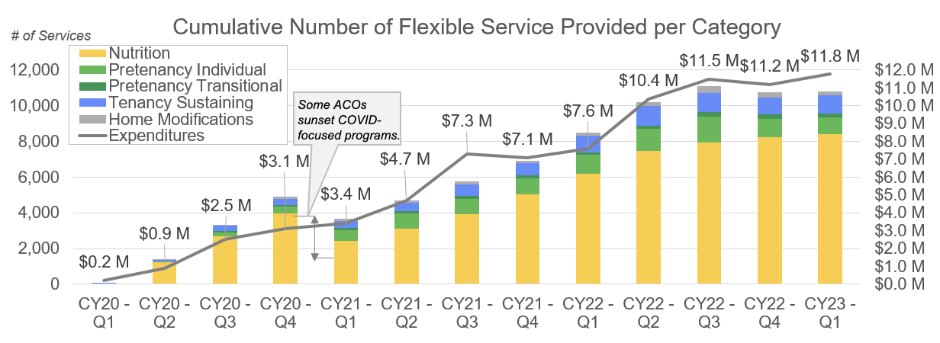Note on Graph 7: MassHealth defines Flexible Services in terms of member-quarters or number of quarters members have received services. A unique member that received services across 4 quarters would count towards 4 services provided.

Key Takeaways:

* **Flexible Services expenditures increased significantly** from 2020 to 2022[8] ($6.8M to $41.9M), corresponding to a 167% **increase in unique members served** (6,133 to 16,380).
* Cumulatively from program launch in 2020 through Q1 2023, over **82,000 Flexible Services were provided to almost 30,000 unique members.**[9]

#### Slide 23: Flexible Services: Early Promising Results

**In 2022, individual SSOs were already seeing early improvements** in health and social outcomes. MassHealth continues to closely track results and evaluate if specific interventions/models are more impactful than others.

***SSO Highlight:* *Project Bread*** *observed positive initial impacts on food security and fruit and vegetable consumption based on their members served from October 1, 2021 – September 30, 2022. Their services include nutrition education, food vouchers, coordination, and transportation.*

* **Snapshot of Services Provided** 
  + Partnered with 3 ACOs to serve over **3,000 members**
  + **42,731 Gift Cards** Sent
  + **4,776 Kitchen Supply** Orders Placed
  + **896 Cooking Class / Counseling Session Attendees**
* **Social Improvements** 
  + **19% decrease in member reported food insecurity** and a **30% increase in SNAP participation** for members receiving nutrition services (N = 2,112) for 6 months
* **Health Improvements**
  + At the end of the six months of services:
    - **91%** of members reported an **improved ability to prepare healthy meals**
    - **94%** of members reported **improvement in their health**
    - **87%** of members reported an increase in their **confidence of their nutrition knowledge**

#### Slide 24: Flexible Services: Early Promising Results (Continued)

**ACO Highlight: Boston Medical Center Healthnet Plan Community Alliance (BACO)** observed encouraging initial impacts on housing status based on their CY2022 members served.

* **Housing Placement and Maintenance:** 
  + BACO’s Housing Supports Program reported **76% of members successfully housed** in their programs (n=34).
  + In further results from the above program, **95% of members maintained housing for one year** after placement (n=32).

**Member Story: Positive Social Outcomes**

A member facing various challenges regarding housing (e.g., in need of financial assistance and guided support for the housing search process) was referred by BACO to a housing program. This program successfully provided the member:

* Assistance with **housing stability** and **eviction defense** (e.g., supported the member in submitting a final motion for extension)
* Assistance with **housing search** and **placement** (e.g., supported search and secured placement in a new unit)
* **Continued guidance and connection to community resources** (e.g., assistance with getting members mental health services reinstated to provide long term, tenancy stabilization support)

### Community Partners (CPs)

#### Slide 26: Summary of CP Progress through March 2023

* CPs contract with ACOs to provide **wrap-around expertise and support for behavioral health (BH) services and long-term services and supports (LTSS)**

* The CP program, which ran from September 2018 to March 2023, continued to see positive trends in utilization and cost measures, including:
  + Data showed reductions in ED and BH inpatient utilization rates for members with longer enrollment in the CP program.
  + Risk-adjusted TCOC was 20% lower for BH CP members following graduation from the CP program vs. members in the 12 months preceding enrollment
  + However, these observed reductions may be confounded by overall utilization declines driven by the pandemic and changes in the CP population over time.[10]
* Despite lingering COVID-related challenges, CPs continued to make **gains in member outreach and engagement.** During 2022, CPs:
  + Served ~44,000 unique members
  + Increased the annual engagement rate[11] of actively enrolled members from 53% to 58%
  + Reduced the statewide average days to a complete care plan (a key indicator of successful coordination with PCPs) from 176 to 152 days (14% reduction)

#### Slide 27: Overall Members with Longer CP Enrollment had lower ED utilization

Graph 8:

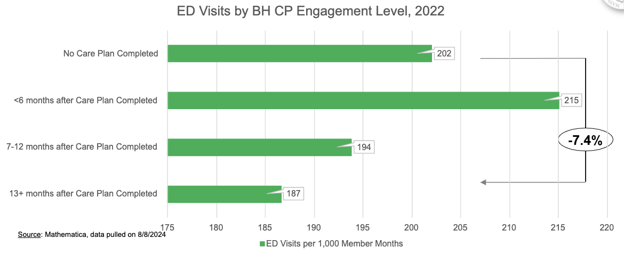Notes for Graph 8: "No Completed Care Plan" means the member is enrolled in CP but their care plan has not yet been completed. The Care Plan is considered completed when its development is finalized. Care plans are reviewed and completed annually for every member or updated when significant changes occur in the member's presentation/needs.

Key Takeaways:

* In 2022, BH CP enrollees 13 months or more after their initial Care Plan was completed had 7.4% lower ED visits than enrollees before their completed Care Plan
* Overall, members with shorter CP enrollment (e.g., ≤ 6 months) had higher ED utilization, while members with longer CP enrollment had lower ED utilization.

#### Slide 28: Members with Longer CP Enrollment had Lower BH Inpatient Admissions

Graph 9:

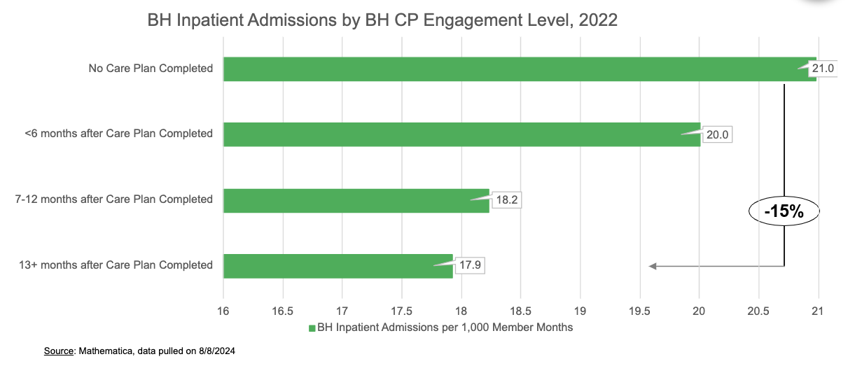

Key Takeaways:

* Overall, **members with longer CP enrollment had lower BH Inpatient Admissions.**
* Members 13 months or more after Care Plan completed had **~15% lower BH inpatient admissions** than members before their completed Care Plan
* However, this is also confounded by large declines in BH inpatient admissions across the ACO population.

#### Slide 29: Risk-Adjusted Total Cost of Care (rTCOC) Declined the Longer CP Members were Engaged[12] in the CP Program

Graph 10:

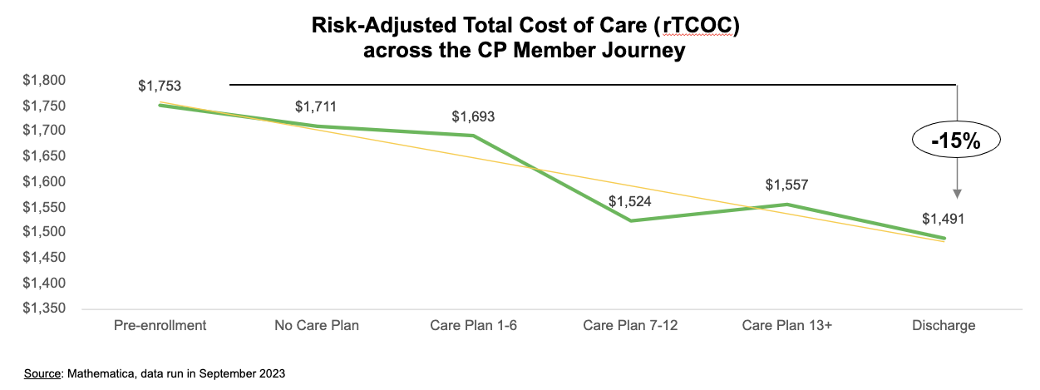Note: Graph 10 is sourced from Mathematica. Data was run in September 2023

Key Takeaways:

* rTCOC is the average amount paid on claims by Medicaid and ACOs/MCOs per CP member per month, risk adjusted within the CP population and excluding members who are dually-eligible for Medicaid and Medicare.
* This graph represents all CP members enrolled in the program between July 1, 2018 to March 31, 2023 and shows the change in rTCOC throughout their time enrolled in the program.
* Overall, rTCOC decreases throughout the time that CP members are engaged with a CP
  + On average, CP members have a 15% lower rTCOC upon discharge compared to CP members in the 12 months prior to enrollment ($1,491 vs. $1,753).

#### Slide 30: CP Member Engagement Continued to Improve During 2022

Graph 11:

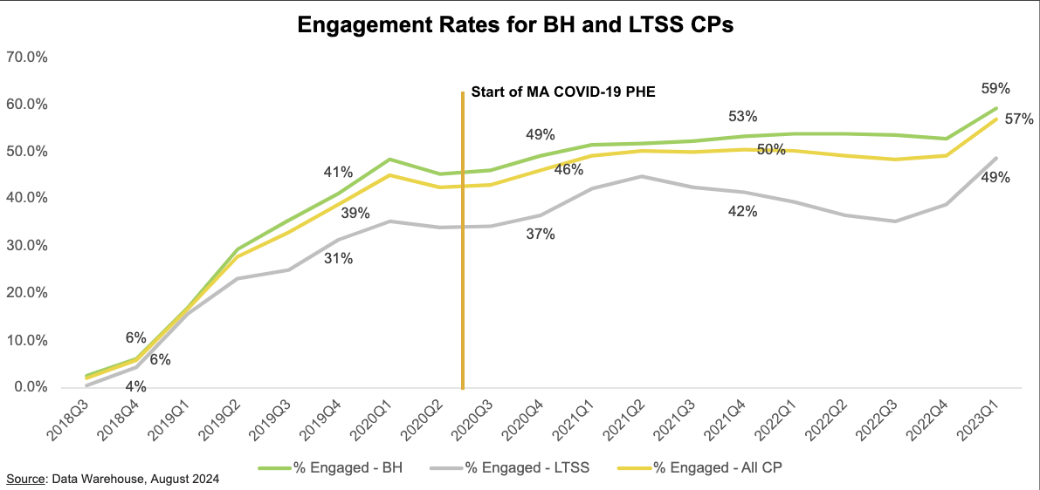Note: Graph 11 is sourced from Data Warehouse. Data was run in August 2024

Key Takeaways:

* As of March 2023, **66% of members enrolled in CPs were engaged**[13]
* This is an i**ncrease from 57%** in March 2022, 56% in March 2021, 51% in March 2020, and 19% in March 2019.

#### Slide 31: CPs Reduced Days to Care Plan Complete in 2022, Building on Improvements in Outreach and Engagement from 2018-2020

Graph 12:

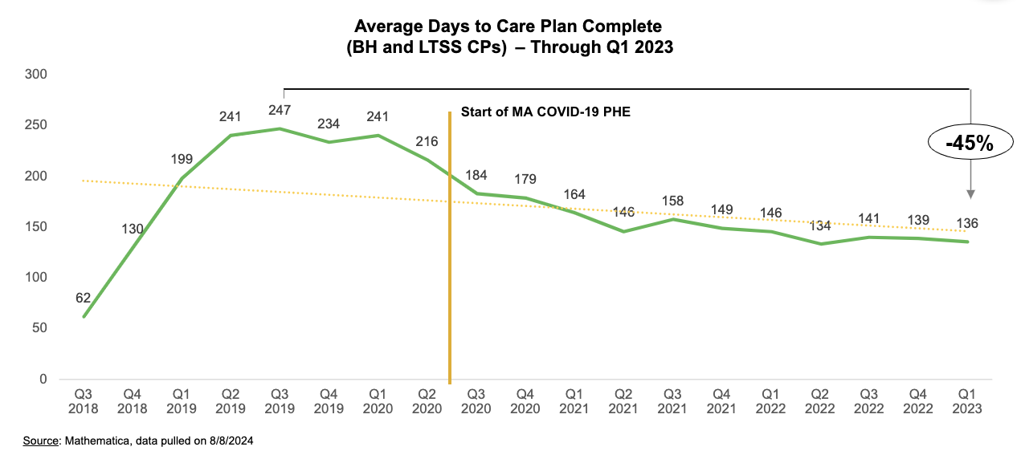Note: Graph 12 is sourced from Mathematica. Data was pulled on September 8th, 2024

Key Takeaways:

* CP members are considered engaged in the CP Program once their Care Plan is completed and approved by their PCP. The Days to Care Plan Complete measure provides insight into how quickly and efficiently CPs are conducting outreach and engaging members and coordinating with other members of the care team
* During 2022, **CPs continued to bring down the average number of days to Care Plan Complete**, from 146 days in Q1 2022 to 139 days in Q4 2022.
* Days to Care Plan Complete has **decreased 45%** from its peak in Q3 2019 (247 days) to Q1 2023 (136 days)

#### Slide 32: Examples of CP Success: Community Care Partners Improves Member Engagement Timelines

Graph 13:

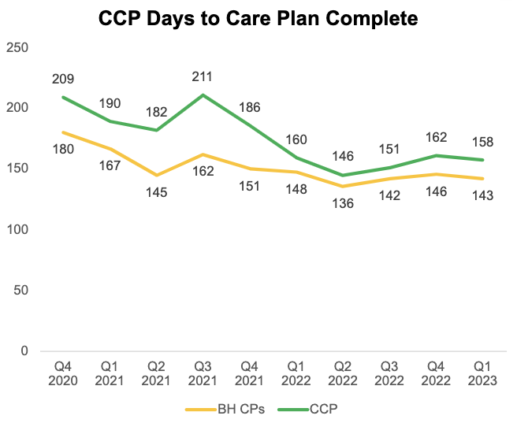

Note: Graph 13 is sourced from Mathematica. Data was pulled on September 8th, 2024

Key Takeaways:

* In 2022, MassHealth engaged with Community Care Partners (CCP) BH CP around performance data related to care plan complete timelines, particularly within their Affiliated Partners, Bay Cove and Vinfen. As a result of these engagements and reviewing MassHealth-provided performance data, CCP CP developed a strategy to focus on decreasing time from enrollment to Assessment and Care Plan Complete milestones.

**Strategies implemented:**

* Ensuring BH CP staff at both Bay Cove and Vinfen were retrained on how to escalate an outstanding Care Plan;
* Continuing to escalate centrally any care plan outstanding for more than 30 days;
* Updating Assessment and Care Planning trainings in New Employee Training and Refresher trainings;
* Developing Comprehensive Assessment and Care Planning guidance tools and ensure care team usability to promote decrease in time to complete documents; and
* Ensuring BH CP Staff at both Bay Cove and Vinfen are retrained on Comp Assessments and Care Planning to promote further efficiencies
* These strategies resulted in a 25% reduction and sustained improvement in the days to Care Plan Complete for their BH CP members from Q4 2020 through Q1 2023.

### DSRIP

#### Slide 34: Overview of DSRIP Program

* The Delivery System Reform Incentive Payment (DSRIP) program was a $1.8 billion, five-year investment program authorized through MassHealth’s 1115 demonstration to support MassHealth’s restructuring efforts; 2022 was the last year of the DSRIP Program.
* ACOs and CPs used DSRIP funds to design and test innovative programs, with the expectation that they measure those programs’ outcomes, and to stand up infrastructure required for population health management
* In 2022[14] ACOs and CPs spent $209.1M in DSRIP funding:
  + $121.4M by ACOs (Startup/Ongoing: $69M; and Flexible Services: $52.4M)[15]
  + $87.7M by CPs (Infrastructure and Care Coordination)
* The most common type of DSRIP-funded ACO program in CY2022 was care coordination and care management programs (113 programs costing $26M; e.g., embedding community health workers in EDs to help members navigate the health care system and share resources upon ED departure)[16]
* From July 1, 2018 to March 31, 2023, ACOs and CPs cumulatively spent $1.2B in DSRIP funding:
  + $794.8M by ACOs (Startup/Ongoing and Flexible Services)
  + $377.1M by CPs (Infrastructure and Care Coordination)
* Additionally, $13.4M of DSRIP funding was used for Statewide Investments in 2022 to support workforce development (training, hiring, retention), technical assistance for ACOs and CPs, and related initiatives.

**Note:** See Appendix for detailed DSRIP funding charts by ACO, CP, and Statewide Investments programs

#### Slide 35: 2022 DSRIP Investments: by the Numbers

* **444 different ACO investments/programs** supported by DSRIP
  + Initiatives implemented by ACOs to improve quality of member care and lower total cost of care
* **$47M spent on personnel/staff** by ACOs
  + Significant investment in workforce (e.g., care coordinators, community health workers, IT staff) to support ACO efforts
* **$14.4M spent on infrastructure** by CPs
  + Build out infrastructure to implement CP program, such as establishing workflows, integrating electronic systems, purchasing tablets to facilitate in-person connections, etc.
* **$73.2M paid to CPs for care coordination supports** 
  + Payments for outreach, assessing needs, care planning, care coordination, etc.

#### Slide 36: ACO DSRIP Startup / Ongoing Investments: Overview by Category

Graph 14:

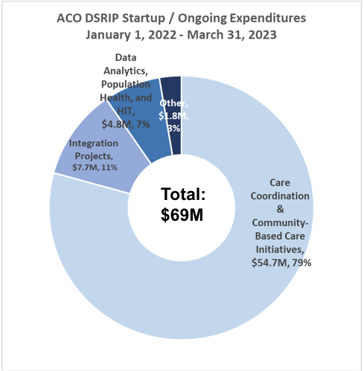

Note for Graph 14: Expenditures do not include ACO Delivery System Transformation Initiative (DSTI) or ACO Flexible Services Expenditures; See appendix for DSRIP funding per ACO.

Key Takeaways:

* 2022 Startup/Ongoing expenditure data ($69M) reflects a decrease from the 2021 report ($87.5M), which corresponds with an overall decrease in DSRIP funding provided to ACOs. ACO DSRIP allocation percentages by category remained relatively constant between 2021 and 2022.
* Overview of categories:
  + **Care Coordination & Community-Based Care Initiatives:** Strengthen care coordination/ management and community-based programming
  + **Integration Projects:** Increase organizational capacity, as well as integration amongst physical health, BH, LTSS, and health-related social services
  + **Data Analytics, Population Health, and Health Information Technology:** Improve data collection, analytic platforms, algorithm development, EHR and care management software improvements, and interoperability
  + **Other:** Support workforce development, culturally and linguistically appropriate services, and other investments

#### Slide 37: CP DSRIP Investments: Overview by Category

Graph 15:

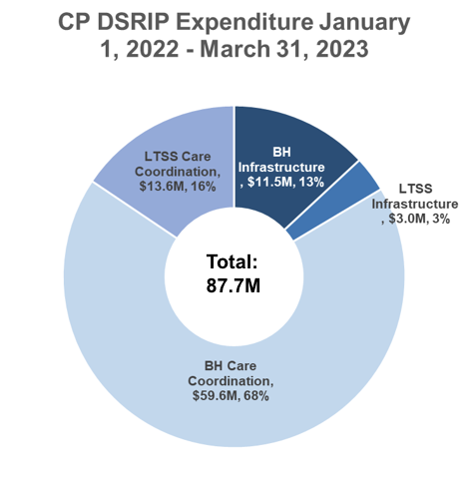

Note for Graph 15: See appendix for DSRIP expenditures by CP

Key Takeaways:

* 2022 expenditure data ($87.7M) reflects a decrease from 2021 expenditures ($95.3M), driven by a decrease in Care Coordination payments and an overall decrease in the CP Infrastructure allocations as the program began to wind down.
* Overview of categories:
  + **Infrastructure:** Investments in technology, workforce development (e.g., recruitment and training expenses), business start up costs, and operational infrastructure (e.g., data analytics staff)
  + **Care coordination:** Payment for outreach, assessing needs, care planning, care coordination, etc.

#### Slide 38: DSRIP Health-Related Social Needs Spending

One of MassHealth’s key priorities for its ACO program is to better address the health-related socials needs (HRSNs) of its ACO-enrolled members. ACOs have two funding sources available to address HRSNs:

* **General DSRIP Funds:**
  + ACOs may use general DSRIP funds on investments such as infrastructure, technology, and workforce in support of ACO goals, and some ACOs have leveraged this funding to address HRSNs.
  + CPs may also use DSRIP funds to address certain HRSNs.
  + Funds Spent On HRSNs[17],[18] – 2017: $7.4M, 2018: $34.3M, 2019: $44M, 2020: $32.9M, 2021: $20.5M[19], 2022: $13M[20]
* **Flexible Services:** 
  + “Flexible Services” funding can be used to pay for certain nutrition and housing supports, including pre-tenancy supports (e.g., transitional assistance), tenancy sustaining supports, home modifications, and nutrition supports, for certain ACO members.
  + The Flexible Services Program launched in January 2020.
  + Details on Flexible Services spending and utilization can be found on p. 18-23.

#### Slide 39: Statewide Investments: by the Numbers – Workforce

Cumulative Through CY22[21]

* **307 student loans repaid for community-based clinicians**
* **$11.1M in student loan repayment**
* **90% of BH and primary care providers who received student loan repayment awards from 2018-2022 that are honoring their multi-year service commitment**
  + Empowers and incentivizes clinicians to work at and remain in safety net provider organizations
* **1027 community health workers and peer specialists trained**
  + Key members of the extended care team, who help engage members in their care
* **34 community health center-based Family Medicine and Family Nurse Practitioner residency training slots supported**
  + Clinicians trained in community-based residency programs more likely to remain in community upon training completion

**Note:** See appendix for DSRIP funding per Statewide Investments program

#### Slide 40: Statewide Investments: by the Numbers – Technical Assistance

Cumulative through CY22

* **366 technical assistance (TA) projects funded at ACOs/CPs**
* **$28.0M of technical assistance support** 
  + ACOs and CPs were given funds to purchase TA support from a curated catalog of 47 TA vendors with expertise in 9 different domains (e.g., population health management, care coordination/integration, performance improvement)
* **2,233 average monthly active users of DSRIP TA website[22]**
  + High interest from ACOs and CPs occurred in 2021

## Quality and Member Experience Data: Updates and Trends

### Quality

#### Slide 42: Overview of 2022 ACO and CP Quality Data and Performance

* The varying impact of the pandemic across ACO and CP quality measures, as well as the addition of various COVID-based scoring modifications 2020-2022, **makes the comparison of year over year overall quality performance difficult.**
* However, at a **high-level, clinical quality performance improved for ACOs** (73.90% vs. 85.25%) and **declined for CPs** (69.84% vs. 64.40%) **when comparing 2021 to 2022 performance.** 
  + In 2022, of the measures that showed substantial declines in performance from 2019 to 2020, all six ACO measures and all four CP measures demonstrated partial to full recovery from their respective previous declines.
  + Despite these improvements, **some measures did not reach their pre-pandemic performance levels or demonstrate improvement over 2021 performance.**
* **Member experience results were similar to 2020-2021,** and demonstrated strong levels of satisfaction with providers, and ongoing opportunities for increased care coordination
* **Note:** Quality results were not generated for the January – March 2023 time period as individual measures and/or benchmarks are designed and tested based on a 12-month measurement period

**Note:** Despite the ongoing PHE, MassHealth and CMS determined 2021 and 2022 data was usable for official quality scoring. This is in contrast to 2020 when data was deemed unusable due to the pandemic. In response to concerns over the pandemic’s impact on individual quality measures, MassHealth and CMS agreed to certain benchmark reductions for ACO/CP measures demonstrating 2019-2020 performance declines. See the appendix for more details on benchmark reductions and for the ACO and CP measure slates.

#### Slide 43: Clinical Quality: Overview of ACO and CP Performance 2019-2022

Table 4 and 5:

|  |  |  |  |  |  |
| --- | --- | --- | --- | --- | --- |
| **ACO** | **2019 Official Quality**  **Score (based on actual 2019 data)** | **2020 Official**  **Quality Score**  **(based on 2019 data + COVID**  **allowances)[23]** | **2020 Actual Quality Score**  **(based on actual 2020 data)** | **2021 Actual Quality Score**  **(based on actual 2021 data)** | **2022 Actual Quality Score**  **(based on actual 2022 data)** |
| **Measures where median ACO passed**  **Attainment**  **Threshold** | 14/16 (87.5%) | 14/16 (87.5%) – *note: mirrors 2019 by definition* | 10/16 (62.5%) | 16/18 (88.9%) | 17/19 (89.5%) |
| **Median ACO quality score** | 75.71% | 97.14% | 61.24%  (proxy score) | 73.90% | 85.25% |

|  |  |  |  |  |  |
| --- | --- | --- | --- | --- | --- |
| **CP** |  |  |  |  |  |
| **Measures where median**  **CP passed**  **Attainment**  **Threshold** | 15/15 (100.0%) | 15/15 (100.0%) - note: mirrors 2019 by definition | 11/15 (73.3%) | 20/20 (100.0%) | 19/20 (95.0%) |
| **Median CP quality score** | 34.96% | 55.53% | 36.92%  (proxy score) | 69.84% | 64.40% |

Key Takeaways:

* **ACO/CP clinical quality performance improved for ACOs (73.90% vs. 85.25%) and CPs (69.84% vs. 64.40%)** when comparing 2021 performance data to 2022 performance data
* **Improvements above reflect both measure level increases as well as benchmarks reductions implemented in 2021-2022.** However, the expansion of measures in pay-for-performance status and differences in scoring methodologies (as a result of COVID-19) place limitations on year-over-year comparisons

#### Slide 44: ACO Clinical Quality: ACO-Level Comparison 2019-2022

Table 6:

|  |  |  |  |  |  |
| --- | --- | --- | --- | --- | --- |
| **ACO** | **2019 Official Quality Score**  **(based on actual 2019 data)** | **2020 Official**  **Quality Score**  **(based on 2019 data + COVID**  **allowances)[24]** | **2020 Actual Quality Score**  **(based on actual 2020 data)**[25] | **2021 Actual**  **Quality**  **Score**  **(based on actual**  **2021 data)** | **2022 Actual Quality**  **Score**  **(based on**  **actual 2022**  **data)** |
| Berkshire Fallon Health Collaborative | 67.19 | 89.34 | 39.18 | 74.39 | 66.23 |
| Fallon 365 Care | 66.52 | 100 | 78.76 | 96.62 | 92.17 |
| Wellforce Care Plan | 76.90 | 90.4 | 53.05 | 57.95 | 84.89 |
| BeHealthy Partnership | 85.78 | 98.96 | 68.04 | 67.64 | 83.41 |
| My Care Family | 90.23 | 97.97 | 55.22 | 69.21 | 86.07 |
| Tufts Health Together with Atrius Health | 75.71 | 94.68 | 68.76 | 76.59 | 91.91 |
| Tufts Health Together with BIDCO | 66.83 | 88.94 | 34.33 | 60.51 | 74.39 |
| Tufts Health Together with CHA | 99.18 | 100 | 65.74 | 73.90 | 85.24 |
| Tufts Health Together with Boston Children's ACO | 72.19 | 89.17 | 71.58 | 81.00 | 95.51 |
| BMC HealthNet Plan Community Alliance | 96.01 | 93.99 | 61.02 | 74.90 | 85.58 |
| BMC HealthNet Plan Mercy Alliance | 66.93 | 94.53 | 66.14 | 72.04 | 82.68 |
| BMC HealthNet Plan Signature Alliance | 100.00 | 98.96 | 61.63 | 81.93 | 92.94 |
| BMC HealthNet Plan Southcoast Alliance | 74.55 | 93.53 | 70.28 | 87.33 | 87.13 |
| Community Care Cooperative | 80.28 | 95.85 | 61.24 | 88.81 | 87.96 |
| Partners HealthCare Choice | 74.53 | 93.52 | 54.93 | 63.52 | 70.03 |
| Steward Health Choice | 64.24 | 90.15 | 50.19 | 68.23 | 76.17 |
| Lahey | 80.82 | 80.77 | 45.31 | 52.86 | 85.25 |

Key Takeaway:

* In 2022, 13/17 ACOs improved their quality performance compared to 2021, and most showed sustained improvements compared to 2019

#### Slide 45: ACO Clinical Quality: 2022 Measures with Substantial Performance Drop

Table 7:

|  |  |  |  |  |  |
| --- | --- | --- | --- | --- | --- |
| Measure | Performance Monitoring | Performance Monitoring | Performance Monitoring | Performance  Monitoring | Performance Monitoring |
|  | 2019-2020 Perf. Drop | 2019-2021 Perf. Drop | 2019-2022 Perf. Drop | Recovery | Recovery % |
| 1. Metabolic monitoring for children using  antipsychotics | -7.9 | -5.6 | -5.5 | +2.4 | 30% |
| 2. Diabetes care: a1c poor control | -11.0 | -3.9 | -3.6 | +7.4 | 67% |
| 3. Controlling high blood pressure | -12.6 | -6.1 | -5.3 | +7.3 | 58% |
| 4. Oral health evaluation | -16.7 | -7.4 | -7.1 | +9.6 | 57% |
| 5. Screening for depression and follow-up plan | -9.0 | -3.7 | -0.8 | +8.2 | 91% |
| 6. ED Visits for individuals with mental illness and/or addiction  (observed/  expected ratio) | -0.4 | -0.5 | 0.1 | 0.5 | 100% |

Key Takeaways:

* In 2020, six ACO quality measures demonstrated substantial drops in performance from 2019 to 2020 (likely due to COVID) and were deemed priority measures for monitoring through 2022
* The table below demonstrates the percentage of initial performance drops in 2020 and the recovery % by the end of 2022. **In 2022, five measures demonstrated partial recovery from their initial 2019-2020 declines, and one measure demonstrated full recovery.** However, three of those measures (#s 1, 2, 4) had partially recovered in 2021 and remained stable in 2022.

#### Slide 46: CP Clinical Quality: BH CP-level Comparison, 2019-2022

Table 8:

|  |  |  |  |  |  |
| --- | --- | --- | --- | --- | --- |
|  | **2019 Official**  **Quality**  **Score**  **(based on actual 2019**  **data)** | **2020 Official**  **Quality Score (based on 2019 data + COVID**  **allowances)[26]** | **2020 Actual**  **Quality Score (based on actual 2020 data)** | **2021 Official Quality**  **Score**  **(based on actual 2021 data)** | **2022 Official**  **Quality**  **Score**  **(based on**  **actual 2022 data)** |
| Boston Coordinated Care Hub | 62.88 | 71.35 | 43.68 | 32.92 | 39.42 |
| South Shore Community Partnership | 30.03 | 48.59 | 40.37 | 83.80 | 71.61 |
| Brien Center Community Partner Program | 16.70 | 52.14 | 27.82 | 56.53 | 41.03 |
| Eliot Community Human Services | 60.78 | 73.52 | 44.04 | 88.09 | 60.11 |
| Behavioral Health Network, Inc. | 64.45 | 74.79 | 27.20 | 61.05 | 64.82 |
| Clinical and Support Options, Inc. | 34.20 | 62.63 | 27.64 | 70.64 | 44.34 |
| Lahey Health Behavioral Services | 16.78 | 32.19 | 14.90 | 45.76 | 84.37 |
| Community Healthlink, Inc. | 25.70 | 48.84 | 26.38 | 43.92 | 43.83 |
| Lowell Community Health Center, Inc, | 23.25 | 49.01 | 58.16 | 92.06 | 64.40 |
| Sstar Care Community Health Center, Inc. | 41.45 | 53.68 | 64.57 | 56.18 | 55.93 |
| Community Counseling of Bristol County, Inc. | 75.05 | 79.33 | 57.62 | 81.68 | 88.73 |
| Riverside Community Care | 21.85 | 51.51 | 21.67 | 93.88 | 73.23 |
| Coordinated Care Network | 67.95 | 67.95 | 36.92 | 89.08 | 70.61 |
| Central Community Health Partnership | 23.40 | 50.70 | 19.16 | 94.14 | 43.79 |
| Innovative Care Partners, LLC | 26.33 | 49.57 | 83.16 | 100.00 | 65.73 |
| Community Care Partners, LLC | 45.38 | 54.41 | 35.22 | 63.88 | 56.27 |
| Behavioral Health Partners of MetroWest, LLC | 32.55 | 47.29 | 43.89 | 100.00 | 63.93 |
| Southeast Community Partnership, LLC | 44.73 | 55.37 | 31.01 | 45.20 | 60.40 |

Key Takeaway:

* In 2022, clinical quality performance declined among most BH CPs relative to 2021, but sustained improvements overall compared to 2020 and 2019.[27]

#### Slide 47: CP Clinical Quality: LTSS CP-level Comparison, 2019-2022

Table 9:

|  |  |  |  |  |  |
| --- | --- | --- | --- | --- | --- |
| **LTSS CP** | **2019 Official Quality Score (based on actual 2019 data)** | **2020 Official**  **Quality Score**  **(based on 2019 data + COVID**  **allowances)[28]** | **2020 Actual Quality Score (based on actual 2020 data)** | **2021 Actual Quality Score (based on**  **actual 2021**  **data)** | **2022 Actual Quality Score**  **(based on actual 2022**  **data)** |
| Care Alliance of Western Mass | 27.48 | 55.32 | 29.59 | 60.94 | 69.43 |
| Merrimack Valley Community Partner | 90.44 | 90.44 | 49.48 | 62.10 | 80.28 |
| North Region LTSS Partnership | 43.52 | 48.98 | 48.79 | 100.00 | 98.00 |
| Central Community Health Partnership | 42.96 | 49.50 | 50.21 | 77.46 | 96.85 |
| Family Service Association | 69.12 | 75.36 | 22.92 | 63.52 | 76.42 |
| Massachusetts Care Coordination Network | 34.96 | 57.58 | 39.79 | 85.31 | 83.11 |
| Boston Allied Partners | 13.80 | 55.92 | 18.79 | 43.70 | 16.20 |
| Innovative Care Partners, LLC | 49.08 | 76.92 | 62.51 | 100.00 | 60.31 |
| LTSS Care Partners, LLC | 27.92 | 65.54 | 10.41 | 51.61 | 48.99 |

Key Takeaway:

* In 2022, clinical quality performance declined among most LTSS CPs relative to 2021, but sustained improvements overall compared to 2020 and 2019.[29]

#### Slide 48: CP Clinical Quality: 2020 Measures with Substantial Performance Drop

Table 10:

|  |  |  |  |  |  |  |
| --- | --- | --- | --- | --- | --- | --- |
| Measure | CP Type | Performance Monitoring | Performance Monitoring | Performance Monitoring | Performance  Monitoring | Performance Monitoring |
|  |  | 2019-2020 Perf. Drop | 2019-2021 Perf. Drop | 2019-2022 Perf. Drop | Recovery | Recovery % |
| Annual Treatment Plan | BH CP | -7.36 | -0.92 | -0.01 | +7.35 | 100% |
| Diabetes Screening for Individuals with Bipolar Disorder | BH CP | -5.37 | -4.33 | -4.71 | +0.66 | 12.29% |
| Oral Health Evaluation | LTSS CP | -15.43 | -1.37 | 0.00 | +15.43 | 100% |
| Hospital Readmissions (observed/ expected ratio) | LTSS CP | -0.36 | -0.39 | -0.08 | +0.28 | 77.77% |

Key Takeaways:

* In 2020, four of the 13 measures demonstrated substantial drops in performance from 2019 to 2020 (likely due to COVID) and were deemed priority measures for monitoring through 2022
* The table below demonstrates the percentage of initial performance drops in 2020 and the recovery % by the end of 2022. **In 2022, two measures demonstrated partial recovery from their initial 2019-2020 declines, and two measure demonstrated full recovery.** However, three measures had partially recovered by 2021.

### Member Experience

#### Slide 50: Member Experience: Summary of 2019-2022 Results

Table 11:

|  |  |  |  |  |  |  |
| --- | --- | --- | --- | --- | --- | --- |
| **Performance**  **Measure** | **2019**  **Aggregate**  **Statewide**  **Score** | **2020 Aggregate**  **Statewide**  **Score** | **2021**  **Aggregate**  **Statewide**  **Score** | **2022**  **Aggregate**  **Statewide**  **Score** | **Threshold** | **Goal** |
| Overall Care Delivery | 89.9 | 88.6 | 88.9 | 87.8 | 75.0 | 92.0 |
| Integration/ Coordination of Care | 83.2 | 81.8 | 80.8 | 81.1 | 71.25 | 86.25 |

Key Takeaways:

* ACOs are accountable for performance on two member experience measures:   
  1) Overall care delivery; and 2) Integration/ coordination of care
  + These measures are based on results from a subset of questions in the primary care survey, based on a nationally validated tool
* As in 2021, members in 2022 expressed strong levels of satisfaction with their providers, and the need for increased coordination managing BH and other specialists and services
* As with 2019-2021 results, 2022 continues to identify opportunities for progress, especially in the integration and coordination of BH care, and in the experience for the LTSS population

#### Slide 51: ACO Patient Safety

* ACPPs and MCOs report two types of patient safety-related events on an annual basis:
  + **Serious Reportable Events (SREs)**
    - Events that occur in hospital or hospital-licensed ambulatory surgical center (ASC) facilities that result in an adverse patient outcome that has been identified as usually or reasonably preventable, and of a nature such that the risk of occurrence is significantly influenced by the policies and procedures of the hospital or ASC
  + **Provider Preventable Conditions (PPCs)**
    - PPCs are a Health Care Acquired Condition or an Other Provider Preventable Condition as defined by CMS regulations and MassHealth policy.

Table 12:

|  |  |  |  |  |  |  |  |  |
| --- | --- | --- | --- | --- | --- | --- | --- | --- |
| Event | Metric | Plan Type | Year 5 (2022) | Year 4 (2021) | Year 3 (2020) | Year 2 (2019) | Year 1 (Mar-Dec. 2018) | Prior MCO |
| SREs | Range per plan | ACPP | 0 to 12 | 0 to 13 | 0 to 13 | 0 to 14 | 0 to 9 |  |
| SREs | Range per plan | MCO | 2 to 13 | 3 to 35 | 7 to 19 | 4 to 21 | 3 to 36 | 0 to 17 |
| SREs | Rate per 1000 members | Combined | 0.06 | 0.08 | 0.11 | 0.12 | 0.09 |  |
| PPCs | Range per plan | ACPP | 0 to 20 | 0 to 25 | 0 to 29 | 0 to 17 | 0 to 10 |  |
| PPCs | Range per plan | MCO | 2 to 40 | 3 to 40 | 7 to 51 | 1 to 19 | 3 to 62 | 0 to 23 |
| PPCs | Rate per 1000 members | Combined | 0.08 | 0.10 | 0.21 | 0.09 | 0.13 |  |

Key Takeaways:

* Both **SRE events and rate per 1,000 members decreased** in 2022 .
* Both **PPC events and rate per 1,000 members decreased** in 2022.
* Overall, the **occurrence of these events is relatively rare** and the numbers are small (e.g., <10 per ACO/MCO).

## Cost Data: Update and Trends

#### Slide 53: Overview of 2022 Cost Data and ACO Financial Performance

**Overall spend**

* In 2022, the ACO program accounted for $6.9B[30] of MassHealth spending, with an average annual total cost of medical services per member of ~$5,800; when including Q1 2023, through the end of the ACO contract, an additional ~$1.8B was spent for a total five-quarter period expense of **$8.7B.**
* ACO medical spend per member increased on average by approximately 2% from 2021 to 2022:
  + Increase concentrated in child population; adult member per year spend was slightly higher
  + Decreases in inpatient were offset by increases in pharmacy, outpatient, and other routine care

**Financial Performance**

* Most ACOs experienced financial gains in 2022
* ACPP/PCACOs were in 1.5%[31] profits (following market adjustment)

**Variation in spend**

* Among 13 ACPPs, profit/loss performance varied by up to ~14 percentage points across ACPPs after applying adjustments
* Among 3 PCACOs, performance varied by up to ~2 percentage points across PCACOs after applying adjustments

**Continuation of New Pricing Policies: Market Adjustment**

* In 2021, MassHealth implemented new pricing policies to adjust for changes that impacted the market as a whole. Through these changes, MassHealth ensures that actual funding (i.e., the rate / benchmark) is adjusted to meet actual costs for the ACO/MCO program overall while continuing to incentivize individual ACOs to perform better than the market. The main changes included:
  + Concurrent risk score adjustments which adjust for member acuity throughout the year
  + Market corridor which applies a market-wide adjustment in instances of significant profits or losses across all plans

#### Slide 54: Total Cost of Care: Comparison Across 2021 & 2022

Table 13 and 14:

Overall Trend[32]

|  |  |  |
| --- | --- | --- |
| 2021 | 2022 |  |
| ~$6.3B | ~$6.9B | Total spent on covered services for ACO members |
| ~$5,700 | ~5,800 | Average per member per year (PMPY) spending |

**Note for table 13:** Total spend and PMPY figures are not directly comparable to estimates in previous annual reports

Trend by Population Type[33]

|  |  |  |  |  |  |  |
| --- | --- | --- | --- | --- | --- | --- |
|  | 2021 | 2021 | 2022 | 2022 | 2022 vs 2021 % Change | 2022 vs 2021 % Change |
| Average PMPY | With  disabilities | Without  disabilities | With  disabilities | Without  disabilities | With  disabilities | Without  disabilities |
| Adults | ~$21,100 | ~$6,700 | ~$21,900 | ~$6,500 | 4% | -2% |
| Children | ~$10,400 | ~$2,200 | ~$11,300 | ~$2,500 | 9% | 12% |

Key Takeaway:

* Both total spend and average per member per year spending increased compared to 2021, driven by the child population. Adult member per year spend decreased slightly from 2021 to 2022.

#### Slide 55: Total Cost of Care: Category of Service Breakdown 2021 vs. 2022

Table 15:

Trend by category of service[34] (ACPP & PCACO combined)

|  |  |  |  |
| --- | --- | --- | --- |
| **Average PMPY** | **2021** | **2022** | **2021 vs. 2022 % change** |
| Inpatient Hospital | 1,033 | 980 | -5% |
| Outpatient Hospital | 1,078 | 1,133 | 5% |
| Inpatient BH | 219 | 219 | 0% |
| Outpatient BH | 632 | 630 | 0% |
| Professional services | 925 | 953 | 3% |
| Pharmacy | 1,579 | 1,657 | 5% |
| All other | 259 | 263 | 1% |
| Total | 5,725 | 5,835 | 2% |

Key Takeaways:

* Inpatient Hospital down -5% vs. 2021
* Most categories saw slight increases vs. 2021. Largest increases were in Outpatient Hospital, Pharmacy, and Professional services
* Inpatient BH and Outpatient BH were flat vs 2021
* Total spend is up 2% vs. 2021

#### Slide 56: Financial Performance: Majority of ACOs Saw Financial Gains in 2022

Table 16:

**2022 projected performance against capitation rates/benchmark[35]**

#of ACOs

|  |  |  |
| --- | --- | --- |
|  | ACPP | PCACO |
| >2% gains | 7 | 1 |
| +/- 2% of breakeven | 4 | 2 |
| >2% losses | 2 | 0 |
|  | 13 | 3 |

Key Takeaways:

* Most ACOs experienced financial gains or were at breakeven in 2022
* For 2021 and beyond, MassHealth adjusted funding to meet actual costs for the ACO program overall.
  + This is done by adjusting for situations in which the market overall is in savings or losses due to some market-wide trend (e.g., pandemic utilization changes, shifts in acuity of the overall caseload).
  + Even in the context of these adjustments, individual ACOs remain incented to perform better than the market overall

#### Slide 57: ACO Financial Performance Varied by Plan

Graph 16:

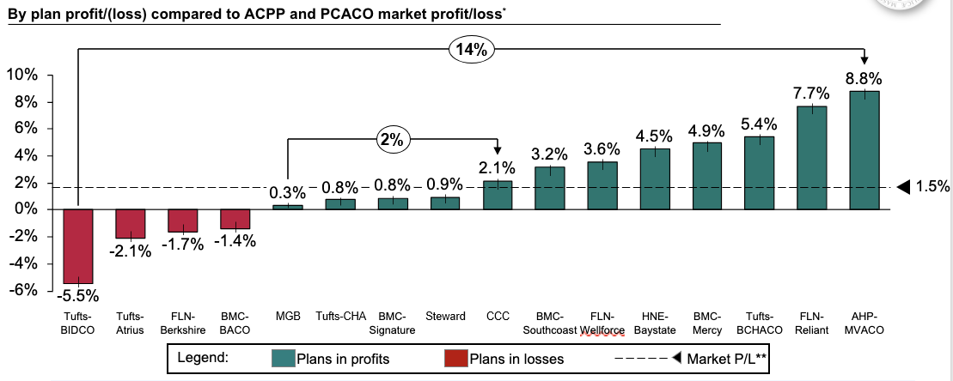Note for Graph 16: January – December 2022 core medical expenditures. ACPP and PCACO data sourced from the 2022 refresh market corridor report which reflects concurrent risk scores and the market corridor adjustments. Figures subject to final reconciliation (including final concurrent risk scores and market corridor adjustments), all percentages presented are prior to risk-sharing. Excludes MCO-Administered ACOs.

Key Takeaways:

* ACPP/PCACO market experienced 1.5%[36] gains after applying concurrent risk scores and the market corridor adjustment (see p. 55)
* Across the ACPP market, performance varied by **up to ~14 percentage points** across ACOs.
* Across the PCACO market, performance varied by **up to ~2 percentage points** across ACOs.

#### Slide 58: 2023 Q1 Extension Overview

Table 17 and 18:

Trend by Category of Service[37]

|  |  |
| --- | --- |
| **Average PMPM** | **2023 Q1** |
| Inpatient Hospital | 132 |
| Outpatient Hospital | 162 |
| Inpatient BH | 24 |
| Outpatient BH | 67 |
| Professional services | 148 |
| Pharmacy | 236 |
| All other | 38 |
| Total | 807 |

Trend by Population Type[38]

|  |  |  |
| --- | --- | --- |
|  | **2023 Q1 Extension** | |
| **Average PMPM** | **With**  **disabilities²** | **Without**  **disabilities²** |
| **Adults** | ~$2,786 | ~$955 |
| **Children** | ~$1,295 | ~$332 |

Key Takeaway:

* The 2023 Q1 period was treated as its own contract period prior to the launch of new ACO contracts in April 2023. During this period, the ACO program accounted for $1.78B of MassHealth spending, with an average total cost of medical services per member of ~$807.

## Next Phase

#### Slide 60: Conclusion of 2017-2022 1115 Demonstration

**Continued recovery from / response to the pandemic**

* In the final year of the 2017-2022 1115 demonstration, ACOs, CPs, and MassHealth continued to address the effects of the pandemic on MassHealth members and the healthcare workforce
* Efforts to re-engage members in care, ramp up home- and community-based services, continue telehealth use as appropriate, promote BH access, and address workforce shortages continued to be crucial.

**Planning for the end of DSRIP funding**

* 2022 marked the last full year for DSRIP funding to support ACO population health strategies as well as funding for the CPs, Flexible Services, and Statewide Investments
* ACOs continued to iterate and refine their DSRIP spending and population health strategies as DSRIP funding declined in the last year, requiring ACOs to continue to prioritize programs that demonstrated success and sustainability
* MassHealth underwent a planning phase to review the successes and challenges of the 2017-2022 waiver, launched stakeholder meetings, and drafted the next 1115 demonstration proposal to continue to invest in and build off of the reforms accomplished under the 2017-2022 demonstration

**Building on successes for the 2022-2027 1115 demonstration**

* In drafting the 2022-2027 1115 demonstration proposal, MassHealth took the most successful program designs and best practices being tested under the 2017-2022 demonstration and incorporated them as core, funded expectations for ACOs, CPs, and primary care practices in 2023 and beyond.
* Critical investment areas include:
  + Enhanced care coordination by ACOs and CPs serving members with complex needs
  + Increased resources to support health equity and health-related social needs along with critical investments in strategic focus areas (e.g., maternal health, pediatrics)
  + High-value MassHealth-serving primary care practices
* Additional information about MassHealth’s 2022 – 2027 1115 demonstration extension can be found at: https://www.mass.gov/info-details/1115-masshealth-demonstration-waiver

1. See Appendix for further background on the 2018 restructuring.
2. Prior reports are available at: <https://www.mass.gov/info-details/massachusetts-delivery-system-reform-incentive-payment-program>
3. Physical health inpatient admissions, excluding BH admissions
4. This section compares year over year trends, and therefore does not include data from Q1 2023.
5. CY 2021 and CY 2022 reflects the latest data and data runout and may not tie to prior years’ reports. Data is pulled from the Program Management Report (or PMR) version 7 covering CY 2021 and CY 2022 utilization data.
6. MassHealth defines Flexible Services in terms of member-quarters or number of quarters members have received services. A unique member that received services across 4 quarters would count towards 4 services provided.
7. The 2022 performance period encompasses five quarters (1/1/2022 – 3/31/2023) rather than the standard four quarters reported in prior years.
8. The performance period for the 2022 report encompasses five quarters (1/1/2022 – 3/31/2023) rather than the standard four quarters reported in 2020 and 2021. For the purposes of year over year comparisons, numbers annualized when reporting CY22 and does not include Q1 2023.
9. MassHealth defines Flexible Services in terms of member-quarters or number of quarters members have received services. A unique member that received services across 4 quarters would count towards 4 services provided.
10. Comparing ED utilization and BH inpatient admissions of members enrolled in BH CP in Q3 of 2018 to members enrolled in BH CP in Q1 of 2023.
11. Engagement rate represents the % of members enrolled at least 1 day in that month who had a Care Plan completed within the past 12 months
12. Members are considered engaged in the CP program when their care plan is completed
13. Engagement rate represents the % of members enrolled at least 1 day in that month in a CP, who had a Care Plan completed within the past 12 months. Members who have been disenrolled from the program in a given month are not included in the denominator for that month.
14. The 2022 performance period encompasses five quarters (1/1/2022 – 3/31/2023) rather than the standard four quarters   
    
15. Certain ACOs also received an additional $104.5M for safety net hospital (Delivery System Transformation Initiative) glide-path funding from the beginning of DSRIP through 12/31/2022.
16. See p. 35-36 for additional details on how ACOs and CPs utilized their DSRIP funding
17. ACOs and CPs made investments in housing stabilization and supports, nonmedical transportation, nutrition, investments that addressed multiple HRSNs, and IT investments that were related to HRSNs. ACOs and CPs did not explicitly report making investments in utility assistance, physical activity, or sexual assault and domestic violence supports.
18. It is likely that ACOs/CPs allocated more than this funding to HRSNs. For instance, many ACOs allocated funds to various care management programs, which likely provide some level of support for a member’s health-related social needs. However, if the HRSN linkage was not explicitly stated in the ACO or CP budgets, the funding allocation tied to those programs was not included in the total amounts referenced above.
19. Flexible Services was launched in 2020; a sizeable portion of HRSN funding shifted over to that program and continued to shift in CY22.
20. The decrease from CY21 to CY22 aligns with the overall decrease in DSRIP spending from CY21 to CY22. This amount is inclusive of spending in Q1 2023.
21. Most programs ended in 2021 and wrapped up in 2022
22. MA DSRIP TA Marketplace: <https://www.ma-dsrip-ta.com/>
23. Official Quality Scores from 2020 utilized data from 2019 plus scoring modifications to help mitigate the impact of the PHE on quality accountability. See appendix for ACO and CP measures.
24. 2020 Official Quality Scores included adjustments determined with CMS in light of PHE-related challenges and were used for ACO quality-based payments. 2020 Actual Quality Score is provided for comparison purposes only and was not tied to payments.
25. 2021 Official Quality Scores compared to 2020 Actual Quality Scores and 2019 Official Quality Scores.
26. 2020 Official Quality Scores included adjustments determined with CMS in light of PHE-related challenges and were used for CP quality-based payments. 2020 Actual Quality Score is provided for comparison purposes only and was not tied to any CP quality-based payments.
27. 2022 Official Quality Scores compared to 2020 Actual Quality Scores and 2019 Official Quality Scores.
28. 2020 Official Quality Scores included adjustments determined with CMS in light of PHE-related challenges and were used for CP quality-based payments. 2020 Actual Quality Score is provided for comparison purposes only and was not tied to any CP quality-based payments.
29. 2022 Official Quality Scores compared to 2020 Actual Quality Scores and 2019 Official Quality Scores.
30. January – December 2021 & 2022 medical expenditures; includes all medical covered services (incl. maternity supplemental and HCD), and excludes ABA, CBHI, and HCV. Excludes MCO-Administered ACOs. Total spend and PMPY figures are not directly comparable to estimates in previous annual reports
31. The Market % profit/loss above will not tie out to the 2022 refresh market corridor report because the above data excludes MCO and PCC plans
32. January – December 2021 & 2022 medical expenditures; includes all medical covered services (incl. maternity supplemental and HCD), and excludes ABA, CBHI, and HCV. Excludes MCO-Administered ACOs.
33. Non-disabled adults include RC IA, RC IX, RC X; disabled adults include RC IIA; non-disabled children include RC IC; disabled children include RC II C
34. January – December 2021 & 2022 medical expenditures. Inpatient includes inpatient physical health maternity and non-maternity. Outpatient includes outpatient hospital, emergency room, and lab and radiology (facility). Pharmacy includes high-cost drugs and excludes HCV. All Other includes DME and supplies, emergency transportation, LTC, home health, and other medical services. Excludes MCO-Administered ACOs.
35. January – December 2022 core medical expenditures. ACPP and PCACO data sourced from the 2022 refresh market corridor report which reflects concurrent risk scores and the market corridor adjustment. Figures subject to final reconciliation (including final concurrent risk scores and market corridor adjustments), all percentages presented are prior to risk-sharing. Excludes MCO-Administered ACOs.
36. The Market % profit/loss above will not tie out to the 2022 refresh market corridor report because the above data excludes MCO and PCC plans
37. January – March 2023 medical expenditures; includes all medical covered services (incl. maternity supplemental and HCD), and excludes ABA, CBHI, and HCV. Excludes MCO-Administered ACOs.
38. Non-disabled adults include RC IA, RC IX, RC X; disabled adults include RC IIA; non-disabled children include RC IC; disabled children include RC II C