**Doula Provider Billing Reference Guide**

***Note: This resource is intended for quick reference. All MassHealth doula providers are required to complete the MassHealth Doula Provider Training, which covers billing in more detail.***

## **Overview of MassHealth covered doula services and rates**

As outlined in [130 CMR 463.000](https://www.mass.gov/regulations/130-CMR-463000-doula-services) and [101 CMR 319.00](https://www.mass.gov/regulations/101-CMR-31900-rates-for-doula-services), MassHealth covers doula services for MassHealth members during the perinatal period, defined as pregnancy and labor and delivery through 12 months following delivery, inclusive of all pregnancy outcomes. Services can be provided in person or via telehealth.

For members who need more than eight hours of perinatal visits per perinatal period, doulas can submit a prior authorization request.

Important: Under MassHealth regulations ([130 CMR 450.203](https://www.mass.gov/regulations/130-CMR-450000-administrative-and-billing-regulations)), MassHealth doula providers are not allowed to charge MassHealth members for covered doula services. For example, if a perinatal visit lasts longer than 90 minutes, the doula may bill MassHealth using the 99600-TF code; the doula cannot charge the member for additional time spent.

## **Job aid for claim submission**

This job aid reviews the process for submitting an electronic professional claim in the Provider Online Service Center (POSC). For specific billing information, see the MassHealth [provider library](https://www.mass.gov/masshealth-provider-library).

Professional claims are used when submitting a claim for professional services. This job aid describes how to enter a single professional claim for services to a member who has MassHealth (Medicaid).

Doulas can expect to receive payment within 30 days after MassHealth receives a claim, as long as the claim does not contain errors. If it does, the doula will receive an explanation of benefits (EOB) with the denial reason. Once the doula receives the denial, they can correct it and resubmit it for payment.

**Submit MassHealth Claim**

From the MassHealth Provider Online Service Center:

1. Click **Manage Claims and Payments** to submit the professional claim.
2. Click **Enter Single Claim**. The **Claim Templates** panel will display.

**Claim Templates**

On the **Claim Templates** panel:

1. Click **Professional Claim**. The **Billing Information** panel will display.

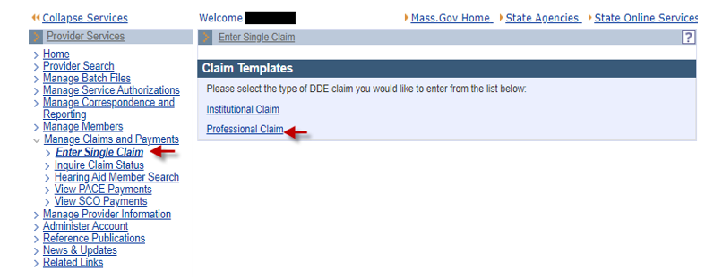

**Billing and Service Tab: Billing Information**

On the **Billing Information** panel:

1. Select a **Billing Provider ID** from the dropdown list.
2. Enter the **Member ID**.
3. Enter the **Patient Account #**.

* This is the patient account number assigned to the member’s record by either the doula or the doula group practice.

1. Enter the member’s **Last Name**.
2. Enter the member’s **First Name**.
3. Enter the member’s **DOB** [date of birth].
4. Select the member’s **Gender** from the dropdown list.
5. Enter the **Member** [Street] **Address**.
6. Enter the **Member City**.
7. Select the **Member State** from thedropdown list.
8. Enter the **Member Zip**.

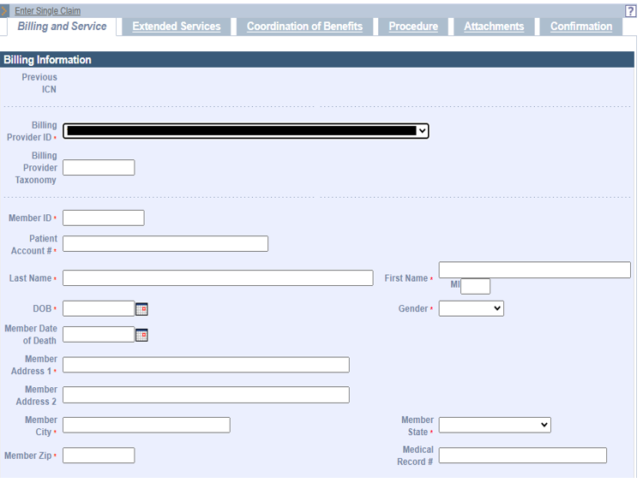

1. Select a **Release of Information** optionfrom the dropdown list.

* Select “Y” or “I”
* Select **Place of Service** from the dropdown list.
* The Centers for Medicare & Medicaid Services (CMS) Place of Service list is [here](https://www.cms.gov/medicare/coding-billing/place-of-service-codes/code-sets).

1. Select an **Assignment of Benefits Ind** optionfrom the dropdown list.

* Select “Yes.”

1. Select a **Signature on File** optionfrom the dropdown list.

* Select “Yes.”

1. Select a **Provider Accepts Assignment** optionfrom the dropdown list.

* Select “Yes.”

1. Select a **Claim Filing Indicator** optionfrom the dropdown list.

* Select “Medicaid.”

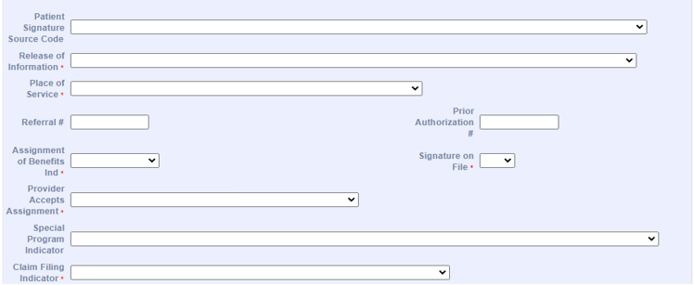

**Billing Information Tab: Service Information and Claims Charges**

1. Select an **ICD-10 Version**.

* The system defaults to ICD-10.

1. Enter at least one **Diagnosis Code**.

* Enter diagnosis code(s) that best describe the member’s health status as it relates to the doula services provided to the member for this claim. To search for the proper diagnosis code, click on the magnifying glass.
* Enter the primary diagnosis code in field 1. Where relevant, enter the secondary diagnosis code in field 2 and the tertiary diagnosis code in field 3. You can use the remaining fields for any additional diagnosis codes related to the claim. You can enter up to 12 diagnosis codes per transaction.

1. Enter **Total Charges**.

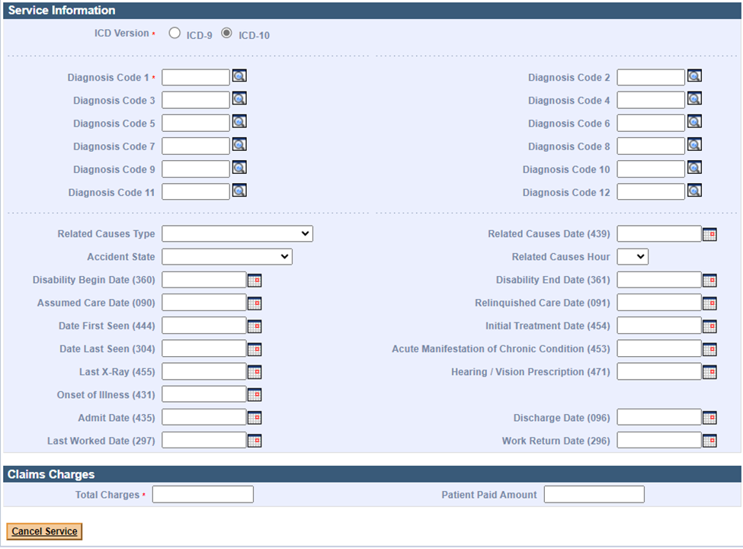

After you’ve entered all the required information on the **Billing and Service** tab, scroll to the top to find the **Extended Services** tab. Select this tab to open the **Extended Service Information** panel.

**Note:** Selecting the Extended Services tab will save the data entered so far and will check for required fields that have not been filled out.

The Extended Services tab is indicated second from left.

**Extended Service Information and Service Facility Provider**

On the **Extended Service Information** panel:

1. Enter or select the following, as appropriate.
   * CLIA Number
   * Homebound Indicator
   * IDE Number
   * EPSDT Referral
   * EPSDT Condition Indicator 1
   * EPSDT Condition Indicator 2
   * EPSDT Condition Indicator 3
   * Pregnancy Indicator
   * Birth Weight
   * Delay Reason Code
   * Last Menstrual Period
   * Estimated Date of Birth
   * Mammography Cert.

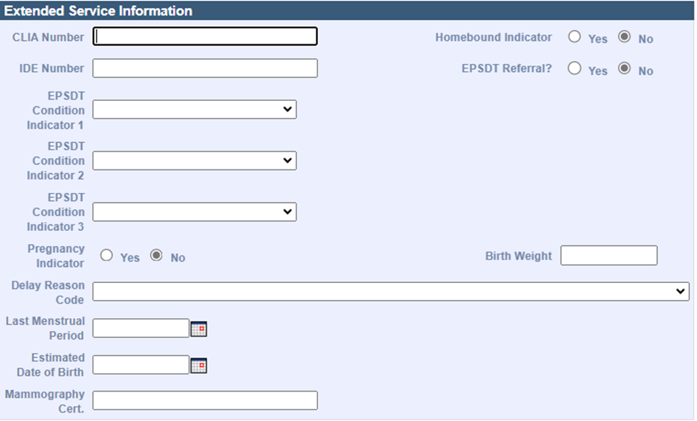

**Delay Reason Code**

* When submitting a 90-day waiver request, enter one of the following Delay Reason Codes.

1. Proof of Eligibility Unknown or Unavailable

4. Delay in Certifying Provider

8. Delay in Eligibility Determination

* When submitting a final deadline appeal request, enter the following Delay Reason Code.

9. Original Claim Rejected or Denied Due to a Reason Unrelated to the Billing Limitation

* When submitting a National Correct Coding Initiative / Medically Unlikely Edit (NCCI/MUE) review request or a special handle claim review request, you must include a detailed letter of why the claim needs to be reviewed. Enter the following Delay Reason Code:

11. Other

**NOTE:** You must upload supporting documentation with the claim when using a Delay Reason Code, or the claim will not suspend for review.

On the **Service Facility Provider** panel:

1. Enter the **Service Facility Provider Name** if the Service Facility Location Address fields are entered.
2. Enter the **Service Facility Provider NPI** if the location of services is different from that of the billing provider and the entity is not a subpart of the billing provider.
3. In the **Service Facility Address 1**, **City**, **State**, and **Zip Code** fields, enter the Service Facility Address if the Service Facility Provider Name is entered.

**Note:** The **Service Facility Address** is required if the **Service Facility Provider Name** is entered on the claim, and vice versa.

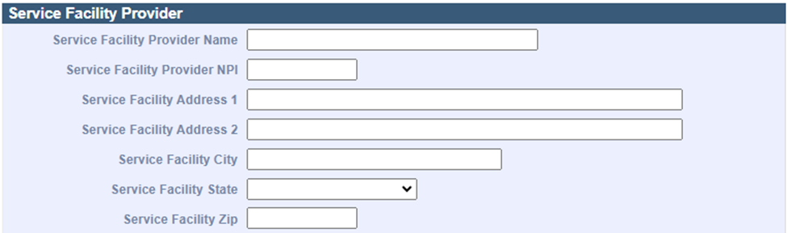

**List of Claim Notes**

On the **List of Claim Notes** panel, if applicable:

1. Click **New Item**. The **Claim Notes Detail** panel displays.

**Note:** A maximum of 10 claim notes can be added to a claim.

**Claim Notes Detail**

On the **Claim Notes Detail** panel:

1. Select **Claim Note Type** from the dropdown list.
2. Enter **Claim Note Description**.
3. Click **Add**.

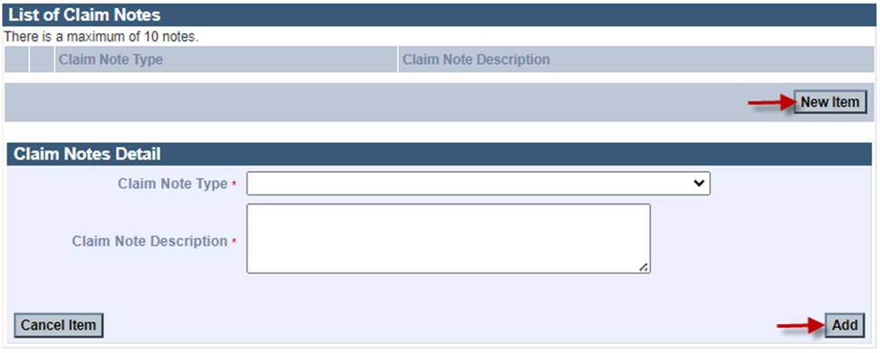

On the **List of Professional Services** panel:

1. Click **New Item**. The **Professional Services Detail** panel displays.

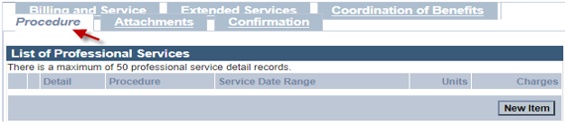

**Professional Services Detail**

On the **Professional Services Detail** panel:

1. Enter one of the following **CPT Procedure Codes**.

* 99600 Perinatal visit up to 60 minutes
* 99600-TF Perinatal visit from 61 minutes up to 90 minutes
* 99199 Labor and Delivery support

1. Enter modifiers if applicable.

* 93 Services rendered via audio-only telehealth
* 95 Services rendered via audio-video telecommunications
* TF Intermediate level of care

1. If billing for an unlisted Procedure Code, enter a description of service – up to 80 characters.

* Enter the Description associated with the code used from number 27.

1. Enter **From Date of Service**.
2. Enter **To Date of Service**.
3. Select a **Place of Service** from the dropdown list.

* The CMS Place of Service list is [here](https://www.cms.gov/medicare/coding-billing/place-of-service-codes/code-sets).

1. Enter **Diag. Cross-Ref**.

**Note:** If applicable, enter the number (1–12) corresponding to the primary, secondary, tertiary, etc., diagnosis code(s) entered for the claim that is related to the service being entered. You can enter up to four diagnosis cross-references. If you performed multiple services, enter the primary reference for each service first, followed by other applicable services. Please ensure that the correct diagnosis code is cross-referenced to the appropriate procedure code. Claims that do not contain compatible diagnosis and procedure codes will be denied.

1. Enter **Charges**.
2. Enter **Units**.

* This will always be one unit.

1. Select the appropriate **Units of Measurement** from the dropdown list.

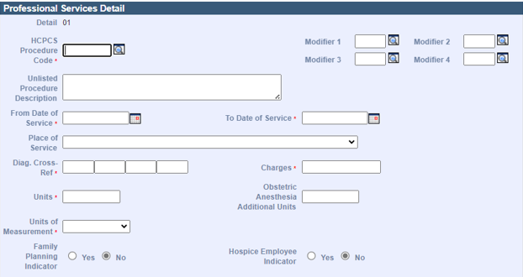

1. If applicable, enter **Rendering Provider Name**.

* The Rendering Provider is the individual who provided doula services to the member associated with the claim. The Rendering Provider may or may not be the same as the Billing Provider. Enter the rendering provider here only if it is different from the one entered on the Billing and Service tab. When billing from a group practice the doula who performed the service should be listed as the rendering provider while the group is listed as the billing provider.
* If you’ve finished entering information about this procedure, click Add at the bottom of the panel. If not, scroll down to continue entering information.

**Confirmation Tab**

On the **Confirmation** panel:

1. Make sure the information is accurate.
2. Click **Submit**.

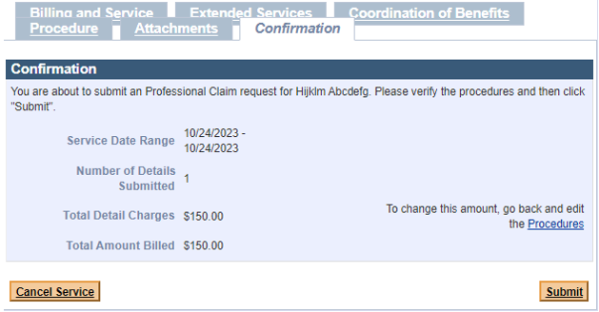

**Explanation of Benefits (EOB) Codes**

On the **Explanation of Benefits (EOB)** panel:

1. Review any EOB codes you see.
2. Click **Close**.

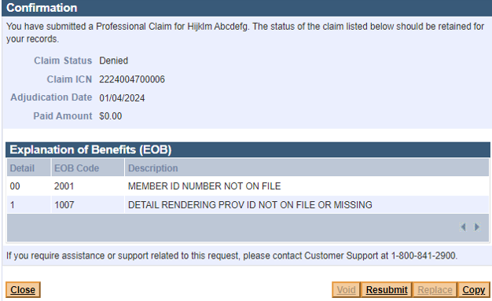

If you need more help with submitting claims, contact the MassHealth Customer Service Center at (800) 841-2900 (TTD/TTY: 711) or email [provider@masshealthquestions.com](mailto:provider@masshealthquestions.com).

Doula-BRG (07/24)