MassHealth Doula Provider Training Instructions
Completion of the MassHealth Doula Provider Training is required prior to applying to enroll as a MassHealth doula provider. The training is free and covers several topics including MassHealth covered doula services and rates, eligibility criteria, application materials and enrollment process, how to submit claims for getting paid, information about protecting member privacy, where to get help with questions, and more.
The video training is segmented into several parts. All parts must be completed to receive credit for the training. The entire training takes about 2 hours to complete. Upon completion, a certificate will be issued, which can be saved and printed. This certificate must be submitted with the MassHealth Doula Provider Application.
Please note: Any doula who attended one of the live training sessions in its entirety has already completed the MassHealth Doula Training requirement. For these doulas, the training certificate is not required to continue the enrollment process.

Account Registration
To access the training, an account must be created. Please follow this link to register your account: Provider LMS Registration.
- Complete all fields marked as required with an asterisk: *
  - For Provider ID, enter Application Pending
  - For Provider Type, select C5 Doula
- Select the New Account button at the bottom of the page to complete the account creation.

Course Enrollment
After registering the account, course enrollment is required. To access the course, select the Catalog button:
- Select the MassHealth Doula Provider Training from the catalog to continue.
- Select the Enroll button at the top of the page:
- A confirmation popup will appear. Select the click here link to continue:

Course Overview
There are two tabs on the course page: Overview and Resources.
- The Overview tab contains the required video training.
  - This training is broken down into several modules. All modules must be completed.
  - It is possible to pause and return to the training at a later time.
  - The entire training takes about 2 hours to complete.
  - Select the play button to start the training:
  - After completing a module, continue to the next part. Complete the modules in the order they are listed.
- The Resources tab contains a PDF version of the presentation.
  - This pdf is available as a reference document only. Reviewing the pdf will not meet the training requirement for the MassHealth Doula Provider Training.

Certificate of Completion
Upon completion of the course, a certificate will be issued. A copy of this certificate MUST be submitted with the MassHealth Doula Application.
- To access the certificate, select 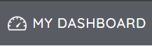 from the banner at the top of the page.
- Select the “Certificates” icon from the widget menu:
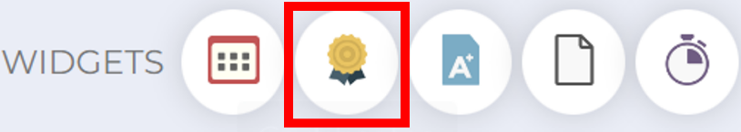
- Download/Print the certificate to submit along with your application and to keep for your records:
