WATER DAMAGE/MOLD INVESTIGATION

MassHealth Enrollment Center
88 Industry Avenue
Springfield, Massachusetts

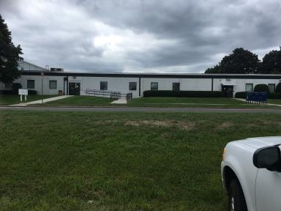

Prepared by:
Massachusetts Department of Public Health
Bureau of Environmental Health
Indoor Air Quality Program
November 2018

BACKGROUND
Building: | MassHealth Enrollment Center (MEC)
Address: | 88 Industry Avenue, Springfield, MA
Assessment Requested by: | Deborah Coleman, Director of Facilities. EOHHS
Reason for Request: | Mold/water damage concerns
Date of Assessment: | August 31, 2018
Massachusetts Department of Public Health/Bureau of Environmental Health (MDPH/BEH) Staff Conducting Assessment: | Michael Feeney, Director, Indoor Air Quality (IAQ) Program
Building Description: | The MEC occupies a one-story former boiler manufacturing building.
Windows: | Windows are not openable.

IAQ Testing Results
Please refer to the IAQ Manual for methods, sampling procedures, and interpretation of results (MDPH, 2015). The following is a summary of testing results.
- Temperature was within or close to the lower end of the recommended range of 70°F to 78°F in the areas tested.
- Relative humidity was within the recommended range of 40 to 60% in most areas tested at the time of the assessment and all but one measurement was lower than outside/background.
- Moisture Measurements in all carpeting showed elevated levels of moisture at the time of assessment.

Background and Discussion
The BEH/IAQ Program was asked to examine the MEC building due to water damage from high relative humidity during the hot, humid weather during the summer months of 2018. During this time, the building lost its capacity to chill air for a period of time.

Microbial/Moisture Concerns
The Boston area experienced an unprecedented period of extended hot, humid weather. According to the Washington Post, “[d]ata…show[s]…cities in the Northeast have witnessed such humidity levels for record-challenging duration...[i]ncluding Albany, Boston, Burlington Portland and Providence” during the summer of 2018 (WP, 2018). “Boston and nearby locations… [saw]…historic numbers of those warm nights with low temperatures at or above 70 degrees…Providence and Blue Hill Observatory have already broken their annual records” (WP, 2018). If a building does not have adequate exhaust ventilation and air chilling capacity to remove/reduce relative humidity from outside air, then hot, moist air can be introduced into a building and linger to increase occupant discomfort as well as possibly moisten materials that may lead to mold growth.
IAQ staff examined the conference room and carpeting throughout the office space. Of note were conference room chairs that appeared mold-colonized (Picture 1). Wall-to-wall carpeting in a number of locations were found rippled (Picture 2), which indicated water exposure. IAQ staff used a moisture meter (Picture 3) to check whether carpeting had dried after the HVAC system breakdown. All flooring sampled had measureable moisture including vinyl tile, carpet tile, and wall-to-wall carpeting (Table 1).
As mentioned, the HVAC system had lost its cooling capacity for a period of time prior to this visit. This condition can contribute to moisture build up in the building. Moisture that is introduced by the AHUs is recirculated within the space, resulting in increased relative humidity and reduced occupant comfort. Over time, chronic moisture from condensation can lead to water damage to building materials.
Moisture from humid air will condense and accumulate on the surface of building materials that have temperatures at or below the dew point. As noted, the building was constructed as a manufacturing facility with a cement floor. Due to the previous use, it is likely the floor has neither insulation nor a vapor barrier between the cement and soil. In this condition, the cement floor frequently will have a temperature similar to the soil beneath the slab (<60°F). If the temperature of the cement is below the dew point, then the surface will become moistened with condensation. The dew point is the temperature that air must reach for saturation to occur. For example, during humid weather when the temperature is 85°F and relative humidity is 90%, the dew point is approximately 82°F. Surfaces with a temperature at or below 82°F are prone to condensation formation.
Of note was a utility closet which appeared to have a moistened floor and moisture in adjacent wall-to-wall carpeting and gypsum wallboard (GW) (Pictures 4 and 5). The source of this moisture appears to be condensation from water service pipes.
In order for mold growth to occur, materials must be exposed to chronic moisture. Relative humidity in excess of 70 percent for extended periods of time, even in the absence of other sources of water, can provide an environment for mold and fungal growth (ASHRAE, 1989). In general, the US Environmental Protection Agency (US EPA) and the American Conference of Governmental Industrial Hygienists (ACGIH) recommends that porous materials (e.g., GW, carpeting) be dried with fans and heating within 24 to 48 hours of becoming wet (US EPA, 2008; ACGIH, 1989). If porous materials are not dried within this time frame, mold growth may occur.

Conclusions/Recommendations
Based on the observations made during the visit, the following recommendations are made:
- Discard water-damaged chairs.
- Discard wall-to-wall carpeting that was water-damaged. Consider replacing with flooring that can serve as a vapor barrier and not be prone to mold growth, e.g., hard floor tile or carpet tile.
- Replace water-damaged GW in utility closet.
- Insulate water service pipes in the utility closet to prevent condensation.
- For more information on mold refer to the US EPA’s “Mold Remediation in Schools and Commercial Buildings”, available at: http://www.epa.gov/mold/mold-remediation-schools-and-commercial-buildings-guide.
- Refer to resource manuals and other related IAQ documents for further building-wide evaluations and advice on maintaining public buildings. Copies of these materials are located on the MDPH’s website: http://mass.gov/dph/iaq.

REFERENCES
ACGIH. 1989. Guidelines for the Assessment of Bioaerosols in the Indoor Environment. American Conference of Governmental Industrial Hygienists, Cincinnati, OH.
ASHRAE. 1989. Ventilation for Acceptable Indoor Air Quality. American Society of Heating, Refrigeration and Air Conditioning Engineers. ANSI/ASHRAE 62-1989.
MDPH. 2015. Massachusetts Department of Public Health. “Indoor Air Quality Manual: Chapters I-III”. Available at: http://www.mass.gov/eohhs/gov/departments/dph/programs/environmental-health/exposure-topics/iaq/iaq-manual/.
US EPA. 2008. Mold Remediation in Schools and Commercial Buildings. US Environmental Protection Agency, Office of Air and Radiation, Indoor Environments Division, Washington, D.C. EPA 402-K-01-001. http://www.epa.gov/mold/mold-remediation-schools-and-commercial-buildings-guide.
WP. 2018. ‘It’s been relentless’: Smothering summer humidity in the Northeast has crushed records. Washington Post, Washington, DC. https://www.washingtonpost.com/news/capital-weather-gang/wp/2018/08/30/its-been-relentless-smothering-summer-humidity-in-the-northeast-has-crushed-records/

Picture 1
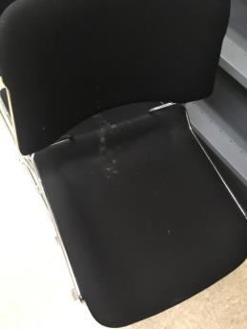
Mold-colonized chairs
Picture 2
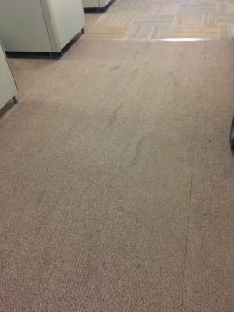
Rippled carpet, indicating water exposure
Picture 3
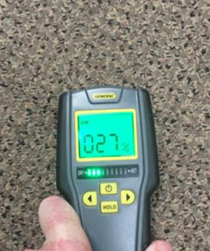
Moisture meter indicating moisture in carpet.
Picture 4
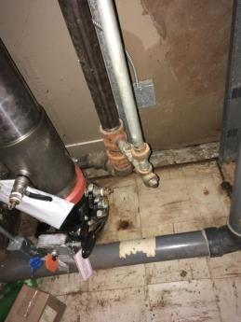
Floor of water-damaged utility closet
Picture 5
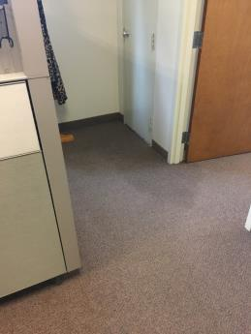
Moistened carpet outside utility closet

Location | Carbon  Dioxide  (ppm) | Carbon Monoxide  (ppm) | Temp  (°F) | Relative  Humidity  (%) | PM2.5  (µg/m3) | Occupants  in Room | Windows  Openable | Ventilation |  | Remarks
 |  |  |  |  |  |  |  | Supply | Exhaust
Background (outdoors) | 434 | ND | 72 | 35 | 2
Waiting room | 784 | ND | 73 | 37 | 4 | 5 | N | Y | Y
Hall | 783 | ND | 73 | 38 | 3 | 5 | N | Y | Y
Reception | 813 | ND | 73 | 35 | 4 | 1 | N | Y | N
110 | 721 | ND | 74 | 36 | 3 | 2 | N | Y | N | Plants
112 | 735 | ND | 73 | 37 | 3 | 4 | N | Y | Y | Water-damaged gypsum wallboard.
117 | 770 | ND | 75 | 37 | 3 | 3 | N | Y | Y
121 | 775 | ND | 75 | 37 | 3 | 2 | N | Y | Y
150 | 754 | ND | 73 | 38 | 3 | 1 | N | Y | N
151 | 755 | ND | 73 | 38 | 3 | 1 | N | Y | N | Plants
153 | 762 | ND | 73 | 38 | 4 | 1 | N | Y | Y | Plants, door open
156 | 679 | ND | 72 | 37 | 2 | 0 | N | Y | N
157 | 741 | ND | 72 | 38 | 3 | 0 | N | Y | N
204 | 675 | ND | 74 | 39 | 1 | 3 | Y | Y | Y | Plants
214 | 642 | ND | 73 | 39 | 1 | 2 | Y | Y | Y | Plants, flowers
215 | 676 | ND | 73 | 39 | 1 | 2 | Y | Y | Y | Plants
219 | 680 | ND | 73 | 39 | 1 | 2 | Y | Y | Y | Plants
224 | 654 | ND | 75 | 36 | 2 | 1 | Y | Y | Y | Plants
230 | 647 | ND | 75 | 37 | 2 | 2 | Y | Y | Y | Plants
235 | 667 | ND | 75 | 37 | 1 | 1 | Y | Y | Y | Plants
241 | 660 | ND | 74 | 39 | 1 | 0 | N | Y | N | Water-damaged sink backsplash
242 | 654 | ND | 73 | 41 | 1 | 0 | N | Y | Y
250 | 723 | ND | 73 | 42 | 2 | 0 | Y | Y | N
251 | 691 | ND | 75 | 37 | 2 | 2 | N | Y | N
252 | 720 | ND | 75 | 37 | 2 | 0 | Y | Y | Y | Door open
253 | 713 | ND | 75 | 37 | 2 | 2 | Y | Y | N | Plants, flowers, door open
255 | 604 | ND | 73 | 39 | 1 | 0 | Y | Y | N
256 | 638 | ND | 74 | 38 | 3 | 0 | Y | Y | N
263 | 653 | ND | 75 | 39 | 3 | 2 | Y | Y | N | Plants

