# Preparing for the End of the Federal Public Health Emergency (FPHE) Eligibility Protections

Executive Office of Health and Human Services

**March 2022**

CONFIDENTIAL; FOR POLICY DEVELOPMENT PURPOSES ONLY

## Agenda

* Overview of FPHE Eligibility Protections
* Overview of Renewal Process
* Anticipated Timeline to End FPHE Eligibility Protections
* Strategies to Minimize Unnecessary Churn

## MassHealth has maintained coverage for members since March 2022 as part of the federal Maintenance of Effort (MOE) provision

### What is the MOE provision?

* In March 2020, **MassHealth suspended eligibility redeterminations and began protecting members’ coverage in compliance with the MOE** provision of the Families First Coronavirus Response Act (FFCRA), allowing the state to claim enhanced federal matching funds.
* This means that even if a member was determined ineligible or did not respond to a renewal, they would not lose coverage during the federal public health emergency (FPHE), except **if a member moves out-of-state, is deceased, or by voluntary withdrawal.**
* Additionally,**children in separate CHIP are not subject to the continuous coverage requirement** and continue to have their eligibility updated to reflect changes in circumstance, which could result in loss of coverage.

### What was the impact of the MOE provision on MassHealth caseload?

* As a result, MassHealth’s membership has **grown from 1.8M in FY19 to 2.2M in FY22.**
* **~700K individuals who normally would have been found ineligible or downgraded from their current benefit remain protected due to the MOE provision**.
* Once the FPHE ends, **MassHealth will be focused on a smooth resumption of redeterminations, ensuring that members receive the benefit for which they are eligible and avoiding unnecessary eligibility churn** through enhanced outreach, streamlined processes, and operational preparation.

## FPHE eligibility protections likely to end August 1, 2022, though timeline is not yet finalized

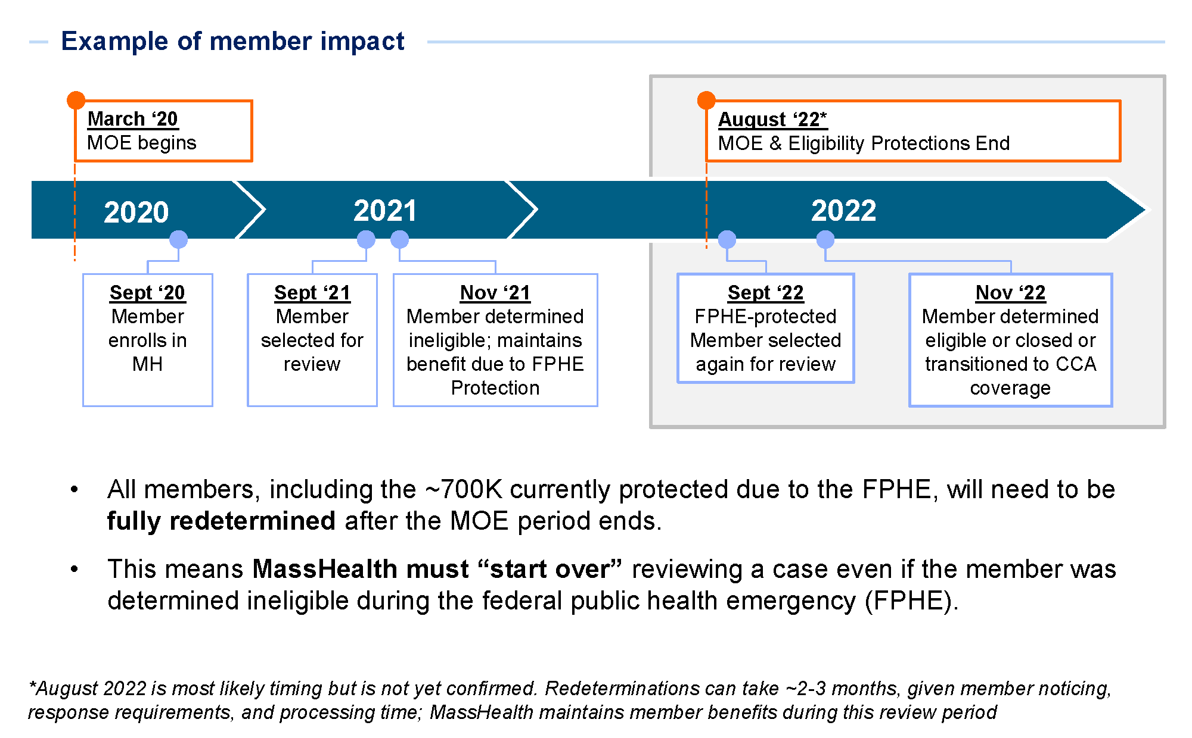

## Overview of MassHealth HIX Annual Renewal Process for those under 65

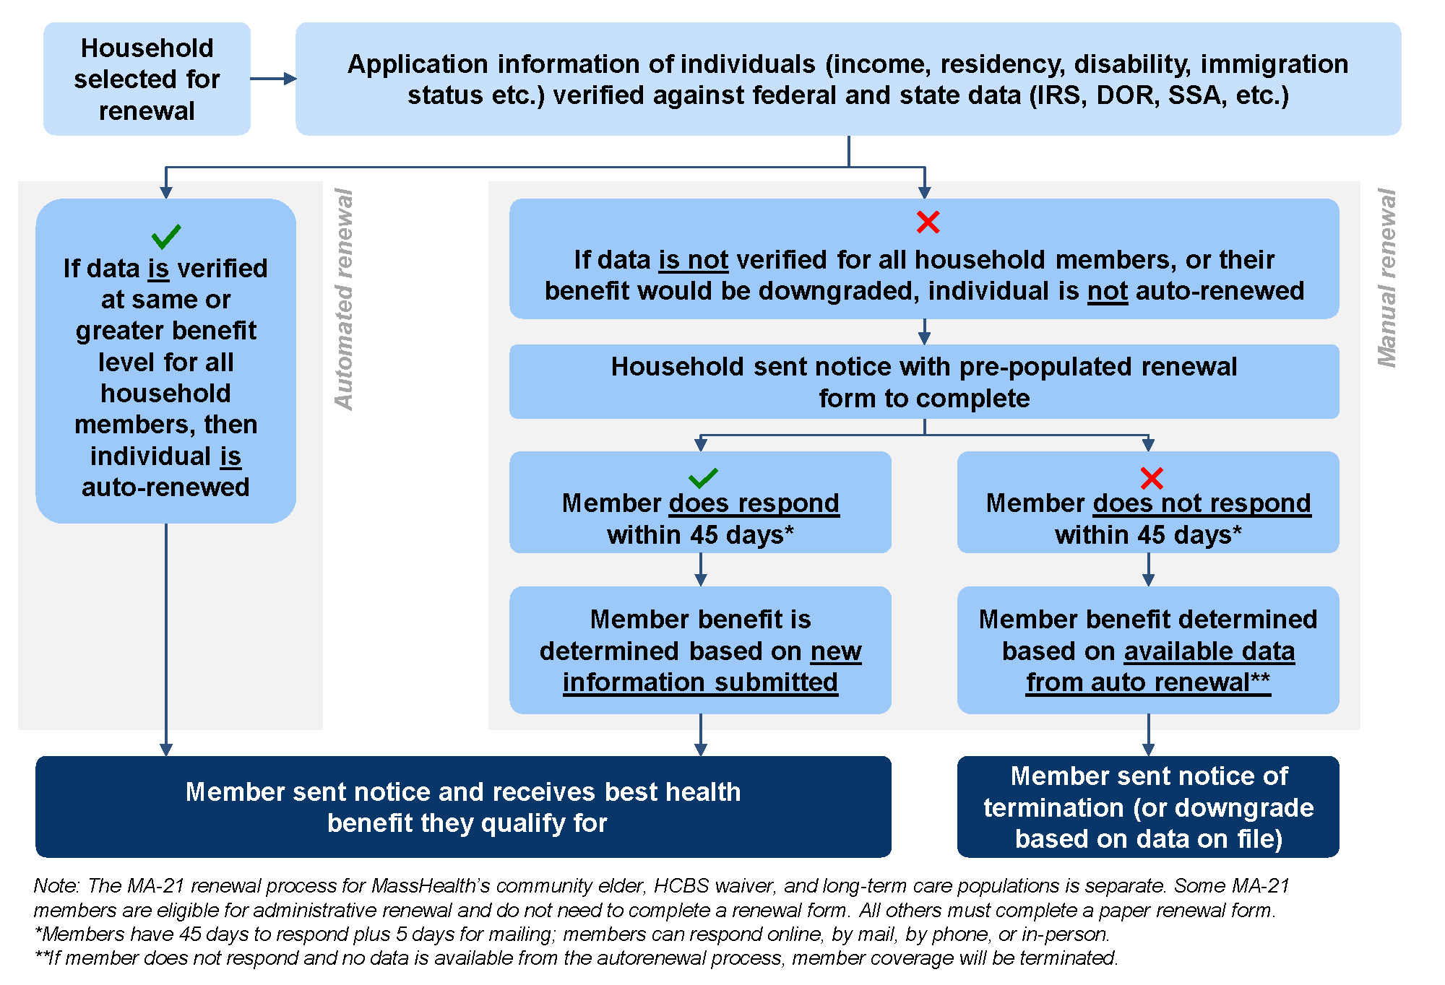

## CMS guidance gives states flexibility on redetermination timing while focusing on promoting continuity

* Once states start the redetermination process, states will have a maximum of **12 months to initiate all renewals, and an additional 2 months to complete all renewals; MassHealth is aiming to complete all renewals in 12 months**
* MassHealth is planning to **prioritize the renewal of individuals with protected eligibility** who may be ineligible for MassHealth and moved into other coverage, based on their earlier renewal results
* MassHealth plans to **start the redetermination process in June 2022** (~two months prior to the end of the FPHE), consistent with federal guidance
* This process will be closely coordinated with **the outreach campaign andin partnership with the Health Connector & Health Care For All**

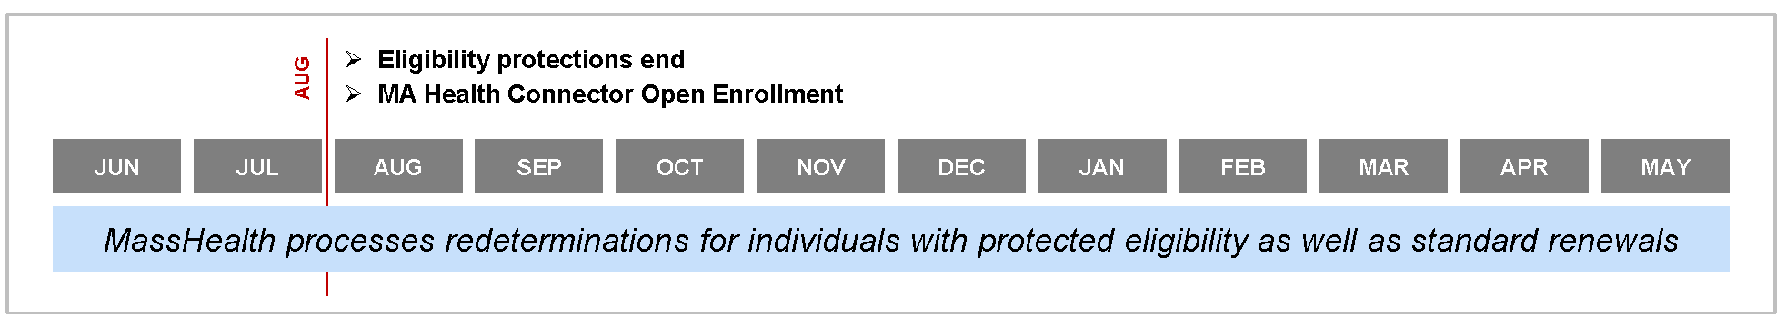

### Benefits of proposed timeline

* **Prevents the need to disrupt operations by pausing renewals**, allowing MassHealth to continue processes that have been occurring since May 2021
* Provides opportunity for slower ramp up prior to open enrollment (OE) to **test systems/processes and refine member experience**
* Enables **more renewals to occur near the end of FPHE**, when public awareness will be highest

## MassHealth is preparing for the end of FPHE protections in order to minimize unnecessary churn and improve member experience

### Increase capacity to address elevated renewal volume

* Hire **additional staff and expand vendor capacity** to support call center, applications processing, and appeals
* Implement operational changes to **increase speed of processing**

### Maximize automated renewals for eligible members

* Automated renewals are based on federal or state data matching and **do not require member action**
* Change compatibility threshold of income matching from 10% to 20% to **increase automated renewals**

### Execute comprehensive outreach strategy

* Collect updated **contact information**
* Develop **equity-oriented messaging** approach
* Coordinate closely with **advocates and community organizations**

## MassHealth’s outreach strategy has three key pillars

### #1. Prioritize collection of updated contact information before eligibility protections end

* Continue to request updated contact information on each call with the Call Center
* Partner with healthplans and community organizations to update contact information
* Encourage members via social media and flyers to update information

### #2. Develop messaging for plans and community partners, in partnership with the Health Connector

* Prioritize **equity-oriented approach** to outreach efforts
  + Messaging will be multi-lingual and culturally relevant based on stakeholder input
  + Hold **regular meetings** with advocates and disability advisory group to solicit feedback and input
* Share **members who are up for renewal** with plans to support outreach directly to members
  + MassHealth to hold regular **meetings with plans** on outreach efforts to members
* Coordinate with **Health Care For All in their deployment of $5M funding for member outreach,** including on-the-ground canvassing in targeted communities, sub-grants to community groups, and media buys

### #3. Improve effectiveness of direct to member outreach

* Develop **email and text message capability** to support member outreach
* **Redesign envelopes** to increase response rate for mail
* Encourage **use of self-service tools**(e.g., HIX online account) for members
* **Specialized approach for homeless individuals and members with disabilities**, including targeted outreach channels and close coordination with advocates

## Sample Communications

