Medical Care Advisory Committee (MCAC) and Payment Policy Advisory Board (PPAB) Meeting

Executive Office of Health and Human Services

March 8, 2023

Table of contents
Update on Behavioral Health Roadmap Progress
Update on Plan for MassHealth Eligibility Redeterminations

Historical and Structural Challenges in Behavioral Health
The Commonwealth has implemented recent legislation, policy reforms, and substantial public investment, despite these efforts further improvement is needed.
The Commonwealth’s Roadmap for Behavioral Health Reform is based upon statewide listening sessions and feedback. In statewide listening sessions, nearly 700 individuals, families, and others identified challenges and gaps in the system:
- Too many people struggle to find the right type of behavioral health treatment and clinical provider that accepts their insurance.
- Too often hospital emergency rooms are the entry point into seeking behavioral health treatment.
- Individuals often can’t get mental health and addiction treatment at the same location, even though mental health conditions and substance use disorder (SUD) often co-occur.
- Culturally competent behavioral health care for racially, ethnically and linguistically diverse communities can be difficult to find.
- These longstanding challenges were exacerbated by the pandemic.

Reforms through the Behavioral Health Roadmap
Improved Structural Support Through Administrative Simplification, Targeted Workforce Development Initiatives, Diversification of the Workforce, and Added Requirements for Cultural and Linguistic Competency of Providers | Increasing Access Through Additional & Enhanced Front Door(s) | Increasing & Strengthening Community-Based Care | Improving the Patient Experience within  Crisis and Acute Care
Improved Structural Support Through Administrative Simplification, Targeted Workforce Development Initiatives, Diversification of the Workforce, and Added Requirements for Cultural and Linguistic Competency of Providers | Behavioral Health  Help Line  Streamlined approach for anyone seeking behavioral health treatment to find and access the treatment they need, including crisis support | Integrated Primary Care  The 1115 Demonstration is changing the way behavioral health is accessed through primary care, including through new payment models and incentives for PCPs to integrate behavioral health treatment, promote early intervention, and increase access | Improving Member Experience and Treatment Options  Improved and expanded behavioral health crisis evaluations in ED settings, including enhanced requirements for discharge planning and warm handoffs.  More inpatient psychiatric beds, stronger 24-hour addiction treatment to address co-occurring needs and better meet patient needs.  Expanded options for crisis stabilization services for adult and youth.
Improved Structural Support Through Administrative Simplification, Targeted Workforce Development Initiatives, Diversification of the Workforce, and Added Requirements for Cultural and Linguistic Competency of Providers | Behavioral Health Urgent Care  Access to same or next day outpatient appointments for urgent needs, follow-up appointments within 14 days, extended weekday and weekend hours. | Behavioral Health Urgent Care  Access to same or next day outpatient appointments for urgent needs, follow-up appointments within 14 days, extended weekday and weekend hours. | Improving Member Experience and Treatment Options  Improved and expanded behavioral health crisis evaluations in ED settings, including enhanced requirements for discharge planning and warm handoffs.  More inpatient psychiatric beds, stronger 24-hour addiction treatment to address co-occurring needs and better meet patient needs.  Expanded options for crisis stabilization services for adult and youth.
Improved Structural Support Through Administrative Simplification, Targeted Workforce Development Initiatives, Diversification of the Workforce, and Added Requirements for Cultural and Linguistic Competency of Providers | Community Behavioral Health Centers  Access to real-time urgent care, evidence-based, integrated mental health and addiction treatment for all ages, 24/7 community crisis response. | Community Behavioral Health Centers  Access to real-time urgent care, evidence-based, integrated mental health and addiction treatment for all ages, 24/7 community crisis response. | Community Behavioral Health Centers  Access to real-time urgent care, evidence-based, integrated mental health and addiction treatment for all ages, 24/7 community crisis response.

Easier, more convenient access to behavioral health services in MA
Behavioral Health Help Line (BHHL)  (833) 773-BHHL | Community Behavioral Health Centers (CBHC)  www.mass.gov/CBHCs  - All ages.  - Mental health and addictions. | Community Behavioral Health Centers (CBHC)  www.mass.gov/CBHCs  - All ages.  - Mental health and addictions. | Community Behavioral Health Centers (CBHC)  www.mass.gov/CBHCs  - All ages.  - Mental health and addictions.
- Multi-lingual live response.  - Call, text, chat.  - 24/7/365.  - No insurance necessary.  - All ages.  - Mental health and addictions.  - Crisis identification and action when needed:  - Dispatch Mobile Crisis Intervention.  - 911 connection when needed.  - Follow-up within 48 hours.  - Clinical assessment, triage and warm handoff to a provider with appropriate expertise.  - Follow-up to ensure connection is made. | - Mobile Crisis Intervention  - 24/7/365.  - No insurance necessary.  - At your home or other community location.  - At the CBHC.  - Clinical assessment, de-escalation, safety planning and triage.  Urgent & ongoing clinic services  - Available to all MassHealth members and may be available through commercial insurance.  - Same day evaluation, assessment, group therapy, peer support.  - Same or next day appointments, including psychopharmacology and medication for addiction treatment.  - Care coordination and referral to needed services.  - Extended hours:  - 8 AM –8 PM week days  - 9-5 weekends  Adult & Youth Community Crisis Stabilization  - 24-hour diversionary level of care for individuals in crisis who don’t need inpatient level of care.  - No insurance necessary. | - Mobile Crisis Intervention  - 24/7/365.  - No insurance necessary.  - At your home or other community location.  - At the CBHC.  - Clinical assessment, de-escalation, safety planning and triage.  Urgent & ongoing clinic services  - Available to all MassHealth members and may be available through commercial insurance.  - Same day evaluation, assessment, group therapy, peer support.  - Same or next day appointments, including psychopharmacology and medication for addiction treatment.  - Care coordination and referral to needed services.  - Extended hours:  - 8 AM –8 PM week days  - 9-5 weekends  Adult & Youth Community Crisis Stabilization  - 24-hour diversionary level of care for individuals in crisis who don’t need inpatient level of care.  - No insurance necessary. | - Mobile Crisis Intervention  - 24/7/365.  - No insurance necessary.  - At your home or other community location.  - At the CBHC.  - Clinical assessment, de-escalation, safety planning and triage.  Urgent & ongoing clinic services  - Available to all MassHealth members and may be available through commercial insurance.  - Same day evaluation, assessment, group therapy, peer support.  - Same or next day appointments, including psychopharmacology and medication for addiction treatment.  - Care coordination and referral to needed services.  - Extended hours:  - 8 AM –8 PM week days  - 9-5 weekends  Adult & Youth Community Crisis Stabilization  - 24-hour diversionary level of care for individuals in crisis who don’t need inpatient level of care.  - No insurance necessary.
Behavioral Health Urgent Care (BH UC)  - Available to all MassHealth members and may be available through commercial insurance.  - Same/next day appointments for diagnostic evaluation for new clients and urgent appointments for existing clients.  - Urgent psychopharmacology, medication for addiction treatment evaluation.  - Non-urgent appointments within 2 weeks.  - Extended hours.  www.mass.gov/BHroadmap | Behavioral Health Urgent Care (BH UC)  - Available to all MassHealth members and may be available through commercial insurance.  - Same/next day appointments for diagnostic evaluation for new clients and urgent appointments for existing clients.  - Urgent psychopharmacology, medication for addiction treatment evaluation.  - Non-urgent appointments within 2 weeks.  - Extended hours.  www.mass.gov/BHroadmap | Behavioral Health Urgent Care (BH UC)  - Available to all MassHealth members and may be available through commercial insurance.  - Same/next day appointments for diagnostic evaluation for new clients and urgent appointments for existing clients.  - Urgent psychopharmacology, medication for addiction treatment evaluation.  - Non-urgent appointments within 2 weeks.  - Extended hours.  www.mass.gov/BHroadmap | Behavioral Health Urgent Care (BH UC)  - Available to all MassHealth members and may be available through commercial insurance.  - Same/next day appointments for diagnostic evaluation for new clients and urgent appointments for existing clients.  - Urgent psychopharmacology, medication for addiction treatment evaluation.  - Non-urgent appointments within 2 weeks.  - Extended hours.  www.mass.gov/BHroadmap

Behavioral Health Help Line
NOW LIVE!
(833) 773-BHHL
The 24/7 Behavioral Health Help Line is a single, insurance-blind, multi-channel entry point for Commonwealth residents in search of mental health and SUD treatment.
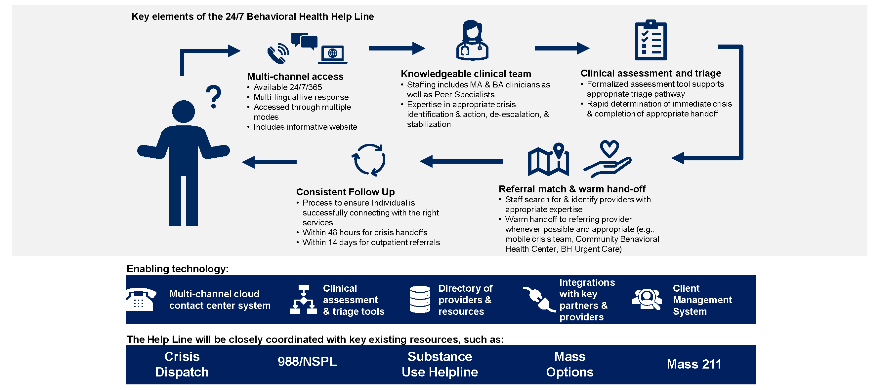

Community Behavioral Health Centers
NOW LIVE!
mass.gov/CBHCs
CBHCs integrate crisis and community-based treatment by combining mobile teams, crisis stabilization, and outpatient and urgent care for mental health and addictions.
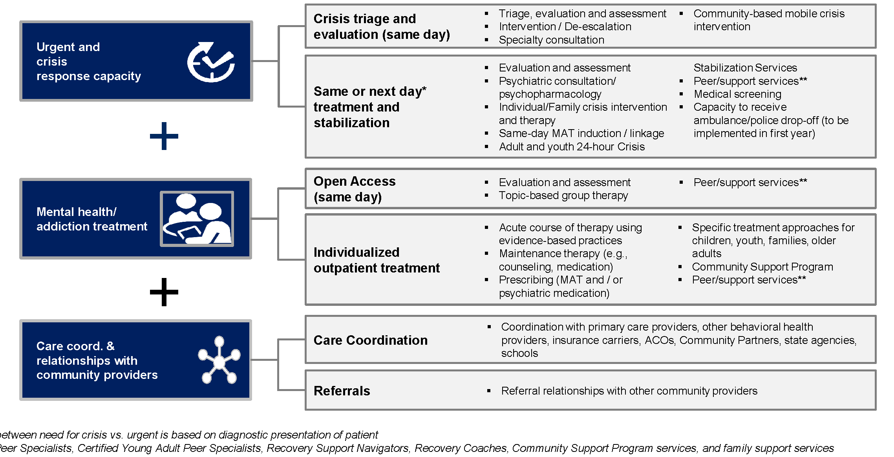

Behavioral Health Urgent Care
NOW LIVE!
mass.gov/BHRoadmap
Behavioral Health Urgent Care centers (BH UC) are Mental Health Centers that provide services more urgently and with extended hours compared to traditional clinics. They also provide more integrated addiction treatment with mental health services.
BH UC centers offer the following services:
- Same/next day appointments available for diagnostic evaluation for new clients and urgent appointments for existing clients
- Urgent psychopharmacology and MAT evaluation available within 72 hours of assessment
- Non-urgent treatment and follow-up appointments within 14 calendar days
- Extended availability during the week outside of weekdays from 9am-5pm, including
  - ​At least 8 hours of extended availability per week during weekdays​
  - At least two 4-hour blocks of availability per month on weekends
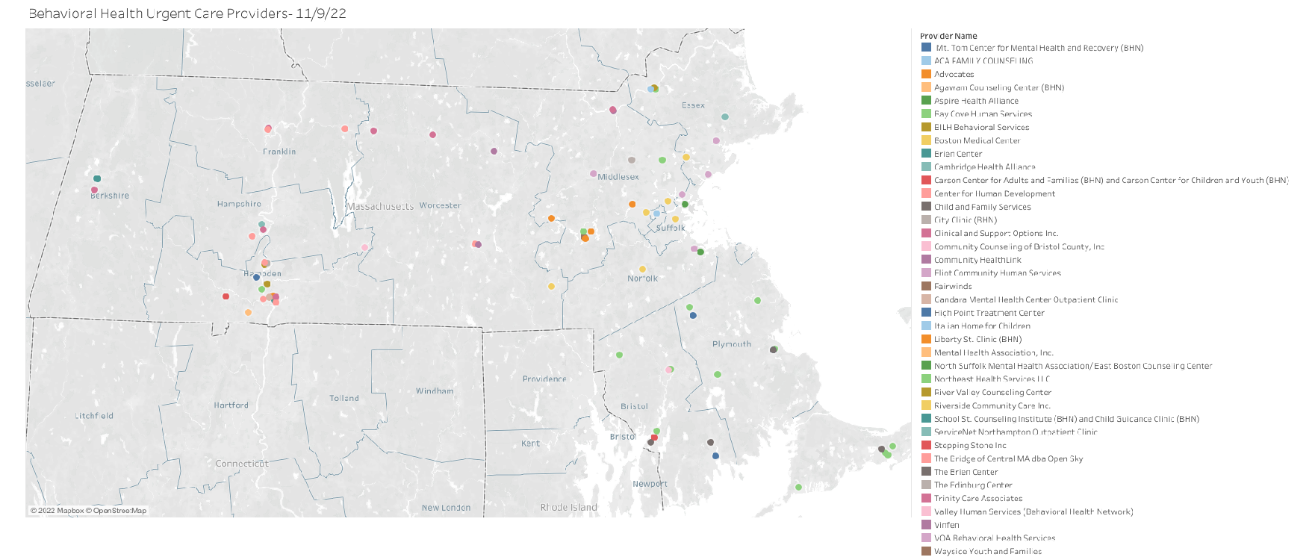

CBHC Providers and Catchment Areas (1 of 3)
Region | Organization | Catchment Area
Central | Advocates | Acton, Ashland, Arlington, Bedford, Belmont, Boxborough, Burlington, Carlisle, Concord, Framingham, Holliston, Hopkinton, Hudson, Lexington, Lincoln, Littleton, Maynard, Marlborough, Natick, Northborough, Sherborn, Southborough, Stow, Sudbury, Waltham, Watertown, Wayland, Westborough, Wilmington, Winchester, and Woburn
Central | Community HealthLink | Ashby, Ayer, Barre, Berlin, Bolton, Clinton, Fitchburg, Groton, Hardwick, Harvard, Lancaster, Leominster, Lunenburg, New Braintree, Oakham, Pepperell, Princeton, Rutland, Shirley, Sterling, and Townsend  Auburn, Boylston, Grafton, Holden, Leicester, Millbury, Paxton, Shrewsbury, Spencer, West Boylston, and Worcester
Central | Riverside Community Care | Bellingham, Blackstone, Brimfield, Brookfield, Charlton, Douglas, Dudley, East Brookfield, Franklin, Holland, Hopedale, Medway, Mendon, Milford, Millville, Northbridge, North Brookfield, Oxford, Southbridge, Sturbridge, Sutton, Upton, Uxbridge, Wales, Warren, Webster, and West Brookfield
Central | Clinical Support Options | Ashburnham, Gardner, Hubbardston, Templeton, Westminster, and Winchendon
Northeast | Beth Israel Lahey Health BH Services | Andover, Lawrence, Methuen, and North Andover
Northeast | Vinfen | Billerica, Chelmsford, Dracut, Dunstable, Lowell, Tewksbury, Tyngsboro, and Westford
Northeast | Eliot Community Human Services | Lynn, Lynnfield, Melrose, Nahant, North Reading, Reading, Saugus, Stoneham, Swampscott, and Wakefield  Amesbury, Beverly, Boxford, Danvers, Essex, Georgetown, Gloucester, Groveland, Hamilton, Haverhill, Ipswich, Manchester by the Sea, Marblehead, Merrimac, Middleton, Newbury, Newburyport, Peabody, Rockport, Rowley, Salem, Salisbury, Topsfield, Wenham, and West Newbury
Metro Boston | Cambridge Health Alliance | Cambridge, Somerville, Everett, Malden, and Medford
Metro Boston | North Suffolk Mental Health Association | Chelsea, Revere, East Boston, Winthrop, and Charlestown
Metro Boston | Boston Medical Center | Boston, Brighton, and Brookline
Metro Boston | Riverside Community Care | Canton, Dedham, Dover, Foxboro, Medfield, Millis, Needham, Newton, Norfolk, Norwood, Plainville, Sharon, Walpole, Wellesley, Weston, Westwood, and Wrentham
Metro Boston | Aspire Health Alliance | Braintree, Cohasset, Hingham, Hull, Milton, Norwell, Quincy, Randolph, Scituate, and Weymouth
Western | Clinical Support Options | Amherst, Chesterfield, Cummington, Easthampton, Florence, Goshen, Hadley, Hatfield, Middlefield, Northampton, Pelham, Plainfield, Westhampton, Williamsburg, and Worthington  Ashfield, Athol, Bernardston, Buckland, Charlemont, Colrain, Conway, Deerfield, Erving, Gill, Greenfield, Hawley, Heath, Leverett, Leyden, Millers Falls, Montague, New Salem, Northfield, Orange, Petersham, Phillipston, Rowe, Royalston, Shelburne, Shutesbury, Sunderland, Turners Falls, Warwick, Wendell, and Whately
Western | Behavioral Health Network | Agawam, Blandford, Chester, East Longmeadow, Granville, Hampden, Huntington, Indian Orchard, Longmeadow, Montgomery, Russell, Southwick, Springfield, Tolland, Westfield, West Springfield, and Wilbraham
Western | Center for Human Development | Belchertown, Bondsville, Chicopee, Granby, Holyoke, Ludlow, Monson, Palmer, South Hadley, Southampton, Thorndike, Three Rivers, and Ware
Western | The Brien Center | Adams, Alford, Becket, Cheshire, Clarksburg, Dalton, Egrement, Florida, Great Barrington, Hancock, Hinsdale, Lanesboro, Lee, Lenox, Monroe, Monterey, Mount Washington, New Ashford, New Marlboro, North Adams, Otis, Peru, Pittsfield, Richmond, Sandisfield, Savoy, Sheffield, Stockbridge, Tyringham, Washington, West Stockbridge, Williamstown, and Windsor
Southeast | High Point | Abington, Avon, Bridgewater, Brockton, East Bridgewater, Easton, Holbrook, Rockland, Stoughton, West Bridgewater, and Whitman
Southeast | Child and Family Services | Acushnet, Carver, Dartmouth, Duxbury, Fairhaven, Halifax, Hanover, Hanson, Kingston, Marion, Marshfield, Mattapoisett, New Bedford, Pembroke, Plymouth, Plympton, Rochester, and Wareham
Southeast | Community Counseling of Bristol County | Attleboro, Berkley, Dighton, Lakeville, Mansfield, Middleborough, North Attleboro, Norton, Raynham, Rehoboth, Seekonk, and Taunton
Southeast | Bay Cove Human Services | Barnstable, Bourne, Brewster, Chatham, Chilmark, Cotuit, Dennis, Eastham, Falmouth, Harwich, Hyannis, Mashpee, Orleans, Osterville, Provincetown, Sandwich, Truro, Wellfleet, Woods Hole, and Yarmouth
Southeast | Fairwinds Center | Nantucket

Table of contents
Update on Behavioral Health Roadmap Progress
Update on Plan for MassHealth Eligibility Redeterminations

Federal Medicaid continuous coverage requirements have been in effect since March 2020 and will expire in April 2023
In the Families First Coronavirus Response Act (FFCRA), MassHealth received enhanced federal funding for adhering to the Maintenance of Effort (MOE) provision.
- This provision meant that individuals receiving Medicaid would generally not lose coverage unless they voluntarily withdrew, moved out of state, or passed away.
- This provision did not apply to children in certain types of coverage, whose eligibility continued to be updated, which could result in loss of coverage.
As a result of the MOE provision, MassHealth’s caseload increased significantly from 1.8M members to over 2.3M members (+>25%) since February 2020.
- Many members have had their eligibility protected because of continuous coverage requirements that went into effect as part of the FFCRA.
- This means that individuals whose coverage would have normally been lost or downgraded –because of loss of eligibility or non-response to a renewal attempt –maintained coverage.
The continuous coverage requirements that were part of the MOE provision end on April 1, 2023, and members’ coverage may begin to change.
- Federal rules require that all member redeterminations must be initiated in the first 12 months of a state’s redetermination process and completed within the first 14 months.
- Previously, the continuous coverage requirement was tied to the federal public health emergency (FPHE); however, recent federal legislation has decoupled this from the FPHE and set a planned end date of continuous coverage for April 1, 2023, while the FPHE (and related flexibilities) will remain in effect.

MassHealth has continued its renewal processes during the MOE period, meaning many members have been renewed as normal in the last 2 years
Redetermination timing for a specific household depends on whether the member was renewed as normal or MOE-protected
Member renewed as normal: Member renewed at the same or greater level of coverage during the MOE period > Member will be selected for renewal 12 months after last renewal*
Member eligibility was protected during MOE period: Member did not respond, was found ineligible, or was found eligible for a lower benefit over the last two years > Member will be selected for renewal in the first ~9 months of the redetermination process
Member Renewal Process:
For each renewal, MassHealth must “start over” its redetermination, even if the member was determined ineligible during their most recent renewal.
- Whenever possible, MassHealth will automatically process a member’s renewal by matching their information against state and federal data sets.
- If a member’s renewal cannot be automatically processed, they will receive a blue envelope in the mail with a renewal form to complete and return to MassHealth.
- Members must submit the requested information to receive the best health benefit they qualify for.
*Note: Households that contain individuals receiving MassHealth and Health Connector coverage will be renewed during the Annual Open Enrollment Period (August to December).

MassHealth completes renewals every year; this upcoming renewal cycle starting April 1, 2023 is different due to renewal volume and lack of member awareness

How this renewal cycle will be the same:
- Renewals are a regular annual requirement
- MassHealth processes renewals every year, including while members’ coverage was protected as part of the continuous coverage requirements that started during the FPHE
- Use of standard tested processes
- MassHealth will use its regular proven process for completing upcoming renewals (with additional new enhancements to streamline the processes further)
How this renewal cycle will be different:

- Increased volume of renewals to be processed
- Due to the continuous coverage requirements, MassHealth enrollment is currently ~2.3M (up from 1.8M) and all 2.3M members will need to be redetermined
- Lack of member familiarity and awareness
- While members have experienced the renewal process throughout the FPHE, they have generally not experienced any coverage repercussions if they did not reply to renewal requests for information. This creates the risk that members will not take the needed actions to ensure they will keep the level of MassHealth coverage that they are eligible for

MassHealth is continuing its preparation for the upcoming redetermination process in coordination with internal and external stakeholders​
Goals:
- Prevent administrative loss of coverage* as much as possible, especially for most vulnerable​
- Ensure members understand and can complete key actions to receive the appropriate health benefit​
- Maintain compliance with federal and state requirements
Focus Areas:
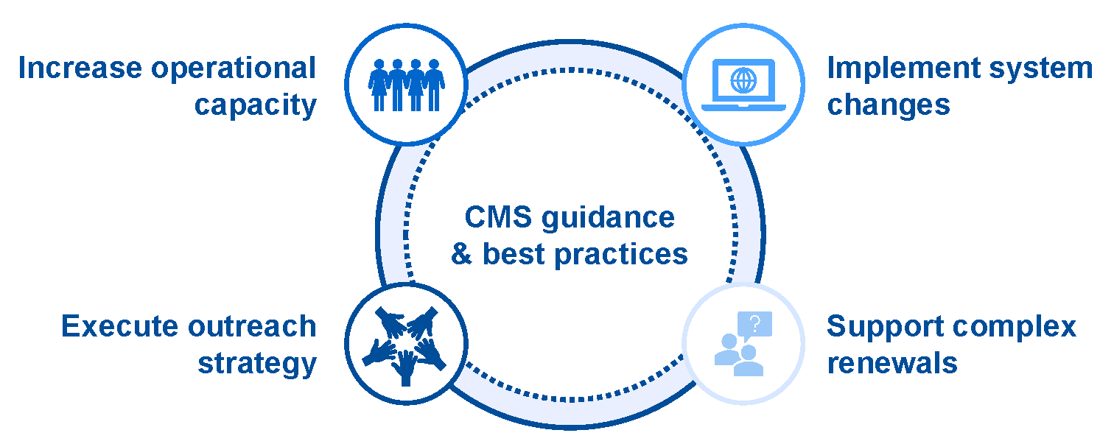

MassHealth has been preparing its systems and operations since 2021, with outreach and communications ramping up as the April 1ststart date approaches

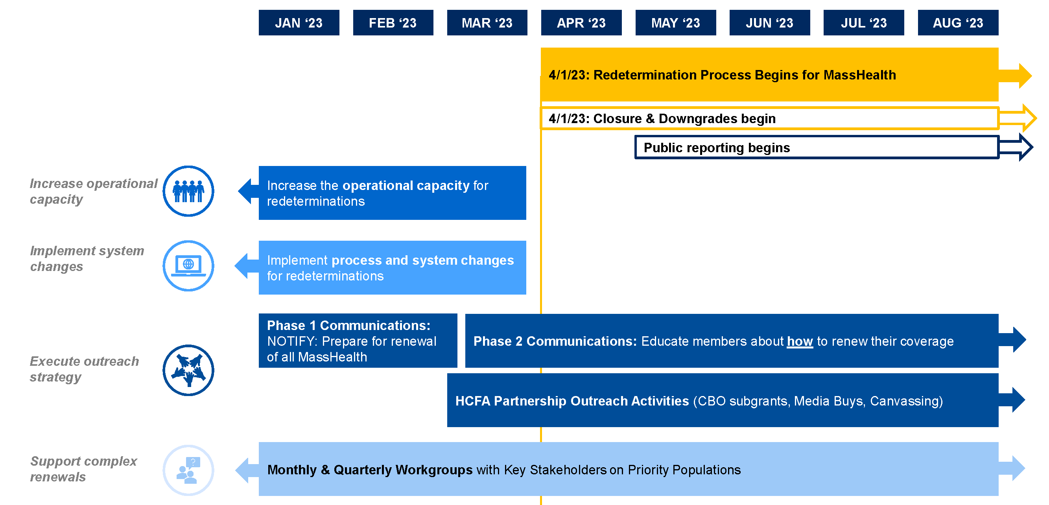

Increasing operational capacity: MassHealth is increasing the capacity of its contact center, enrollment centers, and related renewal and hearing processes

Increase staffing levels to support MassHealth Customer Service Center capacity, application processing, and hearings
- Hire over 150additional permanent andtemporary staff to support the influx of redeterminations and increase capacity at theMassHealth Enrollment Centers
- Increase frontline customer service agents from 300 to almost 500 to support the forecasted increase in service demand
- Reinforce training of staff at MassHealth Enrollment Centers and theMassHealth Customer Service Center to be prepared to answer questions and help members with their redeterminations
- Increase the number of “assisters,” including Navigators and Certified Application Counselors (CACs) to support the redetermination process
Improve efficiency of key steps in redetermination process
- Promote use of online MA Login Accounts (https://www.mass.gov/masshealth-ma-login-accounts) to enable self-service options (available for most MassHealth members under age 65)
- Encourage use of appointment scheduling system to enable timely access to the support theyneed
- Begin sending texts and emails to members requesting them to update contact information on file and alert members if their renewal notice mailing was returned with no forwarding address
- 19

Implementing system changes: MassHealth is implementing system and policy changes to adhere to federal requirements and enable a smoother renewal process for members
Increase reasonable compatibility threshold from 10% to 20%
- MassHealth will process an application automatically as long as the reported income matches the data hub information within a 20% buffer range (up from 10%), enabling the renewal to proceed without additional member involvement required
Align response timelines across Modified Adjusted Gross Income (MAGI)* and non-MAGI** populations
- This will provide all members with 90 days to respond to requests for information and with a 90-day renewal reconsideration period
Implement system changes to make the renewal process easier for members:
- MassHealth designed a simplified Senior Affordable Care Act (SACA) renewal form for most non-MAGI members¹
- Implemented self-service Interactive Voice Response enabling members to understand what documents are outstanding without having to speak to an agent
- Developed eSubmission application to enable an online option for renewals for 65+ population
Validate and update member contact information from trusted sources in alignment with federal best practices
Execute system changes to align with federal requirements regarding eligibility protections and adverse actions
*The MAGI population includes individuals, families, and people with disabilities who are 64 years old and younger, or 65+ and parent/caretaker of a child(ren) under the age of 19
**The Non-MAGI population includes seniors and populations who receive long-term care, comprising of Seniors 65+ in the community, 18+ receiving services through HCBS Waiver, Children up to age 9 with Autism Spectrum Disorder, Disabled children up to age 18 that require skilled nursing LOC living in community (Kaileigh Mulligan), and Individuals of any age living in nursing home or other LTC facility
¹Members who will not be able to use the simplified SACA renewal form include members who have turned 65 during the FPHE, Kaleigh Mulligan renewals, mixed age households, long term care/MSP annual renewals, and households with one or more individuals receiving Health Connector

Executing outreach: MassHealth is focused on effective and comprehensive outreach to members to minimize administrative loss of coverage and support members
Phase 1 –Notify–Prepare for renewal of all MassHealth members
Timeline: Now through Mid-March 2023
Key messages:
- Update your contact information
- Report any household changes
- Create an MA Login Account
- Read all mail from MassHealth
Phase 2: Educate members about how to renew their coverage
Timeline: Mid-March 2023 through June 2024
Key messages:
- Update your information with MassHealth
- Check your mail for a blue envelope from MassHealth
- Respond to MassHealth before the deadline
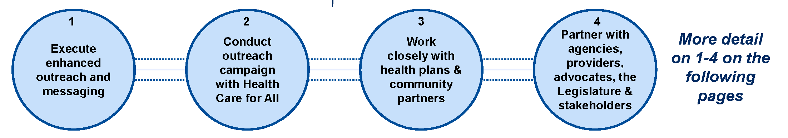

Executing outreach: Execute enhanced outreach & messaging

- Begin using blue envelopes for renewals to support increased response rate
- ▪Conduct live outbound calls to members with overdue renewals, capacity permitting
- ▪Social media campaign for each phase, focusing on key messages
- ▪Add insert to renewal notices emphasizing the importance of responding to receive the best benefit members qualify for, once the redetermination process begins
- ▪Launch text and email capability, which will alert members when a renewal form is sent to them and if their mail is returned
- ▪Develop videos on the end of the continuous coverage requirement and the renewal process

Executing outreach: Conduct outreach campaign with Health Care for All (HCFA)
HCFA received $5M in funding from state legislature to support redeterminations. In partnership with MassHealth and the Connector:
- Held member focus groups to hear feedback on communications approach
- Identified key messaging and branding for the “Your Family, Your Health” campaign
Developed three key prongs of outreach campaign:
- On-the-ground outreach (canvassing as well as tabling at local events and community spaces) in target communities
- Grants to community-based organizations, focusing on target communities and populations
- Community-oriented media buy (radio, TV, newspaper, social media)
Targeted Outreach Communities
- Boston
- Brockton
- Chelsea
- Everett
- Fall River
- Framingham
- Lawrence
- Lowell
- Lynn
- Malden
- New Bedford
- Quincy
- Revere
- Springfield
- Worcester

Executing outreach: Work closely with health plans & community partners
MassHealth is coordinating closely with health plans and community partners and began regular working group meetings in February 2023. Collaborations include:
Toolkit outlining best practices for member outreach:

- Plans will conduct calls, emails, and/or text messaging to alert members about their upcoming renewal.
- Plans will partner with primary care physicians and other providers to raise awareness about the importance of responding to MassHealth requests. This may include providing member-facing materials to provider offices.
- Plans are also encouraged to explore additional ways to outreach members, such as mailed letters, in-person enrollment events, or media buys.
Assistance updating member contact information:
- Plans will work to validate and update member contact information and share all new contact information with MassHealth.
Consistent data exchange regarding redeterminations
- MassHealth will send files each week to plans and community partners that identify members who have had their eligibility protected during the MOE period as well as members who are up for renewal.
- Plans will use these files to support member outreach, both inbound and outbound.

Executing outreach: Partner with providers, advocates, and other stakeholders to amplify key messages

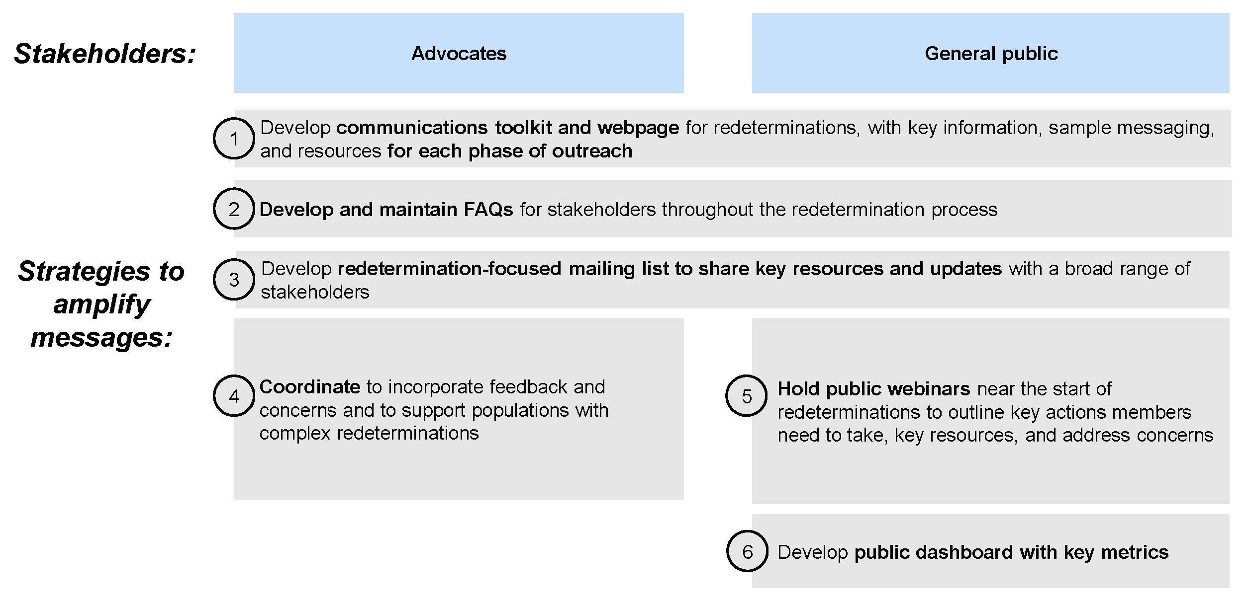

MassHealth is committed to supporting all members, especially those with complex redeterminations or who are most vulnerable

 | Focus | Subset of planned efforts
Members who are Homeless | Reaching transient members and assisting with enrollment and eligibility for those without a permanent address | - Outreach and coordination with shelters  - Coordinate with the Department of Housing and Community Development (DHCD)
Members with Disabilities | Ensuring messaging about redeterminations is accessible and assisting with enrollment complexities related to disabilities | - Monthly meetings with advocates  - Coordination and outreach in partnership with state agencies, community organizations, and advocates  - Member-facing eligibility charts and instructions
Members who are 65+ | Spreading information about redeterminations and dual-eligibility, particularly for members who turned 65 during the MOE period (and therefore transition from MAGI to Senior Affordable Care Act (SACA) renewal application) | - Trainings, instructions, and templates for Certified Application Counselors (CACs) on SACA  - Revamp Community Specialist (BIP) program  - Coordination with stakeholder and advocates
Immigrant populations | Sharing information about MassHealth eligibility for immigrants and refugees and reaching those populations with that information | - Coordination and outreach in partnership with Office for Refugees and Immigrants (ORI)  - Translation of key materials into top 7-9 languages for members
Children & Families | Reaching parents of children on MassHealth and sharing information about changes for members who age out of certain coverage protections | - Conduct outreach in partnership with the state education system, family & child assistance programs, and parent/child-focused agencies

To promote transparency and comply with federal requirements, MassHealth will develop public-facing reports and submit federal reports throughout the redetermination period
 | Metric Categories: | Update Cadence:
Public Dashboard | - Total Caseload  - Monthly Change in Caseload  - Member Re-openings  - Member Renewals  - Member Departures  - New Members | - Regularly throughout the redeterminations period
Federal Reporting | - Application processing  - Renewals  - Policy for Completing Renewals/ Renewals & Outcomes  - Medicaid Fair Hearings | Monthly

Help MassHealth spread the word to ensure all MassHealth members are prepared for renewals
What can you do today?
Share MassHealth Phase 1 Toolkit communications with your network
Find it here: mass.gov/masshealthrenew
- Post on social media
- Hang a flyer
- Sign up for MassHealth Eligibility Redeterminations email notifications
- Spread the word!

- MassHealth is finalizing its state operational unwinding plan, which will be sent to CMS
- Look out for our public redetermination dashboard coming out in early spring

