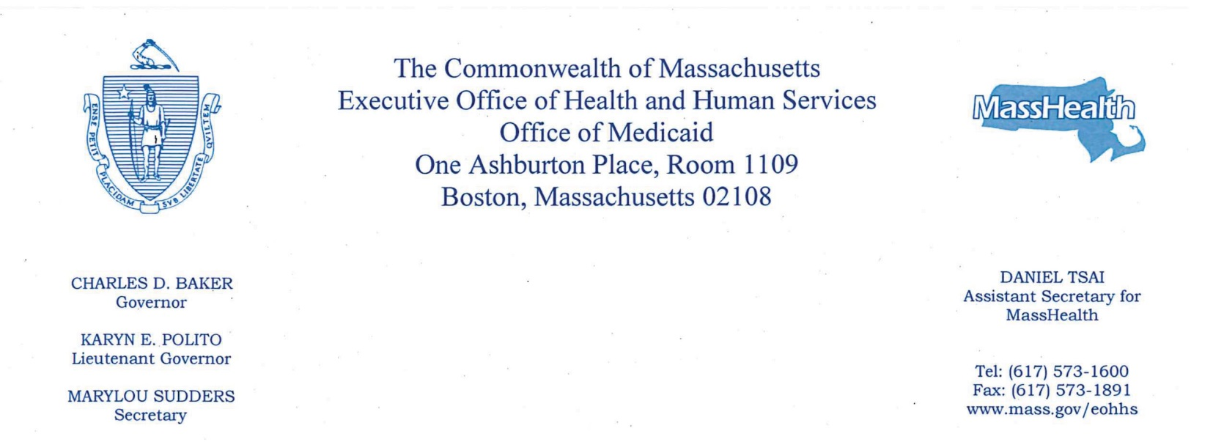

March 9, 2018

Chairwoman Karen Spilka
Senate Committee on Ways and Means
State House, Room 212
Boston, MA 02133

Chairman James Welch
Senate Chair, Joint Committee on Health Care Financing
State House, Room 413B
Boston, MA 02133
Chairman Jeffrey Sanchez
House Committee on Ways and Means
State House, Room 243
Boston, MA 02133

Vice Chair Jeffrey Roy
House Chair, Joint Committee on Health Care Financing
State House, Room 236
Boston, MA 02133

Dear Chairwoman Spilka, Chairman Sanchez, Chairman Welch, and Vice Chairman Roy,

Section 6 of Chapter 118E requires that the Office of Medicaid report on the previous state fiscal year activities of the Medical Care Advisory Committee (MCAC).

The attached report includes the agendas and materials for MCAC meetings in Fiscal Year 2017. Please note that, since August 2010, these meetings have been held jointly with the MassHealth Payment Policy Advisory Board.

I hope you find the attached materials useful and informative. Please feel free to contact Monica Sawhney at (617) 573-1649 if you have any questions.

Sincerely,

Daniel Tsai
Assistant Secretary for MassHealth and Medicaid Director

cc: Marylou Sudders, Secretary

Attachments:
November 17, 2016 Payment Policy Advisory Board and Medical Care Advisory Committee Agenda
November 17, 2016 Meeting Presentation
December 11, 2017 Payment Policy Advisory Board and Medical Care Advisory Committee Agenda
December 11, 2017 Meeting Presentation

