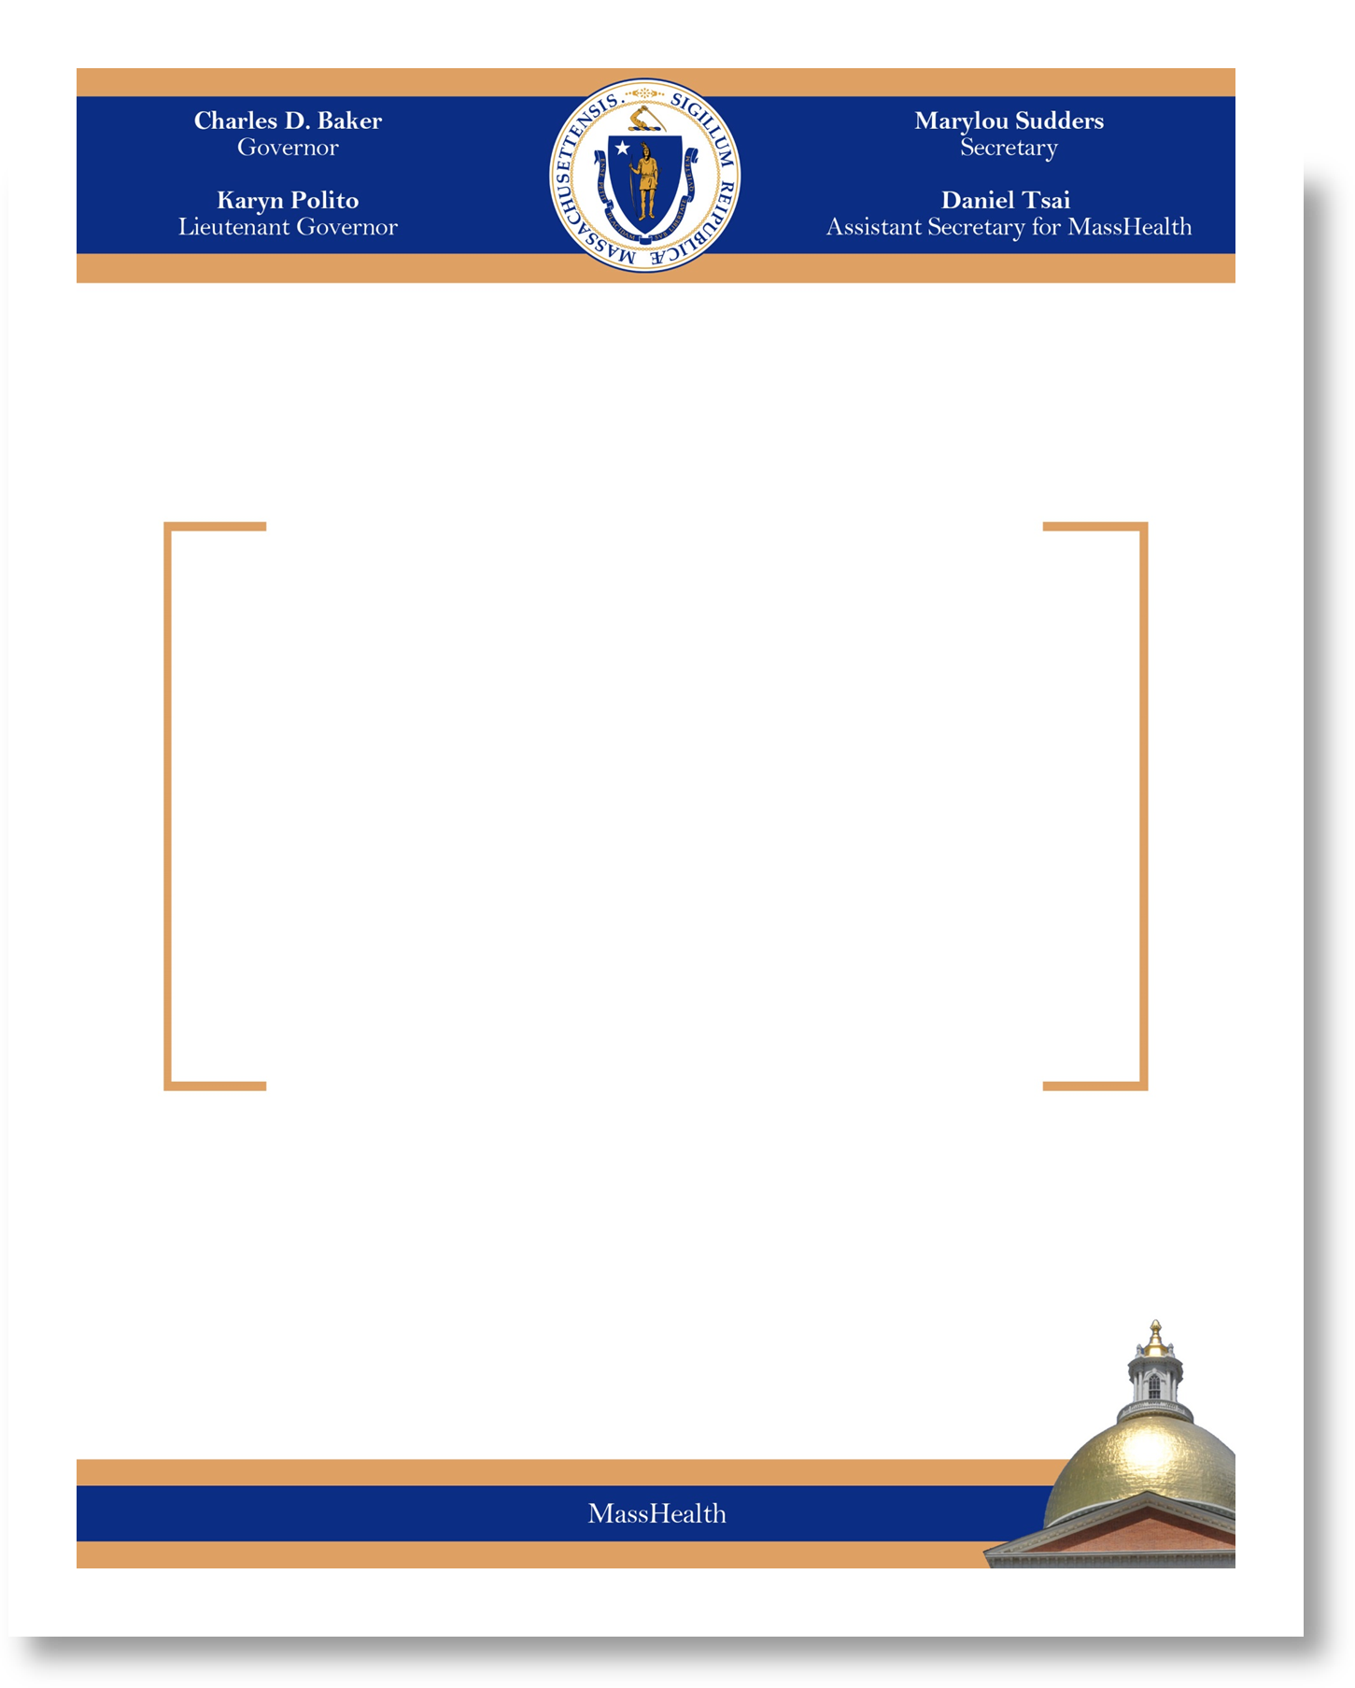

Report on the Medical Care Advisory Committee for Fiscal Year 2015

October 1, 2015

