Job Aid: Copying a Claim

This job aid describes how to:

- Copy a previously submitted paid or denied claim.

This allows you to submit a claim for a different member for the same service.

To Copy a Claim
From the Claim Confirmation panel:
- Click Copy.
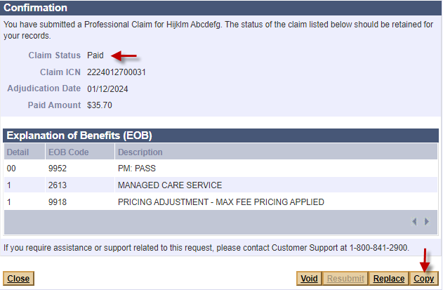

Continue with the Billing Information Panel
From the Billing Information panel:
- Enter the claim information for the replaced claim as you would for any new claim.
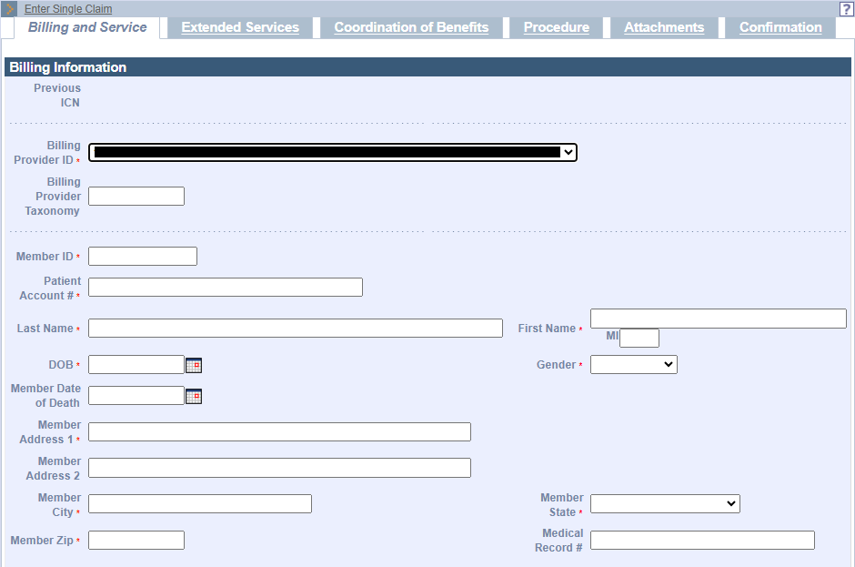

To copy a previously submitted claim:
From the POSC home page:
- Click Manage Claims and Payments.
- Click Inquire Claim Status.
- In the Claims Search panel, enter the ICN of the previous claim you want to copy.
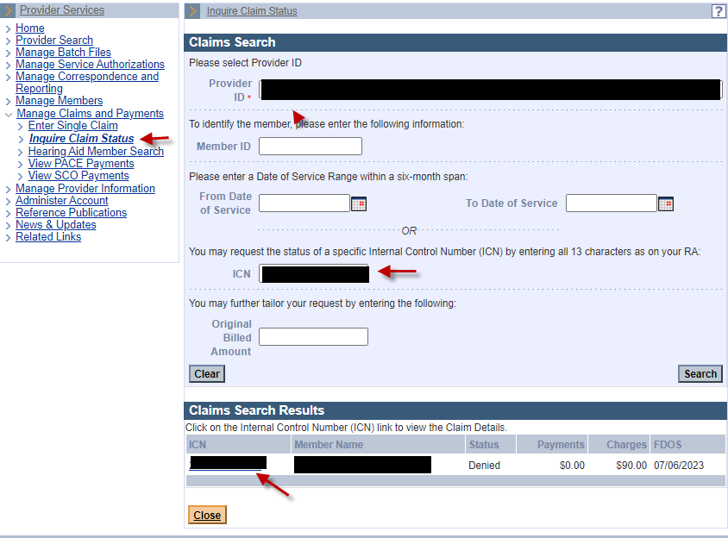
- Click on the ICN in the Claims Search Results panel. The Claim Detail panel will display.
- Click Copy.

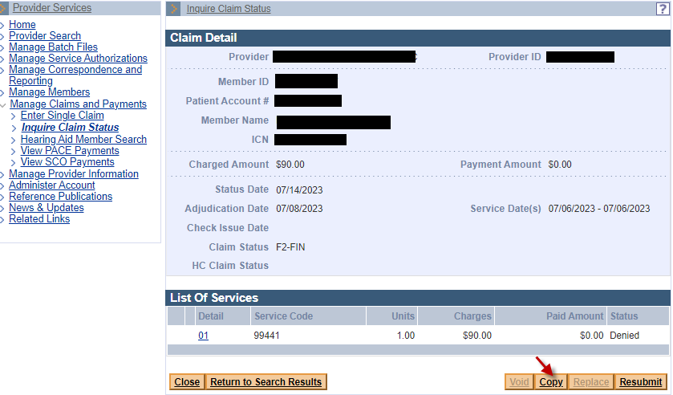

Continue with the Billing Information Panel
From the Billing Information panel:
- Enter all the claim information on each appropriate tab/panel and submit to MassHealth.

