Job Aid: Create a Conversion Request

This job aid describes how to create and submit a pre-admission screening (PAS) request using the MassHealth Provider Online Service Center (POSC). The PAS authorizes elective/nonemergency acute or chronic hospital stays.

You must have the Provider ID (PID) and Service Location (SL) for the facility to create a PAS request. Click on the Providers tab and enter the national provider identifier (NPI) to obtain the PID and SL.

- If you are a Registered User, click the Login button on the POSC landing page.

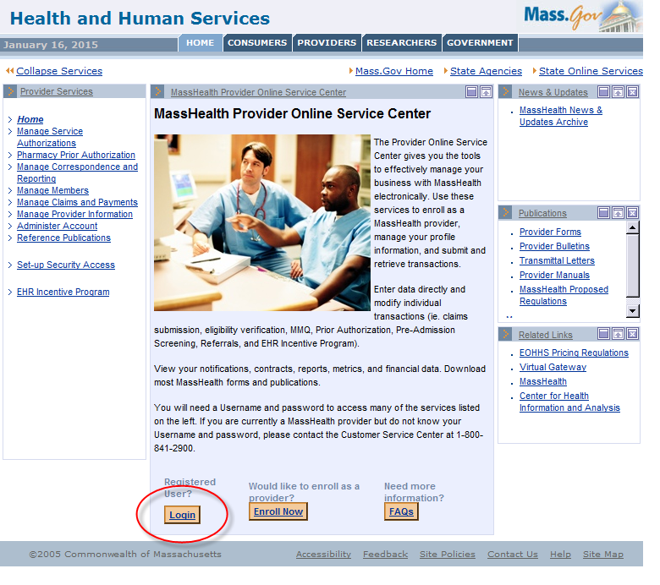

- In the Provider Login section, enter your username and password. Click Submit.

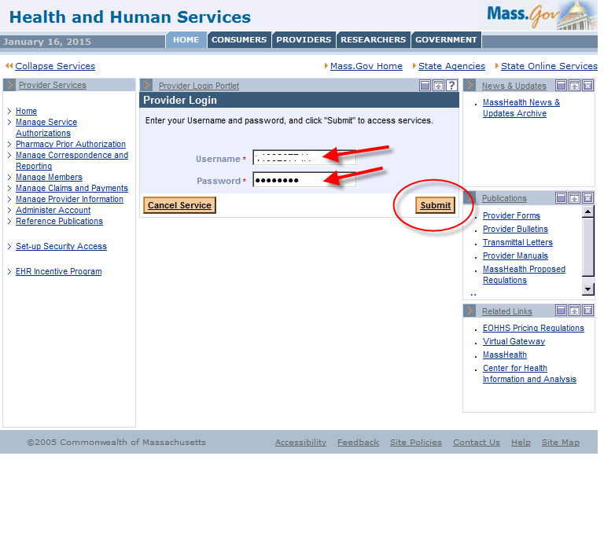

- Click on Manage Service Authorizations on the left section of the page.

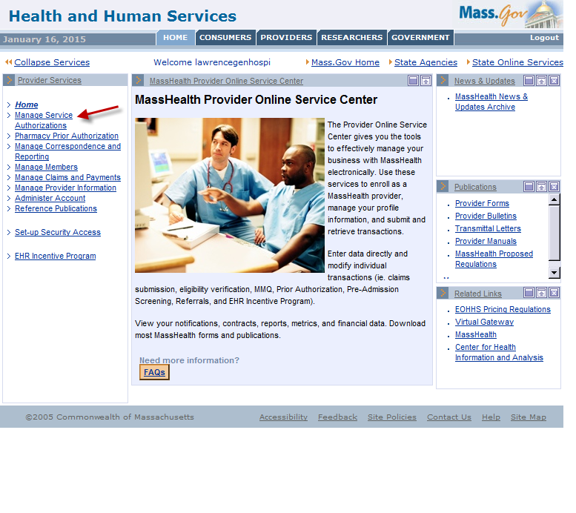

- Click on Enter PAS Request.

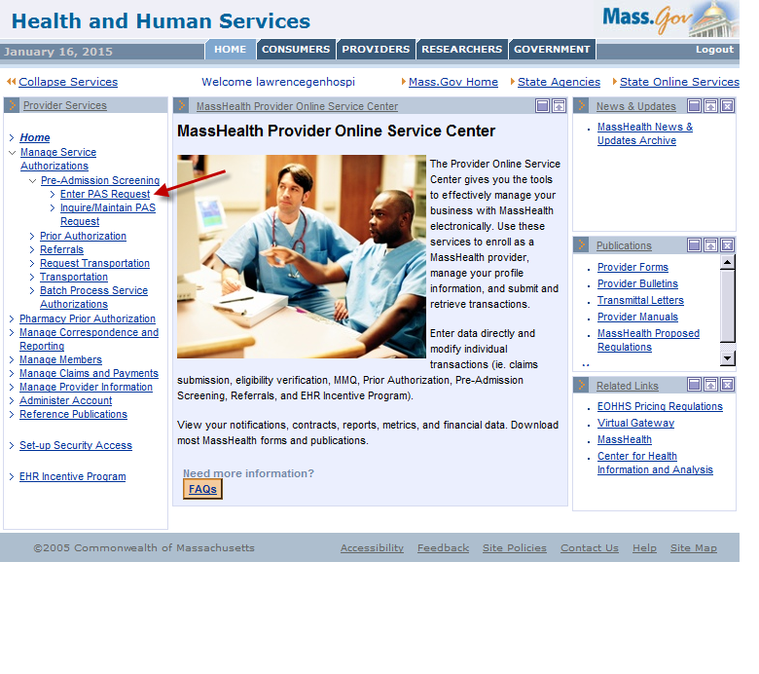

Base Information Instructions
Below is the Base Information page on the PAS Information tab. (See detailed instructions on the next page of this job aid.)

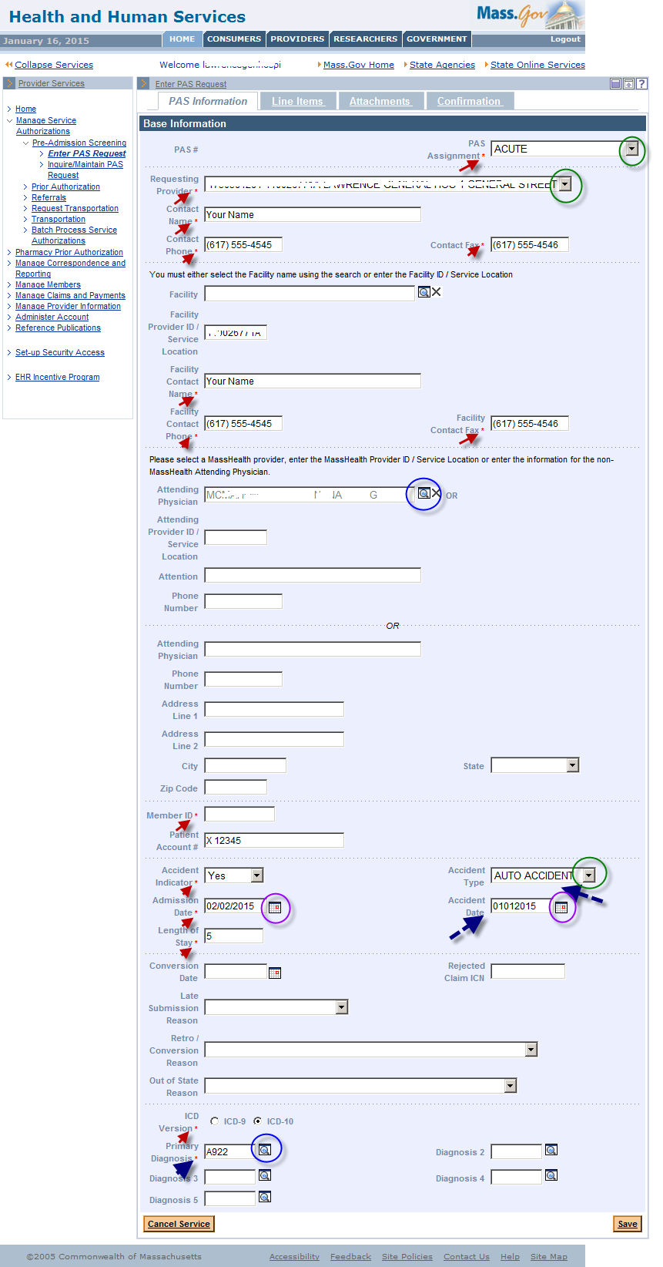

Base Information Instructions, continued:
- Fill in the required fields. Required fields are denoted with an asterisk (*).
  - Admission Date is the admission date to the facility. The conversion date will be entered further down.
  - Length of Stay is the entire length of stay, from admission date thru the days requested in the line item.
- Fields with dropdown lists allow you to pick an option from a list of valid values.
You must choose “Acute,” “Acute with Rehab,” or “Chronic” from the PAS Assignment field. If you are submitting the request from a chronic disease and rehab hospital, you should always choose “Chronic”

- Fields with a magnifying-glass icon have a pop-up search option. Selecting a value from the search result will populate this field for you. You may also manually enter details.
- Include PID and SL when entering information in the Facility Provider ID and Attending Provider ID fields.
- If the Accident Indicator field is set to Yes, you must fill in the Accident Type and Accident Date fields.
- Use the Provider Comments box (see below) to note any additional details about the procedure. If you have more than five CPT codes to enter, you can enter them here.

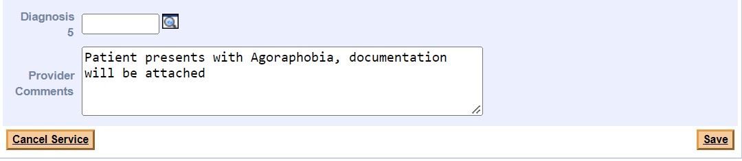

- Fill in the Conversion Date and Retro/Conversion Reason. These fields are required to complete a conversion.
  - Conversion Date is the date that MassHealth will become the primary payer. For example, if the primary payer exhausts on 1/15/2023, the conversion date to MassHealth is 1/16/2023.
  - Select the appropriate Retro/Conversion Reason from the dropdown list.

If the conversion date is before the submission date of the request, you will also need to complete the Late Submission Reason field.

- Click Save.

Line Item Instructions
The Line Items panel allows the provider to enter specifics about the requested stay.
- Click the Line Items tab.

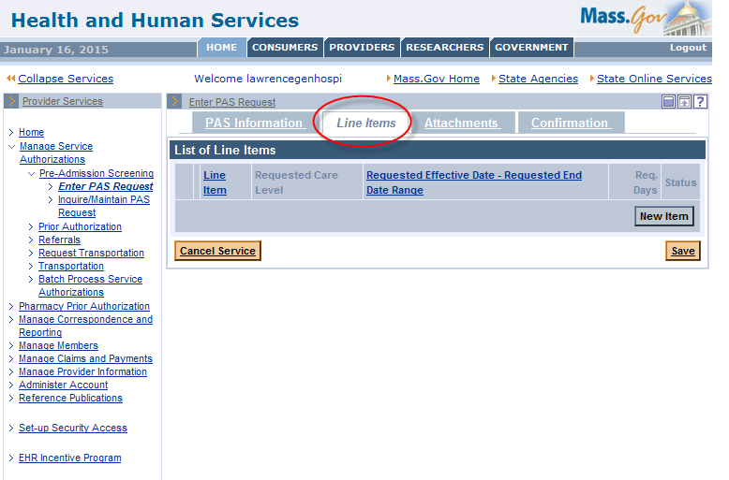

- Click the New Item button.

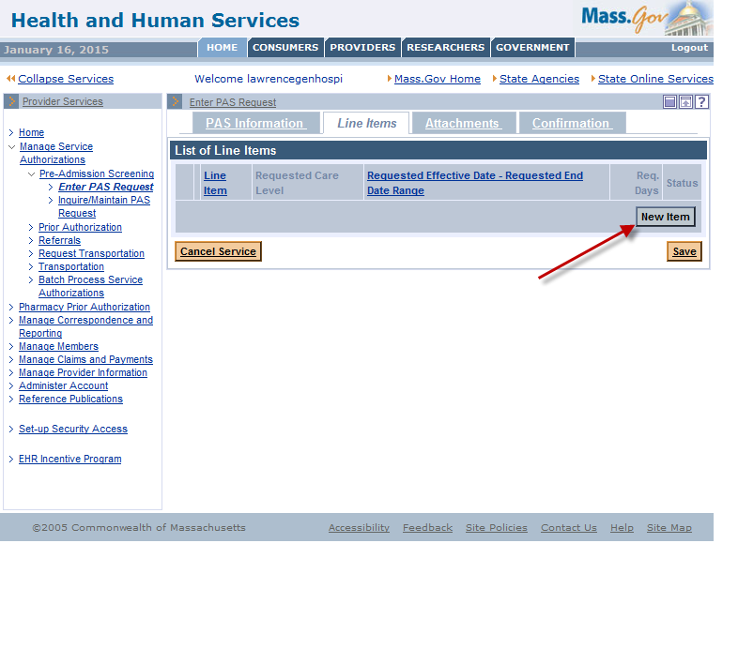

- Complete all required fields indicated with an asterisk.
Requested Level of Care will be either Chronic Rehab: Hospital Level of Care or
Chronic Rehab: Administrative Day Level of Care.

Requested Admission Type will be either Medical or Rehab.

Requested Effective Date is the date you are requesting MassHealth to become the primary payer.

Requested Days is how many days you are requesting to be authorized.

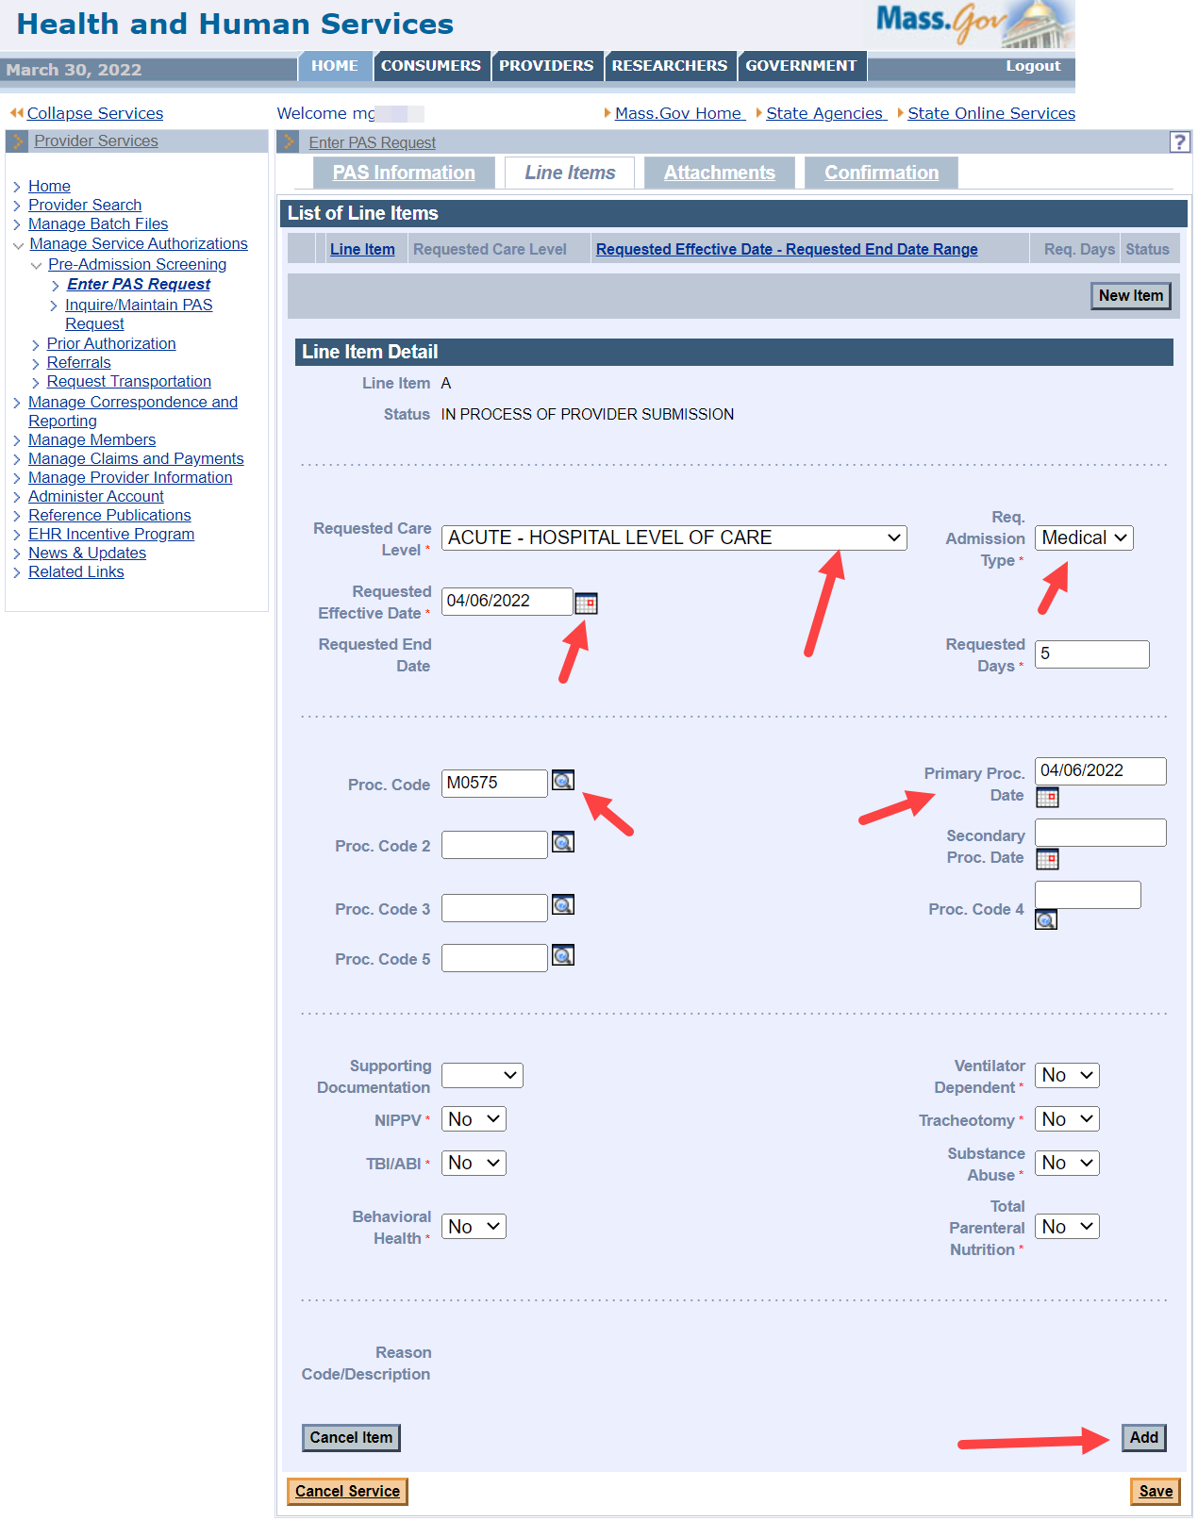

- Select Yes or No for NIPPV, TBI/ABI, Behavioral Health, Ventilator Dependent, Tracheostomy, Substance Abuse, and Total Parenteral Nutrition. These fields are defaulted to “No,” so make sure the answers accurately reflect the request being submitted.
- Click the Add button to add the line item data to the request.
Do not add more than one line item.

- Click Save.

Attachments Instructions
Include any clinically pertinent documentation with your request.
- Click on the Attachments tab.
- Click the New Item button to add an attachment to the PAS request.
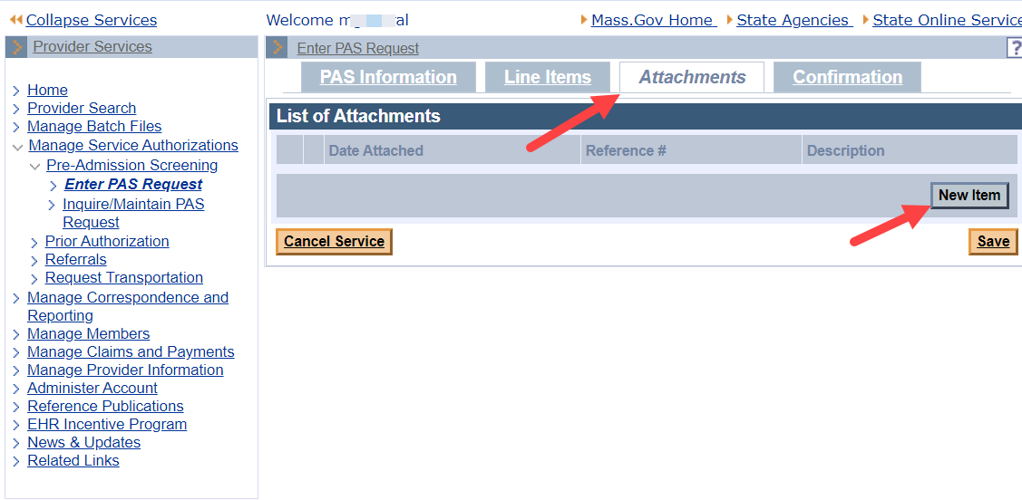

- On the Attachments Detail page, select the Report Type from the dropdown list.
- Select ELECTRONICALLY ONLY from the Transmission Code dropdown list.
- In the Description field, enter a brief description of the document you are attaching.
- Click the Browse button to locate the electronic document on your computer.
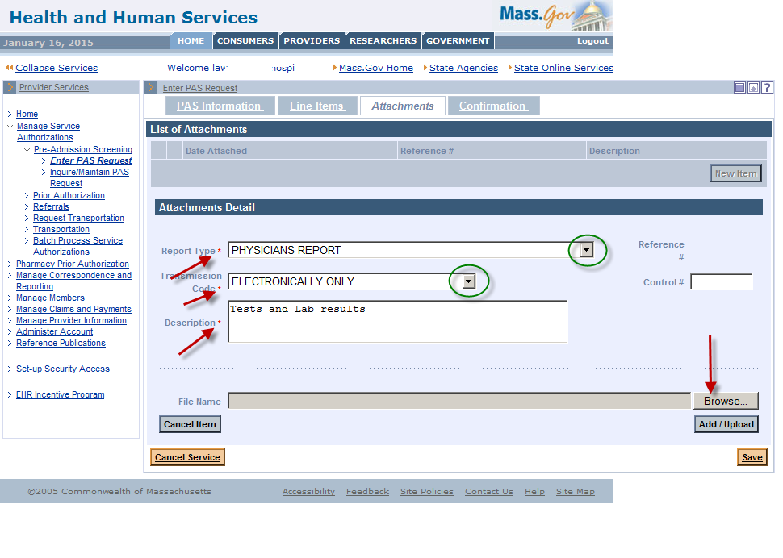
- Select a file on your computer and click Open. This will populate the file name on the panel.

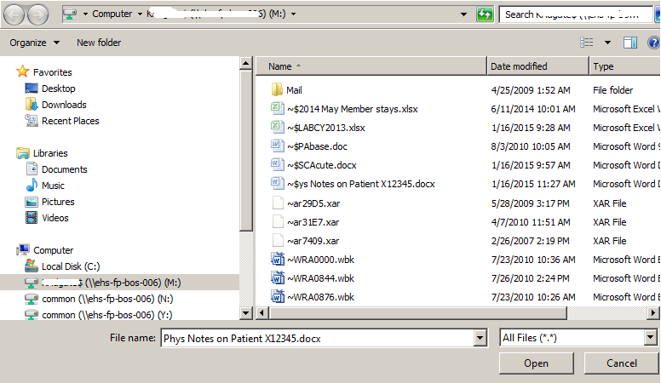

- Click Add/Upload to attach your selected file to the request.
- You may attach additional documents by repeating the process. We recommend noting the specific report type. For example:
  - Medical Record Attachment;
  - Physicians Report; or
  - Radiology Report.
- Click Save.
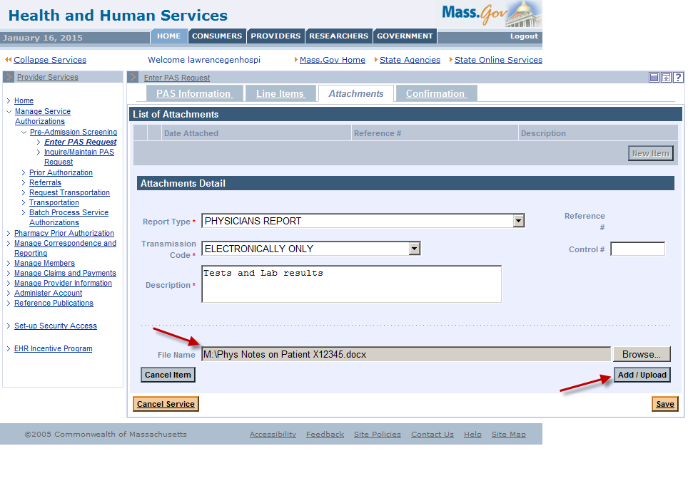

Confirmation/Completion Instructions

- Click on the Confirmation tab. This is where you will submit the new request for review.
- Click Submit.
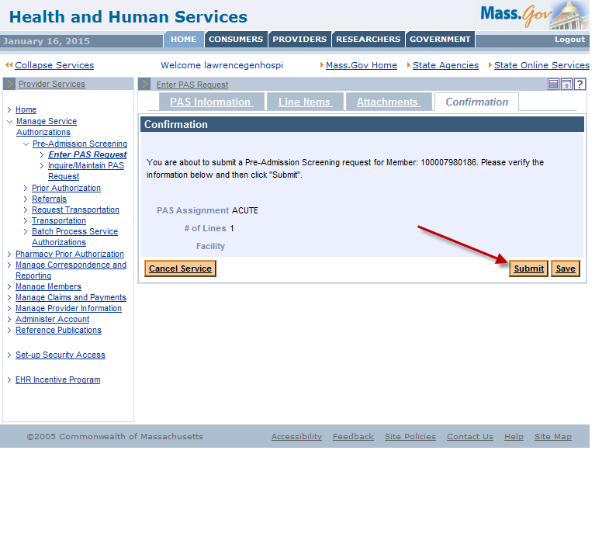

IMPORTANT:
- If you click Save, the request is not complete. The data you entered will be saved in the system for completion and submission at a later time. The status of the saved request will say, “In Process of Provider Submission.”
- Once you click Submit, the request will say, “Ready for Review.”
The request will not be reviewed until you click Submit.

- When you click Submit, the data you entered is edited and validated.
- If you receive any errors, you must fix them before the request can be resubmitted.
Open the tab where the field in error is found and correct the error or add missing required values.

- If you receive warnings, acknowledge them by checking the box. You do not need to make changes to any data fields.
- After you have corrected the errors and acknowledged the warnings, you will see a new page called the Pre-Admission Screening Response page.

The Pre-Admission Screening Response
This page will give you the PAS number and confirm successful submission of your PAS request.
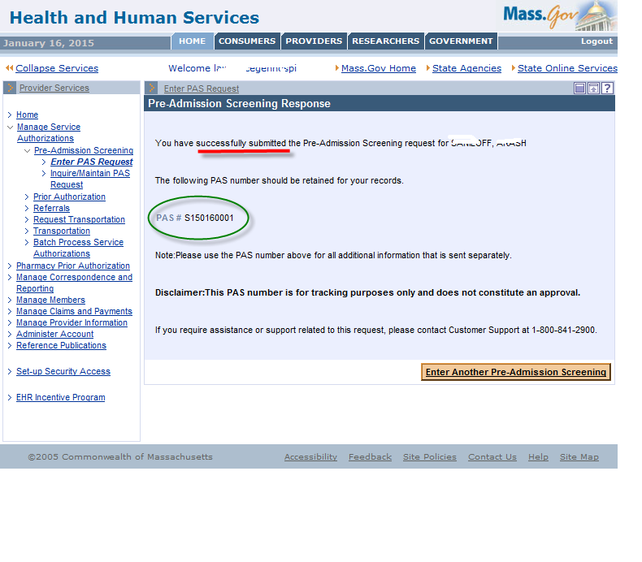
This screen will confirm that your request has been successfully submitted. The final step is to call the CDRH dedicated line at (800) 554-5127 and leave a message. Say that you have submitted a conversion request and include the PAS number.

