# Job Aid: Disenroll a Member from PACE

The Program of All-inclusive Care for the Elderly (PACE) is a comprehensive health program designed to keep frail, older individuals living in the community. PACE serves individuals who are 55 and older, certified to need nursing home care, and able to live safely in the community at the time of enrollment. Enrollment may end at the request of the member or because of death.

This job aid describes how to do the following.

* Search for a member record
* Enter the disenrollment reason
* Submit the request

## Access Enroll/Disenroll PACE Members

From the **POSC** home page:

1. Click **Manage Members**.
2. Click **Enrollment**.
3. Click **Enroll/Disenroll PACE Members**.

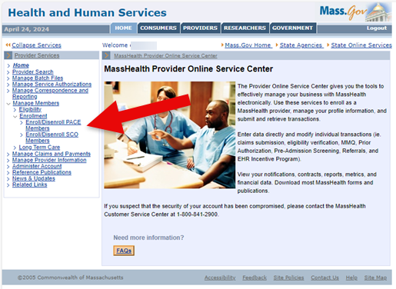

## Search for Member Record

On the **Member Search** panel:

1. Verify your health plan’s provider ID defaults in the **Provider ID** field.
2. Enter the **Member ID**.
3. Enter the MassHealth member’s **Last Name**. (The last name must be spelled exactly as it appears on the MassHealth member’s ID card.)
4. Enter the MassHealth member’s **First Name**. (The first name must be spelled exactly as it appears on the MassHealth member’s ID card.)
5. Click **Search** to locate the member’s information.

**Note:** If the member is currently a valid member of PACE, the **Disenrollment** panel will display.

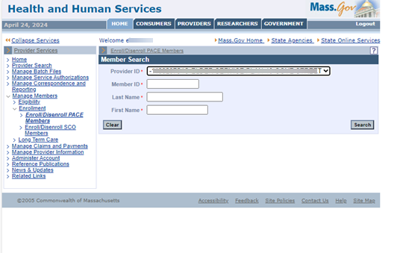

## Disenroll Member

On the **Disenrollment** panel:

1. Select the disenrollment reason from the dropdown list.
2. Click **Submit** to submit the disenrollment.

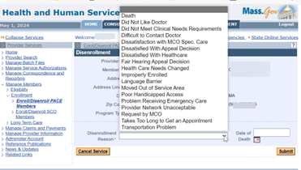

## Disenrollment Confirmation

On the **Disenrollment Confirmation** panel:

1. Verify that the disenrollment has been validated by MMIS.

**Note:** Disenrollment occurs on the last calendar day of the month.

1. Click **Enroll/Disenroll Another Member** if you have additional enrollments or **Home** on the left menu to end the process.

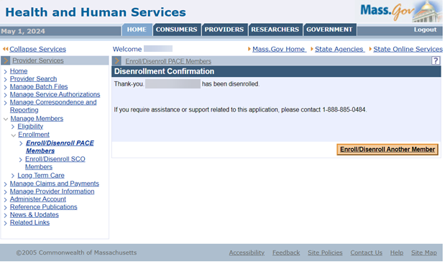

If you experience any issues with enrolling or disenrolling participants, please contact the Integrated Care Team at enrollmentoperations@mass.gov.