# Job Aid: Disenroll a Member from Senior Care Options (SCO)

Senior Care Options (SCO) is a comprehensive health plan that covers all of the services reimbursable under Medicare and MassHealth through a senior care organization and its network of providers.

This job aid describes how to do the following.

* Search for a member record
* Enter the disenrollment reason
* Submit the request

## Access Enroll/Disenroll SCO Members

From the MassHealth **Provider Online Service Center (POSC)** home page:

1. Click **Manage Members**.

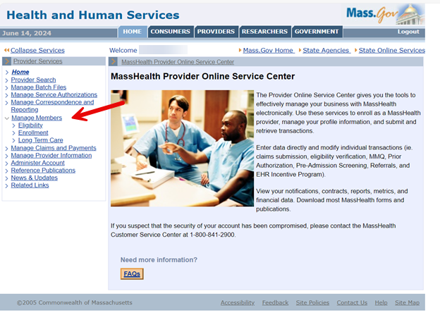

1. Click **Enrollment**.

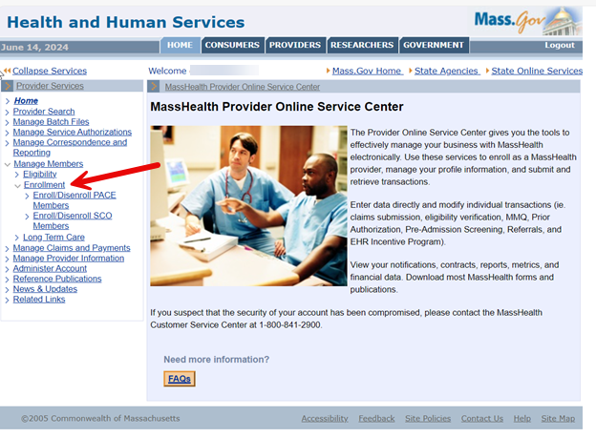

1. Click **Enroll/Disenroll SCO Members**.

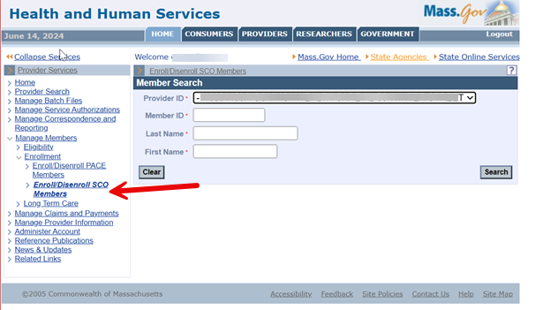

## Search for Member Record

On the **Member Search** panel:

1. Verify your health plan’s provider ID defaults in the **Provider ID** field.
2. Enter the **Member ID**.
3. Enter the MassHealth member’s **Last Name**. (The last name must be spelled exactly as it appears on the MassHealth member’s ID card.)
4. Enter the MassHealth member’s **First Name**. (The first name must be spelled exactly as it appears on the MassHealth member’s ID card.)
5. Click **Search** to locate the member’s information.

**Note:** If the member is currently a valid member of SCO, the **Disenrollment** panel will display.

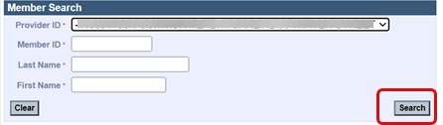

## Disenroll Member

On the **Disenrollment** panel:

1. Select the **Disenrollment Reason** from the dropdown list.

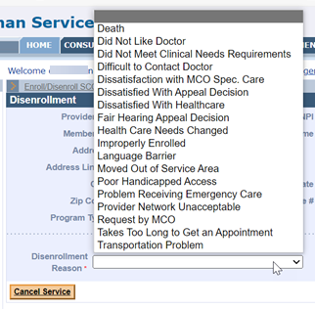

1. Click **Submit** to submit the disenrollment.

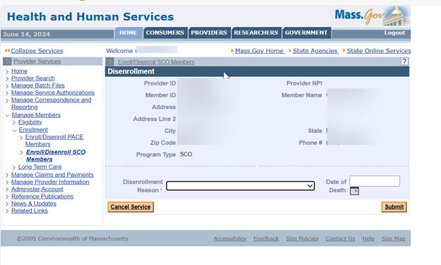

## Disenrollment Confirmation

On the **Disenrollment Confirmation** panel:

1. Verify that the disenrollment has been validated by MMIS.

**Note:** The member will be disenrolled as of the last calendar day of the month. The provider will receive a confirmation via the 834 batch file transaction.

1. Click **Enroll/Disenroll Another Member** if you have additional enrollments or **Home** on the left menu to end the process.

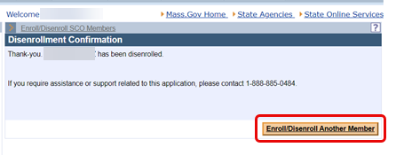

If you experience any issues with enrolling or disenrolling participants, please contact the Integrated Care Team at enrollmentoperations@mass.gov.