# Job Aid: Enroll a Member in PACE

The Program of All-inclusive Care for the Elderly (PACE) is a comprehensive health program designed to keep frail, older individuals living in the community. PACE serves individuals who are 55 and older, certified to need nursing home care, and able to live safely in the community at the time

This job aid describes how to do the following.

* Search for a member record
* Confirm the rate cell
* Certify that the individual completed the MassHealth application
* Submit the enrollment

## Access Enroll/Disenroll PACE Members

From the **POSC** home page:

1. Click **Manage Members**.
2. Click **Enrollment**.
3. Click **Enroll/Disenroll PACE Members**.

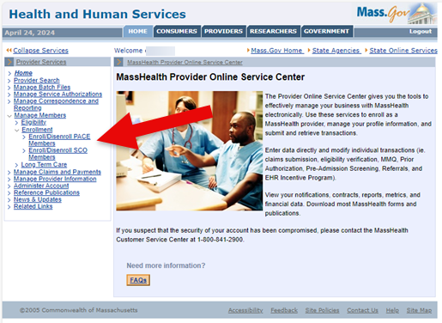

## Search for Member Record

On the **Member Search** panel:

1. Verify your health plan’s provider ID defaults in the **Provider ID** field.
2. Enter the **Member ID**.
3. Enter the MassHealth member’s **Last Name**. (The last name must be spelled exactly as it appears on the MassHealth member’s ID card.)
4. Enter the MassHealth member’s **First Name**. (The first name must be spelled exactly as it appears on the MassHealth member’s ID card.)
5. Click **Search** to locate the member’s information.

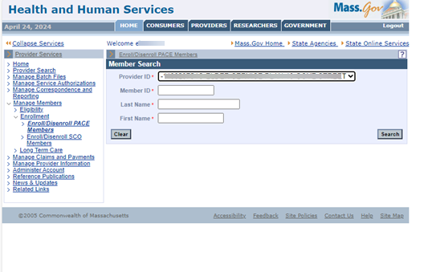

## Verify Rate Cell

On the **Verification** panel:

1. Verify the member information.
2. Verify the rate cell is correct for the member.
3. Click **Confirm** to enroll the member in the rate cell.

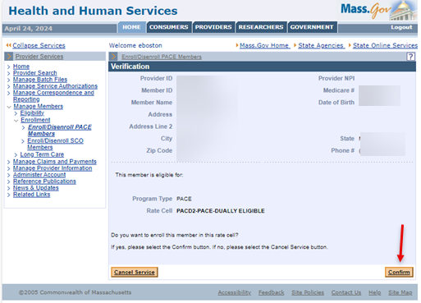

## Certify Member

On the **Certification** panel:

1. Select the Certification checkbox to certify that the member has a MassHealth Enrollment package on file.
2. Click **Submit** to submit the enrollment.

**Note:** This certifies that the member has completed a PACE Enrollment Agreement.

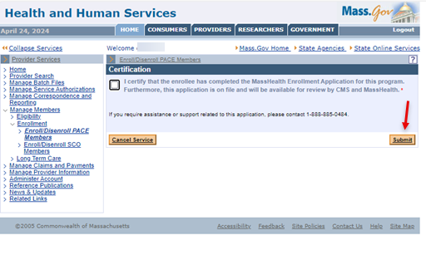

## Confirmation

On the **Confirmation** panel:

1. Verify that the enrollment has been validated by MMIS.

**Note:** The member is enrolled as of the first calendar day of the following month. The provider will receive a confirmation via the 834 batch file transaction.

1. Click **Enroll/Disenroll Another Member** if you have additional enrollments or click **Home** on the left menu to end the process.

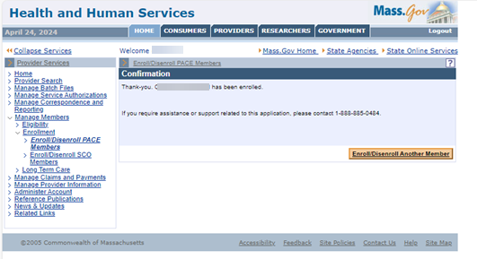

If you experience any issues with enrolling or disenrolling participants, please contact the Integrated Care Team at enrollmentoperations@mass.gov.