# Job Aid: Enroll a Member in Senior Care Options

Senior Care Options (SCO) is a comprehensive health plan that covers all of the services reimbursable under Medicare and MassHealth through a senior care organization and its network of providers.

This job aid describes how to do the following.

* Search for a member record
* Confirm the rate cell
* Certify that the individual completed the MassHealth application
* Submit the enrollment

**Access Enroll/Disenroll SCO Members**

From the **POSC** home page:

1. Click **Manage Members**.
2. Click **Enrollment**.
3. Click **Enroll/Disenroll SCO Members**. The **Member Search** panel displays.

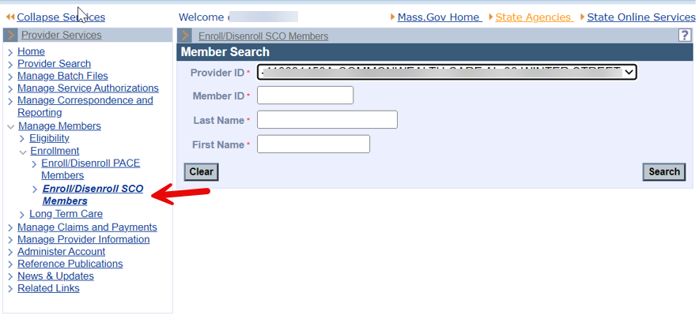

**Search for Member Record**

On the **Member Search** panel:

1. Verify that your health plan’s provider ID defaults in the **Provider ID** field.
2. Enter the **Member ID**.
3. Enter the MassHealth member’s **Last Name**. (The last name must be spelled exactly as it appears on the MassHealth member’s ID card.)
4. Enter the MassHealth member’s **First Name**. (The first name must be spelled exactly as it appears on the MassHealth member’s ID card.)
5. Click Search to locate the member’s information.

**Note:** The search authenticates the user and validates eligibility. If the member is eligible to enroll in SCO, the user is navigated to the **Verification** panel.

**Verify Rate Cell**

On the **Verification** panel:

1. Verify the rate cell is correct for the member.
2. Click **Confirm** to enroll the member in the rate cell. The **Certification** panel displays.

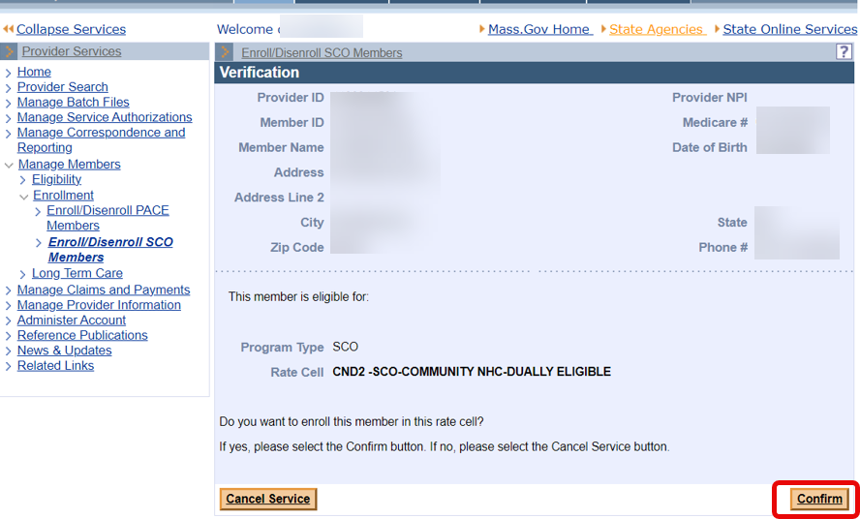

**Certify Member**

On the **Certification** panel:

1. Select the Certification checkbox to certify that the member has a MassHealth Enrollment package on file.
2. Click **Submit** to submit the enrollment. The **Confirmation** panel displays.

**Note:** This certifies that the member has completed the requirements for an SCO applicant and submits the certification.

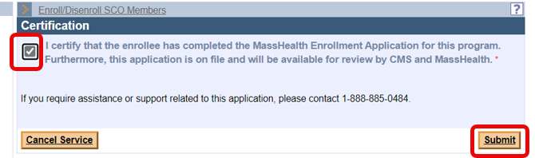

**Confirmation**

On the **Confirmation** panel:

1. Verify that the enrollment has been validated by MMIS.

**Note:** The member is enrolled as of the first calendar day of the following month. The provider will receive a confirmation via the 834 batch file transaction.

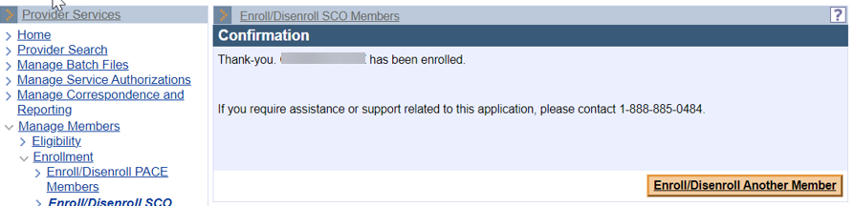

1. Click **Enroll/Disenroll Another Member** if you have additional enrollments or click **Home** on the left menu to end the process.

If you experience any issues with enrolling or disenrolling participants, please contact the Integrated Care Team at enrollmentoperations@mass.gov.