Job Aid: Extend a Pre-admission Screening Request
This job aid describes how to extend a pre-admission screening (PAS) request using the MassHealth Provider Online Service Center (POSC). The extension of a PAS authorization (or Continued Stay Request) applies only to chronic disease and rehabilitation hospital (CDRH) stays.

- Click the Login button on the POSC landing page.
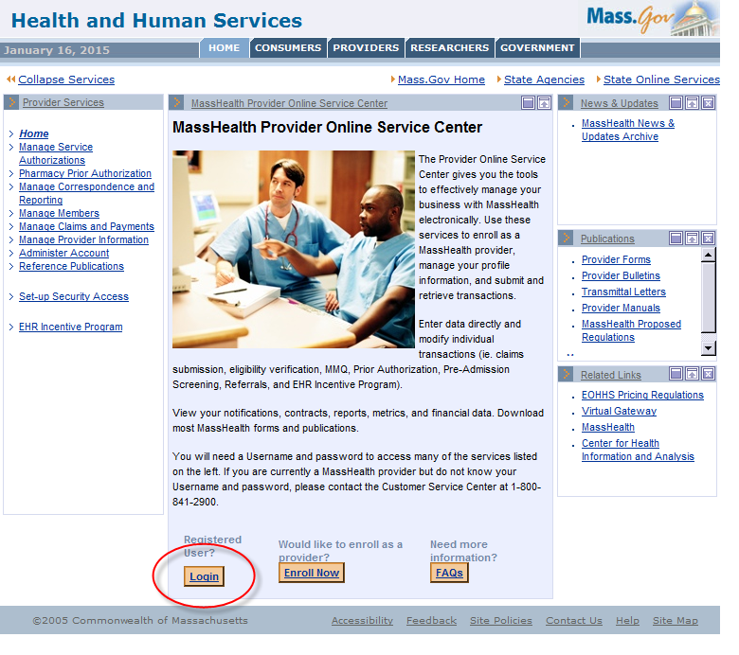
- In the Provider Login panel, enter your username and password. Click Submit.

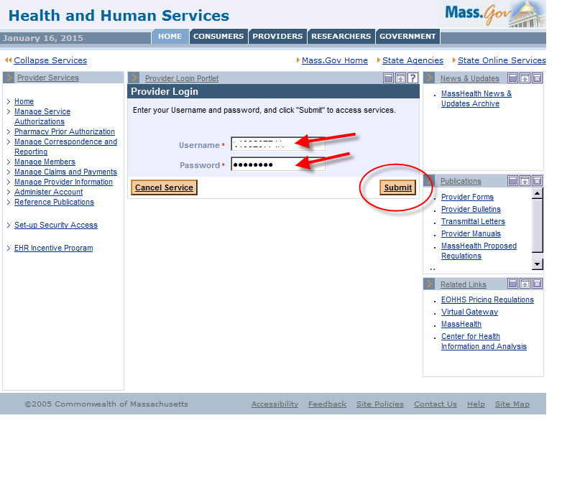
- Click on Manage Service Authorizations on the left section of the page.
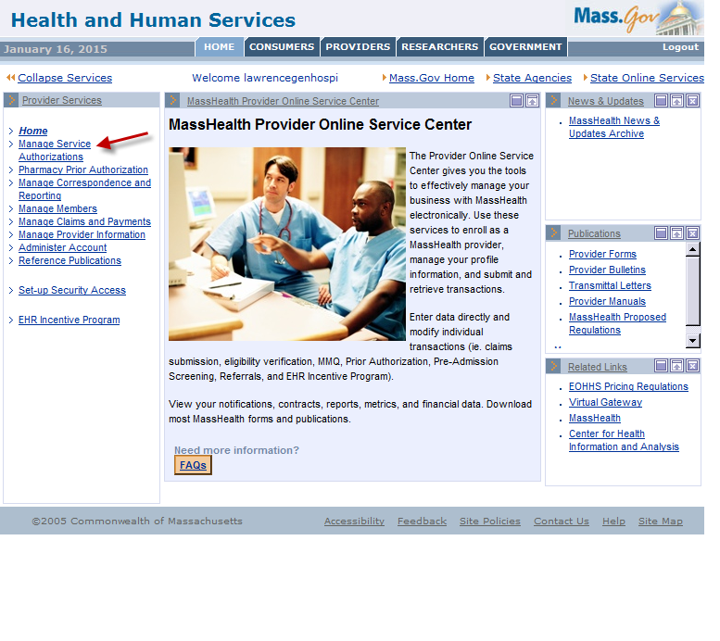
- Click on Inquire/Maintain PAS Request.
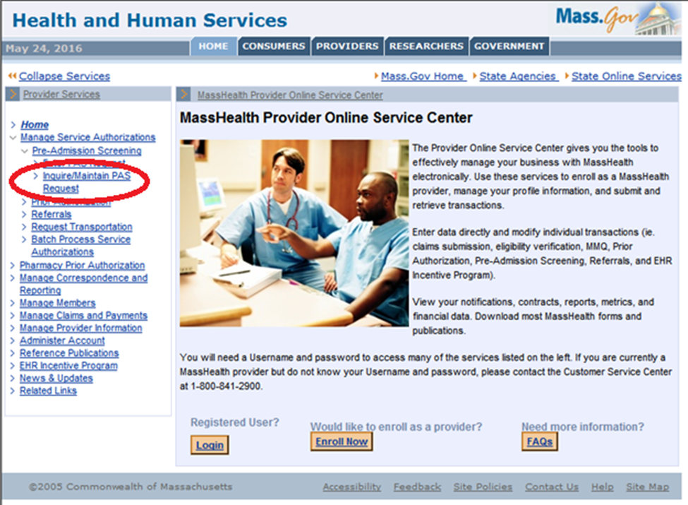

- Enter the PAS number in the PAS field of the PAS Search panel.
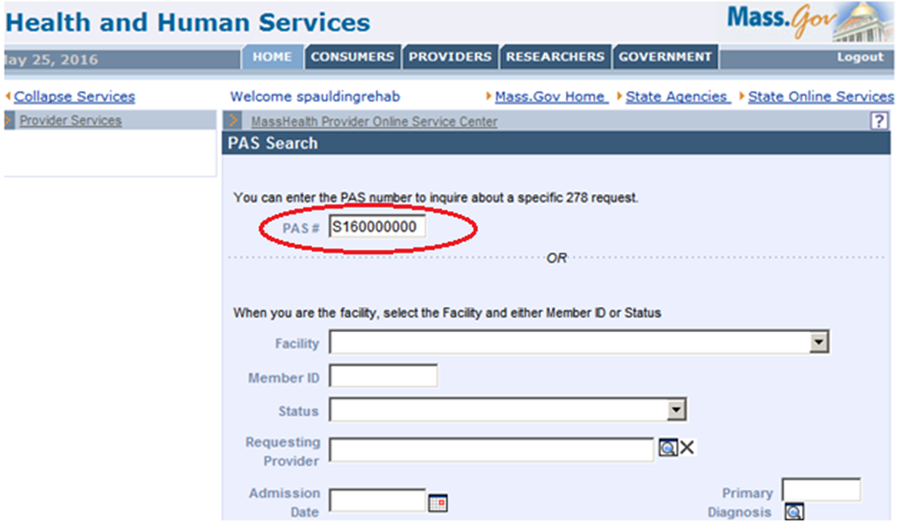
- Scroll to the bottom of the screen and click the Search button on the right.
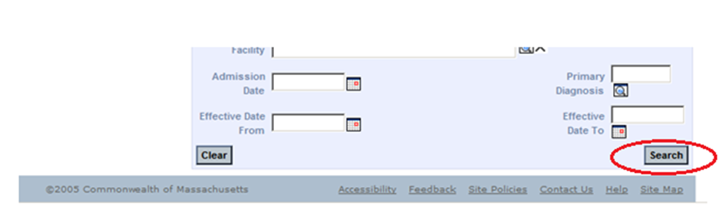

- Click the desired PAS number in the left column of the PAS Search Results panel.
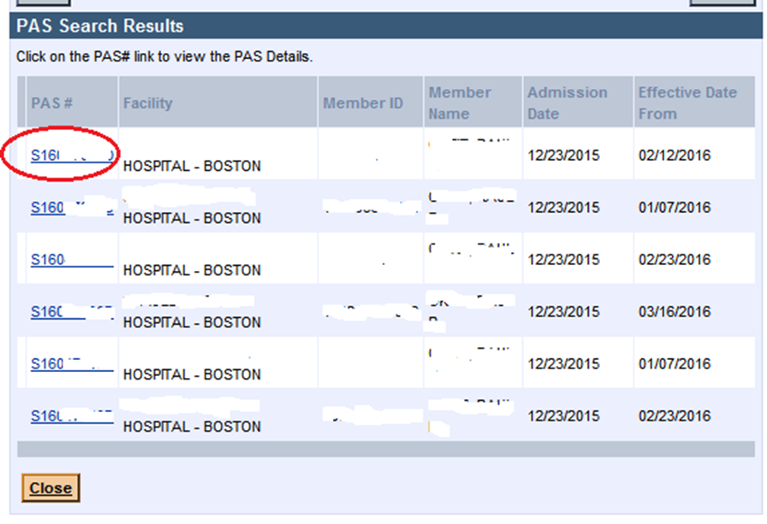

- When the Base Information panel appears, click on the Line Items tab.
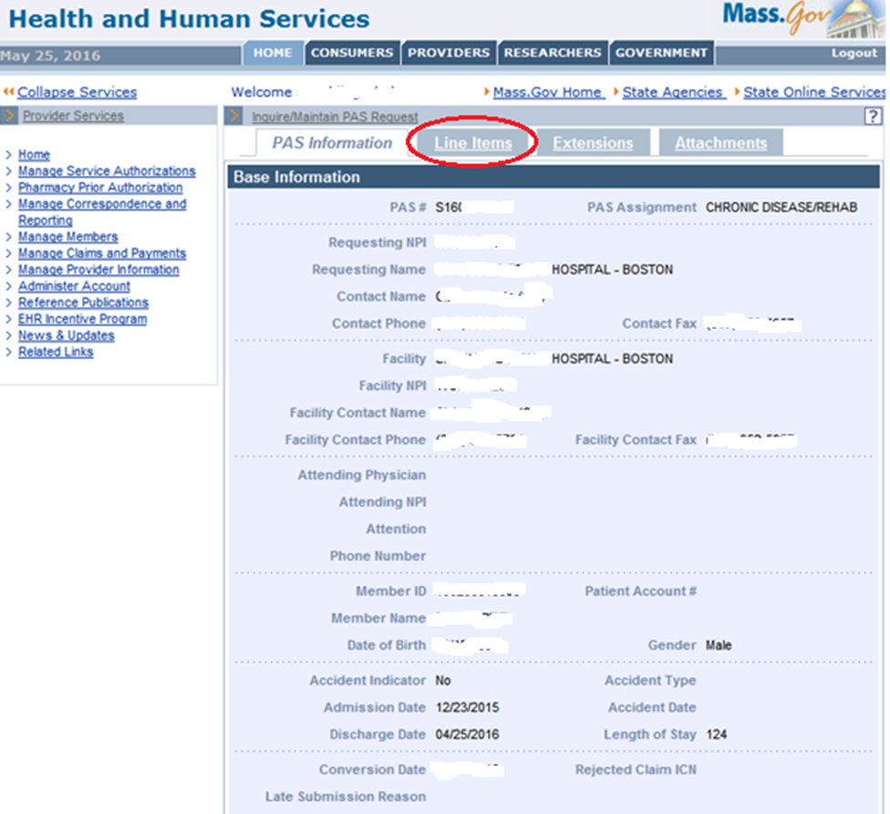

- Click on the correct line item that you wish to extend.
The “active” line item should be the line item with a current authorization end date. In the example below, the F line has the most current end date.
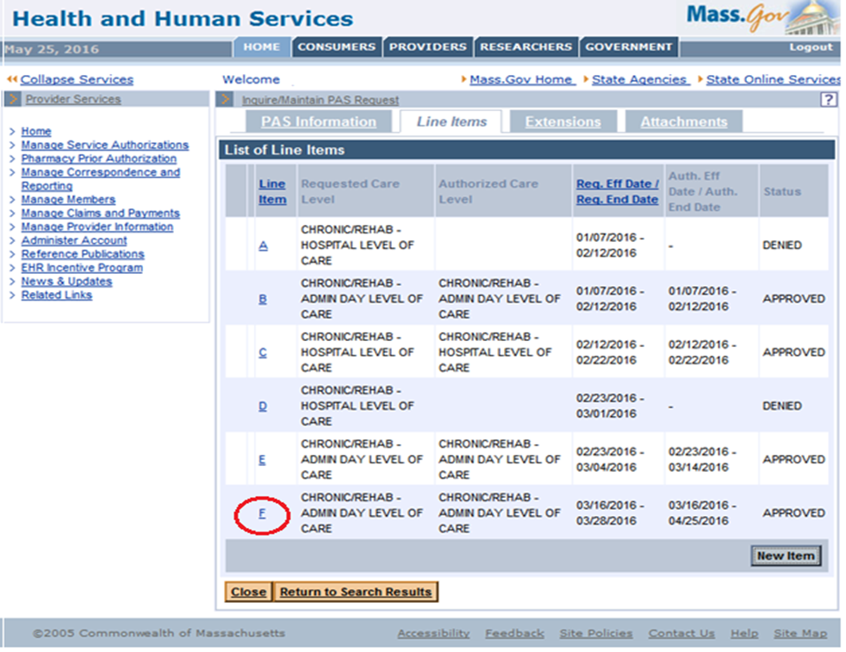

- Once you have selected the specific line item, an arrow will appear to the left of the line item. This indicates where the line-item extension will be added.
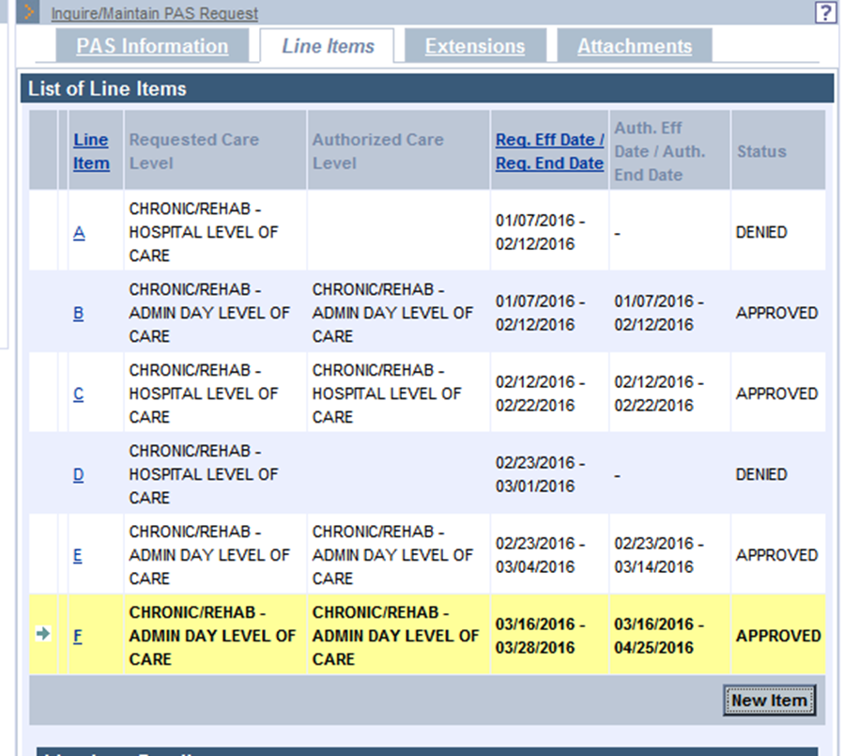

- Once the correct line item has been selected, click the Extensions tab at the top of the page.
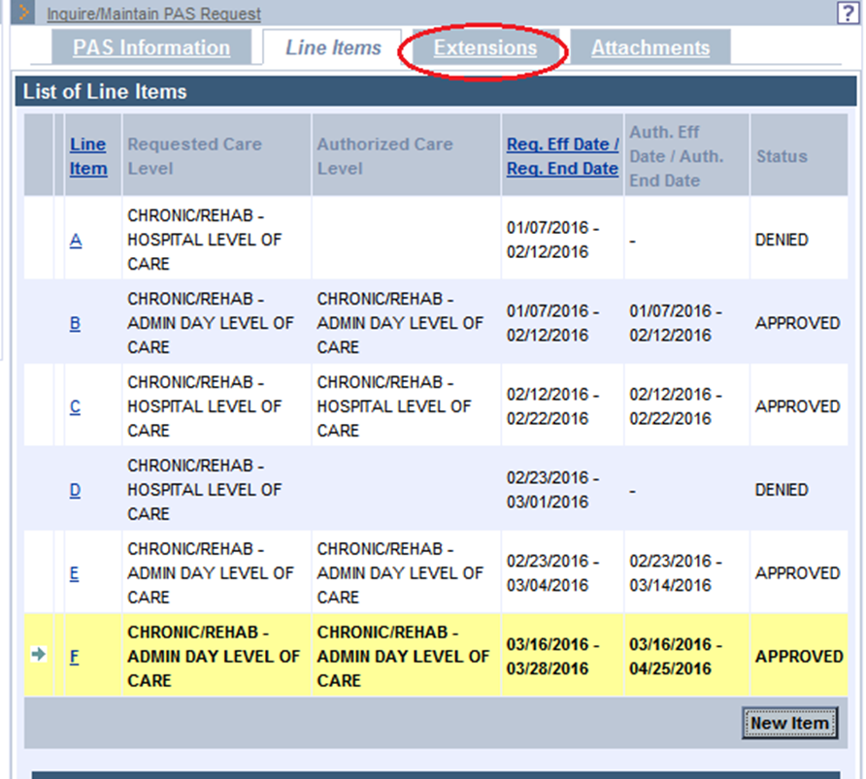

- A panel will open at the bottom of the page with a complete list of extensions for the selected line item. Click the New Item button in the bottom right corner.
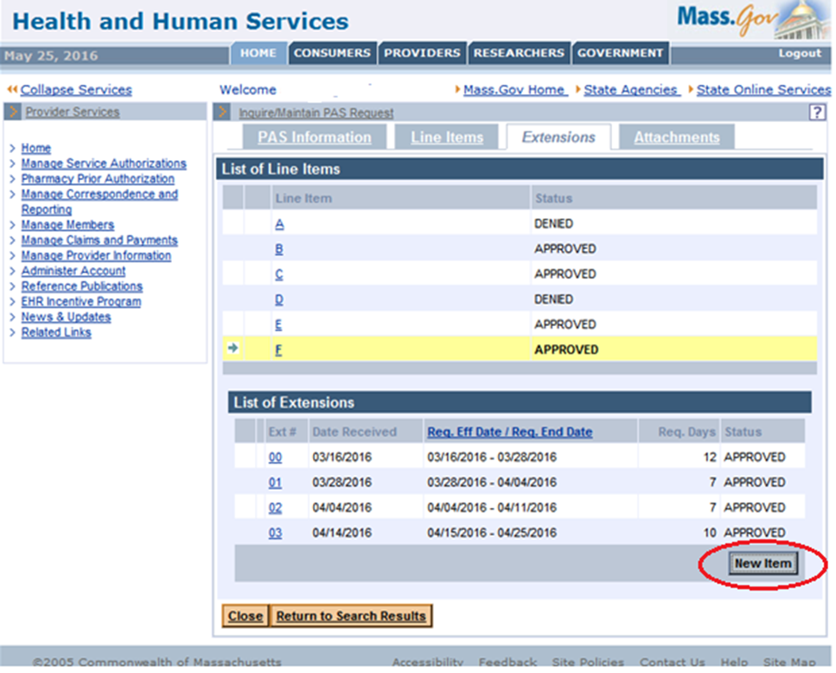

- When you click the New Item button, a new Extension Detail panel will open. Click the dropdown menu for Requested Admission Type. Choose either Medical or Rehab. The Requested Effective Date is auto populated with the end date of the previous approval date. (If the submission is late, you must notify MassHealth at (800) 554-5127.) Enter the number of additional days being requested for authorization in the Requested Days field.
There are several yes/no fields that have been added to the Extension Detail panel that must be answered: Ventilator Dependent, TPN, Behavioral Health, Tracheotomy, SUD, TBI/ABI, and NIPPV. Not all are included in this screenshot but will be clearly visible when the provider fills out the required fields in the Extension Detail panel.
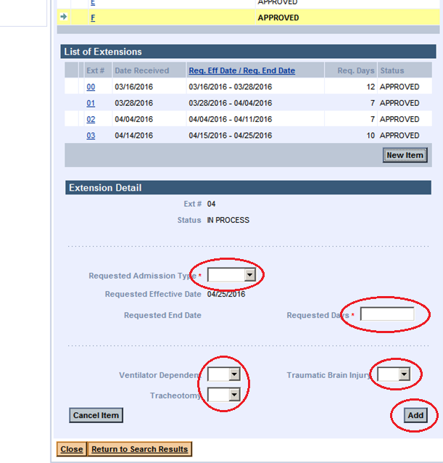
- Click the Add button in the bottom right corner of the panel. The new line-item extension will appear in the List of Extensions panel (see next step).

- Click the Attachments tab in the top right. This is where you will attach the clinical data needed to support the requested authorization extension.
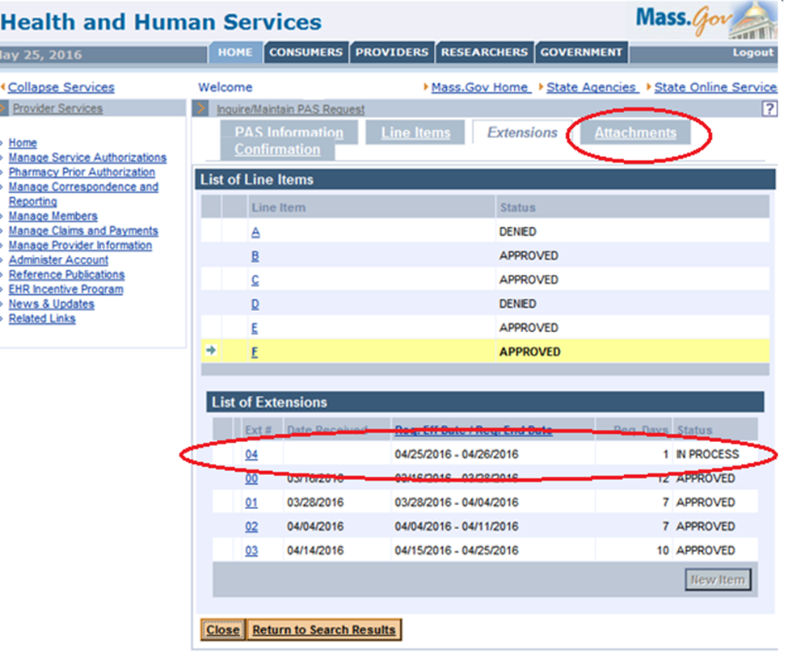

- When the List of Attachments panel opens, click the New Item button in the bottom right corner of the panel. This will open the Attachment Detail panel. Fill in the Report Type, Transmission Code (electronic only), and Description fields.
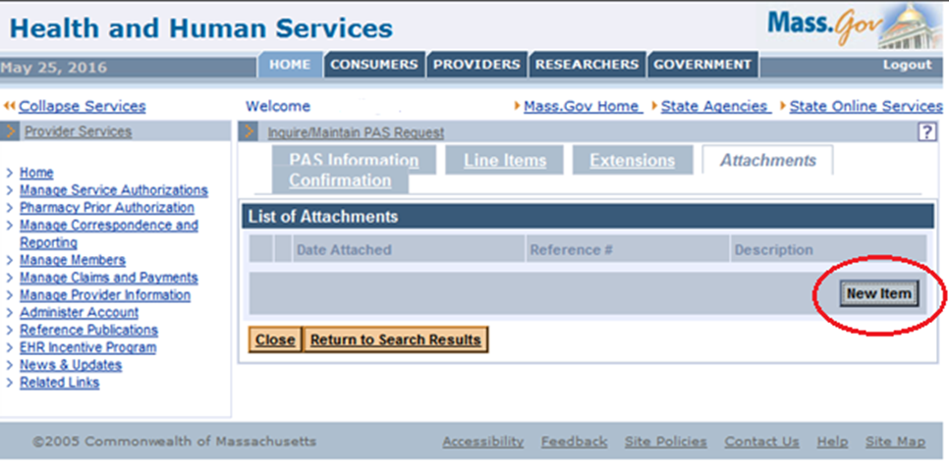
- Click the Browse button to view your computer files. Select the file you want to attach to support the request for continued stay. Then click the Open button to upload the file to the POSC.
When saving files to your PC, do not use special characters (*, @, /, #, %) in the file name. Simply include the type of file and/or patient’s name with an underscore (_), followed by the date in the following format: MM.DD.YY.
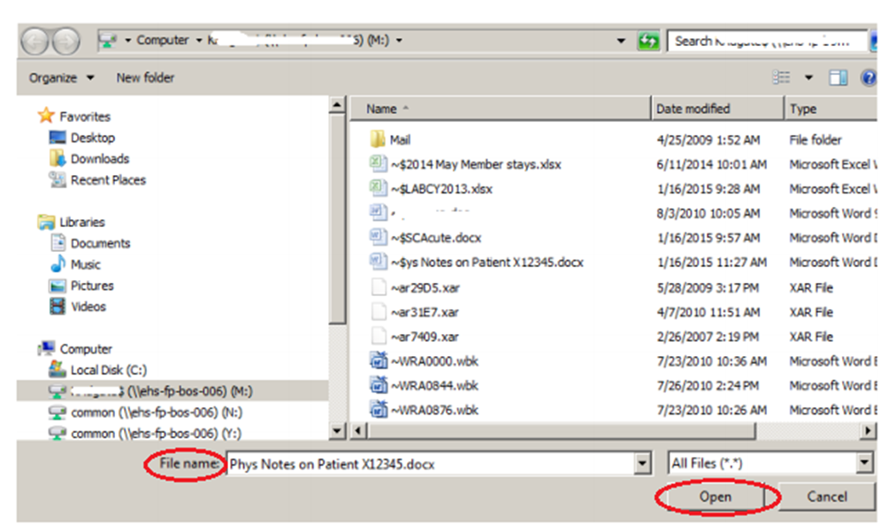
- Once the File Name field populates with the selected file, click the Add/Upload button in the bottom right of the panel.
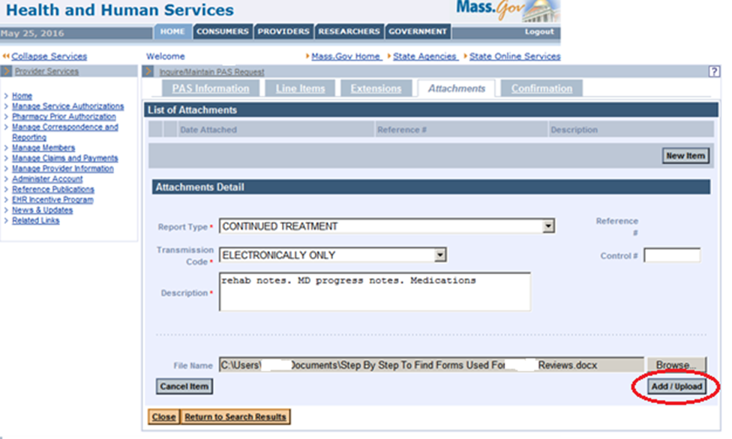

- Click the Confirmation tab at the top of the screen.
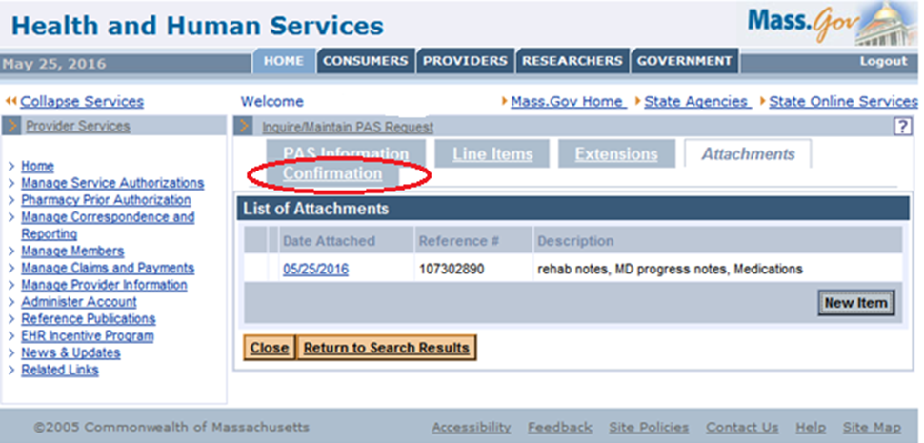

- Click the Submit button in the bottom right of the Confirmation panel.
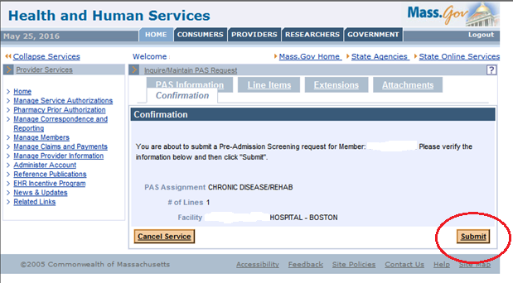
- When you click Submit, the POSC edits and validates the data submitted. You may receive yellow edit boxes that need to be acknowledged to complete the submission. If you receive red edits, these indicate errors that need to be addressed. Once addressed, the Pre-Admission Screening Response Page will appear and confirm that your request has been successfully submitted.
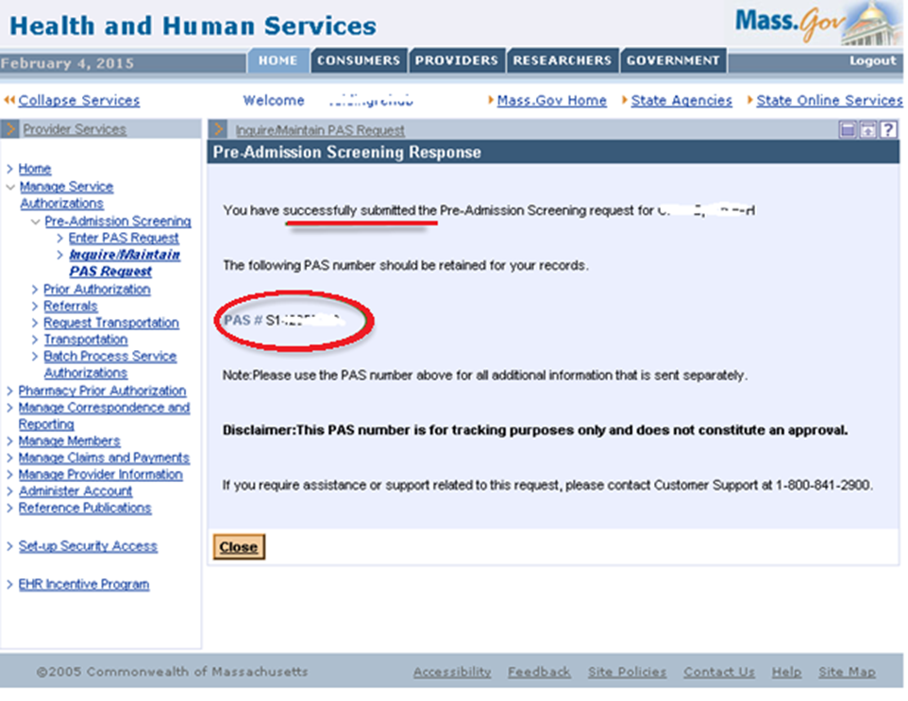
- Call the CDRH dedicated line at (800) 554-5127. Leave a message with the following information: member name, PAS #, your name, and contact number.

