# Job Aid: Hearing Aid Member Search

This job aid describes how to determine when a member has received hearing aid services.

## Access the Hearing Aid Member Search Panel

From the **Provider Online Service Center (POSC)** home page:

1. Log in to the POSC.

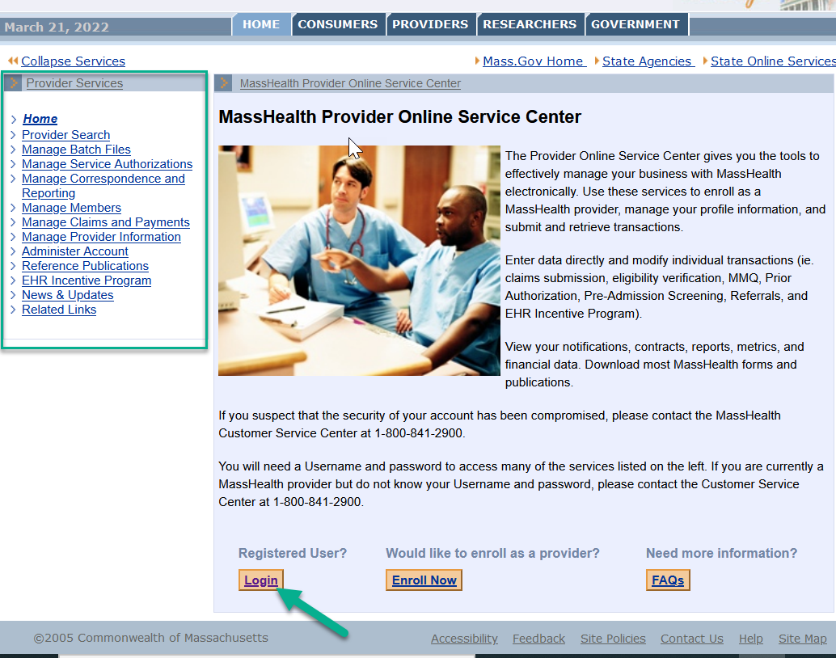

1. Click **Hearing Aid Member Search** in the left-hand navigation pane, under **Provider Services**.

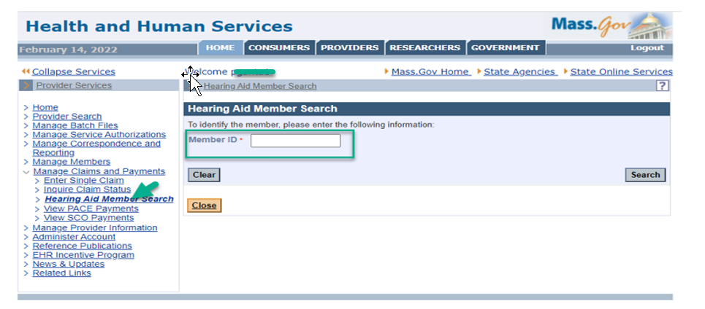

**Note:** If you do not have access to the Hearing Aid Member Search panel, you will receive the following message.

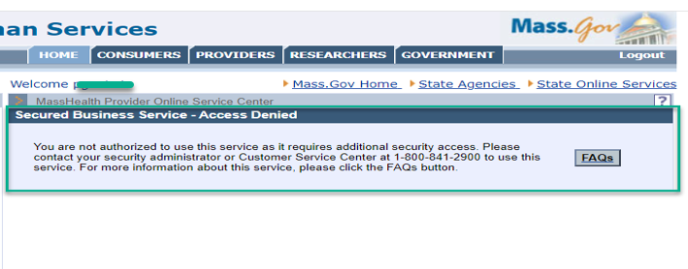

1. Enter a valid 12-digit MassHealth Member Identification Number in the **Member ID** field. This is a required field.
2. Click **Search**.

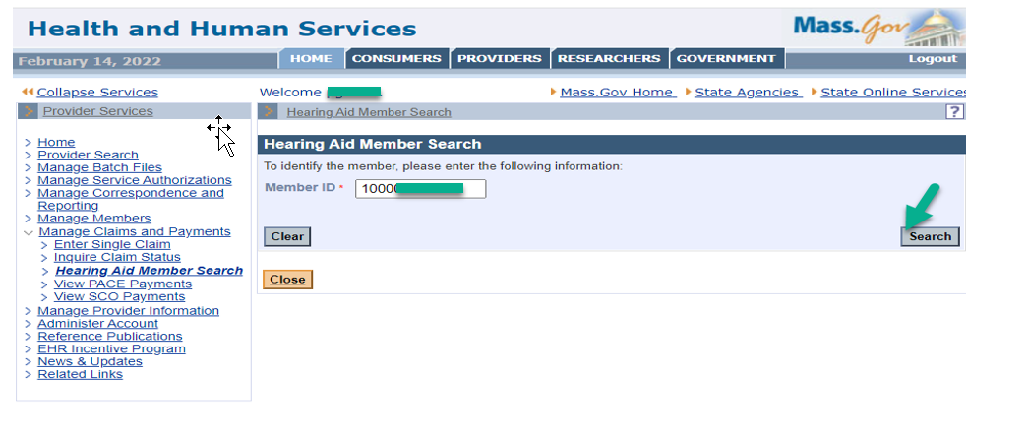

## Hearing Aid Member Search Results

From the **Hearing Aid Member Search** panel:

1. Determine whether the member identified in the **Member ID** field has received hearing aid services.

**Note:** “Hearing aid services” are defined by the business. Only those defined as such will appear in the **Hearing Aid Member Search Results**. If the member has received services, the results will identify the **Member ID**, **Member Name**, **Procedure** code(s), any applicable **Modifiers**, the From Date of Service (**FDOS**), and the To Date of Service (**TDOS**). If the member has not received services, the results will indicate that no records were found.

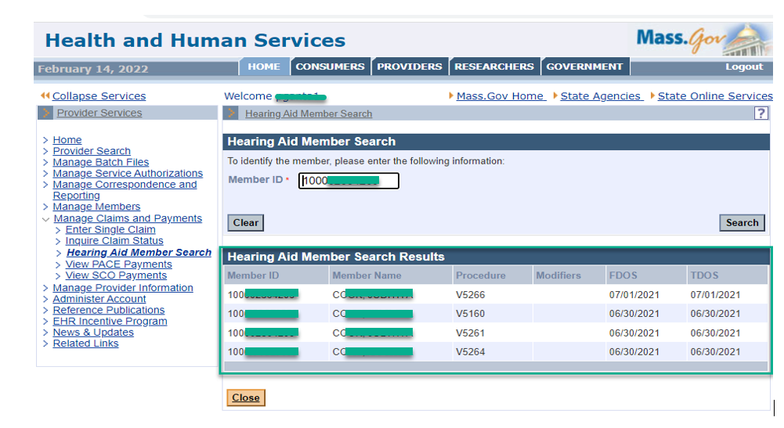

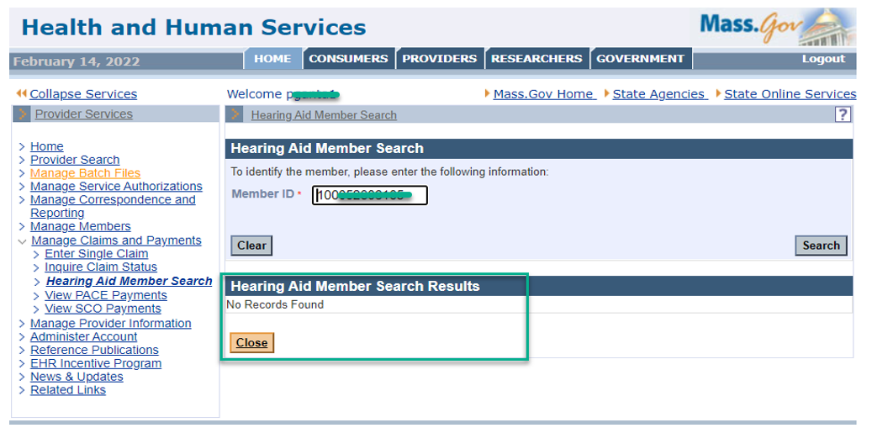

1. Click **Close**.

## Field Help

From the **Hearing Aid Member Search** panel:

1. Click on the **Member ID** field to display the **Field Help**.

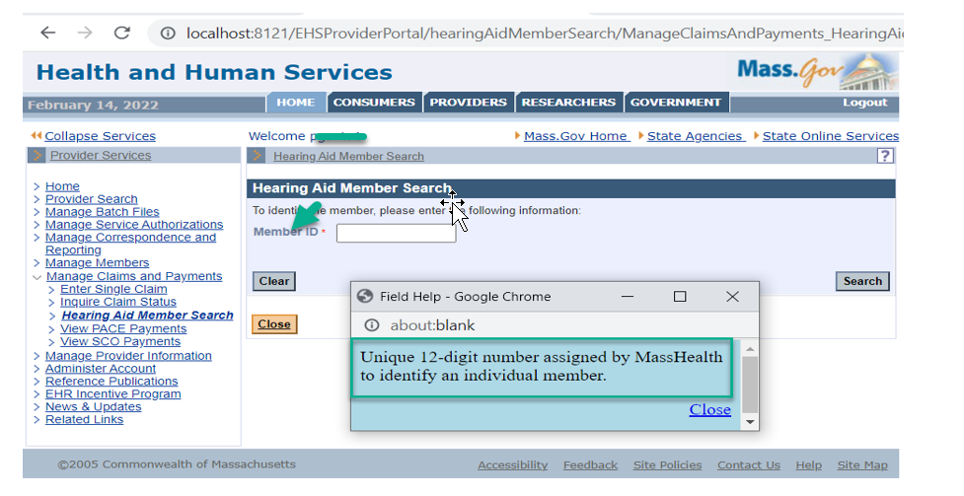

## Panel Help

From the **Hearing Aid Member Search** panel:

1. Click on the question mark icon to open the **Panel Help**.

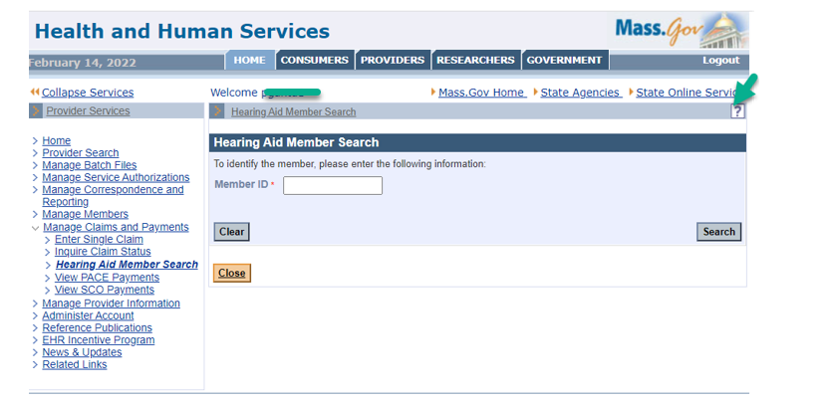

**Note:** This will open the page’s help function, which explains how to use the panel.

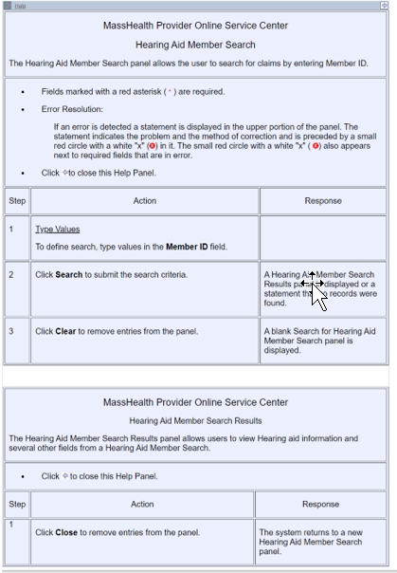

## Error Messages

1. Alphanumeric Member IDs, as well as Member IDs containing special characters, are not allowed and will display the following error message.

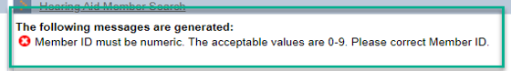

1. Member IDs with fewer than 12 digits are not allowed and will display the following error message.

