Job Aid: Inquire about a Prior Authorization Request

This job aid describes how to inquire about a previously submitted prior authorization (PA) request via the Provider Online Service Center (POSC).
- Click the Login button on the POSC landing page.
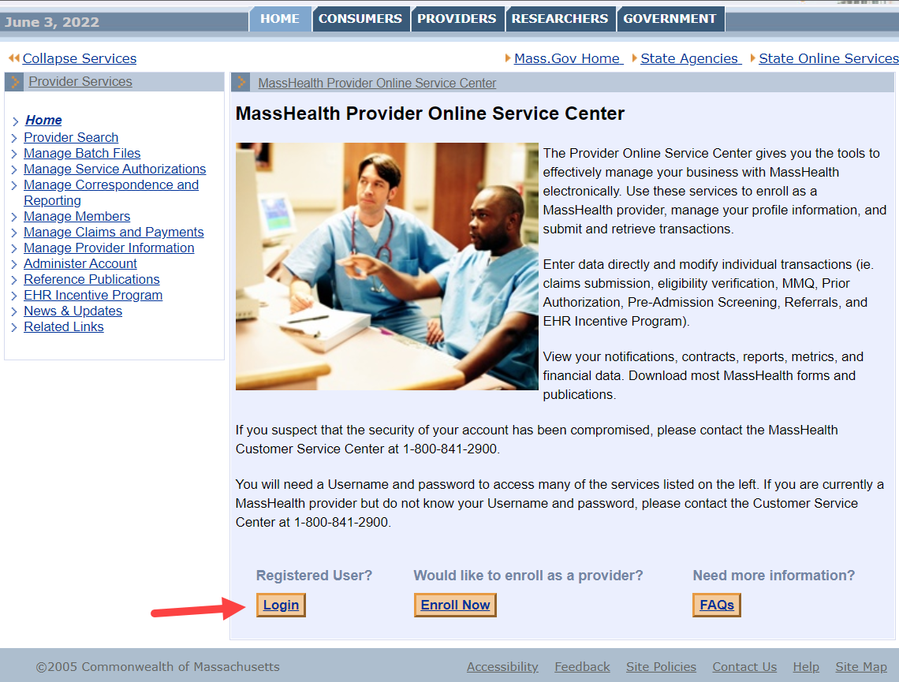

Inquire/Maintain PA Request
From the Provider Online Service Center home page:
1. Click Manage Service Authorizations.
2. Click Prior Authorizations.
3. Click Inquire/Maintain PA Request. The Prior Authorization Search panel is displayed.
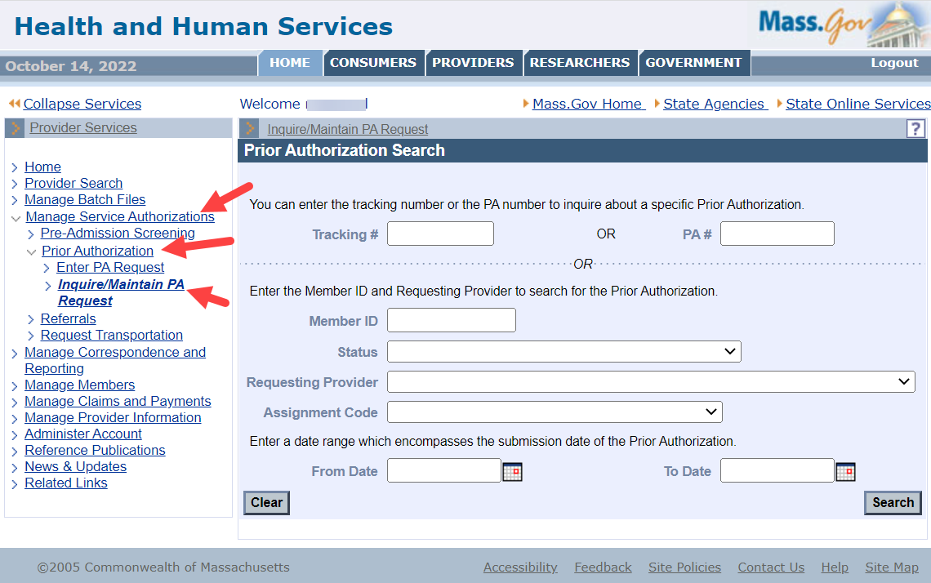

Search for a PA Request
1. Enter the Member ID associated with the request.
2. Select the Status from the dropdown list (Optional)
3. Select the Requesting Provider from the dropdown list.
4. Select the Assignment Code from the dropdown list (Optional)
5. In the From Date and To Date fields, enter a date range for the search.
6. Click Search.
7. Click the Tracking Number of the desired request on the Search Results panel.
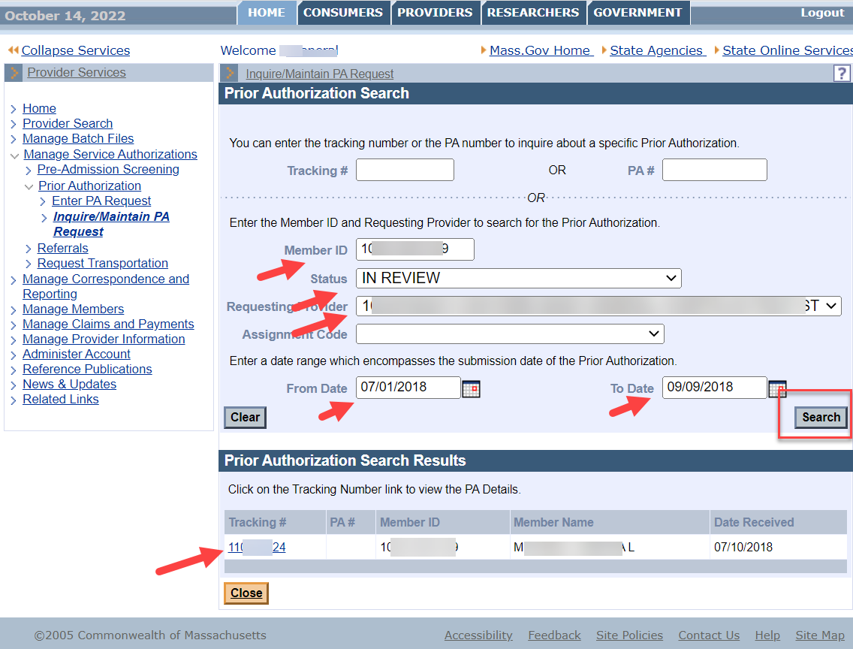

Review Request
Review the request information on the Base Information panel. When you have finished reviewing the request, you can do one of the following:
- Click Close to go back to the Prior Authorization Search panel, where you can start a new search for a request; or
- Click Return to Search Results to go back to the Search Results panel, where you can select another request matching the current search criteria.
