**Job Aid: Inquire on a Pre-Admission Screening Request**

The purpose of the Pre-Admission Screening (PAS) request is to authorize elective/non-emergency acute or chronic hospital stays. Providers can inquire on a previously submitted PAS to determine whether it has been approved, denied, or is in process.

This job aid describes how to inquire on a pre-admission screening request in MMIS.

## **Access Pre-Admission Screening Requests**

From the **POSC** home page:

1. Click **Login**.
2. Enter **Username & Password**.
3. Click **Manage Service Authorization**.

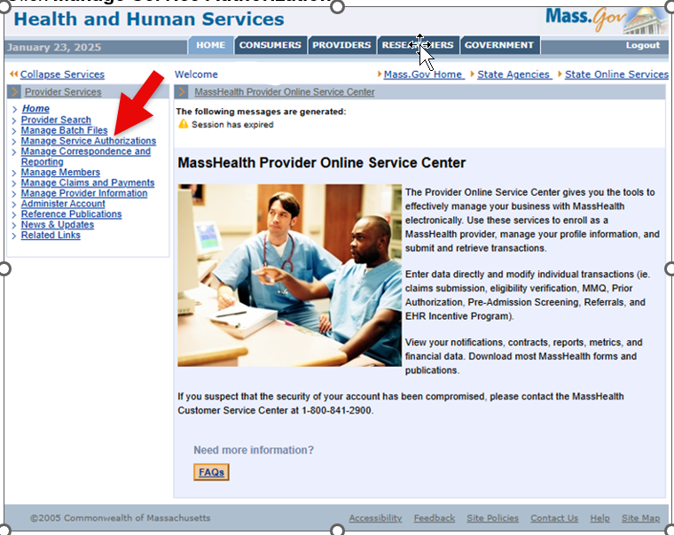

1. Click **Pre-Admission Screening**.

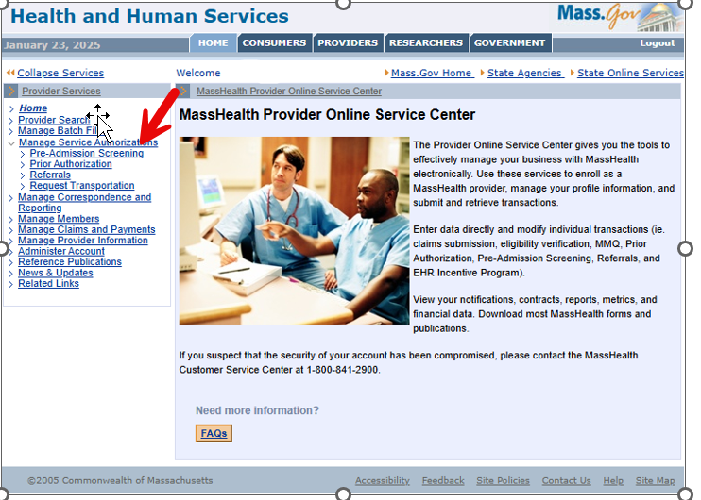

1. Click **Inquire/Maintain PAS Request**. The **Pre-Admission Screening Search** panel will display.

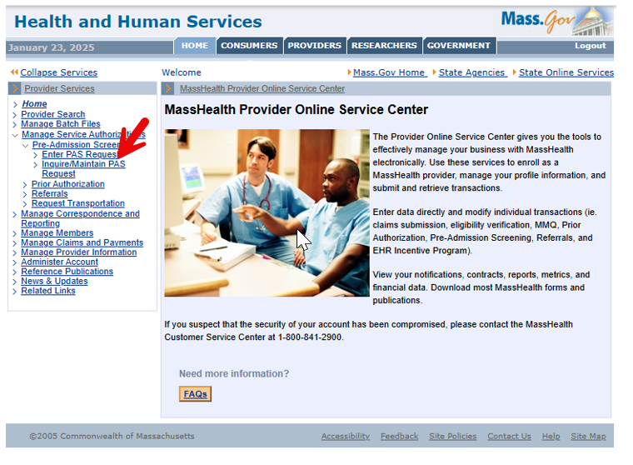

## **Search for a PAS Request**

**On the PAS Search** panel:

1. Enter the **PAS** number in the appropriate field.

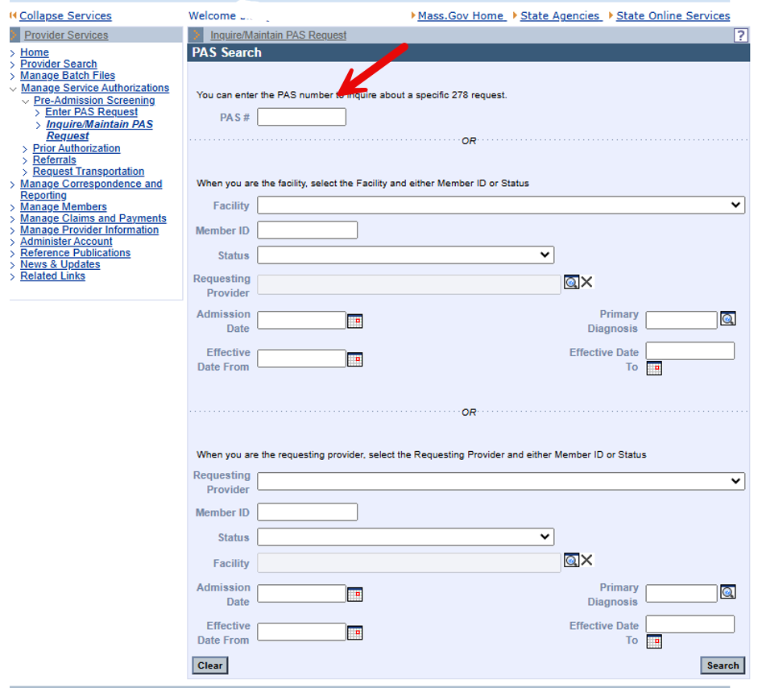

1. Click **Search**. The **PAS Search Results** Panel will display.

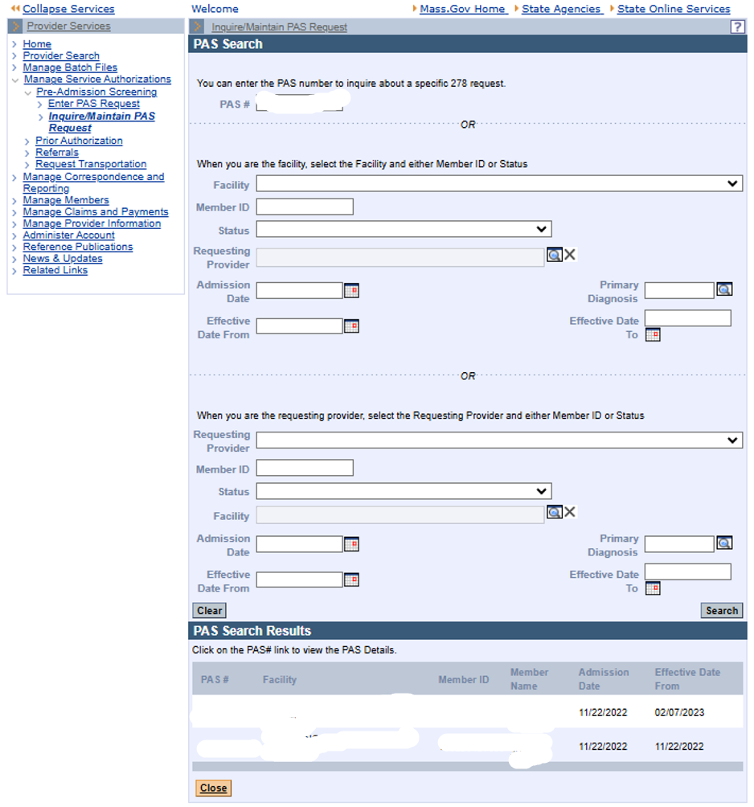

1. Click on the displayed PAS number. The **Base Information** panel will open. This panel has all the facility and member demographics and contact information that was entered with the request. There is no editing on this form. However, there is an open text box for comments.

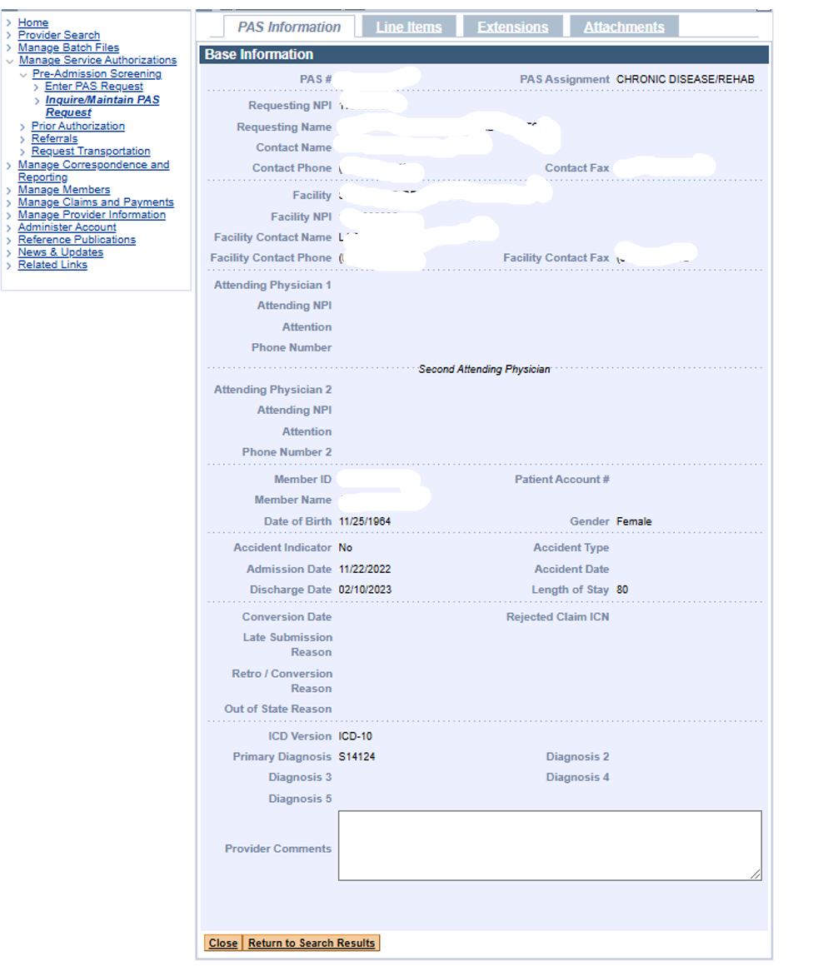

1. Click the **Line Items** tab.

Each line item will display in the **List of Line Items** panel. Each line item includes the assigned level of care, the dates of service, and the status. This view provides only a summary level of each line item.

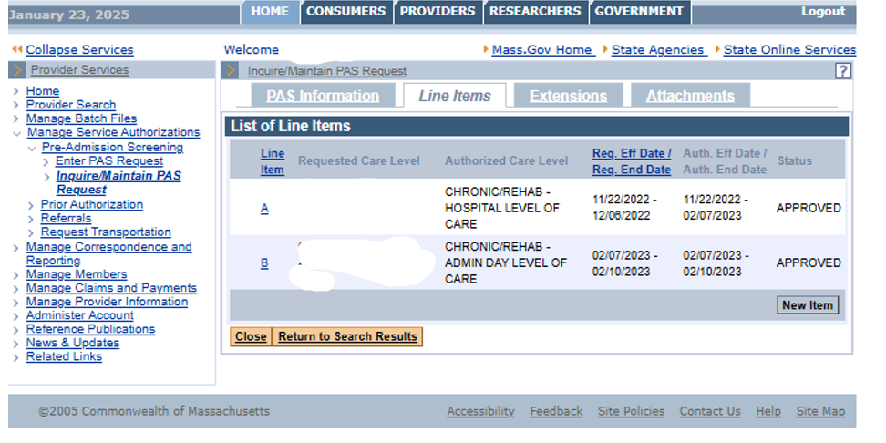

1. Click the **Extensions** tab. The **List of Line Items** will display.

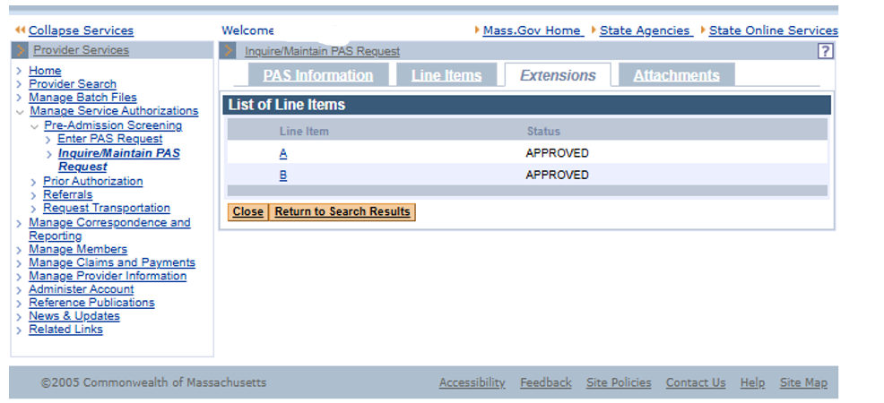

1. Select a line item from the list. This will open the **List of Extensions** panel for the Line Item selected. This view provides summary information for each extension for the selected line item.

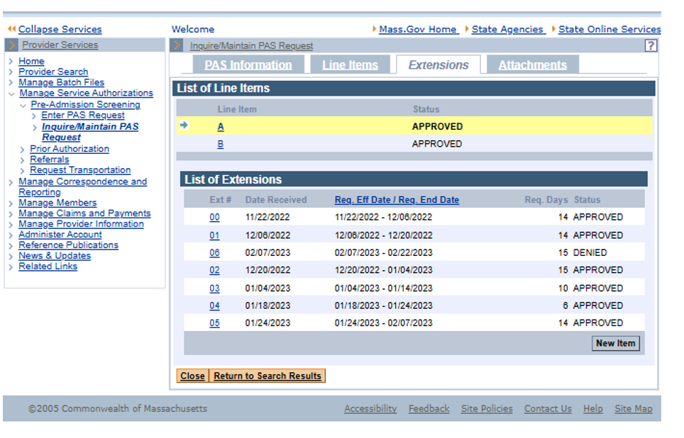

1. Hover over any of the extensions in the list and left click to select that extension. The **Extension Detail** panel will open.

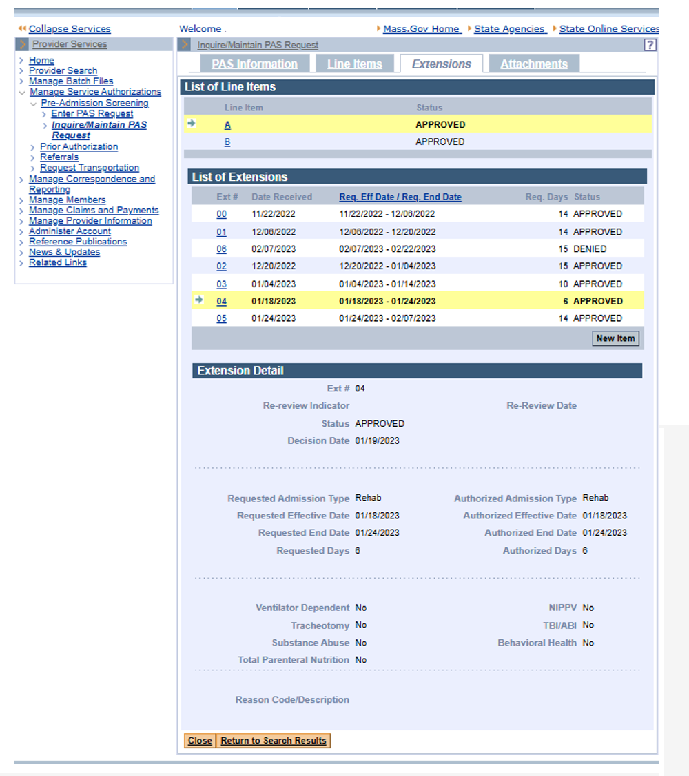

1. These instructions are for inquiring only. There is no “save” option unless you have added something during the search.