**Job Aid: Inquire on a Referral**

When a Primary Care Clinician (PCC) has submitted a member referral and the referral has been accepted into the system, MMIS automatically generates a referral notice. The service provider who receives the referral notification is the provider who needs to provide the service and submit the claim.

This job aid describes how to inquire about and review a referral submitted by a PCC to the Service Provider.

**Note:** If the PCC plan member is not on your enrollment roster and does not have a referral but is in your office to receive services, you can contact the member’s PCC to request a referral.

**Access Inquire Referral**

From the **POSC** home page:

1. Click **Manage Service Authorizations**.

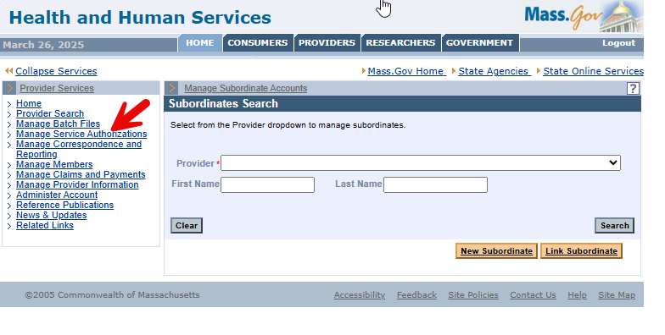

1. Click **Referrals**.

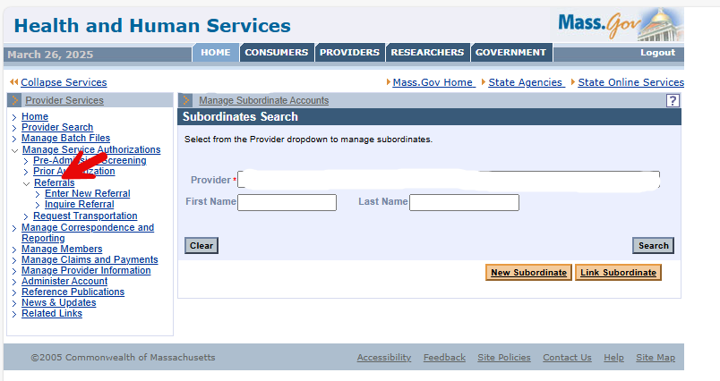

1. Click **Inquire Referral**. The **Referral Search** panel will display.

**Search for Referral**

On the **Referral Search** panel, the Service Provider can search the referrals submitted to them by the Referring Provider. The Referring Provider can also search for referrals they submitted to a Service Provider.

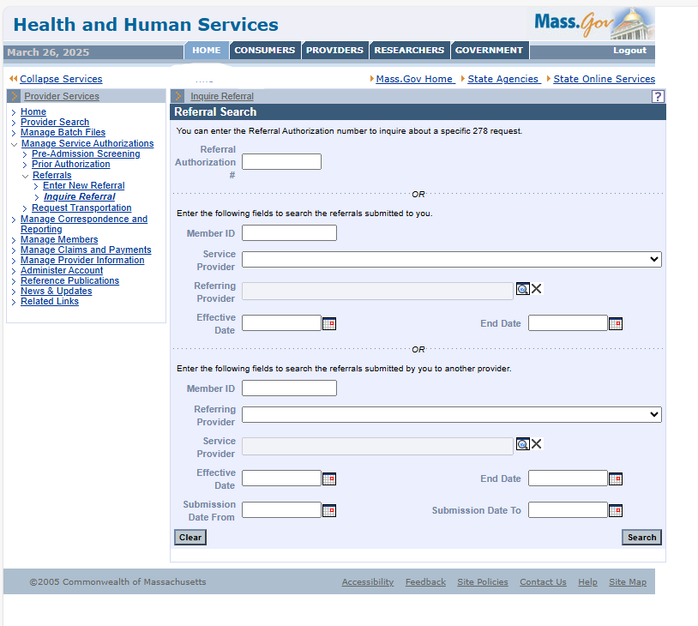

1. If you know the referral number:
   * Enter the referral number in the **Referral Authorization Number** field.
   * Click **Search**.
   * Skip to Step 8.
2. If you don’t know the referral number and want to find the referrals a Referring Provider submitted to you (the Service Provider):
   * Enter the **Member ID**.
   * Select the **Service Provider** from the dropdown list. This is determined by your login to the POSC.
   * In the **Referring Provider** field, click the **Field Search** button to display the **Search for Provider** panel, where you can perform a search for the referring provider. Enter as much information in the search criteria as possible.
   * Click **Search**.
   * Click the **Name** of the desired **Referring Provider**.
3. If you don’t know the referral number and want to find the referrals you (the Referring Provider) submitted to a Service Provider:
   * Enter the **Member ID**.
   * Select the **Referring Provider** from the dropdown list which is determined by your login to the POSC.
   * In the **Service Provider** field, click the **Field Search** button to display the **Search for Provider** panel, where you can perform a search for the service provider. Enter as much information in the search criteria as possible.
   * Click **Search**.
   * Click the **Name** of the desired **Service Provider**.

**Refine the Referral Search**

1. On either of the **Referral Search** panels:
   * Enter a date prior to or equal to the **Effective Date** of the referral.
   * Enter an **End Date** equal to or after the end date for the referral.
   * Click **Search**. The **Referral Search Results** panel will display.

**Select Desired Referral from the Search Result Panel List of Referrals**

1. Click the **Referral Number** link of the desired referral. The **Referral Information** panel will display.

**Review Referral**

1. Review the referral information. When you have finished reviewing the referral, you can do one of the following.
   * Click **Close** to go back to the **Inquire Referral** panel, where you can start a new search for a referral.
   * Click **Return to** **Search Results** to go back to the **Referral Search Results** panel, where you can select another referral matching the current search criteria.

**Notes**

The referral remains active and available under the following conditions.

* The referral matches the **Member and Service Provider**.
* The **Effective Date** and **End Date** range includes the date of service that will appear on the claim.
* The total number of **Visits** (episodes of service) on the referral has not been exceeded.

The referral will be automatically canceled under the following conditions.

* For any available referral, if the member leaves the PCC Plan, the **End Date** is changed to the close date.
* When a member changes enrollment to a different PCC, the **End Date** of the referral will
  + remain unchanged if the **End Date** on the referral is less than or equal to **30** days after the close date; or
  + be set to a grace period of **30** days after the close date, if the **End Date** on the referral is greater than **30** days after the close date.