Job Aid: Institutional Claims Submission

This job aid reviews the process of submitting an electronic institutional claim in the Provider Online Service Center (POSC). For specific billing information, refer to the National Uniform Billing Committee (NUBC) or the relevant Billing Guides available at www.mass.gov/how-to/masshealth-billing-guides-for-paper-claim-submitters. Click on the appropriate document to access a specific guide.

This job aid describes how to:

- Enter and submit a single institutional claim for a member who has MassHealth coverage.

Note: Fields with an asterisk are required fields and must be completed to proceed to the next panel.

Access Enter Single Claim
From the POSC home page:
- Click Manage Claims and Payments.
- Click Enter Single Claim. The Claims Templates panel displays.
On the Claim Templates panel:
- Click Institutional Claim. The Billing Information panel displays.
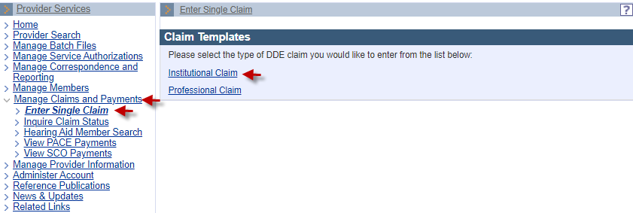

Billing and Service Tab: Enter Billing and Member Information
On the Billing Information panel:
- Select the Type of Bill* from the dropdown list.
- Select the Billing Provider ID* from the dropdown list.
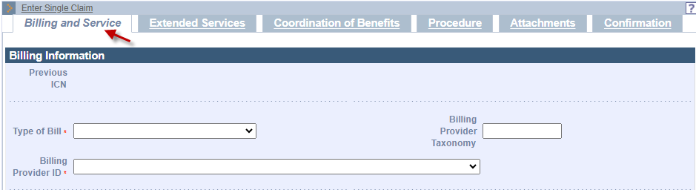
- Enter the Member ID* for the claim.
- Enter the Patient Account #*.
- Enter the member’s name in the Last Name* and First Name* fields.
- Enter the member’s date of birth in the DOB* field.
- Select the member’s Gender* from the dropdown list.
- Enter the member’s street address in the Member Address 1* field.
Note: Additional address information (for example, apartment numbers) can be entered in the Member Address 2 field.
- Enter the member’s City*, State*, and Zip* code in their respective fields.
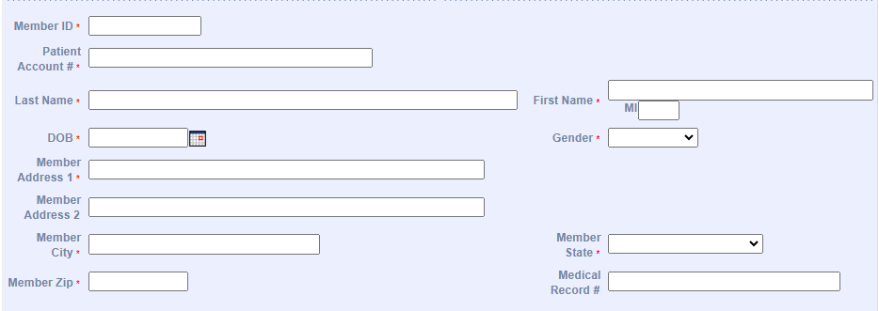

Billing and Service: Enter Provider and Benefit Information
On the Billing Information panel:
- In the Attending Phys Last Name and Attending Phys First Name fields, enter the name of the attending physician associated with the claim. The attending physician must be actively participating or enrolled in MassHealth as at least a nonbilling provider.
- Enter the Attending Phys NPI.
- If a surgical code is being submitted, you must enter the name of the operating physician associated with the claim in the Operating Phys Last Name and Operating Phys First Name fields. The operating physician must be actively participating or enrolled in MassHealth as at least a nonbilling provider.
- If an operating physician was named, you must enter the Operating Phys NPI.
- If there is more than one operating physician, enter the name of the other operating physician in the Other Operating Phys Last Name and Other Operating Phys First Name fields. The other operating physician must also be actively participating or enrolled in MassHealth as at least a nonbilling provider.
- If another operating physician was named, you must enter the Other Operating Phys NPI .
- If the service was referred, you must enter the Referring Provider Name. Click on the magnifying glass to select a referring provider. Enter the referring provider name. Click on the provider name. The referring provider must be actively participating or enrolled in MassHealth as at least a nonbilling provider.
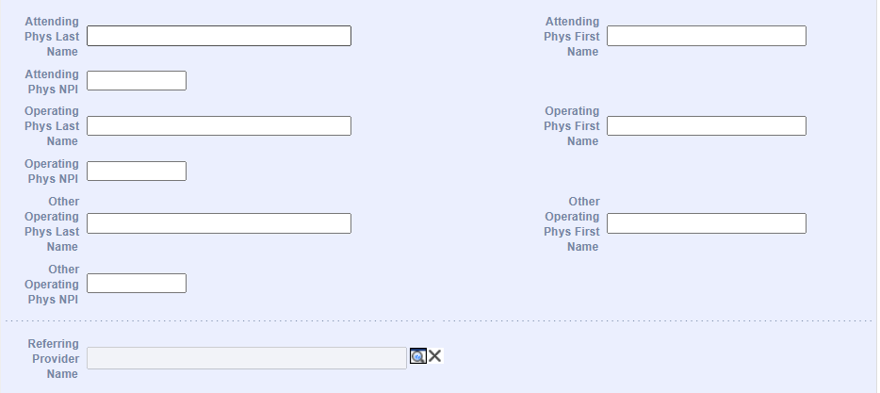
- Enter a Referral # if applicable.
Note: If no referral is entered and there is a referral on file, MassHealth will use it to process the claim once the claim is submitted.
- Enter a Prior Authorization (PA)/Pre-Admission Screening (PAS) # if applicable.
Note: If no PA or PAS is entered and there is one on file, MassHealth will use it to process the claim with the approved PA or PAS once the claim is submitted.
- In the Assignment of Benefits* dropdown, select whether the member authorizes benefits to be paid to the provider.
Note: When submitting a MassHealth claim, this field should always be Yes.
- Select the appropriate value in the Provider Accepts Assignment* dropdown list.
- Select the Claim Filing Indicator* from the dropdown list.
- Select the Release of Information* from the dropdown list.
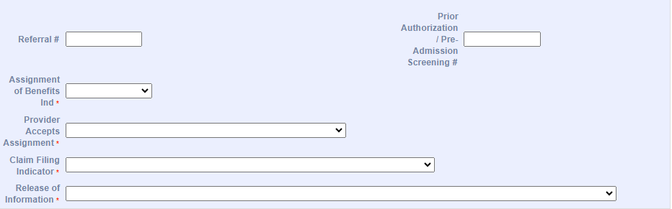

Billing and Service: Enter Service Information
On the Service Information panel:
- In the From Date* and Through Date* fields, enter the date range for the claim.
- Select the Patient Status* from the dropdown list.
- Select the Admit or Visit Source from the dropdown list.
- Select the Admission or Visit Type* from the dropdown list.
- Enter the Admission Date.
- Select the Admission Hour from the dropdown list.
Note: The Admission Hour field uses the 24-hour clock (military time).
- Select the Discharge Hour from the dropdown list.
Note: The Discharge Hour field uses the 24-hour clock (military time).
- If applicable, select the appropriate code from the Delay Reason Code dropdown list.
Delay Reason Codes:
- When submitting a 90-Day Waiver Request, enter one of the following Delay Reason Codes:
1-Proof of Eligibility Unknown or Unavailable
4-Delay in Certifying Provider
8-Delay in Eligibility Determination
- When submitting a Final Deadline Appeal Request, enter the following Delay Reason Code:
9-Original Claim Rejected or Denied Due to a Reason Unrelated to the Billing Limitation
- When submitting a National Correct Coding Initiative/Medically Unlikely Edit (NCCI/MUE) Review Request or a Special Handle Claim Review Request, you must include a detailed letter of why the claim needs to be reviewed. Enter the following Delay Reason Code:
11-Other
Note: Supporting documentation must be uploaded with the claim when using a Delay Reason Code. The claim will not suspend for review if the supporting documentation is not uploaded.
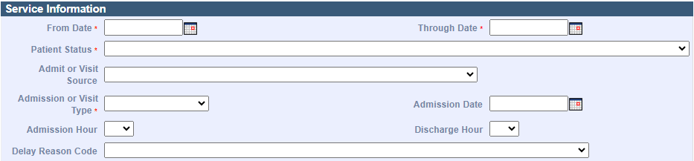

Billing and Service: Enter the Claim Charges
On the Claims Charges panel:
- Enter the Total Charges* for the claim.
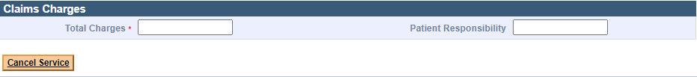

Extended Service: Service Facility Provider
- Scroll up to click on the Extended Services tab. On the Service Facility Provider panel, enter the Service Facility Provider Name if the location of services is different than that of the billing provider.
- Enter the Service Facility Provider NPI.
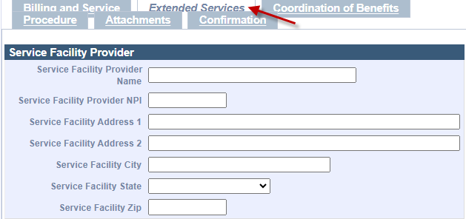

On the List of Conditions panel:
- To add a Condition code, click New Item.
- The Condition Code Detail panel displays. Select a Condition Code/Description* from the dropdown list, then click Add.
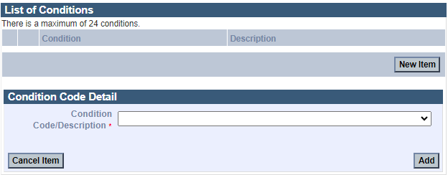
On the List of Occurrences panel:
- Click New Item. The Occurrence Code Detail panel displays.
On the Occurrence Code Detail panel:
- Select the Occurrence Code* from the dropdown list.
- Select the Type* of occurrence from the dropdown list.
- In the Date fields, enter the date range for the claim.
- Select the Type* of occurrence from the dropdown list.
- Click Add to save the Occurrence information.
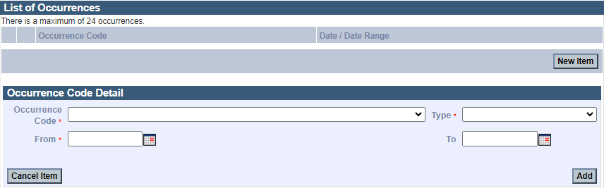

Extended Service: Enter Value Code Information
On the List of Values panel:
- Click New Item. The Value Code Detail panel displays.
On the Value Code Detail panel:
- Select the Value Code* from the dropdown list.
- In the Value* field, enter the amount of the claim that MassHealth is paying.
- Click Add to save the Value Code information.
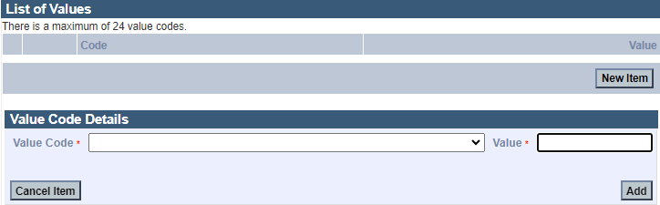

Extended Service: Enter ICD Version
On the ICD Version panel, the radio button will default to ICD-10.
On the Principal and Admitting Diagnosis Codes panel:
- Enter the Principal Diagnosis Code*.
- Enter Principal Present on Admission from the dropdown menu.
- Enter the Admitting Diagnosis Code.
Note: You must add the Principal Diagnosis Code and Admitting Diagnosis Code when applicable.
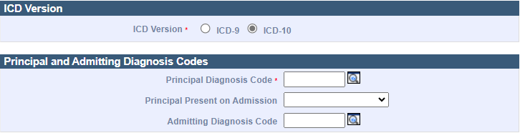

Extended Service: List of Diagnosis Information
On the List of Other Diagnoses panel:
- Click New Item. The Diagnosis Code Detail panel displays.
- Enter the Diagnosis Code*.
- Select the Present on Admission indicator from the dropdown list.
- Click Add to save the Diagnosis Code information. Enter information on all remaining panels as required.
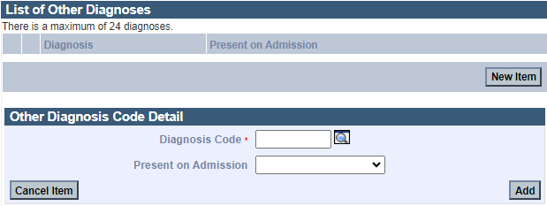

Enter Claim Note
To add a Claim Note:
- Click New Item.
- Choose Claim Note Type* from the dropdown menu.
- Add a Claim Note Description*.
- Click Add to save the claim note.
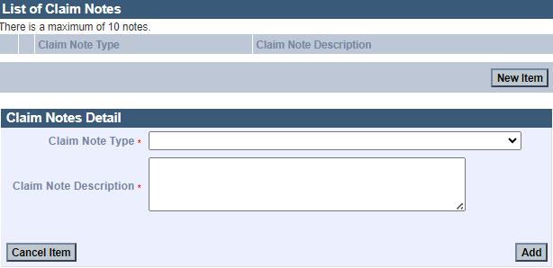

Enter Procedure Information
- Click on the Procedure tab.
On the List of Institutional Services panel:
- Click New Item. The Institutional Service Detail panel displays.
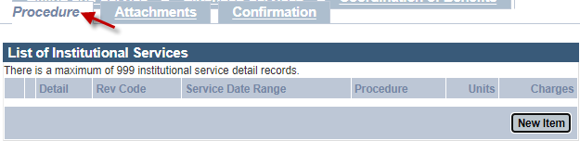
On the Institutional Service Detail panel:
- Enter the Revenue Code*.
- When applicable, enter HCPCS Procedure Code, associated modifier, and date information.
- Enter the Units* for the claim.
- Select the Units of Measurement* from the dropdown list.
- Enter the Charges* for the claim.
- Enter Drug Identification information if the HCPC code entered on the claim is for drug charges. Complete the following fields as appropriate.
  - NDC – enter the complete ID number of drug
  - Units of Measurement
  - Units
  - Rx Qualifer
  - Rx Number
- Click Add.
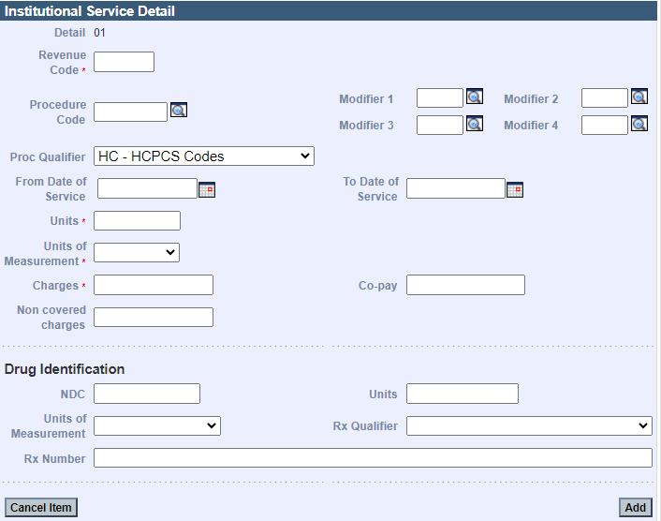
Add Attachments
- Click the Attachments tab.
On the List of Attachments panel:
- Click New Item. The Attachments Details panel displays.
On the Attachments Detail panel:
- Select the Report Type from the dropdown list.
- Select the Transmission Code of the report from the dropdown list.
- Click Browse. The “Choose file” window displays.
- Navigate to the file you want to attach and click Open.
- Click Add/Upload.
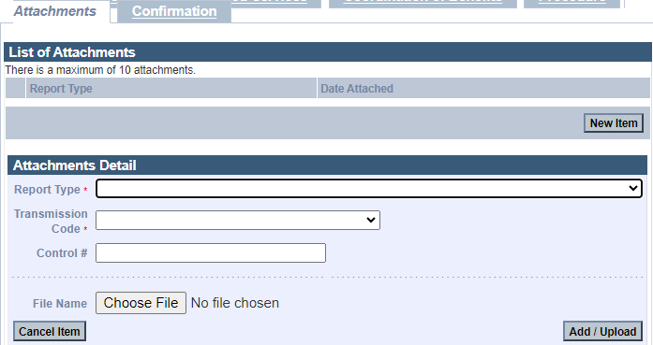

Confirm Claim
- Click the Confirmation tab.
On the Confirmation panel:
- Verify that the claim information is correct.
- Once you verify the claim is correct, click Submit.
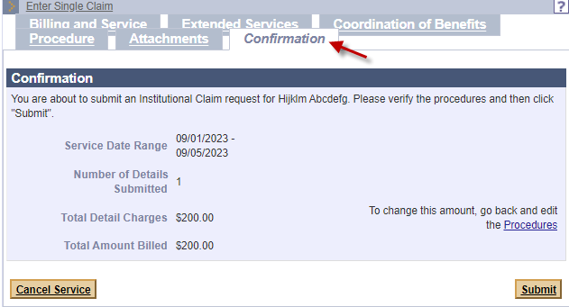
Claim Status Response
On the Conformation panel:
- Review the status of the claim, including any Explanation of Benefit (EOB) codes that may appear.
- Click Close.
