**Job Aid:** **Instructions for Submitting Inpatient Claims for MassHealth Dually Eligible Members with Medicare Part B Coverage Only**

This job aid contains billing instructions for submitting 837I transactions, or direct-data entry claims (DDE), for dually eligible members (Medicare and MassHealth) who have active MassHealth coverage and active Medicare Part B coverage, but do not have active Medicare Part A coverage. When submitting an institutional DDE claim, follow the instructions outlined in the [MassHealth Institutional Claims Submission](https://www.mass.gov/lists/job-aids-for-the-provider-online-service-center) job aid, then use this job aid to report Coordination of Benefits (COB) information.

For specific billing information, providers should reference the relevant billing guides available at

* [MassHealth Provider Publications](http://www.mass.gov/eohhs/gov/laws-regs/masshealth/provider-library/)
* [MassHealth Administrative and Billing Regulations](https://www.mass.gov/regulations/130-CMR-450000-administrative-and-billing-regulations), Third Party Liability at 130 CMR 450.316 through 450.318
* [Administrative and Billing Instructions](https://www.mass.gov/doc/subchapter-5-administrative-and-billing-instructions-for-all-masshealth-providers), Part 7. Other Insurance
* [MassHealth Standard HIPAA Companion Guide for Health Care Claim: Institutional (837)](https://www.mass.gov/doc/masshealth-standard-companion-guide-health-care-claim-institutional-837i/download)

Please note that Institutional Claims with COB information must follow COB balancing rules as described in the HIPAA 837I Implementation Guide.

**Billing Instructions for 837I Transactions**

The following table contains the critical loops and segments that providers must first complete for submitting inpatient claims to MassHealth for dually eligible members who have active MassHealth coverage and active Medicare Part B coverage, but no active Medicare Part A coverage.

Providers must then follow the instructions described in the HIPAA 837I Implementation Guide and MassHealth 837I Companion Guide to complete other required COB and non-COB portions of the 837I claim submission.

This section of the job aid supplements the instructions found in the HIPAA 837I Implementation Guide or the MassHealth 837I Companion Guide.

|  |  |  |
| --- | --- | --- |
| **Loop** | **Segment** | **Value Description** |
| 2320 | SBR09 (Claim Filing Indicator) | MB |
| 2320 | AMT01 (Paid Amount Qualifier) | D |
| 2320 | AMT02 (Paid amount) | Medicare Part B paid amount |
| 2330B | NM109 (Other Payer Name) | 0085000 |
| 2330B | DTP01 (Date Claim Paid Qualifier) | 573 |
| 2330B | DTP03 (Check or Remittance Date) | Medicare payment date |

**Note**: For COB balancing, the sum of the claim-level Medicare Part B Payer Paid Amount and HIPAA adjustment reason code amounts must balance to the claim billed amount. Providers should report a claim adjustment segment (CAS) with the appropriate HIPAA Adjustment Reason Code and Amount on their Medicare Part B payer loop.

**Billing Instructions for Direct Data Entry (DDE)**

This section of the job aid describes the steps for submitting an Inpatient claim in the Provider Online Service Center (POSC) for dually eligible members who have active MassHealth coverage and active Medicare Part B coverage, but no active Medicare Part A coverage.

**Note:** Fields with an asterisk are required fields and must be completed to proceed to the next panel.

**Coordination of Benefits**

1. Click on the **Coordination of Benefits** tab.

On the **List of Coordination of Benefits (COB)** panel:

1. Click **New Item**. The **Coordination of Benefits (COB) Detail** panel displays.

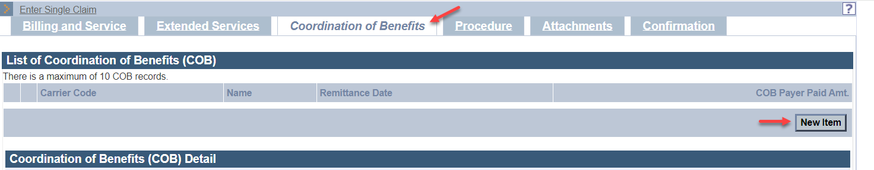

On the **COB Detail** panel:

1. In the **Carrier Code\*** field, enter **0085000**.
2. In the **Carrier Name\*** field, enter **Medicare B**.
3. In the **Remittance Date** field, enter the Medicare Part B remittance payment date. The **Remittance Date** is a critical field and cannot be entered on both the **Coordination of Benefits** tab and **Procedure** tab.
4. In the **Payer Claim\*** number field, enter the Medicare claim number from the Explanation of Medicare Benefits (EOMB).
5. In the **Payer Responsibility\*** field, select the appropriate code from the dropdown list.
6. In the **COB Payer Paid Amount** field, enter the Medicare Part B paid amount.
7. Do not enter a value in the **Total Noncovered Amount** field. The total noncovered amount should be entered only for authorized TPL exception billing. Refer to supplemental instructions in your provider manual appendix for conditions for which this field may be used.
8. Do not enter a value in the **Remaining Patient Liability** field**.** This is not a required field and is not necessary for claims adjudication.
9. In the **Claim Filing Indicator\*** field,select **MB – Medicare Part B** from the dropdown list.
10. In the **Release of Information\*** field,select the appropriate code from the dropdown list.
11. In the **Assignment of Benefits\*** field,select the appropriate code from the dropdown list.
12. In the **Relationship to Subscriber\*** field, select the appropriate code from the dropdown list.

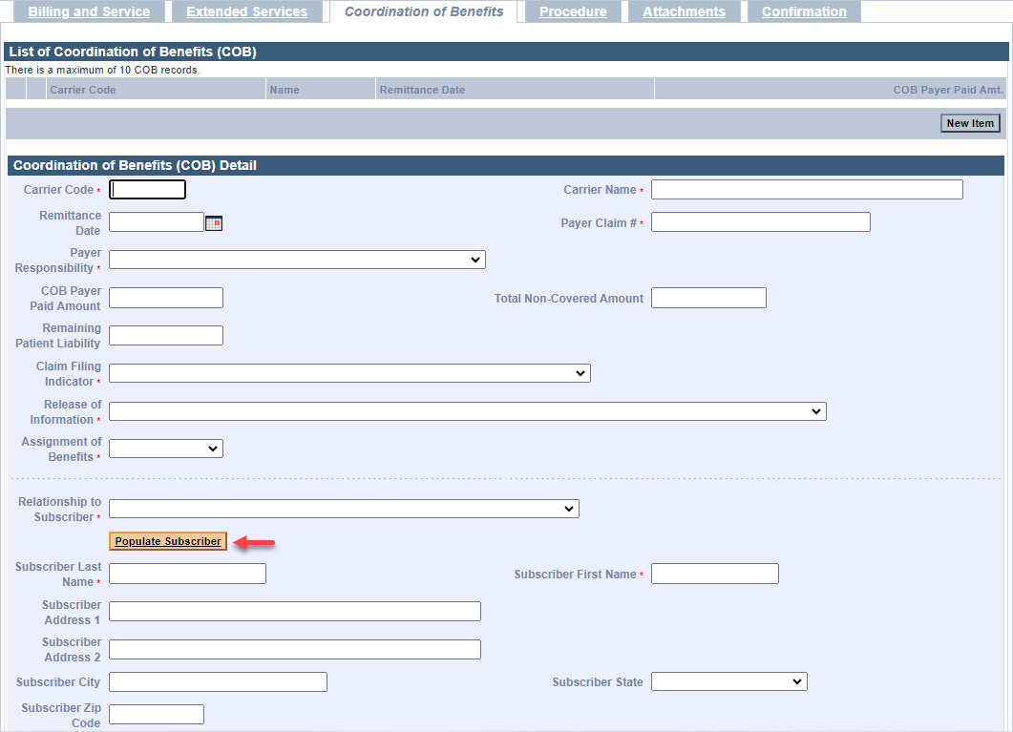

If you selected “**18—SELF**” from the “**Relationship to Subscriber**” dropdown list, then click “**Populate Subscriber**.” The following data fields entered on the “**Billing and Service**” tab will be populated.

* Subscriber Last Name
* Subscriber First Name
* Subscriber Address
* Subscriber City
* Subscriber State
* Subscriber ZIP Code

If you select any other value from the “**Relationship to Subscriber**” dropdown list, you must enter the following required fields.

* Subscriber Last Name
* Subscriber First Name

1. In the **Subscriber ID\*** field, enter the other insurance subscriber ID number.

**Note:** The remaining data fields on this panel starting from **Subscriber Group #** through **PPS-Capital Exception Amount** are not required for claim adjudication.

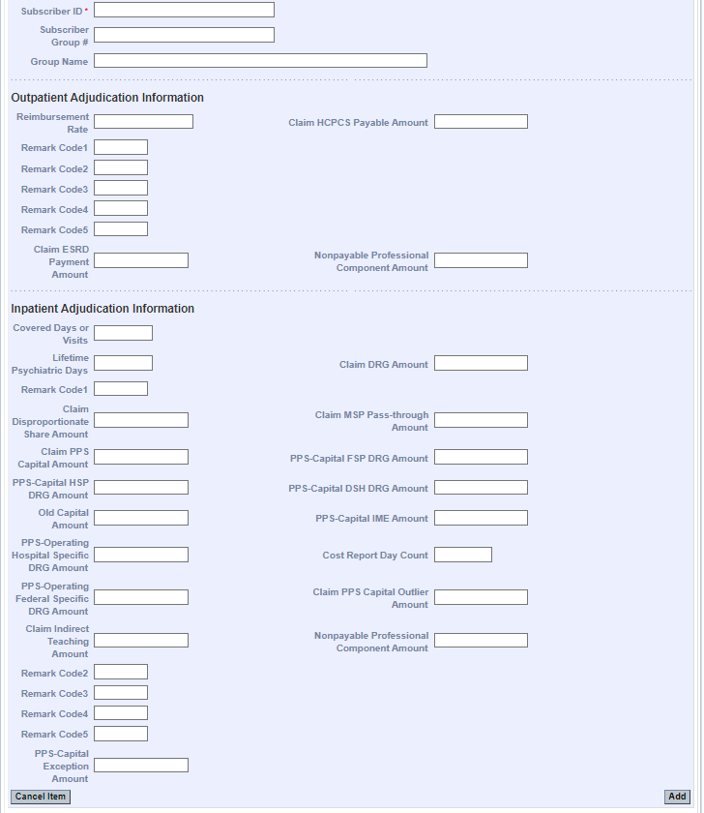

1. For all inpatient and nursing facility room and board claims, continue to the List of **COB Reasons/COB Reasons Detail Panel** section.

**List of COB Reasons/COB Reasons Detail Panel**

For inpatient and nursing facility room and board claims, complete this panel. Do not repeat this information on the **Procedure** tab.

This HIPAA claim adjustment amount cannot be entered on both the **Coordination of Benefits** and the **Procedure** tabs.

On the **List of** **COB Reasons** panel:

1. Click **New Item**. The **COB Reasons Detail** panel displays.

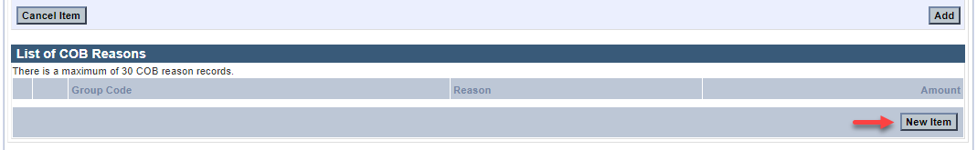

On the **COB Reasons Detail** panel:

1. In the **Group Code\*** field, select the appropriate HIPAA Claim Adjustment Group code (CAGC)identifying the general category of payment adjustment from the dropdown list.
2. In the **Amount\*** field, enter the HIPAA adjustment amount associated with the group/reason code.
3. In the **Unit** **of Service\*** field, enter the units of service being adjusted.
4. In the **Reason\*** field, enter the HIPAA Claim Adjustment Reason code (CARC) identifying the detailed reason that the adjustment was made. Do not enter proprietary insurance reason codes. Proprietary codes must be translated to a HIPAA CARC.
5. Click **Add** to save COB Reasons Detail.

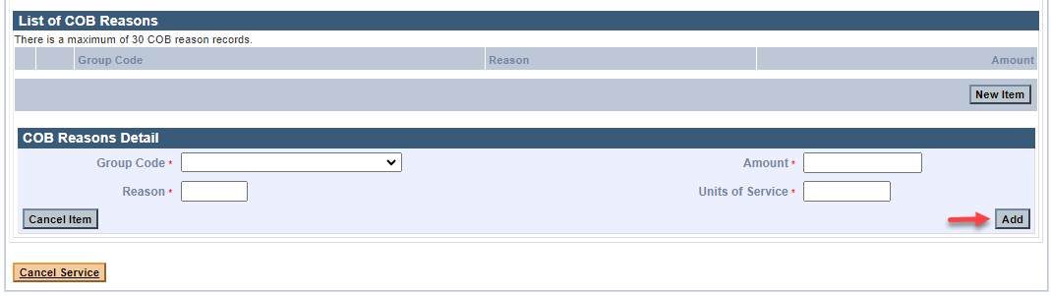

**Note:** To report additional COB Reasons, repeat steps 16–22.

1. Click **Add** on the **COB Detail Information** panel to save the COB information.

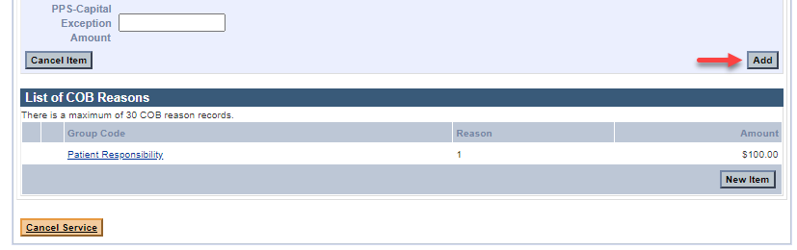

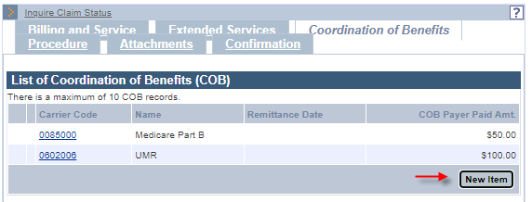**Note:** To report multiple payers, click **New Item** on the **List of COB** panel, and then repeat steps 1–22.

Continue to the **Institutional Service Detail Panel section** instructions found in the [MassHealth Institutional Claim Submission with Coordination of Benefits](https://www.mass.gov/lists/job-aids-for-the-provider-online-service-center) job aid.

**Note**: Your claim will receive suspend edit 2543 “MEDICARE PAYMENT OR PATIENT RESPONSIBILITY IS > 0” and will be released for adjudication after a manual review is completed.