Job Aid: Manage Batch Files

This job aid describes how to manage batch files on the MassHealth Provider Online Service Center (POSC). Providers can upload HIPAA transactions or other batch files and download HIPAA response transactions and other batch files from MassHealth.
This feature is helpful to providers, such as hospitals or large group practices, that need to upload and/or download multiple transactions daily. Batch processing is an alternative to processing separate requests through direct data entry on the POSC.

Upload Batch Files
From the POSC home panel:

Click Manage Batch Files.

Click Upload Batch File.
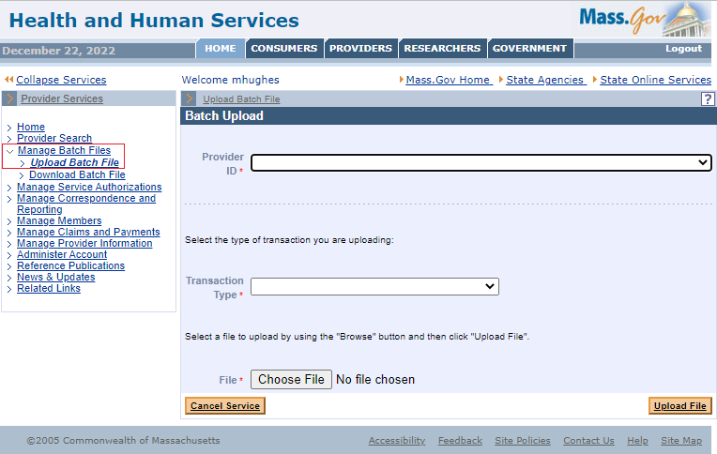

Select the applicable Provider ID from the dropdown list.
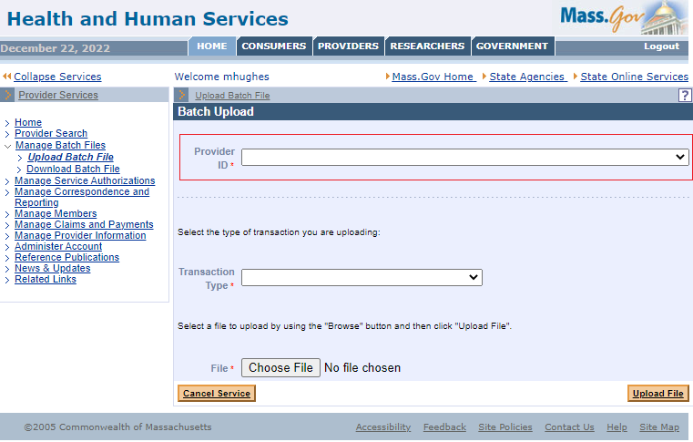

Select the Transaction Type from the dropdown list.
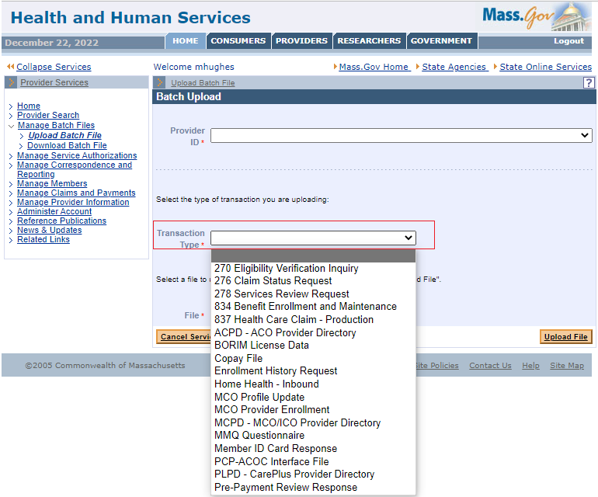

Click Choose a File to select the file that you want to upload to the POSC.

Click Upload File. 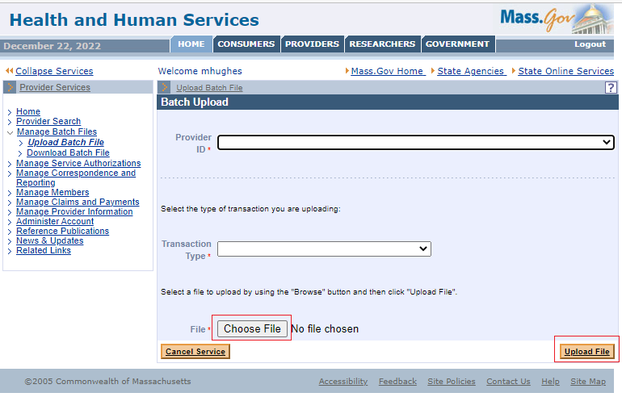

Review the Batch Upload Confirmation message.

Make a note of your tracking number.

Upload another file, if needed.
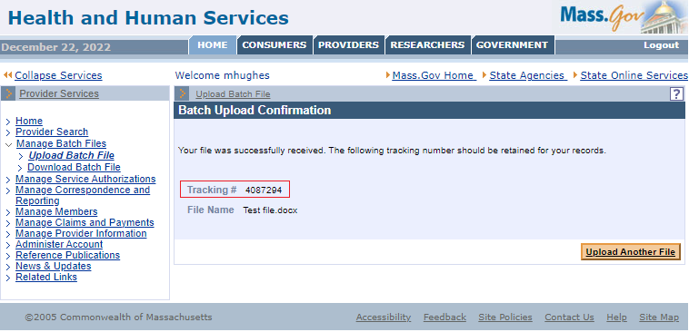

Download Batch Files
From the MassHealth POSC home page:

Click Manage Batch Files.

Click Download Batch File.
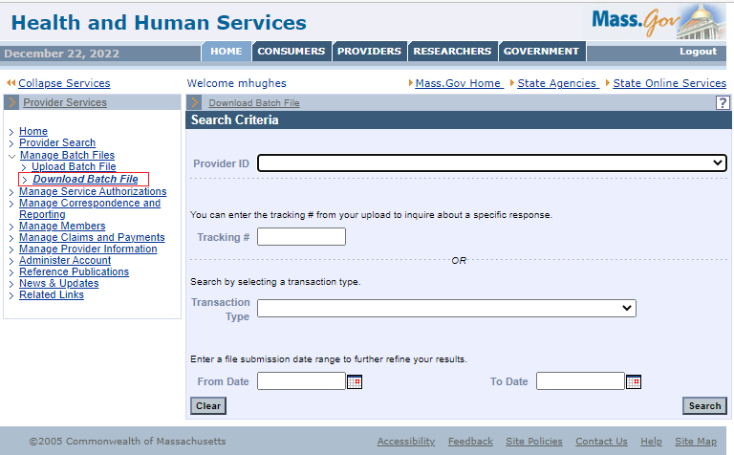

Access the Search Criteria Panel
- Select the applicable Provider ID from the dropdown list.
- Enter the Tracking Number OR select the Transaction Type from the dropdown list.
- Enter the From Date.
- Enter the To Date.
- Click Search.
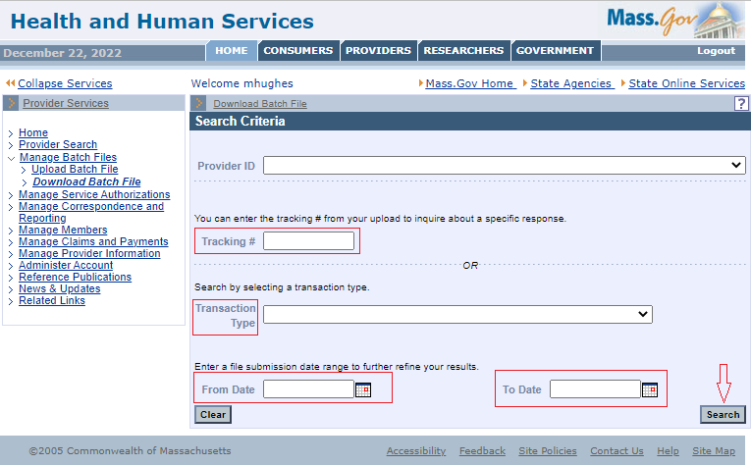

Access the Search Results Panel

Click the file name link you wish to view.
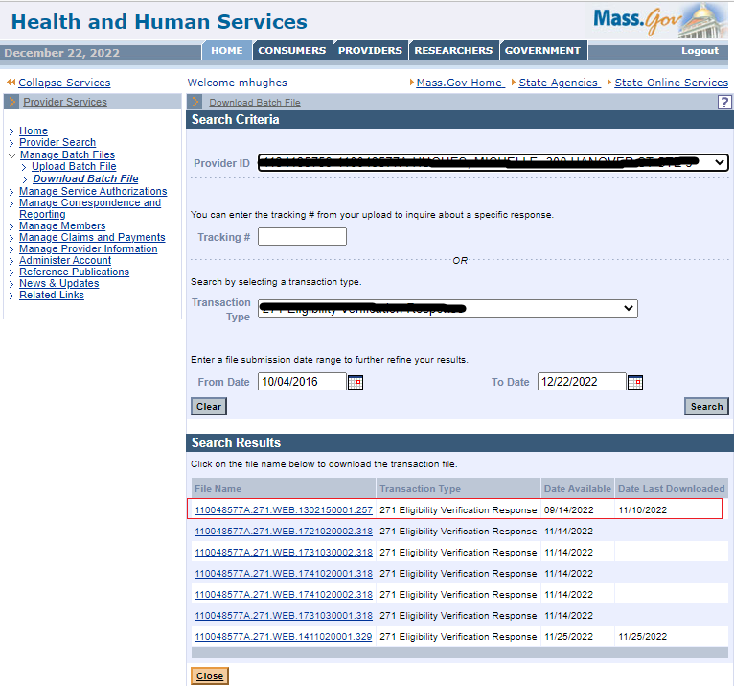
- Open the file or click Save.

Save the Transaction File
From the Save As window:
- Determine where you want to save the downloaded file on your computer.
- Click Save.
- Click Close.

APPENDIX A: POSC Transaction Types
Transaction Type | Description
270/271 | Ability to submit an Eligibility Inquiry and receive an Eligibility Response
820 | Ability to issue managed care payment information to managed care entities
834 | Ability to issue daily, weekly, or monthly managed care enrollment files
835 | Ability to issue the status of claims payments via the 835
837 (P&I) | Ability to submit, adjust, and void claims
999/TA1 | Ability to issue acknowledgements for file submissions
ACPD – ACO Provider Directory | Ability for ACOAs to upload their provider directories
BORIM License Data | Ability to keep BORIM data current in MMIS
Copay File/Health Plan Daily Copay | Incoming/outgoing copay file exchange between MCOs, ACOAs, and MassHealth
MMQ Questionnaire/MMQ Summary Response | Ability to direct data entered in an MMQ
Member ID card Request/Member ID Card Response | Ability to upload/download the member ID card file
MCO Profile Update/MCO profile Update Response | Ability to update the MCO provider’s profile information
MCO Provider Enrollment/MCO Provider Enrollment response | Ability to enroll and update provider data from MCEs
MCPD -MCO/ACO Provider Directory | Ability for MCOs to upload provider directory
PCP – ACOC Interface file | Ability of the MCOs and ACOAs to update or add a member’s PCP
Pre-Payment Review Request/Pre-Payment Review Response | Ability to submit pre-payment review requests and receive responses
Carrier Code File | Ability to download the most recent carrier code file
Daily FEW File | A file of members to be enrolled in the SCO
Daily SCO File | A file of members to be enrolled in the SCO
Miscellaneous Reports | Ability to download ad hoc reports
PCP ACOC Error File | Ability of the MCOs and ACOAs to correct errors detected in their PCPC-ACOC Interface file submission
276/277 | Ability to submit a claims status inquiry and receive a claims status response
Enrollment History Request/Enrollment History Response | Not currently used by MassHealth
PLPD-Care Plus Provider Directory | Not currently used by MassHealth
Request to Initiate Recovery/Initiate Recovery Response | Not currently used by MassHealth
TPL Historic Claims Request/TPL Historic Claims Response | Not currently used by MassHealth
TPL Recovery Data | Not currently used by MassHealth
FFS Wrap File | Not currently used by MassHealth
Home Health Outbound | Not currently used by MassHealth
MCO Provider Enrollment Summary | Not currently used by MassHealth
Open PCC File | Not currently used by MassHealth
Open Provider File | Not currently used by MassHealth

