**Job Aid: Managed Care Providers – 834 and 820 Submission and Download**

MCO, MBPH, SCO, and PACE providers have specific links available for the submission and download of 834 and 820 transactions. This job aid describes how to do the following.

* Upload MCO and BH batch files
* Download MCO and BH responses
* Upload batch 834 SCO and PACE files
* Download 820 SCO and PACE confirmations

**Upload MCO and BH Batch Files: Access Batch Upload panel**

From the **POSC** home page:

1. Click **Manage Members**.
2. Click **Enrollment**.
3. Click **Upload MCO/BH Batch Files**.
4. Log in with your username and password.
5. The **Batch Upload** panel displays.

**Upload MCO and BH Batch Files: Upload Batch File**

From the **Batch Upload** panel:

1. Select **Provider ID** from the dropdown list.
2. Select **Transaction Type** from the dropdown list.
3. Click **Browse** and navigate to the folder containing the batch files.
4. Select the desired file and click **Open**.
5. Click **Upload File**.

**Upload MCO and BH Batch Files: Upload Confirmation**

On the **Batch Upload Confirmation** panel:

1. Record the **Tracking Number**.
2. Click **Close**.

**Note:** Click **Upload Another File** to upload another batch file.

**Download MCO and BH Batch Files: Access Download Response panel**

From the **POSC** home page:

1. Click **Enrollment**.
2. Click **Download MCO/BH Responses**.
3. Click **Download Responses**. The **Search Criteria** panel displays.

**Download MCO and BH Batch Files: Search for Download Response(s)**

From the **Search Criteria** panel:

1. Select **Provider ID** from the dropdown list.
2. Do one of the following.

* To inquire on a specific response, enter the **Tracking Number**.
* To download all of a certain type of transaction, select a **Transaction Type** from the dropdown list.

1. If desired, enter a date range in the **From Date** and **To Date** fields to refine your results.
2. Click **Search**.

On the **Search Results** panel:

1. Confirm download responses.

**Note:** To open a file, click the file name you want to view. Then click **Open** to view the file or **Save** to save it to a specific location.

**Upload Batch 834 SCO and PACE Files: Access Batch Upload panel**

From the **POSC** home page:

1. Click **Upload Batch File**.
2. Click **Upload Batch**. The **Batch Upload** panel displays.

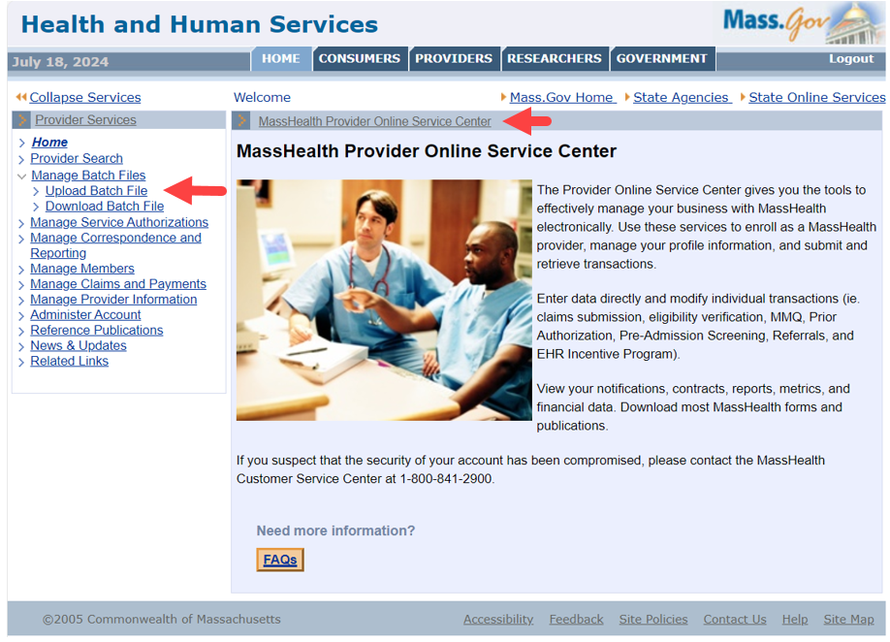

**Upload Batch 834 SCO and PACE Files: Upload Batch File**

From the **Batch Upload** panel:

1. Select **Provider ID** from the dropdown list.
2. Select **Transaction Type** from the dropdown list.
3. Click **Choose File** and navigate to the folder containing the batch files.
4. Select the desired file and click **Open**.
5. Click **Upload File**.

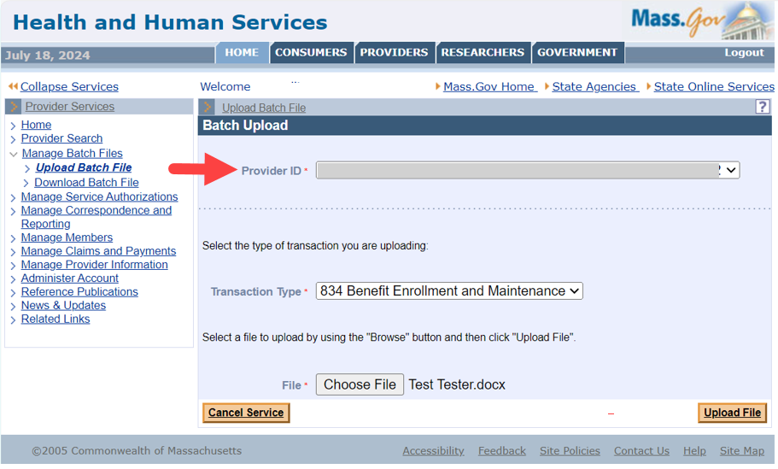

**Upload Batch 834 SCO and PACE Files: Upload Confirmation**

On the **Batch Upload Confirmation** panel:

1. Record the **Tracking Number**.
2. Click **Close**.

**Note:** Click **Upload Another File** to upload another batch file.

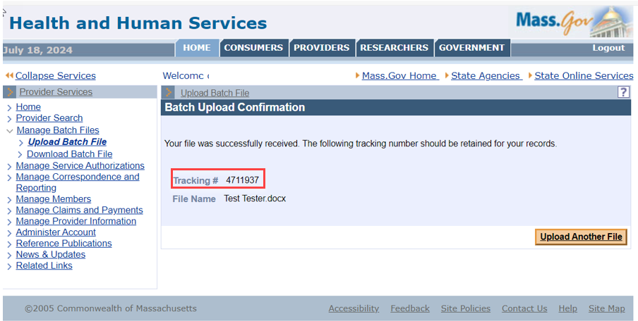

**Download 820 SCO and PACE Confirmations: Access Download Response panel**

From the **POSC** home page:

1. Click **Manage Batch Files**.
2. Click **Download Batch File**. The **Search Criteria** panel displays.

**Download 820 SCO and PACE Confirmations: Search for Download Response(s)**

From the **Search Criteria** panel:

1. Select **Provider ID** from the dropdown list.
2. Do one of the following.

* To inquire on a specific response, enter the **Tracking Number**.
* To download all of a certain type of transaction, select a **Transaction Type** from the dropdown list.

1. If desired, enter a date range in the **From Date** and **To Date** fields to refine your results.
2. Click **Search**.

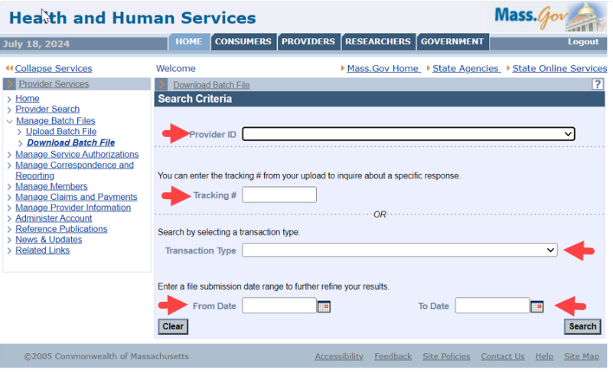

On the **Search Results** panel:

1. Confirm download responses.

**Note:** To open a file, click the file name you want to view. Then click **Open** to view the file or **Save** to save it to a specific location.

