**Job Aid: Modify a Pre-Admission Screening Request**

The purpose of the Pre-Admission Screening (PAS) request is to authorize elective/non-emergency acute or chronic hospital stays. PAS requests may be updated if they have been saved but not submitted.

This job aid describes how to

* modify a pre-admissions screening request submitted through the MassHealth Provider Online Service Center (POSC); and
* submit the request.

**Access Inquire/Maintain PAS Request**

From the **POSC** home page:

1. Click **Manage Service Authorizations**.

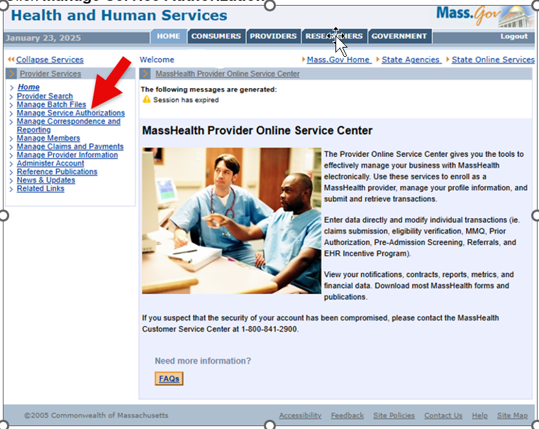

1. Click **Pre-Admission Screening**.

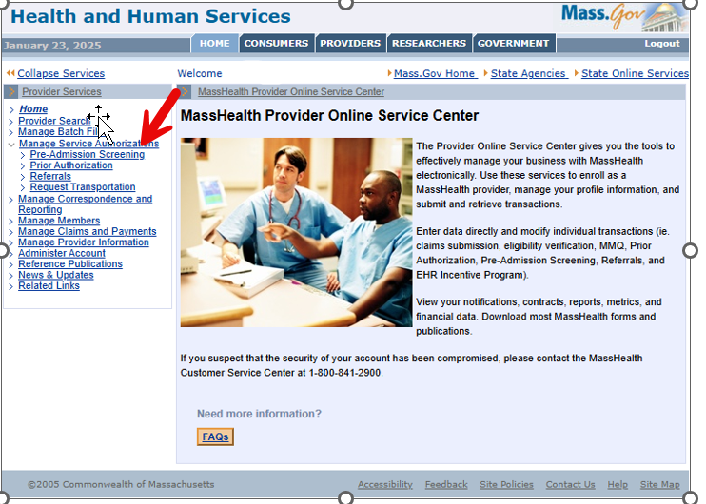

1. Click **Inquire/Maintain PAS Request**. The **Search for PAS** panel will display.

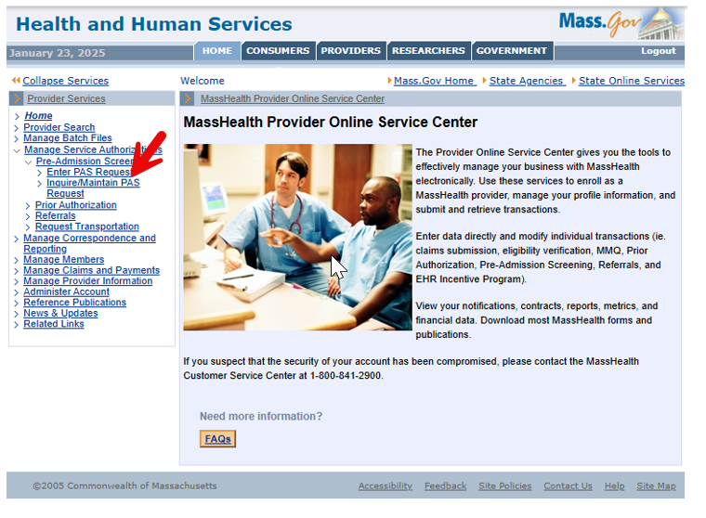

**Search for PAS**

On the **Search for PAS** panel:

1. If known, enter the **PAS Number**. If you do not know the number, do the following.
   * Select the **Facility** from the dropdown list.
   * Enter the **Member ID**.
   * Select the **Status** from the dropdown list.
2. Click **Search**. The **PAS Search Results** panel will display.

**Select PAS Number**

On the **PAS Search Results** panel:

1. Select the **PAS Number**. If more than one record appears, use the admission date as a guide.

**Modify a PAS**

On the **Base Information** panel:

1. Click **Modify**.

**Update the PAS Request**

On the **PAS Information** panel:

1. Click **Line Items**.

On the **List of Line Items** panel:

1. Select the **Line Item** to be updated.

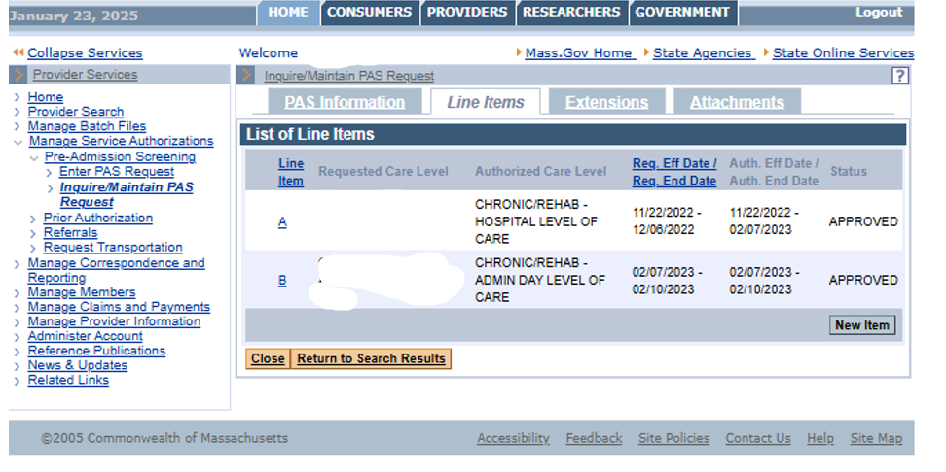

On the **Line Item Detail** panel:

1. Modify the request as needed.
2. Click **Update**.
3. Click on the **Confirmation** tab.

**Submit the PAS Request**

On the **Confirmation** panel:

1. View the confirmation message, then click **Submit**.

