

Job Aid: Primary User Report
This job aid describes how a primary user generates and reviews a Primary User Report in the Provider Online Service Center (POSC). This will give the primary user the capability to see who has access to their Provider ID/Service Locations (PID/SLs), both currently and previously, as well as what roles the user currently has.

Request Primary User Report
From the POSC home page:
- Click Administer Account.
- Click Request Primary User Report.
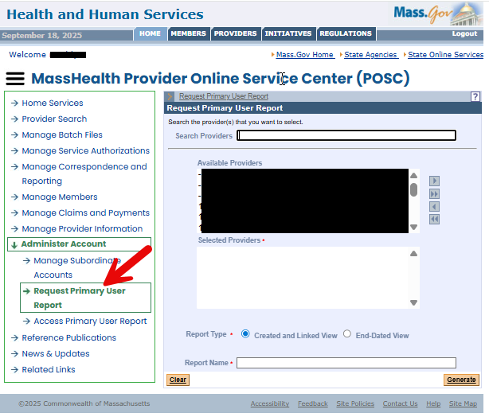
- Populate the providers (PID/SLs) you wish to see on the report. You have two options: search for a particular provider, or highlight providers in the Available Providers box and click the arrow to populate into the Selected Provider(s) box.
- Choose either Created and Linked View or End-Dated View. Created and Linked View will show you the users who are currently linked. End-Dated View will show you the users who were previously linked.
- Enter the name of the report defined by the user.
- Click Generate.
- You’ll receive a message that your report was successfully submitted. At that point, you have the option to generate another report.
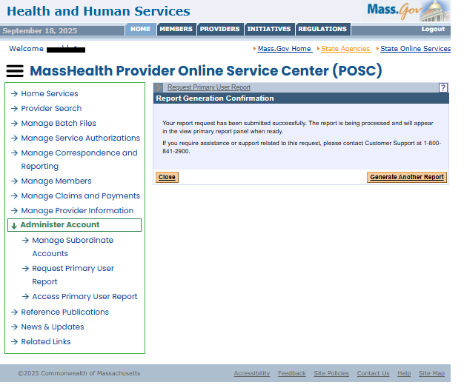

Access Primary User Report
From the POSC home page:
- Click Administer Account.
- Click Access Primary User Report.
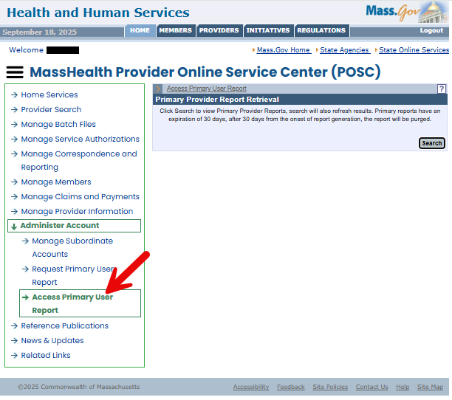

- Click the Search button.
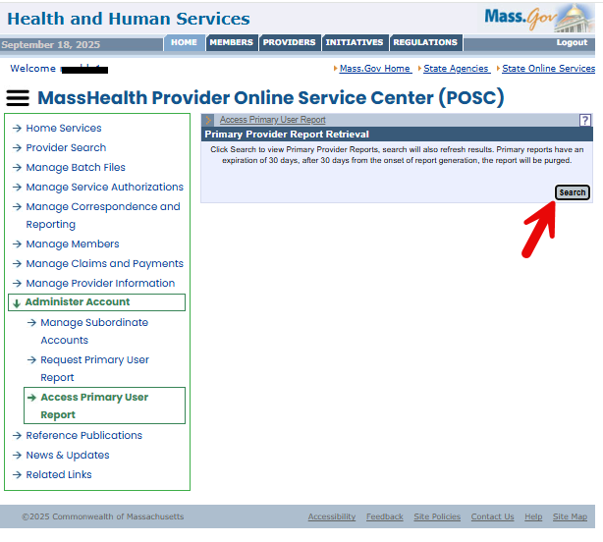

- Click on the “xlxs” link of the Excel report you want to open. Reports will stay available for 30 days.
