# Job Aid: Provider Online Service Center Overview

This job aid includes a brief description of the various functions available in the Provider Online Service Center (POSC).

## Introduction

The **POSC** is a web-based portal that allows enrolled MassHealth providers to perform a number of functions to facilitate the delivery of healthcare services provided to MassHealth members and supports related to billing and payment functions. These functions include the following.

* Real-time, interactive processing of claims
* Verifying eligibility
* Direct Data Entry (DDE) and modification of service authorizations (e.g., prior authorization)
* Viewing notifications, contracts, reports, metrics, and financial data
* Enrolling in the MassHealth program and managing profile information
* Uploading and downloading batch transactions (e.g., claims and eligibility) and other formatted content
* Managing access to the POSC through the “Administer Account” feature
* Accessing links to MassHealth publications, news, updates, and other content on mass.gov

## POSC Home Page

Key areas of the POSC home page include the following.

* The tabs along the top of the page provide quick access to information about the Executive Office of Health and Human Services (EOHHS). There are tabs for consumers, providers, researchers, and government.
* The navigational links on the left side of the page allow the user to access various areas of the POSC. To hide this menu and increase the size of the panel, click **Collapse Services**.
* The panel on the right side of the page provides an overview of the POSC and includes links that allow the user to login, enroll as a MassHealth provider, and access the Frequently Asked Questions (FAQ).
* After logging in with a unique username and password, users can access many of the services based on their login.

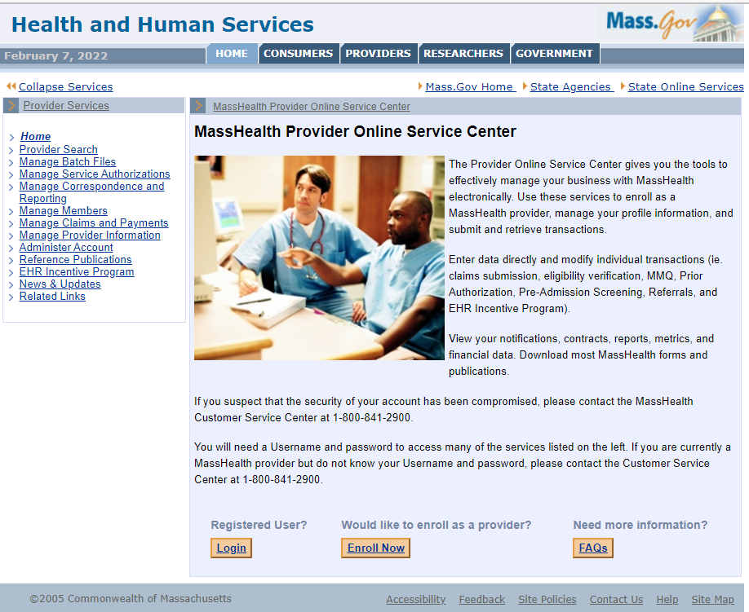

## Provider Search

This function allows providers to search the Medicaid Management Information System (MMIS) to identify MassHealth’s enrolled providers and business partners by using various criteria (e.g., first name, last name, National Provider Identifier (NPI), etc.).

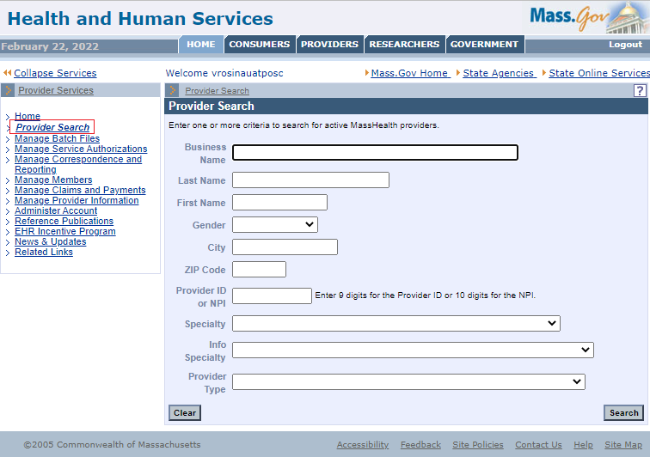

## Manage Batch Files

This function allows providers to upload and download batch healthcare transactions, including X-12 files and other formatted files and content.

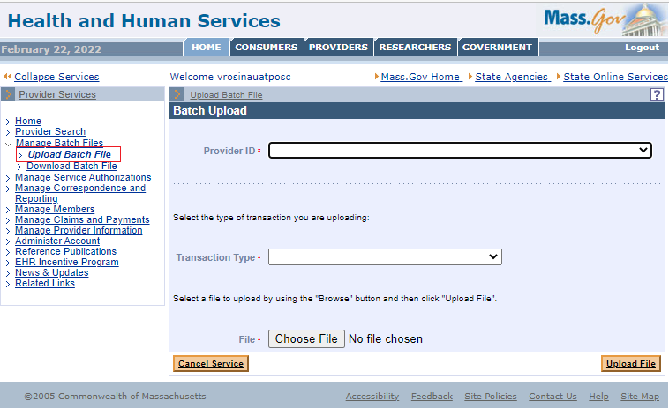

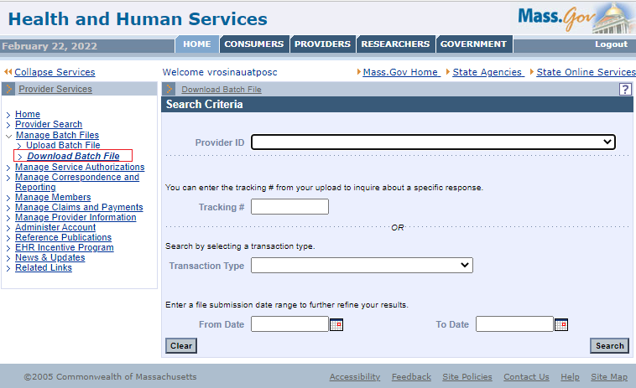

## Manage Service Authorizations

This function allows providers to enter, update, and inquire about Pre-Admission Screening (PAS), Prior Authorizations (PA), and referrals. Providers can also request non-emergency transportation for members.

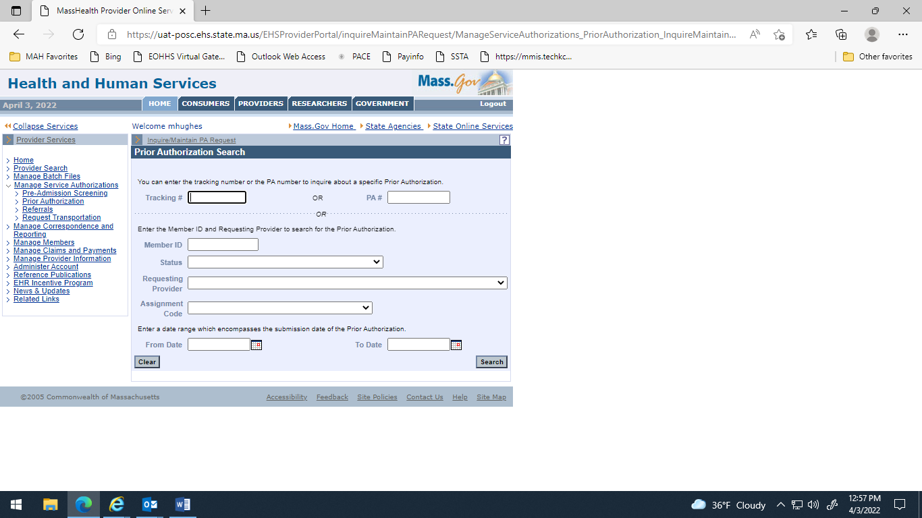

## Manage Correspondence and Reporting

This function allows providers to view messages, reports, metrics, notifications, contracts, and documents. Providers can also use this function to submit feedback to EOHHS.

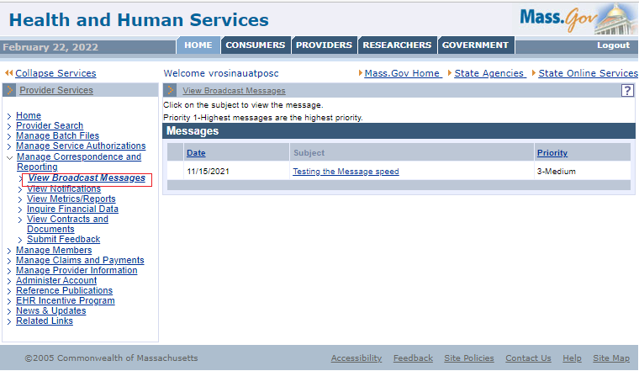

**Manage Correspondence and Reporting** functions include the following.

* **View Notifications** allows providers to view notices issued by EOHHS (e.g., service authorization approvals).
* **View Broadcast Messages** allows providers to view the details of the user-selected broadcast message issued by MassHealth.
* **View Metrics and Reports** allows providers to view remittance advices and the top 10 claim denial reasons for user-defined periods of time.
* **Inquire Financial Data** allows providers to view their payment history for a user-defined period of time.
* **View Contracts and Documents** allows providers to view submitted documentation to support the provider’s contract with MassHealth.
* **Submit Feedback** allows providers to submit feedback to MassHealth by email.

## Manage Members

This function allows providers to verify member eligibility via DDE or batch upload/download, enroll and disenroll members for the Senior Care Options (SCO) plan and Program of All-inclusive Care for the Elderly (PACE). Providers can also submit Management Minutes Questionnaires (MMQ).

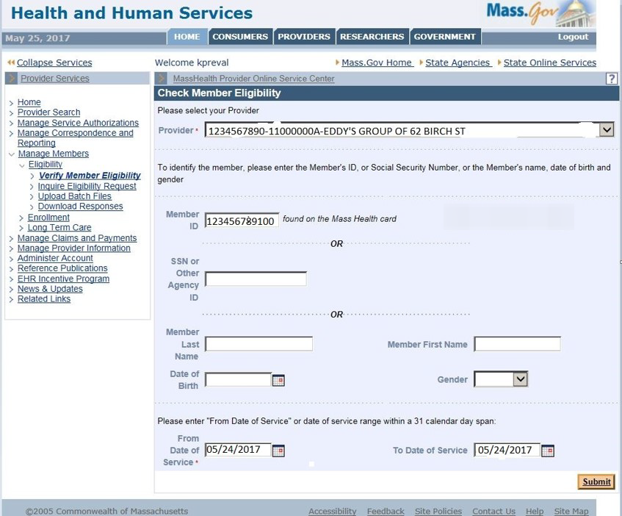

## Manage Claims and Payments

This function allows providers to submit DDE claims to MassHealth in real time. It also provides continuous, interactive claims processing. Upon claim submission, providers receive instant confirmation of claim status. Providers can also upload and download healthcare claims transactions and view SCO and PACE payments.

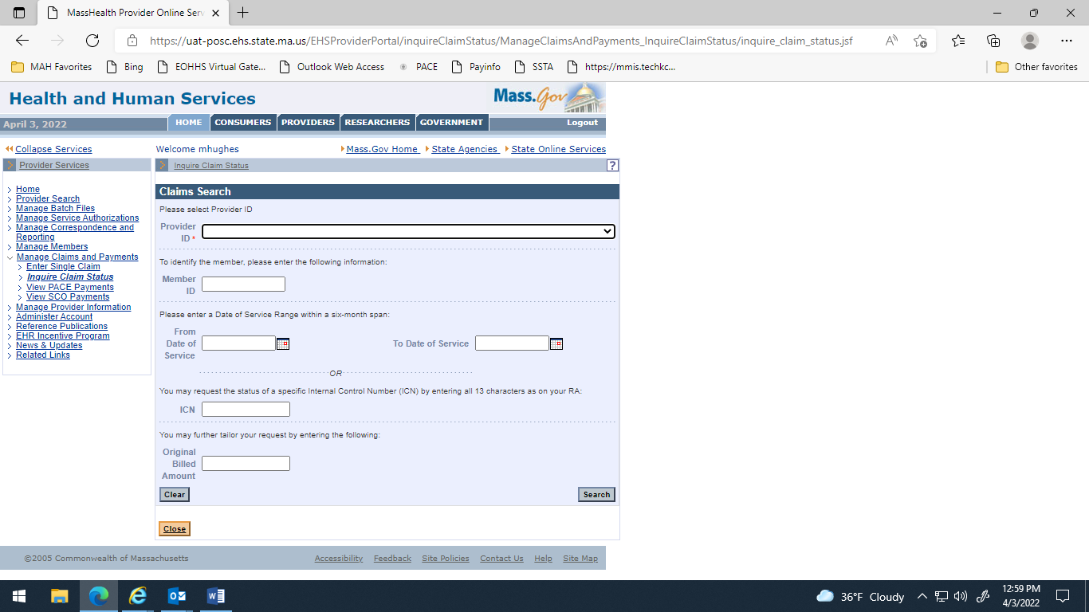

## Manage Provider Information

This function allows providers to enroll in MassHealth and update their profile information. Providers can download an enrollment application, request a hard copy of the application, and enroll online from this page. MassHealth business partners (e.g., billing intermediaries/vendors), can also enroll with MassHealth.

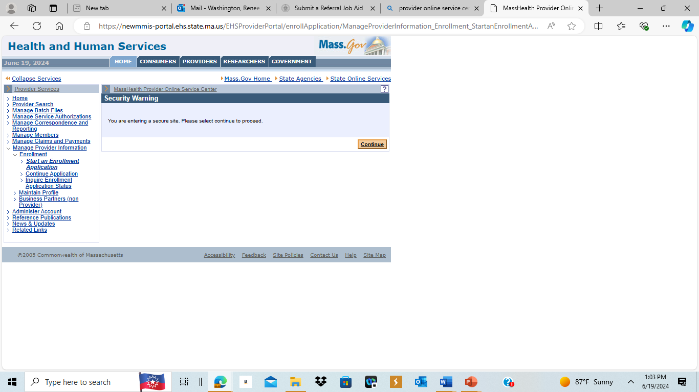

## Administer Account

This function allows providers to manage their organization’s access to the POSC. It enables the organization’s Primary User to add or update subordinate accounts and reset account passwords. The Primary User can also link other subordinate users to the provider’s account to allow them to perform functions on behalf of the provider’s organization (e.g., billing intermediaries/vendors, etc.).

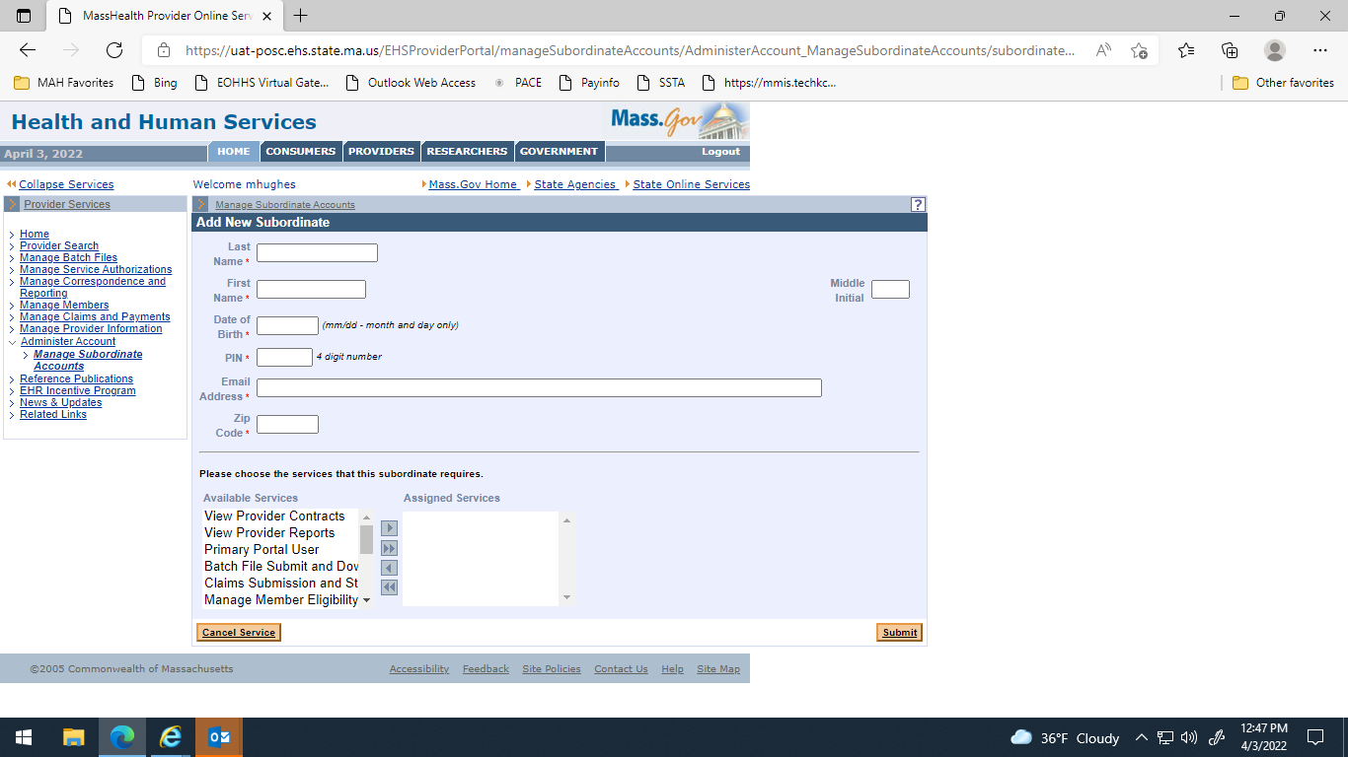

## Reference Publications

This function allows providers to link to downloadable forms, MassHealth publications, registration for training, training materials, and MassHealth regulations. The downloadable forms include standard forms for all providers, community health centers, durable medical goods, home health agencies, hospice, independent nurses, long-term care, orthotics, outpatient hospitals, personal care, pharmacy, therapists, and transportation. Organizations can also order publications and view frequently asked questions.

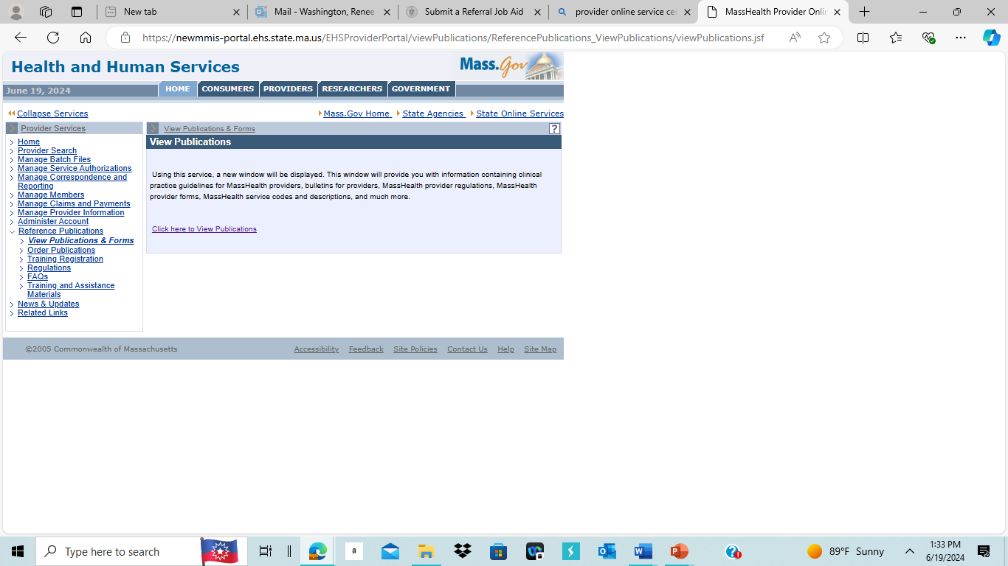

## News and Updates

This function allows providers to view EOHHS news and updates on [mass.gov](https://www.mass.gov/).

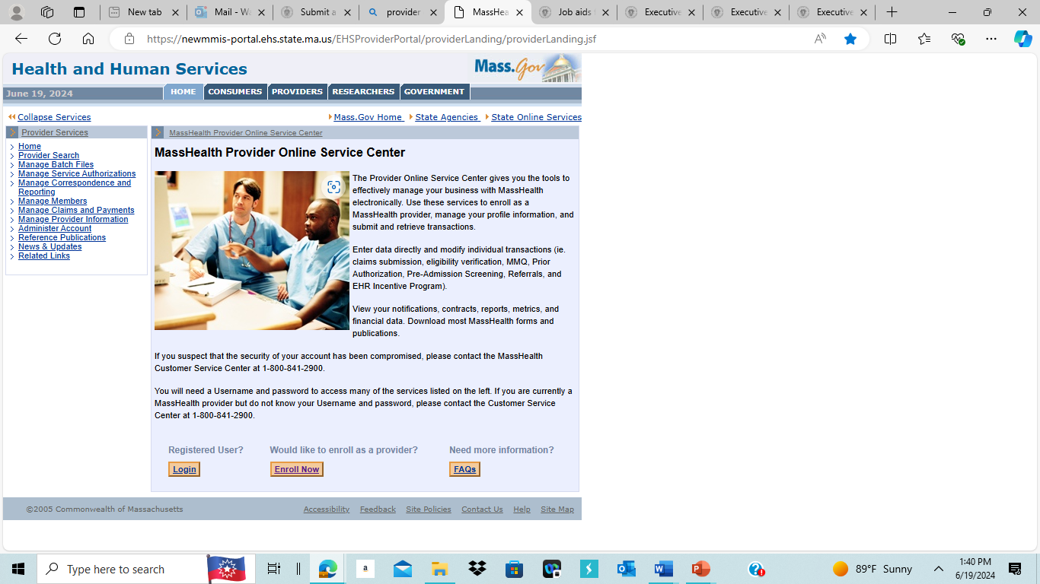

## Related Links

This function allows providers to visit MassHealth pricing regulations, the Virtual Gateway, the Center for Health Information and Analysis (CHIA), and MassHealth pages to view and reference applicable information.

