**Job Aid: Re-Review a Pre-Admission Screening Request**

The purpose of the Pre-Admission Screening (PAS) request is to authorize elective/non-emergency acute or chronic hospital stays. PAS requests may be updated if they have been saved but not submitted.

A PAS request may be submitted for a second opinion if it meets the following criteria.

* The PAS is in a Denied status.
* A re-review has not already been requested.
* The re-review request falls within seven days of the denial notice date.

This job aid describes how to

* set a PAS for re-review; and
* submit the re-review for processing.

From the **POSC** home page:

1. Click **Manage Service Authorizations**.

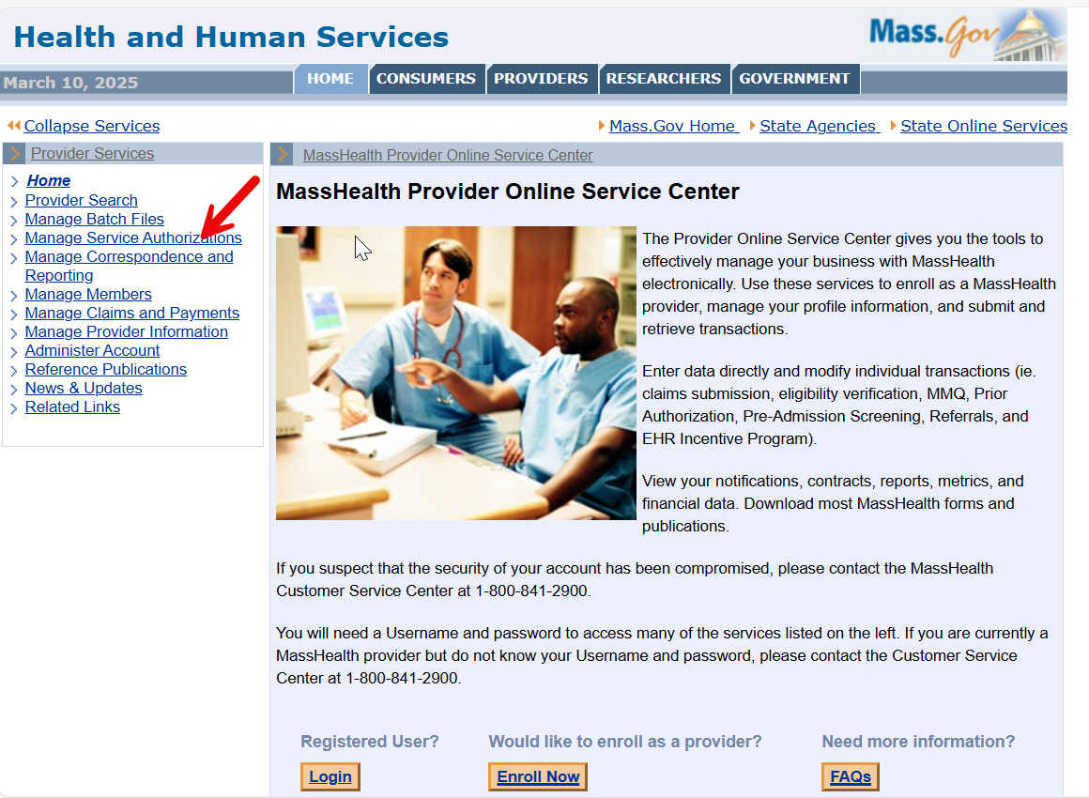

1. Click **Pre-Admission Screening**.

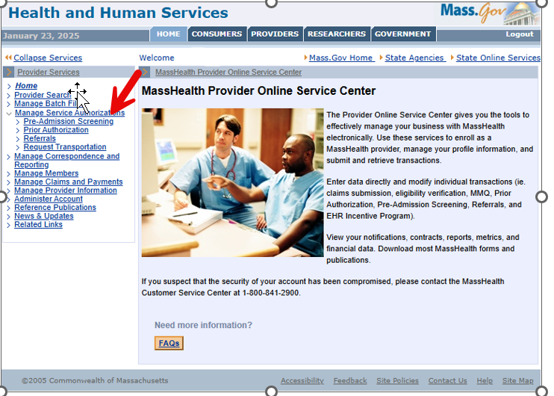

1. Click **Inquire/Maintain PAS Request**. The **Search for PAS** panel will display.

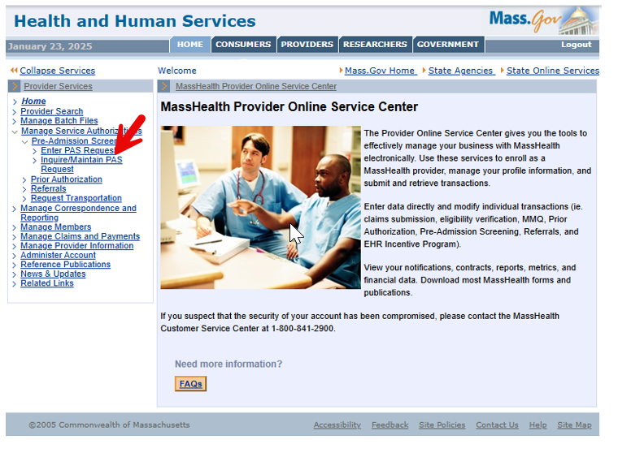

**Search for PAS**

On the **Search for PAS** panel:

1. If known, enter the **PAS Number**. If you do not know the number, do the following.
   * Select the **Facility** from the dropdown list.
   * Enter the **Member ID**.
   * Select the **Status** from the dropdown list.

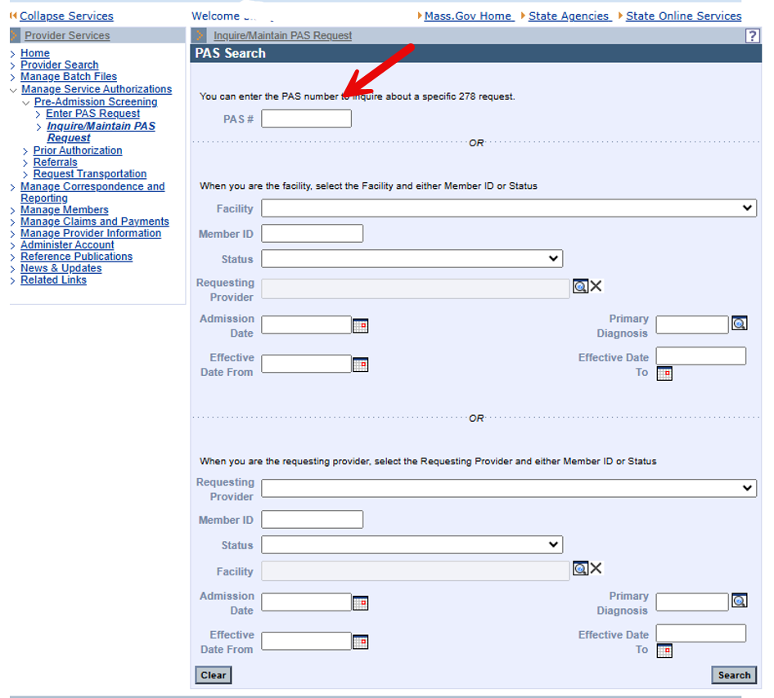

1. Click **Search**. The **PAS Search Results** panel will display.

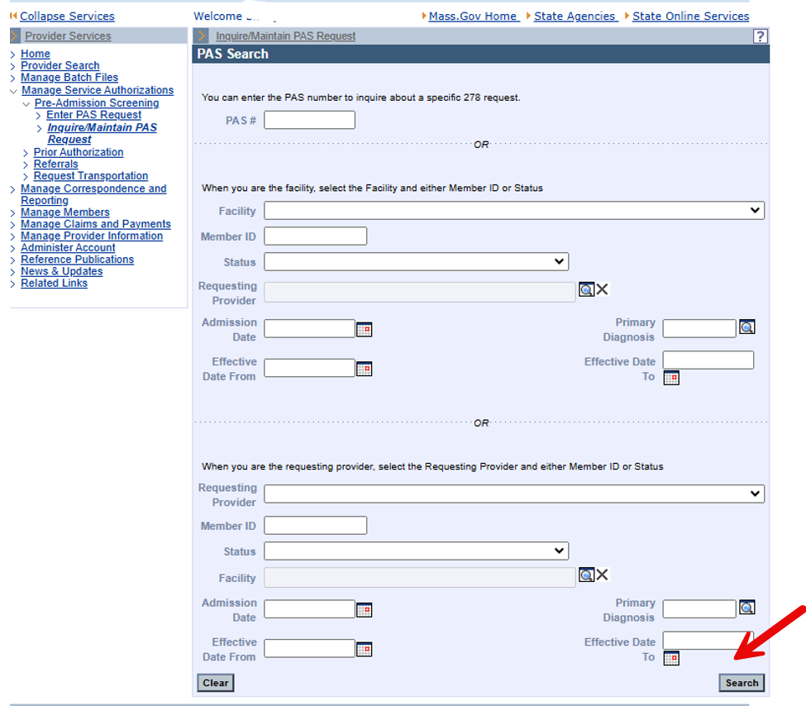

1. Select the **PAS Number**. If more than one record appears, use the admission date as a guide.

Selecting the PAS number will open the **Base Information** panel. It includes all the demographic information.

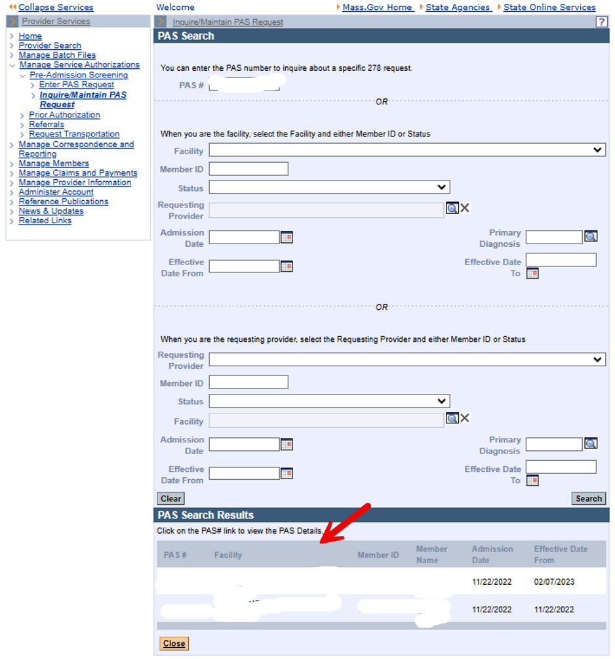

**Initiate the Re-Review Process**

Select the **Line Item** tab.

1. Select the line item associated with the denied request.

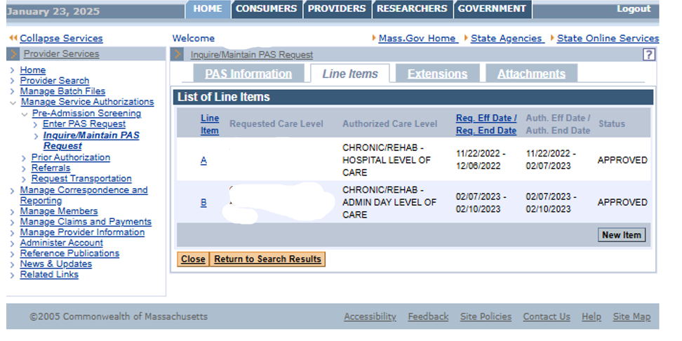

1. The **Line Item Detail** panel will display.

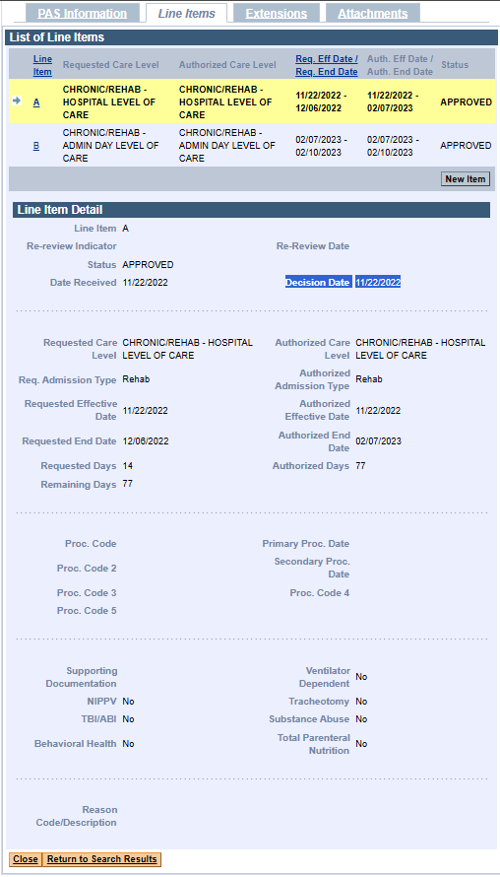

1. Click the **Extensions** tab. The list of extensions will display.

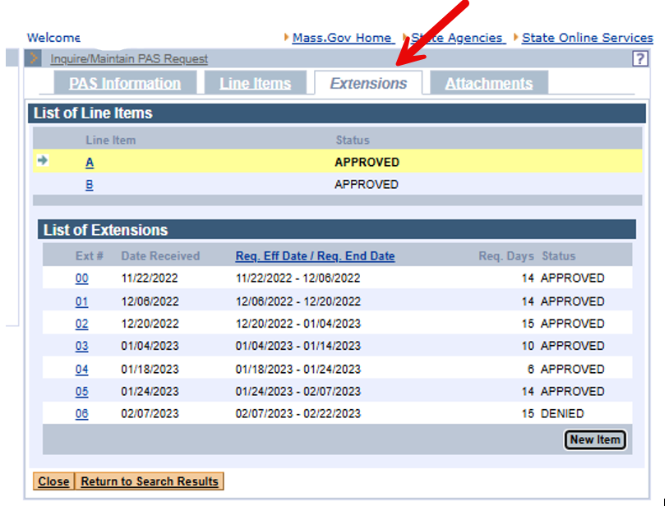

1. Select the extension number corresponding to the DENIED status. The **Extension Detail Panel** will be displayed.

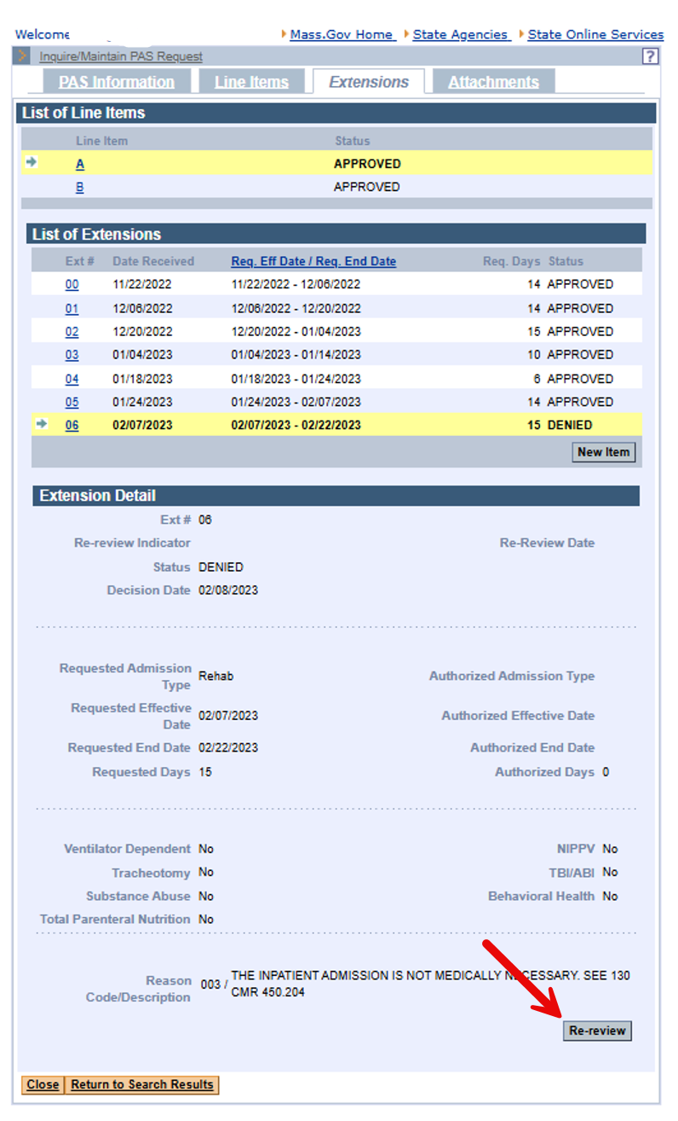

1. Scroll to the bottom of the panel. Click the **Re-review** button in the bottom right corner. The

**Extension Detail** panel will be displayed.

**Note:** Only the finalized, most recent extension will display the Re-review button.

1. Set the **Re-review Indicator** to **YES**.
2. Click the **Update** button in the bottom right corner.

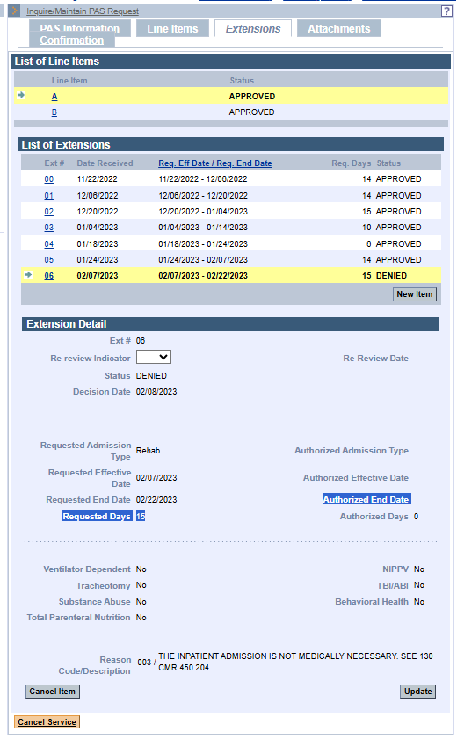

**Submit the Re-review Request**

1. Click the **Confirmation** tab. The **Confirmation** panel will be displayed.
2. Click the **Submit** button in the bottom right corner. The **Pre-Admission Screening Response** notice will display, indicating the status of the request.

