**Job Aid: Replace or Adjust a Paid Claim**

This job aid describes how to:

* Replace or adjust a claim after it has been paid by MassHealth.

**Note:** The ICN for the new adjusted claim will begin with “58” or “59.”

**Access Inquire Claim Status**

From the **POSC** home page:

1. Click **Manage Claims and Payments**.
2. Click **Inquire Claim Status**. The **Search for Claims** panel is displayed.

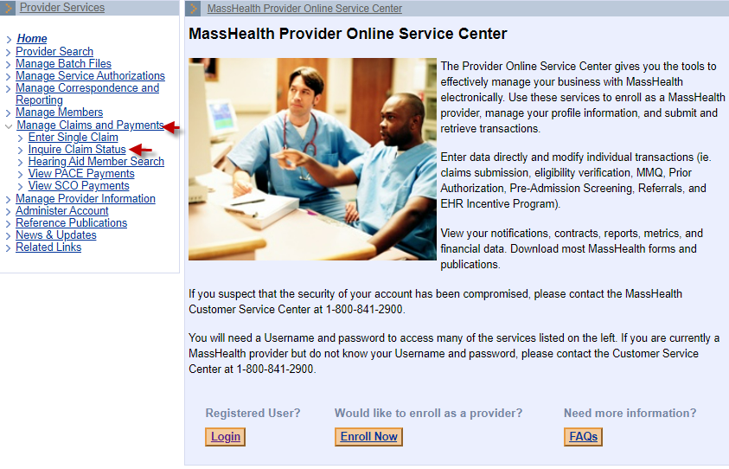

**Enter Search Criteria**

For more effective claim searching, enter as much search information as possible.

From the **Claims Search** panel:

1. Select **Provider ID** from the dropdown list.
2. Enter the **Member ID**.
3. Enter **From Date of Service** and **To Date of Service**, within a six-month time span.

**Note:** If known, enter the exact date of service or **ICN**, which returns only the specific claim in the Search Results.

1. Click **Search**.

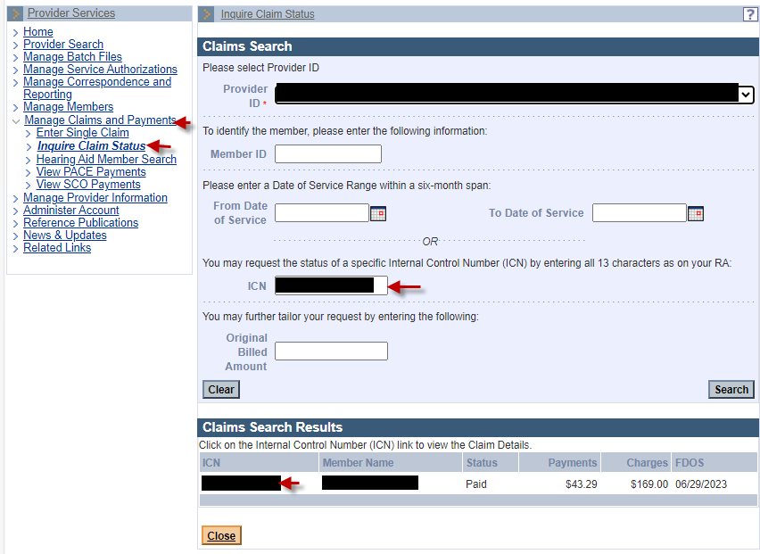

From the **Claims Search Results** panel:

1. Select the paid claim to be adjusted or replaced.

From the **Claim Detail** panel:

1. Review the claim details.
2. Click **Replace**.

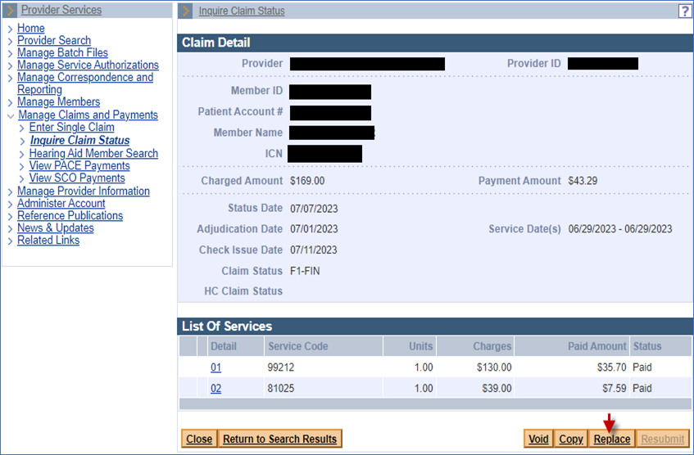

**Continue to the Tabs/Panel(s) Where the Information Is to Be Corrected**

1. Enter the corrected/updated information on the appropriate tab/panel.
2. Once all the information is corrected/updated, continue to the **Confirmation** panel and click **Submit**.

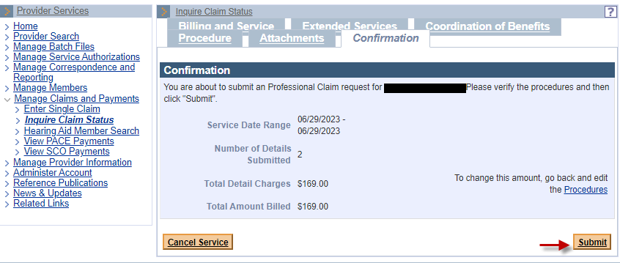

1. Click **Close** when you are finished.

