# MassHealth logoJob Aid: Respond to a Deferred Prior Authorization Request

This job aid describes how to:

* Respond to a Deferred Status decision on your prior authorization (PA) request; and
* Submit the request.

If MassHealth defers a PA request, the provider and the member will receive a **Deferred Decision Status** notification explaining why. The most common reason for a deferral is missing documentation. When MassHealth needs more information to make a decision, you will be asked to submit supporting documentation. You can submit the needed information by attaching it to the online PA request. When the required information is received, the consultant can continue the review.

1. Click the **Login** button on the Provider Online Service Center (POSC) landing page.

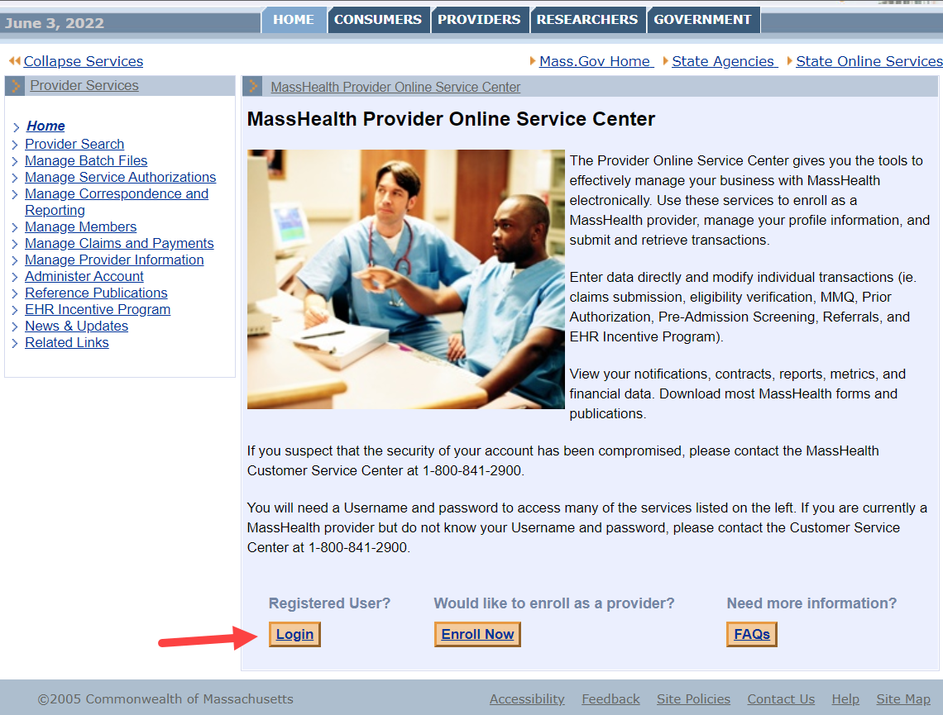

## Search for a Deferred PA Request

From the Provider Online Service Center home page:

1. Click **Manage Service Authorizations**.
2. Click **Prior Authorizations.**
3. Click **Inquire/Maintain PA Request**. The **Search for Prior Authorization panel** is displayed.

You can view the status of the request on the **Prior Authorization Search Panel** by:

* entering the **Tracking Number** or **PA number**; or
* entering the **Requesting Provider’s PIDSL** and a **Member ID**, or **Status**.

Additional information can be added to narrow the search. In the example below, the provider searched for all PAs in a DEFERRED status. This yielded one result.

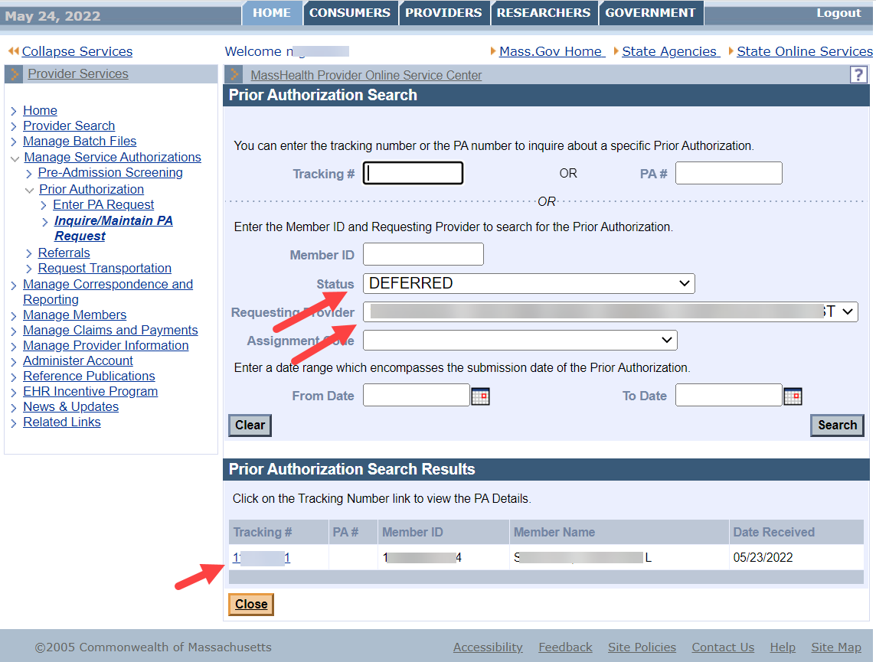

A view of the **Line Items** tab confirms that the status is **DEFERRED**.

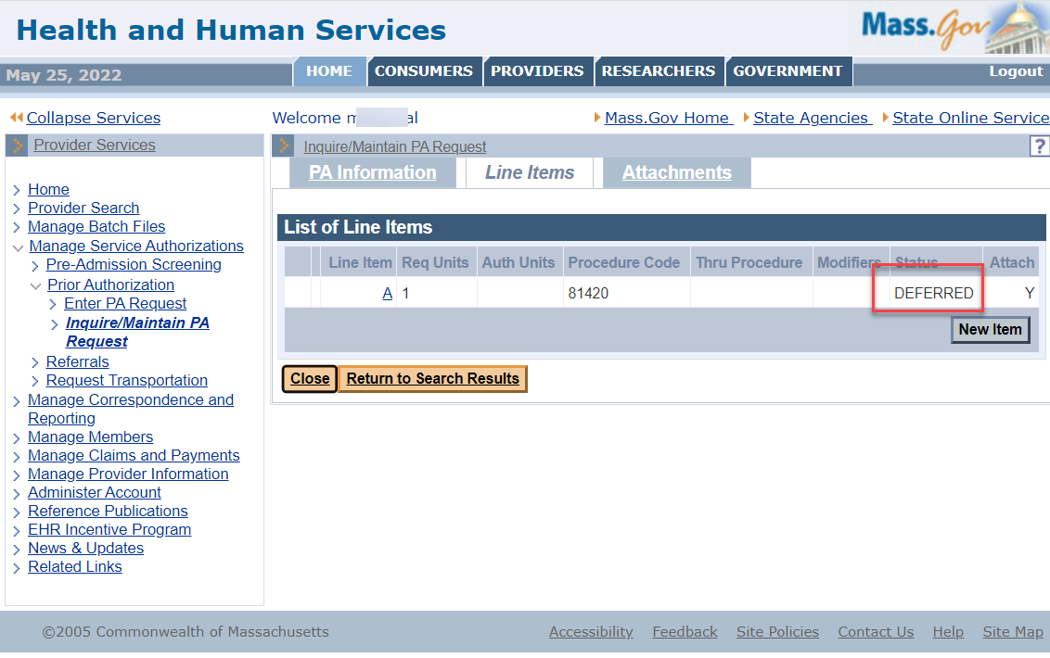

When a PA is deferred, the clinical reviewer requests additional information. This request is viewable on the **Attachments** tab.

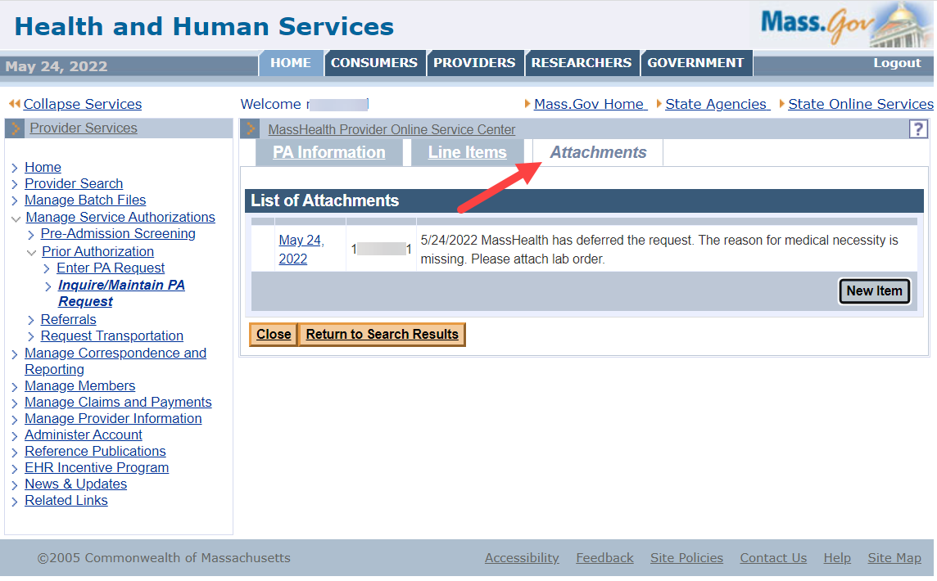

The provider can view the details of the request for additional information by clicking on the hyperlinkeddate in the **List of Attachments**. This opens up the details of the request.

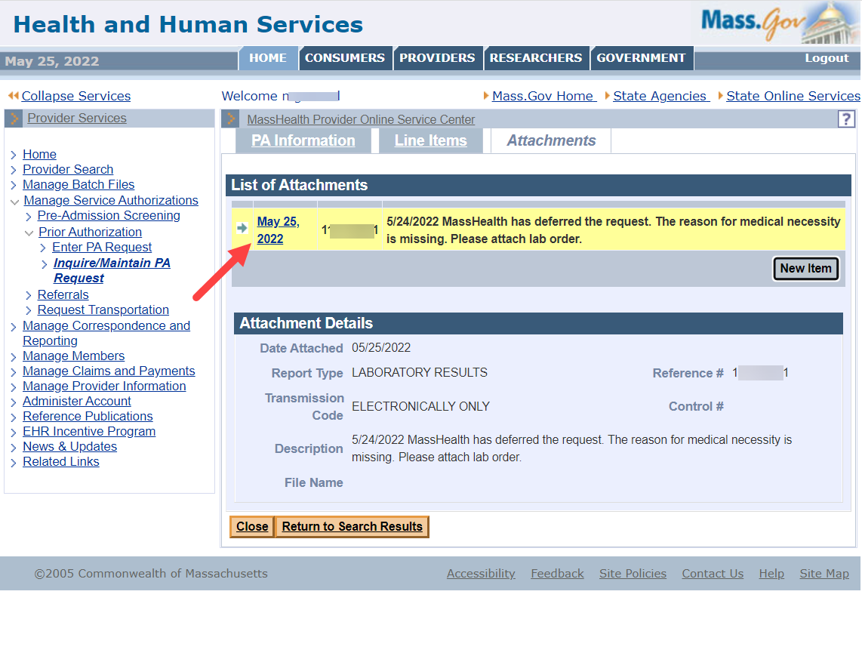

The provider can respond to the request for additional information by clicking on the **New Item** button on the **Attachments** tab.

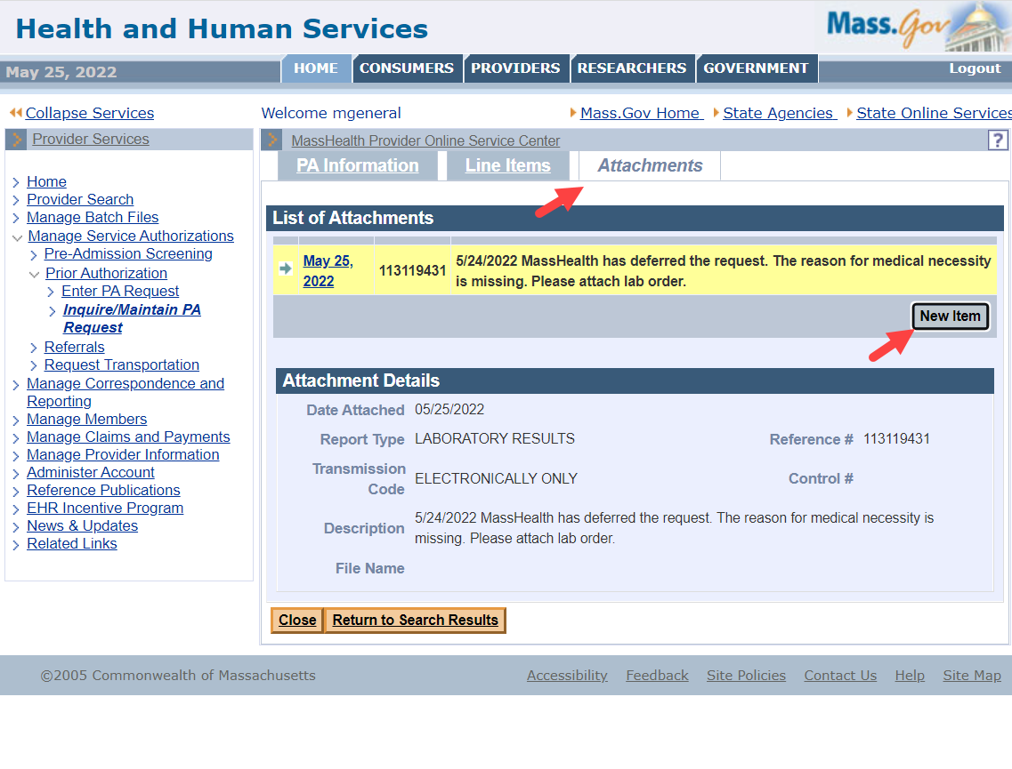

The following fields are required information:

* Select **Report Type** from the dropdown list.
* Select **Transmission Code** (Electronic Only) from the dropdown list.
* Provide a **Description** of the attachment.
* Click on the **Choose File** button to attach a file from the provider’s computer.

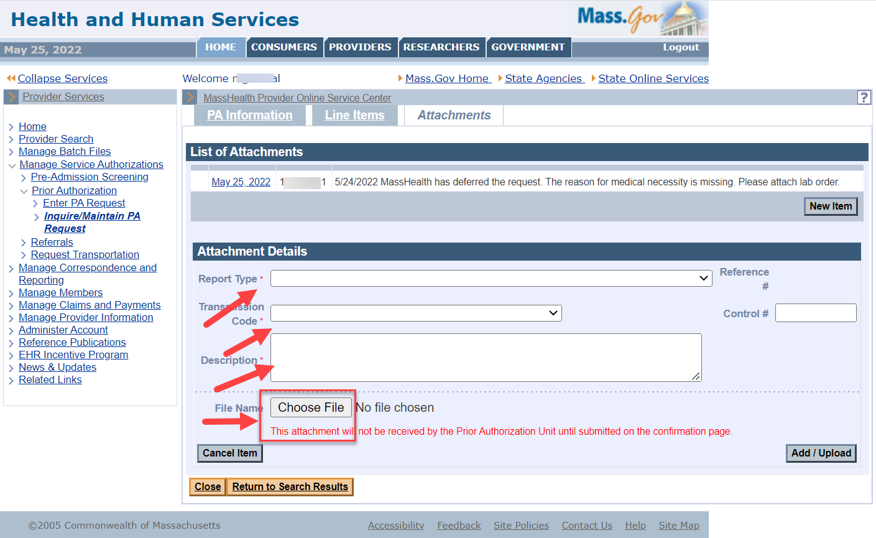

Select a file and click **Open**. This selects the file to attach.

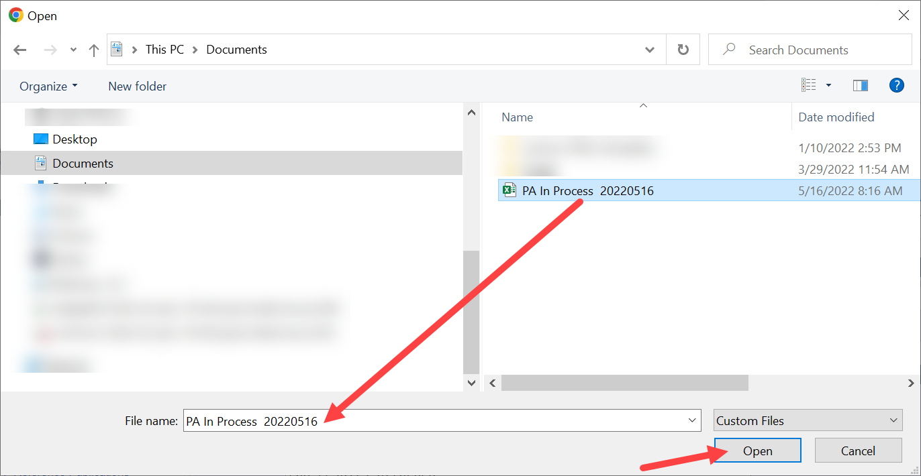

When a file is selected, the window closes. The **Attachment Details** panel appears, and the file name is displayed for confirmation.

* Click the **Add/Upload** button. This attaches the file to the PA request.

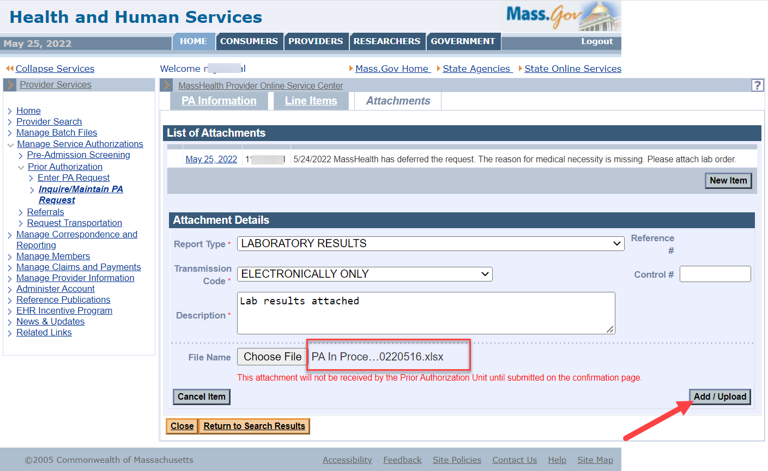

When the **List of Attachments** panel is redisplayed, the attachment is now viewable in the list.

Select the **Confirmation** tab so that the attachment can be sent to the reviewer.

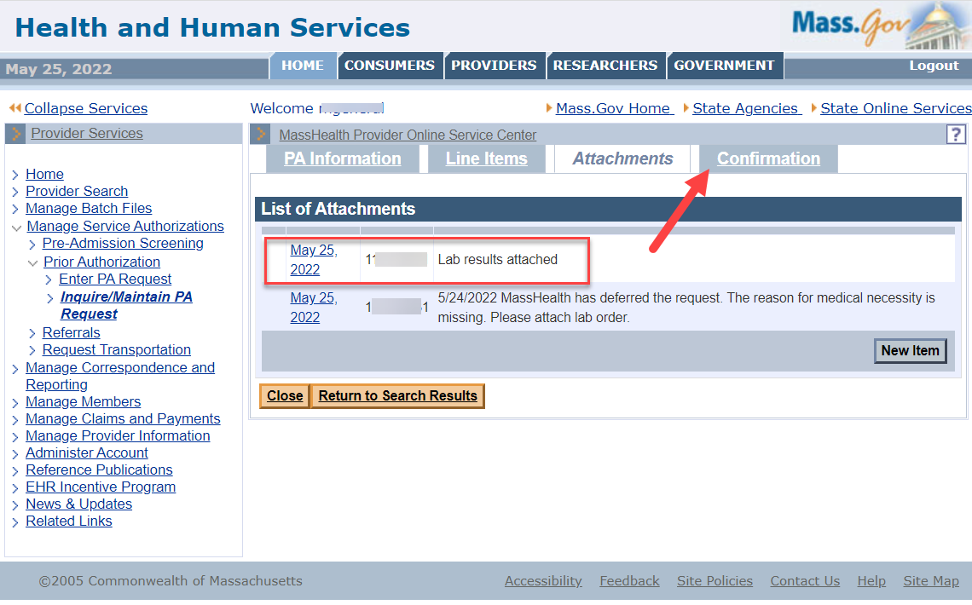

The provider can review the details of the PA in the **Confirmation** panel.

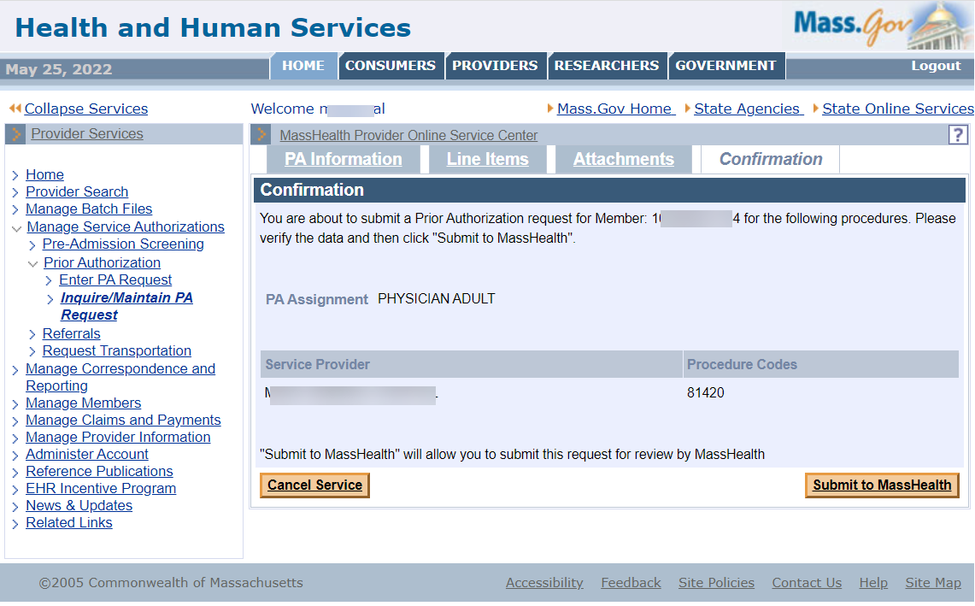

## Submit to MassHealth

Click **Submit to MassHealth** on the **Confirmation** panel. This allows the system to verify the data before sending the attachment to MassHealth.

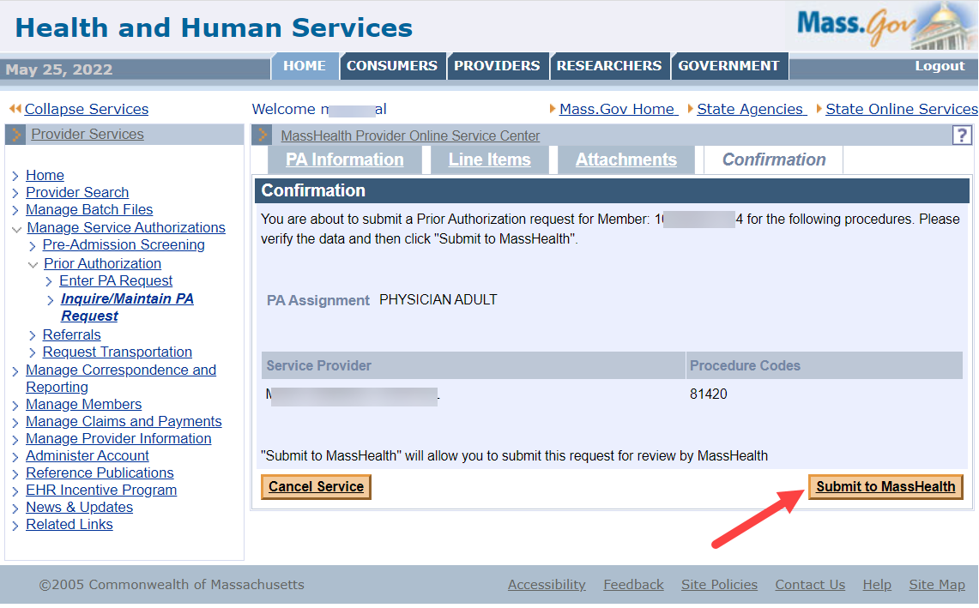

Confirm that you have reviewed any warning messages and fixed any errors.

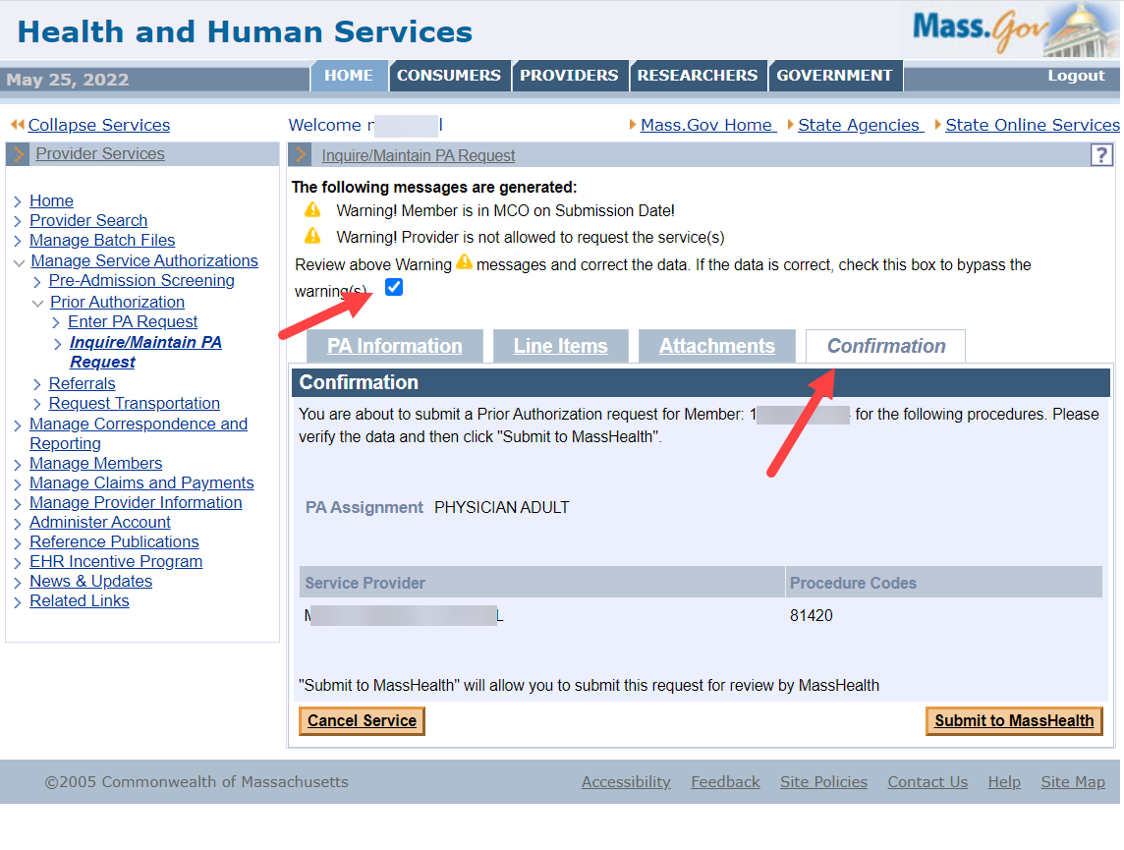

The **Prior Authorization** **Response** page confirms successful submission once all errors and warnings are cleared.

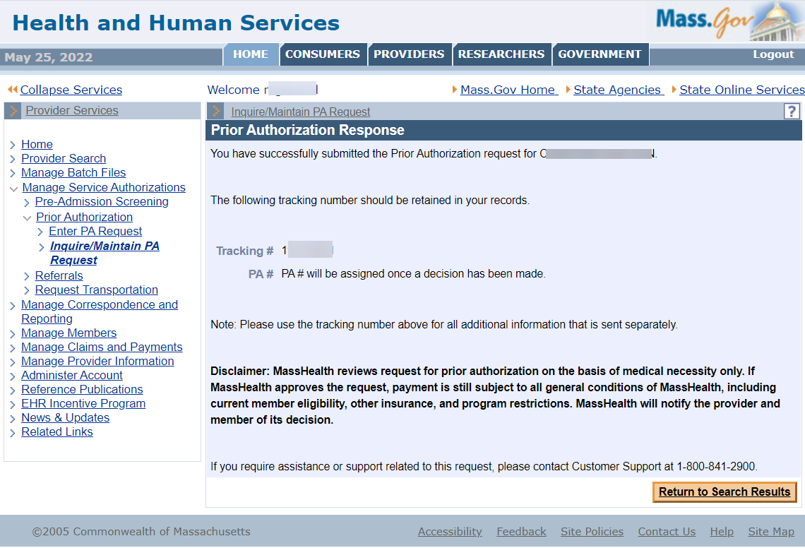

Return to the **Prior Authorization Search** page and search for the PA in deferred status. Note that the PA is no longer there.

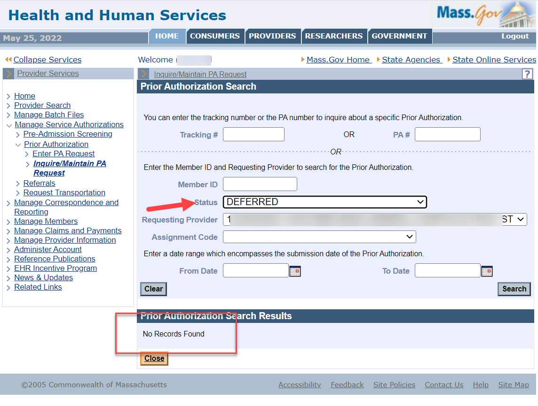

The PA status will update to show that the additional information has been received. The results will include the assigned tracking number.

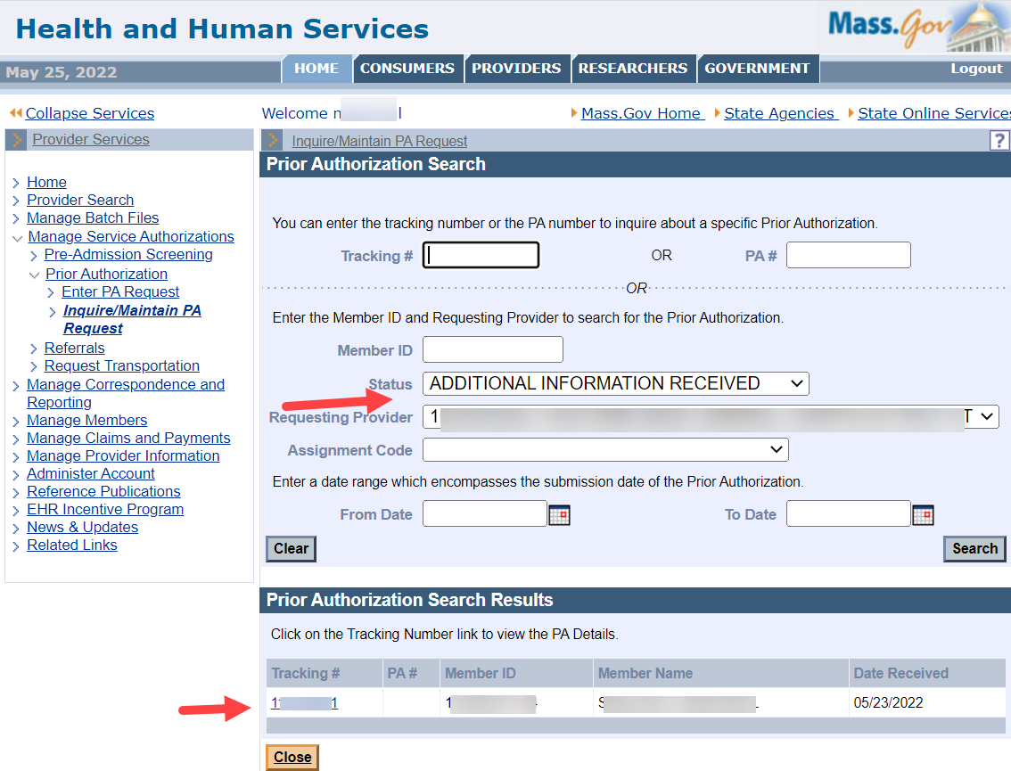

Return to the **Base Information** panel. You can see that the status has changed on the **Information** tab.

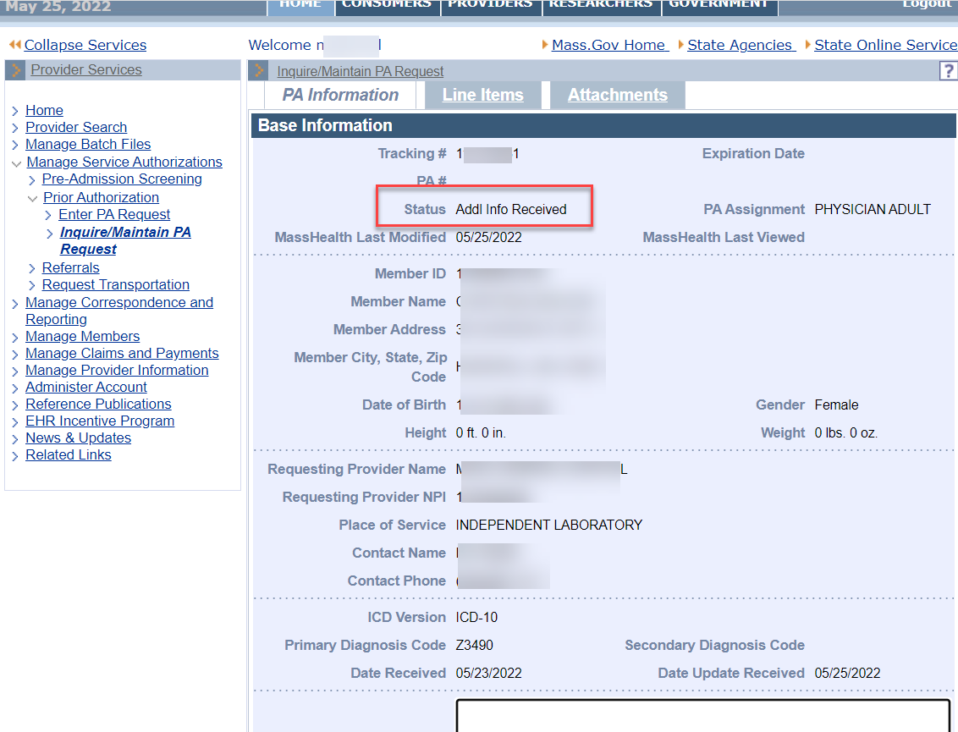

The status has also changed on the **Line Items** tab.

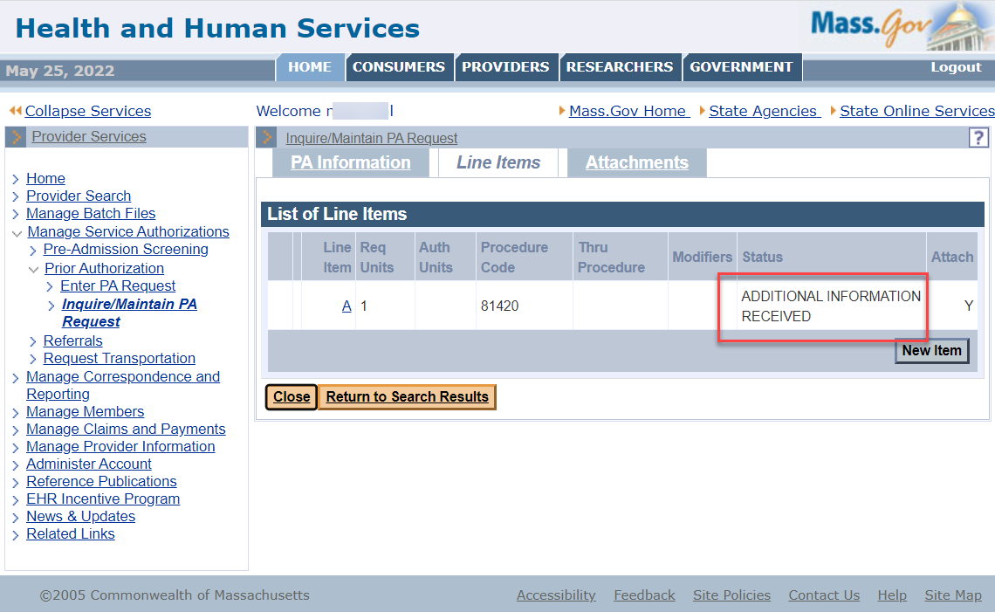

A reviewer can now select the PA request from the MassHealth Worklist to continue the review.