Job Aid: Submit a Residential Care Home Claim

This job aid describes how to submit a single Residential Care Home institutional claim in the Provider Online Service Center (POSC). For specific billing information, refer to the [Residential Care Home Billing Guide for the UB-04](https://www.mass.gov/doc/residential-care-home-billing-guide-for-the-ub-04-2/download).

**Note:** Fields with an asterisk are required fields and must be completed to proceed to the next panel.

# Access Enter Single Claim

From the **POSC** home page:

1. Click **Manage Claims Payments**.
2. Click **Enter Single Claim**. The **Claim Templates** panel displays.

On the **Claim Templates** panel:

1. Click **Institutional Claim**. The **Billing Information** panel displays.

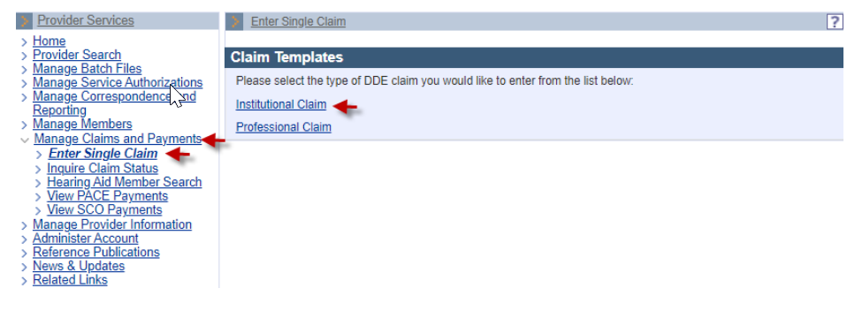

# Billing Information: Enter Billing and Resident Information

On the **Billing Information** panel:

1. Select the **Type of Bill\*** from the dropdown list.
2. Select the **Billing Provider ID\*** from the dropdown list. This is the 10-digit identification number/service location code assigned to the residential care home by MassHealth.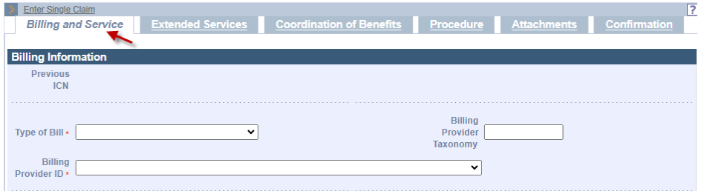
3. Enter the **Member ID\*** for the claim. This is the resident’s 12-digit member identification number.
4. Enter the **Patient Account #\***. If you use an account number to identify and track your residents, enter this account number in this field.
5. Enter the resident’s name in the **Last Name\*** and **First Name\*** fields.
6. In the **DOB\*** field, enter the resident’s date of birth.
7. Select the resident’s **Gender\*** from the dropdown list.
8. In the **Member Address 1\*** field, enter the street address of the residential care home in which the resident lives.
9. Enter the resident’s **City\***, **State\***, and **ZIP code\*** for the residential care home in which the resident lives.

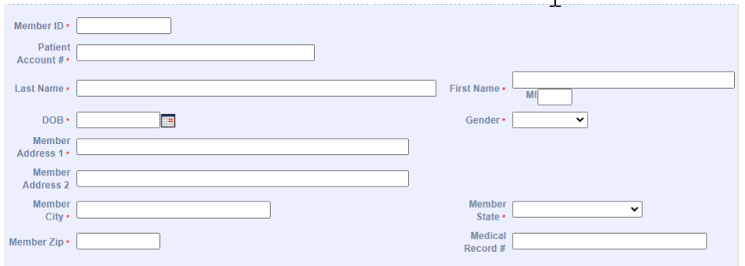

# Billing Information: Enter Provider and Benefit Information

On the **Billing Information** panel:

1. In the **Attending Phys Last Name** and **Attending Phys First Name** fields, enter the name of the attending physician associated with the claim.
2. Enter the **Attending Phys NPI** (national provider number).

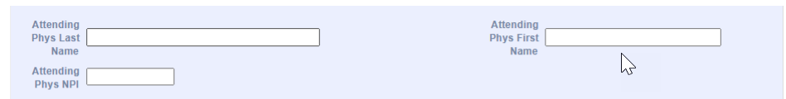

1. In the **Assignment of Benefits Ind\*** dropdown list, select whether the resident authorizes benefits to be paid to the residential care home.
2. Select the appropriate value in the **Provider Accepts Assignment\*** dropdown list.
3. Select the **Claim Filing Indicator\*** from the dropdown list.
4. Select the **Release of Information\*** from the dropdown list.

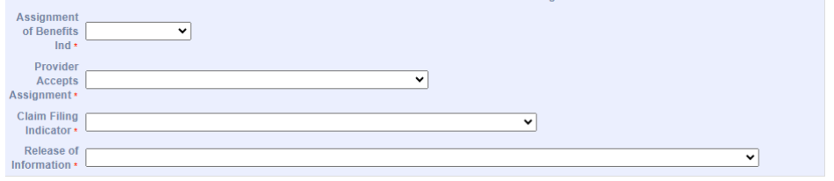

# Service Information: Enter Service Information

On the **Service Information** panel:

1. In the **From Date\*** and **Through Date\*** fields, enter the date range for the claim.
2. Select the **Patient Status\*** from the dropdown list.
3. Select the **Admit or Visit Source** from the dropdown list.
4. Enter the **Admission or Visit Type\*** from the dropdown list.
5. Enter the **Admission Date**. Enter the date of the resident’s initial admission to the residential care home or the date of the most recent readmission following a three-day hospital stay.

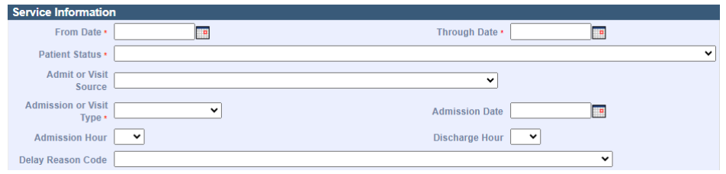

# Claims Charges: Enter the Claim Charges

On the **Claims Charges** panel:

1. Enter the **Total Charges\*** for the claim.

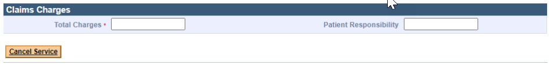

# Extended Services: Enter Occurrence Information

**Note:** This section is applicable only if entering MLOA—Medical Leaveand NMLOA—Non-Medical Leaveinformation.

1. Click the **Extended Services** tab.

On the **List of Occurrences** panel:

1. Click **New Item**. The **Occurrence Code Detail** panel displays.

On the **Occurrence Code Detail** panel:

1. Select the **Occurrence Code\*** from the dropdown list.
2. Select the **Type\*** of occurrence from the dropdown list.
3. In the **From\*** and **To** fields, enter the date range for the occurrence code for the claim.
4. Click **Add** to save the Occurrence information. Repeat steps 26–30 to add more occurrences.

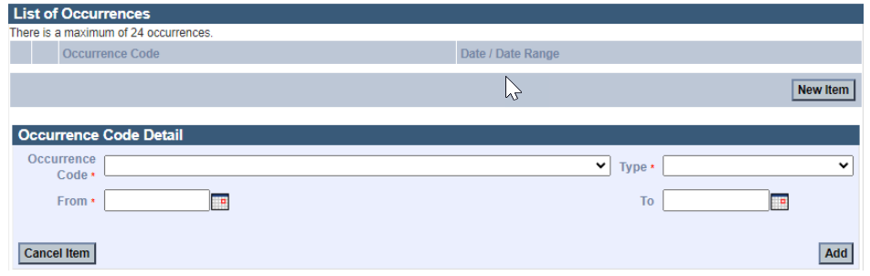

On the **List of Values** panel:

1. Click **New Item**. The **Value Code Detail** panel displays.

On the **Value Code Details** panel:

1. Select the **Value Code\*** from the dropdown list.
2. In the **Value\*** field, enter the value.
3. Click **Add** to save the Value information. Repeat steps 31–34 to add more values.

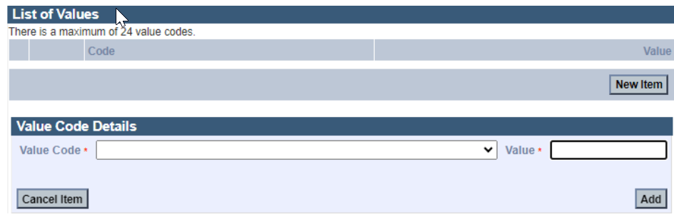

# ICD Version: Specify the ICD Version

1. On the **ICD Version\*** panel, the radio button will default to ICD-10.
2. On the **Principal and Admitting Diagnosis Codes** panel:
3. Enter the **Principal Diagnosis Code\***.
4. Enter **Principal Present on Admission** from the dropdown menu.
5. Enter the **Admitting Diagnosis Code**.

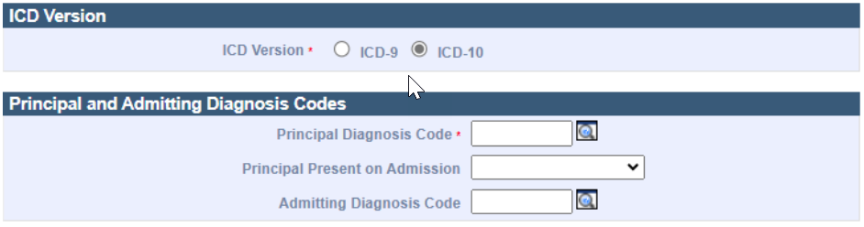

# List of Diagnoses: Enter Diagnosis Information

On the **List of Diagnoses** panel:

1. Click **New Item**. The **Diagnosis Code Detail** panel displays.

On the **Diagnosis Code Detail** panel:

1. Enter the **Diagnosis Code\***. This is the ICD-CM code that describes the resident’s principal diagnosis. Refer to the [NUBC Instruction Manual](https://www.nubc.org/) for code values.
2. Select the **Type** of diagnosis code from the dropdown list.
3. Click **Add** to save the diagnosis code. Repeat steps 41–43 to add more diagnosis codes.

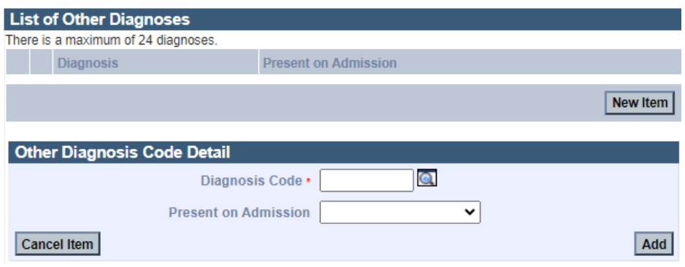

# Enter Procedure Information

1. Click the **Procedure** tab.

On the **List of Institutional Services** panel:

1. Click **New Item**. The **Institutional Service Detail** panel displays.

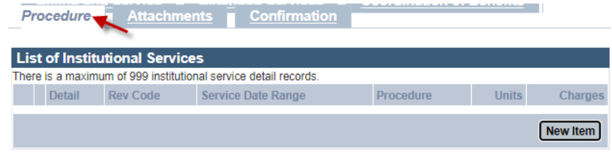

On the **Institutional Service Detail** panel:

1. Enter the **Revenue Code\***.
2. Enter the number of **Units\*** for the claim. This is the number of days for the claim.
3. Select the **Units of Measurement\*** from the dropdown list.
4. Enter the **Charges\*** for the claim.
5. Click **Add**. Repeat steps 45–50 to add more claim lines.

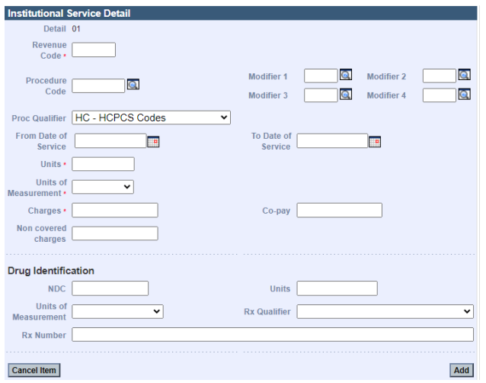

# Confirm Claim

1. Click the **Confirmation** tab.
2. Verify that the claim information is correct.
3. Once you have verified the claim is correct, click **Submit**.

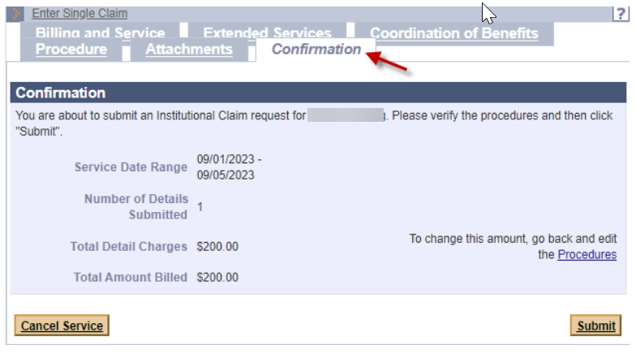

1. Review the adjudicated claim results as identified on the confirmation page. Verify the claim status.

# Explanation of Benefits (EOB) Codes

On the **Explanation of Benefits (EOB)** panel:

1. Review any EOB codes that may appear. If the claim status is denied, correct any errors and resubmit the claim.
2. Click **Close**.

