Job Aid: Submit Management Minutes Questionnaire

The Management Minutes Questionnaire (MMQ) is used to determine the total minutes of care per day that a resident requires. The score received at the end of the MMQ determines the reimbursement rate a nursing facility receives for each resident.

This job aid describes how to:

- Access MMQ service questions;
- Enter the required information on an MMQ; and
- Submit an MMQ.

Note: MMQ is only required for dates of service prior to October 1, 2023. For all dates of service on or after October 1, 2023, nursing facilities need to submit Minimum Data Set (MDS) 3.0 in accordance with the MDS 3.0 Resident Assessment Instrument (RAI) Manual and guidelines. Refer to MassHealth Nursing Facility Bulletin 181 for guidance on the MDS process.

Access the MMQ
From the Provider Online Service Center (POSC) home page:
- Click Manage Members.
- Click Long Term Care.
- Click Enter Management Minute Questionnaires (MMQ).
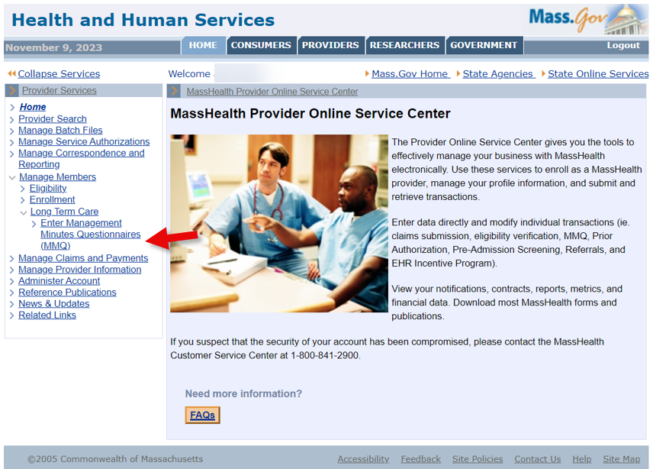

Member Search
On the Member Search panel:
- Select Provider ID from the dropdown list.
- Enter the Member ID.
- Enter the Last Name.
- Enter the First Initial.
- Select the Reason for Submission from the dropdown list.
- Click Search.
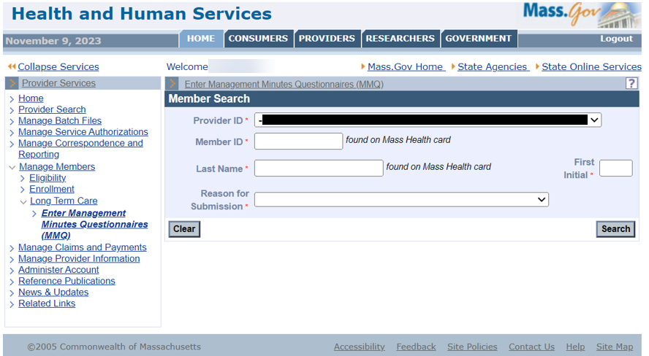

Complete the Personal Information Panel
On the Personal Information panel:
- Enter the Effective Date.
- Enter the Date of Admission.
Note: The Date of Admission field is blank for MMQs for new admissions and conversions. For other submission reasons (for example, semiannual score change), the admission date is returned in the search response. This date cannot be in the future.
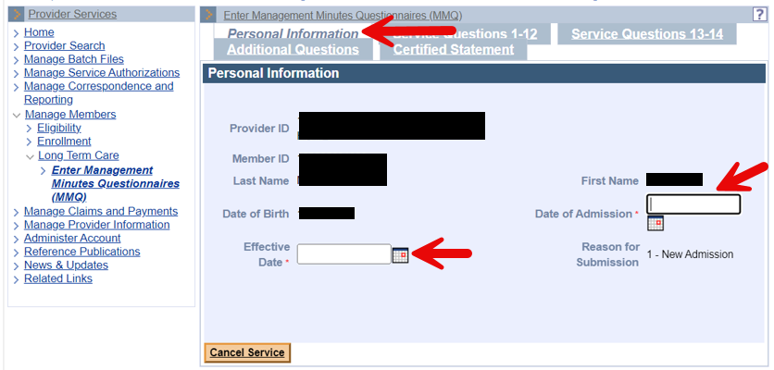
- Click the Service Questions 1–12 tab.

Complete the Service Questions 1–12 Panel
On the Service Questions 1–12 panel:
- Select the Skilled Observation Daily choice from the dropdown list (Question 2).
Note: The Dispense Medications and Chart field (Question 1) is pre-filled for all members.
- Select the Bathing and Grooming choices from each dropdown list (Question 3: Personal Hygiene).
- Select the Dressing choice from the dropdown list (Question 4).
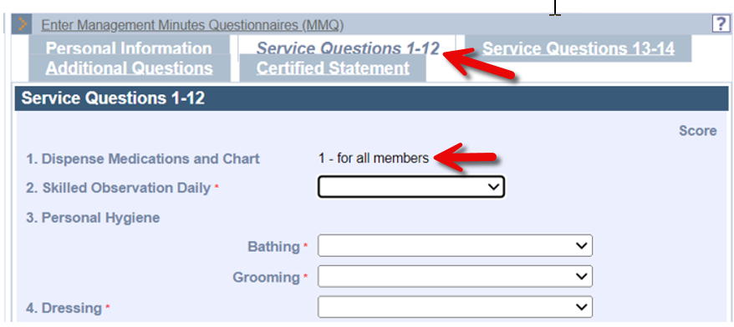

- Select the Mobility choice from the dropdown list (Question 5).
- Select the Eating choice from the dropdown list (Question 6).
- Select the Bladder and Bowel choices from each dropdown list (Question 7: Continence/Catheter).
- Select the Bladder/Bowel Retaining choice from the dropdown list (Question 8).
- Select the Positioning choice from the dropdown list (Question 9).
- Select the Pressure Ulcer Prevention choice from the dropdown list (Question 10).
- Select the Stage 1, Stage 2, Stage 3, Stage 4, and Frequency choices from each dropdown list (Question 11: Skill Procedure Daily/Pressure Ulcer).
- Select the Skilled Procedure Daily/Other, Procedure 1, Procedure 2, and Procedure 3 choices from each dropdown list (Question 12).
- Click Get Score.
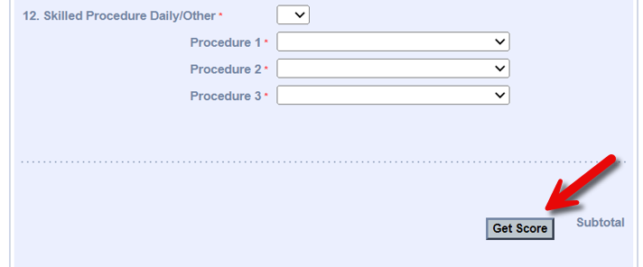
Note: Get Score is not required to get the next panel, but it allows you to keep track of the total range of minutes as you proceed through the questionnaire. It will also identify any errors on this panel.

Complete the Service Questions 13–14 Panel
On the Service Questions 13–14 panel:
- Select the Immobility, Severe Spasticity/rigidity, Behavioral problems, and Isolation choices from each dropdown list (Question 13: Special Attention).
- Select the Code/Type1, Code/Type 2, and Code/Type 3 choices from each dropdown list (Question 14: Restorative Nursing).
- Click Get Score.
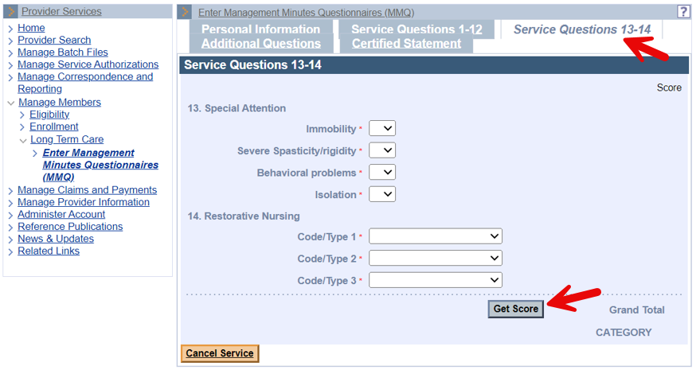
Note: Get Score is not required to get the next panel, but it allows you to keep track of the total range of minutes as you proceed through the questionnaire. It will also identify any errors on this panel.

Complete the Additional Questions Panel
On the Additional Questions panel:
- Select the Toilet Use choice from the dropdown list (Question 15).
- Select the Transfer choice from the dropdown list (Question 16).
- Select the Mental Status choice from the dropdown list (Question 17).
- Select the Restraint choice from the dropdown list (Question 18).
- Select the Activities Participation choice from the dropdown list (Question 19).
- Select the Consultation Type and Frequency choices from each dropdown list for numbers 1–4 (Question 20).
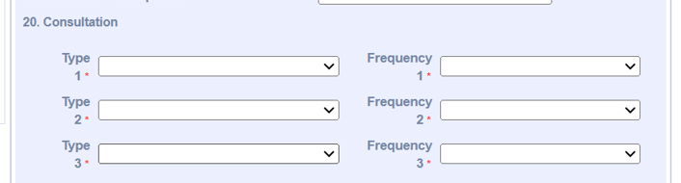
- Select the Medication Type and Frequency choices from each dropdown list for numbers 1–4 (Question 21).
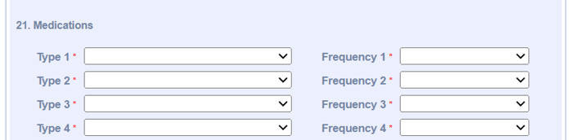
- Select the Accidents, Contracture, and Weight Change choices from each dropdown list (Question 22).
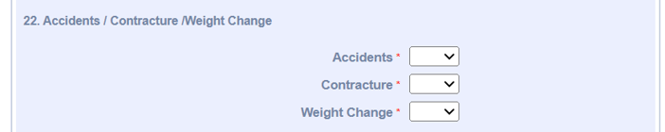
- Enter the ICD-CM code in the Primary ICD Diagnosis Code field (Question 23).
- Enter any Secondary ICD diagnoses in the Secondary Diagnosis Codes fields (Question 24).
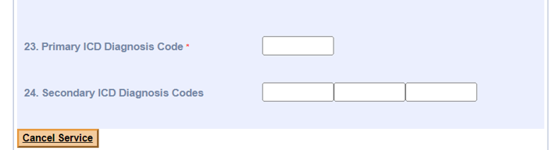

Complete the Certified Statement Panel
On the Certified Statement panel:
- Enter the name of the registered nurse who completed the MMQ in the Name of RN Evaluator field.
- Enter the date of the MMQ evaluation in the Evaluation Date field.
- Enter the name of the facility’s administrator in the Name of Administrator field.
- Select the affiliation from the Affiliation dropdown list.
- Select the Discharge Reason from the dropdown list if the member is being discharged.
- Enter the Discharge Date if the member is being discharged.
- Click Submit.
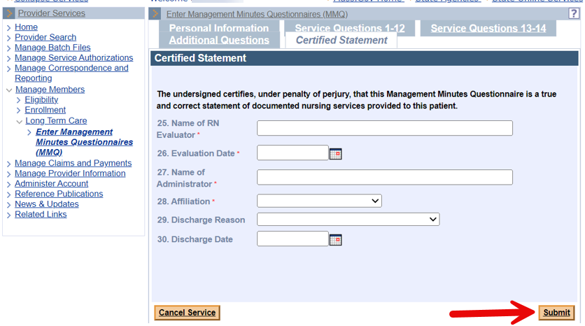

Confirmation Screen
Upon successful submission of the MMQ, the confirmation panel displays and includes the numerical score and the Category, which reflects the range of minutes for the MMQ.
- Click one of the following:
- Print;
- Request Another MMQ; or
- Close.
Note: If the MMQ was successfully processed, but no LTC segment was found for the member and Provider ID, the MMQ will be pended and the Pended panel will display.

