**Job Aid: Submit a Referral**

A MassHealth member is enrolled with the Primary Care Clinician (PCC) Plan at the service location/site level. MassHealth services provided by a provider other than the member’s PCC require referral from the member’s PCC in order to be payable, unless the service is exempted. Referral requirements and exceptions are noted in the MassHealth regulations at [130 CMR 450.118(J)](https://www.mass.gov/regulations/130-CMR-450000-administrative-and-billing-regulations).

This job aid describes how to

* submit a referral for a service provider; and
* use the **Search for Provider** function to locate a MassHealth provider.

**Enter a New Referral**

From the **POSC** home page:

1. Click **Manage Service Authorizations**.

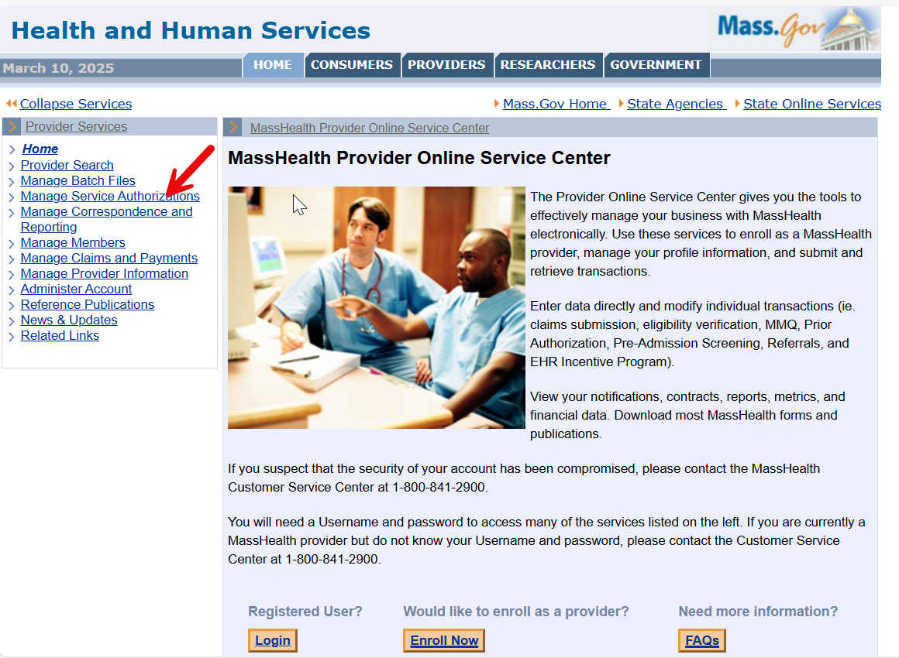

1. Click **Referrals**.
2. Click **Enter New Referral**.

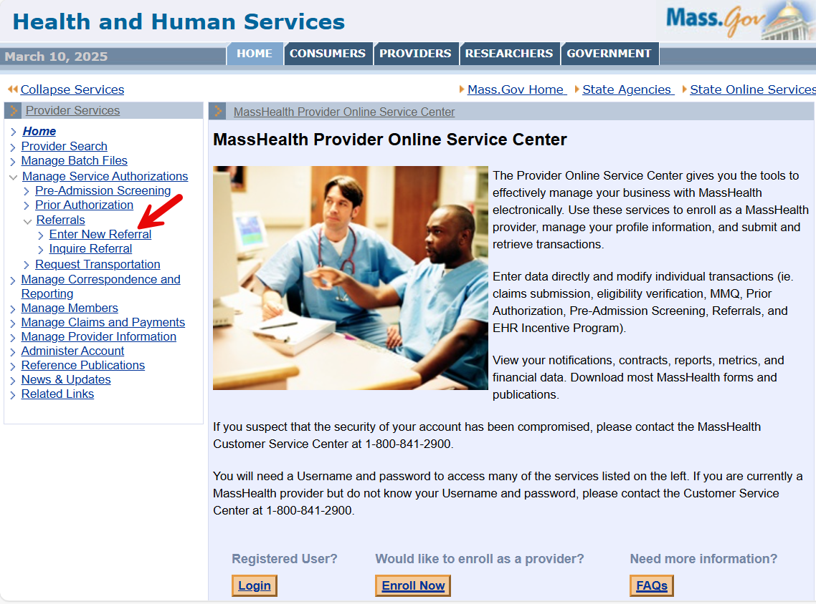

1. The **Referral Information** panel will display.

**Enter Member and Provider Information**

On the **Referral Information** panel:

1. Enter the **Member ID**.
2. Select the **Referring Provider** (the member’s PCC) from the dropdown list. This field will be populated based on the credentials used by the PCC to log in to the POSC.
3. In the **Service Provider** field, click the **Field Search** button to display the **Search for Provider** panel, where you can perform a search for the service provider.

**Search for Service Provider**

On the **Search for Provider** panel:

1. Enter the search criteria for the service provider.

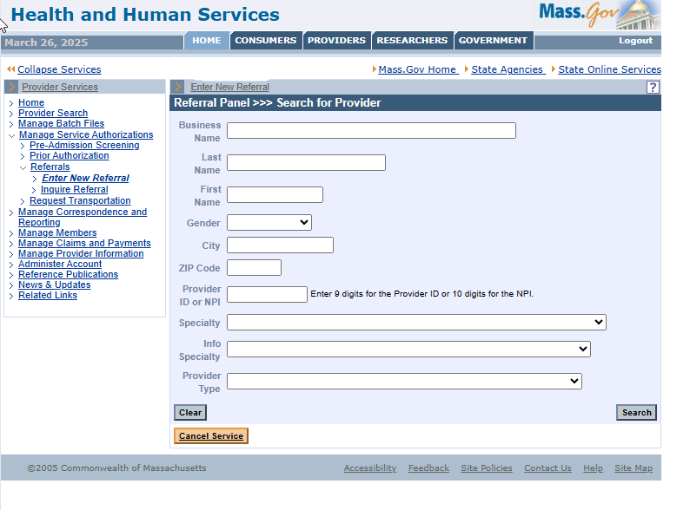

**Note:** For effective searching, enter as much search information as possible. You can search for service providers using one or more of the following search criteria.

* Business Name
* Provider’s Last Name
* Provider’s First Name
* Gender
* City
* ZIP Code
* Provider ID or NPI
* Specialty
* Provider Type

**Note:** The current MMIS provider search capability within the Service Authorizations subsystem is limited to active MassHealth providers and specialties such as nursing homes, abortion services, etc.

1. Click **Search**. A **List of Service Providers** panel will be displayed.

You may select a provider at the individual or group level. The specificity of your selection determines the **Service Provider** who can file a claim for the services requested by your referral. For example, if you select a **Group Practice Provider** level, any provider in the group can submit a claim. If you select at the Individual Provider level, only that provider will be allowed to submit claim(s). To identify board-certified specialists, use your current business process/methods through your own network of providers.

**Select Referring Provider**

On the **List of Providers** panel:

1. Click the hyperlinked **Name** of the desired service provider. Within the **Referral Information** panel, the selected provider’s name will populate the **Service Provider** field.

**Referral Details and Submit**

On the **Referral Information** panel, complete at least the fields marked with an asterisk (*). Fields without an asterisk are informational and not required.

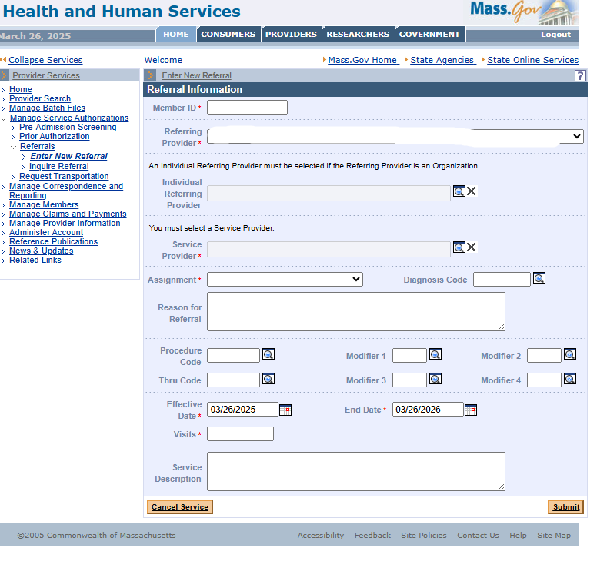

1. In the **Assignment** field, select the type of referral from the dropdown list. Payment edits are not applied to the selection.
2. Enter the **Diagnosis Code** (optional).
3. Enter the **Reason for Referral** (optional). In this text box and **Service Description**, consider entering brief details about the purpose for issuing a referral.
4. Enter **Procedure Code** and **Thru Code with Modifiers** (optional).
5. Enter the **Effective Date** of the referral.
6. Enter the **End Date** of the referral.

**Note:** When an **Effective Date** is entered, the **End Date** field is automatically populated with a date one year from the Effective Date. Enter a different End Date or leave the default date of one year. You can use the **Inquire Referral** panel to change the End Date in the future, after the referral has been submitted.

1. In the **Visits** field, enter the total number of authorized visits to the **Service Provider**. The number of Visits can be less than, equal to, or greater than the number of days the referral is active.
2. Once you have entered all the required information, click the **Submit** button. A **Referral Confirmation** panel will display, indicating that you have successfully submitted the referral and providing you with the **Referral Number** that has been assigned.
3. All service providers listed on the referral will automatically be notified on the evening of the approval.

**Referral Updates** (See **Update a Referral** and **Inquire on a Referral** Job Aids)

**Notes:**

1. The referral remains active and available under the following conditions.

* The referral matches the **Member** and **Service Provider**.
* The **Effective Date** and **End Date** range includes the date of service of the claim.
* The total number of **Visits** (episodes of service) on the referral has not been exceeded.

1. The referral will be automatically canceled under the following conditions.

* For any available referral, when the member leaves the PCC Plan, the **End Date** is changed to the close date.
* When a member changes enrollment to a different PCC, the **End Date** of the referral will
  + remain unchanged if the **End Date** on the referral is less than or equal to **30** days after the close date; or
  + be set to a grace period of **30** days after the close date, if the **End Date** on the referral is greater than **30** days after the close date.