# Job Aid: Update Provider Profile – Doing Business As (DBA) Address

This job aid describes how to update the provider DBA address via the MassHealth Provider Online Service Center (POSC).

* Update the provider DBA address via the MassHealth Provider Online Service Center (POSC).

This job aid is not intended for the following provider types.

* + Long-Term Services & Supports (LTSS)
  + Dentist
  + Ordering, referring, and prescribing (ORP)

## Updating Provider Address

Each MassHealth provider must notify MassHealth prior to or no later than the effective date of the change. Changes made via the POSC may still require the submission of paper documentation. For certain providers, a new application may be required when there is a change to the “doing business as” (DBA) address. To understand what documents are needed for certain types of address changes, please refer to the **Change of Address – Provider Requirements** webpage at [mass.gov/info-details/change-of-address-provider-requirements](https://www.mass.gov/info-details/change-of-address-provider-requirements).

Non-billing ordering, referring, and prescribing (ORP) providers must submit any update in writing. Address changes should be reported by submitting the [MassHealth Change of Address](https://www.mass.gov/doc/masshealth-provider-change-of-address-form-3/download) form.

Long-Term Services and Supports (LTSS) providers cannot update via this portal. Please contact MassHealth LTSS Provider Services at [masshealthltss.com](http://www.masshealthltss.com).

Dentists cannot update via this portal. Please contact the MassHealth Customer Service for Dental Providers here at [masshealth-dental.net](https://www.masshealth-dental.net/).

**Note:** Fields with an asterisk are required fields and must be completed to proceed to the next panel.

### **Address Types**

* **Doing business as (DBA) Address** –the service location address where services are rendered. For certain providers, a new application may be required when there is a change to the DBA address. Please review the [Change of Address – Provider Requirements](https://www.mass.gov/info-details/change-of-address-provider-requirements).
* **Legal Entity Address** - Individual providers must list their home address in this section. For entities, you must list the address registered with the IRS for this FEIN. To request a change to this address, please submit the [MassHealth Provider Change of Address Form](https://www.mass.gov/info-details/change-of-address-provider-requirements).
* **Billing Address** – The provider billing address must match DBA if the NPI is linked to more than one PID/SL.
* **Check Mailing Address** – Listed as the Remittance Address on the MA-W-9. MassHealth requires all providers to accept payment via EFT. This address would be used to mail checks if there were EFT issues.
* **Mailing Address** – no longer is use.
* **Remittance Address** – no longer is use. Provider must download their MassHealth remittance advices from the POSC.

**Note:** If the provider shares the NPI for multiple PID/SLs, you may be required to bill the service location address in the 2010AA and/or MassHealth assigned taxonomy in the 2000A PRV segments to avoid claim denials.

## Access Update Your MassHealth Profile

From the **POSC** home page:

1. Click **Manage Provider Information**.
2. Click **Maintain Profile**.
3. Click **Update Your MassHealth Profile** to access the **List of Providers** panel.

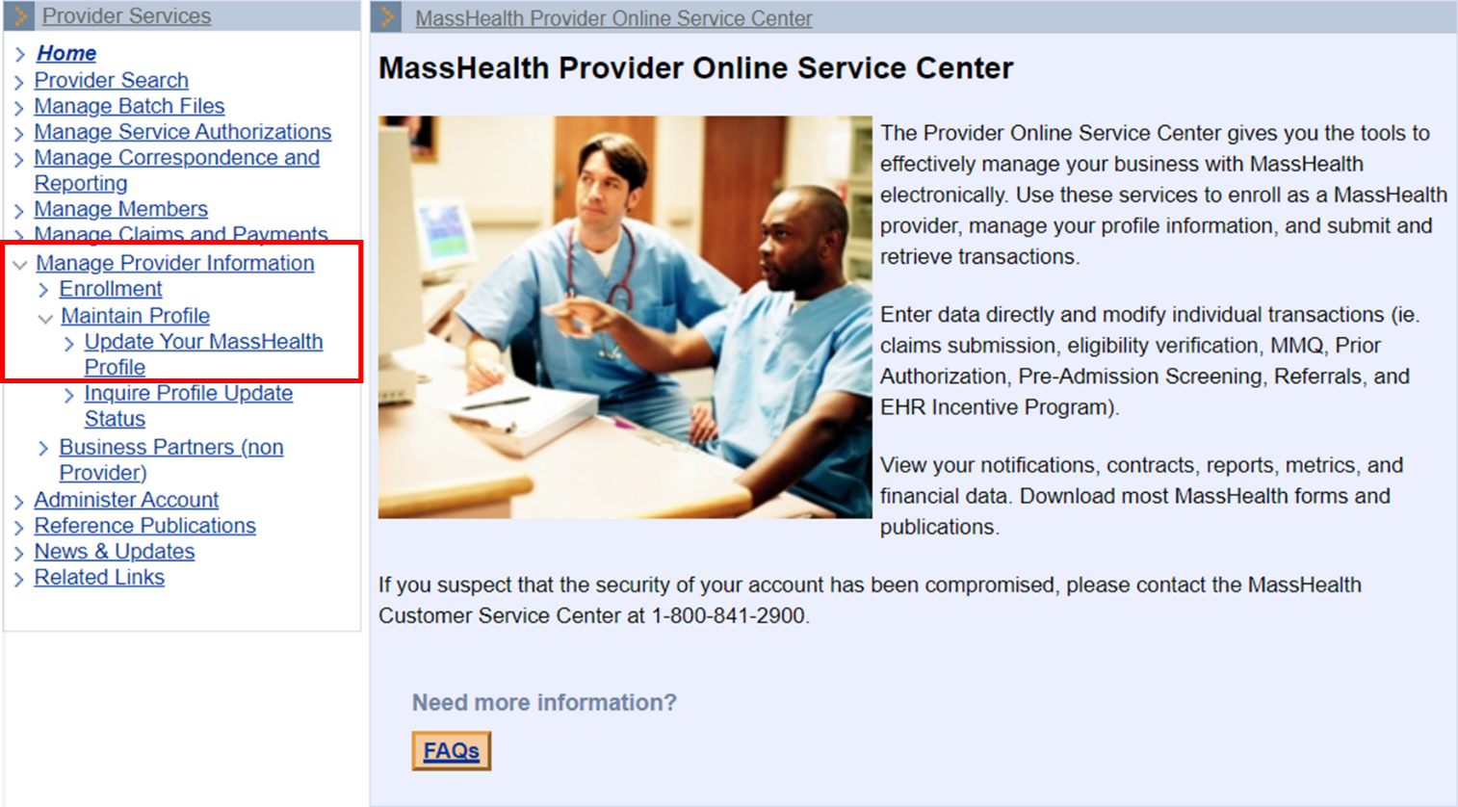

1. Select the provider you wish to update.  
   Reminder: Updates for LTSS, Dental, and/or ORP providers cannot be submitted via the Provider Online Service Center.

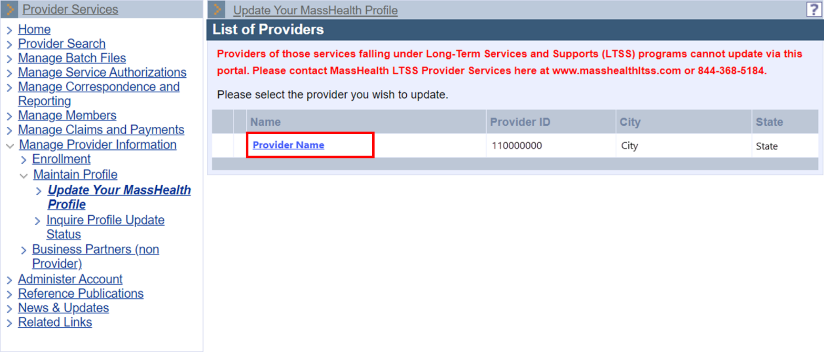

1. On the **Steps** panel, click **Service Locations** to open the **List of Locations** panel.   
   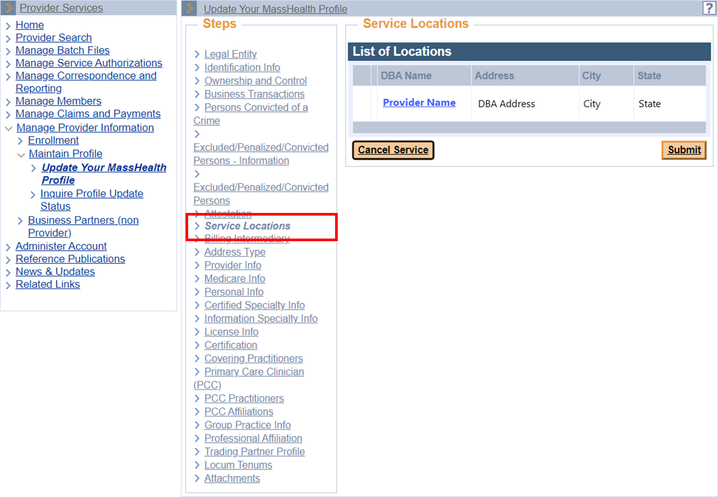
2. Select the service location being updated from the **List of Locations** panel. You will see all the providers you have access to under your User ID. If you do not see the provider location you are looking for, contact the Primary User for that provider ID/service location (PID/SL). The **Location Detail** panel will display.  
   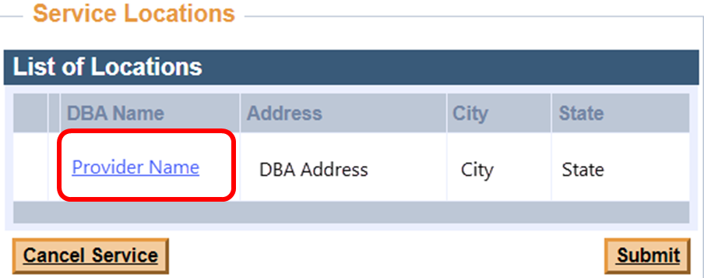
3. On the **Location Detail** panel, update the DBA address information. Be sure to complete all fields marked with a red asterisk.  
   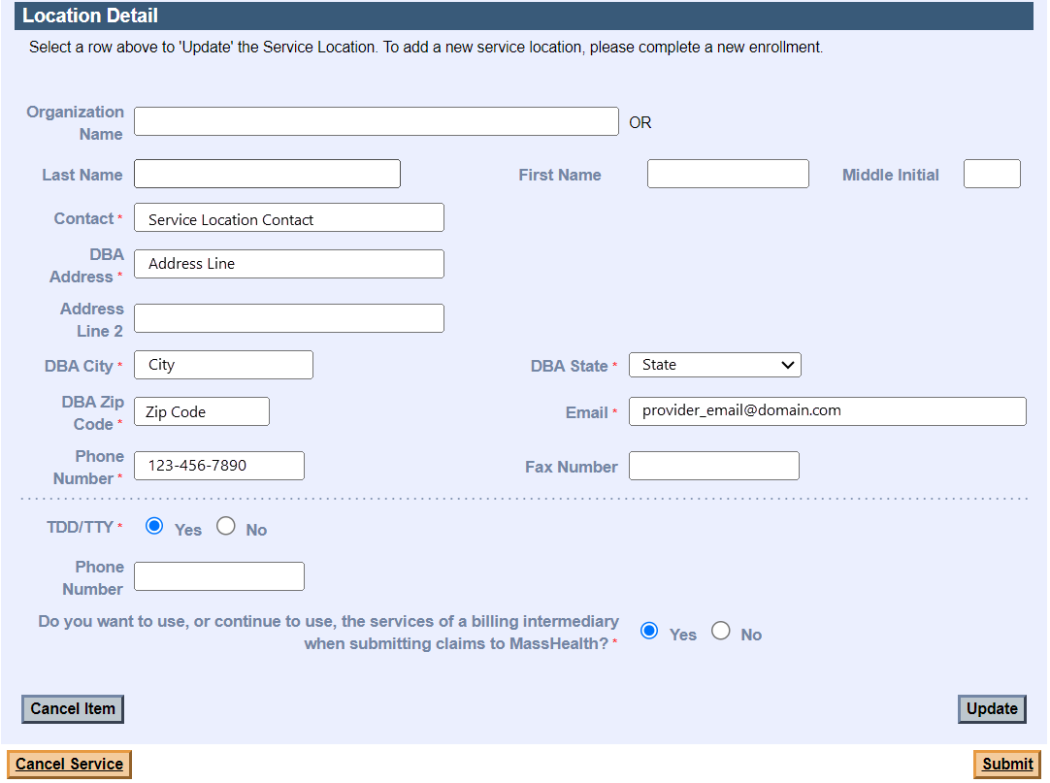
4. Select **Update** to return to the **List of Locations** panel.  
   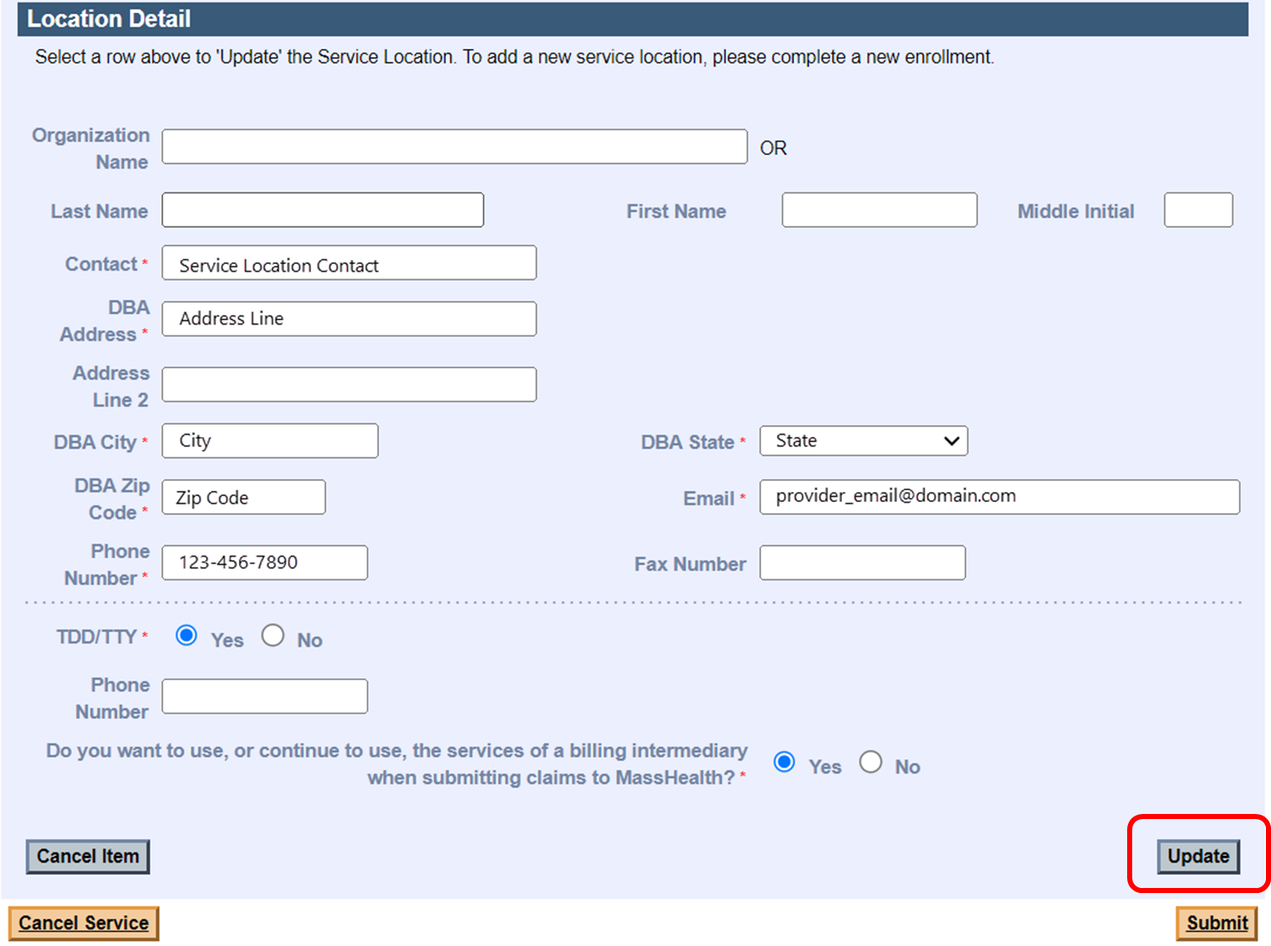
5. On the **List of Locations** panel, select **Submit**.  
   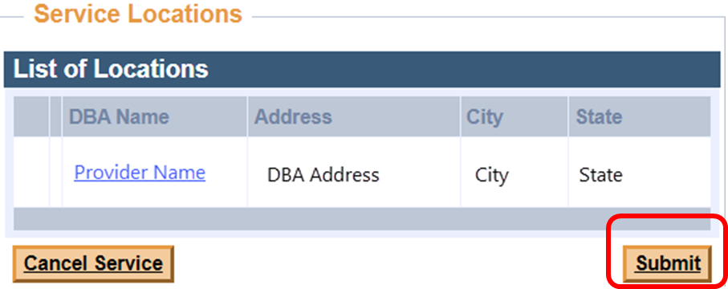

## Attestation

All update requests submitted via the POSC require a certification of agreement.

1. On the **Agreement** panel, click the indicated box to certify. Click **Submit** to submit the update request for processing.  
   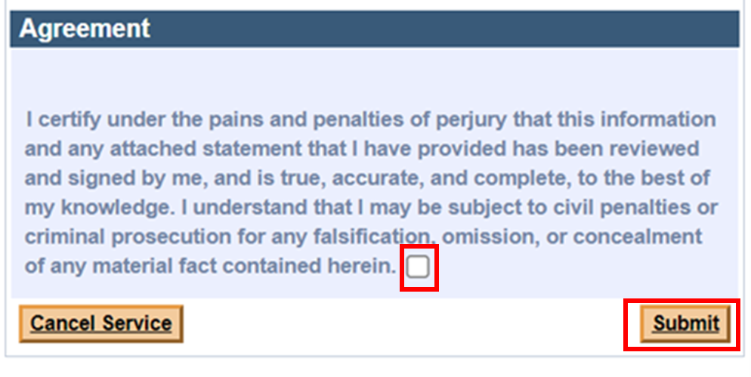

## Processing

All provider file update requests will be processed within 10 business days. A letter will be sent to the requesting provider’s DBA address once the change request is processed.