# Job Aid: Update Provider Profile - Group Link Requests

This job aid describes how to do the following.

* Update a Provider Profile via the MassHealth Provider Online Service Center (POSC).
* Request a group practice link.

This job aid is not intended for the following provider types.

* + Long-Term Services & Supports (LTSS)
  + Dentist
  + Ordering, referring, and prescribing (ORP)

Each MassHealth provider must notify MassHealth of any change to their information on file within 14 days. Failure to do so constitutes a breach of the provider contract. In no event may a group practice file a claim for services provided by an individual practitioner until the individual practitioner is enrolled and approved by MassHealth as a member of the group. See [130 CMR 450.223 (B)](https://www.mass.gov/regulations/130-CMR-450000-all-provider).

Group practice organizations must notify MassHealth when an individual practitioner joins or leaves the group practice prior to or no later than the effective date of change. MassHealth will not backdate the effective date of a group link request. Claims submitted for rendering providers not linked to the group will deny so timely updates are important.

Providers of those services falling under Long-Term Services and Supports (LTSS) programs cannot update via this portal. Please contact MassHealth LTSS Provider Services at [masshealthltss.com](http://www.masshealthltss.com).

Dentists cannot update via this portal. Please contact the MassHealth Customer Service for Dental Providers at [masshealth-dental.net](https://www.masshealth-dental.net/).

**Note:** Fields with an asterisk are required fields and must be completed to proceed to the next panel.

## Access Update Your MassHealth Profile

From the **POSC** home page:

1. Click **Manage Provider Information**.
2. Click **Maintain Profile**.
3. Click **Update Your MassHealth Profile** to access the **List of Providers** panel.

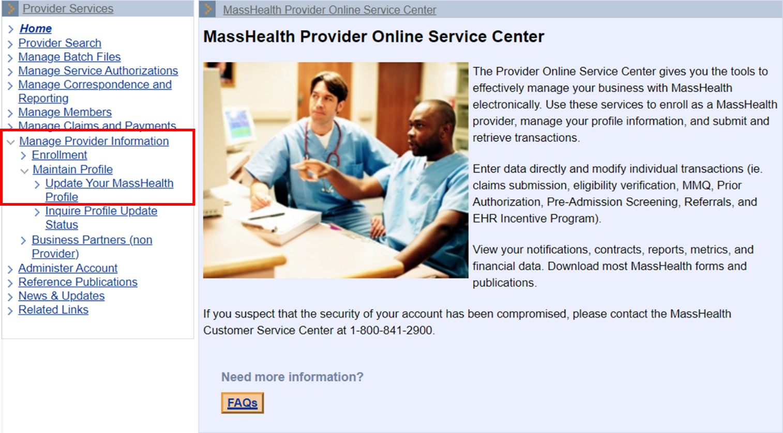

1. Select the provider you wish to update.  
   **Reminder:** Updates for LTSS, Dental, and/or ORP providers cannot be submitted via the Provider Online Service Center.

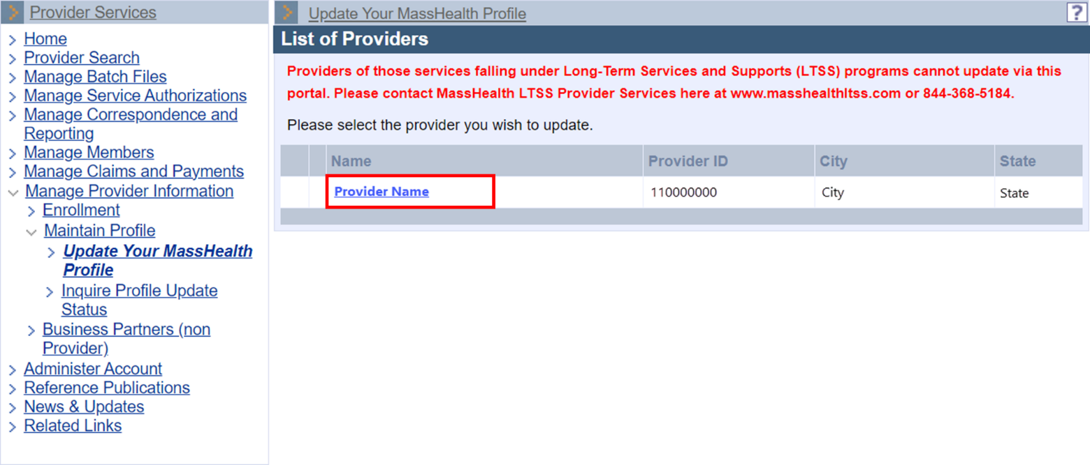

1. On the **Steps** panel, select **Group Practice Info**.  
   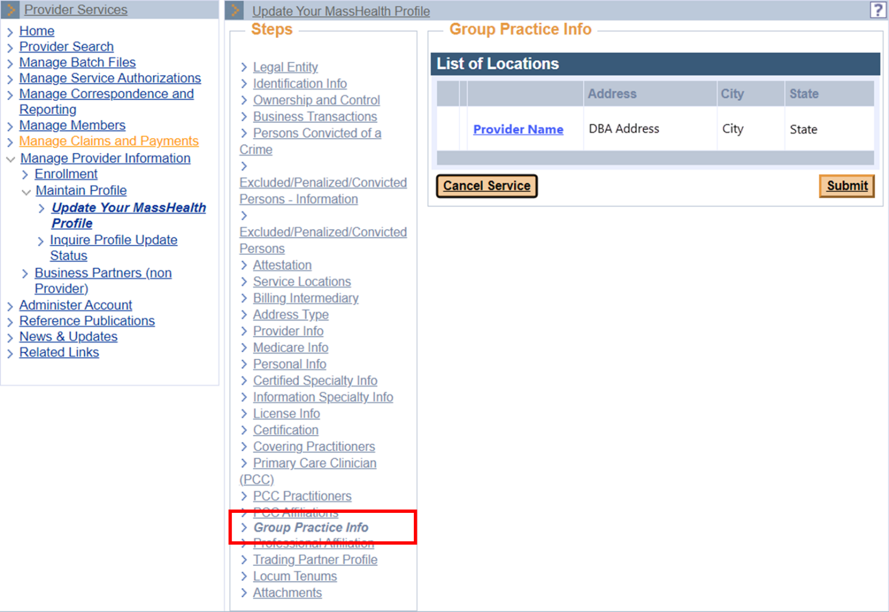
2. The **List of Locations** panel displays the providers granted to the User ID. If you do not see the provider location you are looking for, contact the Primary User for that provider ID/service location (PID/SL).  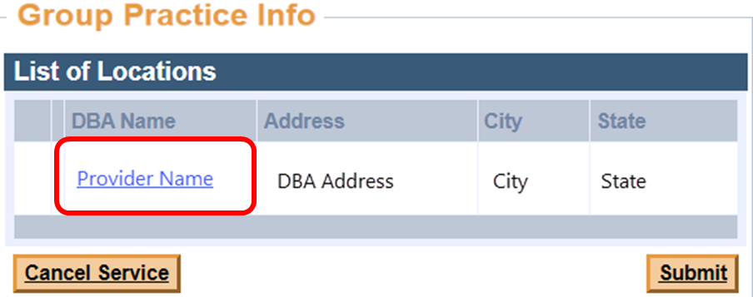
3. Select the appropriate **Service Location.** The **List of Servicing Providers** panel will display. This panel will list all servicing providers previously and currently linked to the group practice. If the individual practitioner is not listed, a link update must be submitted. Select **New Item**.  
   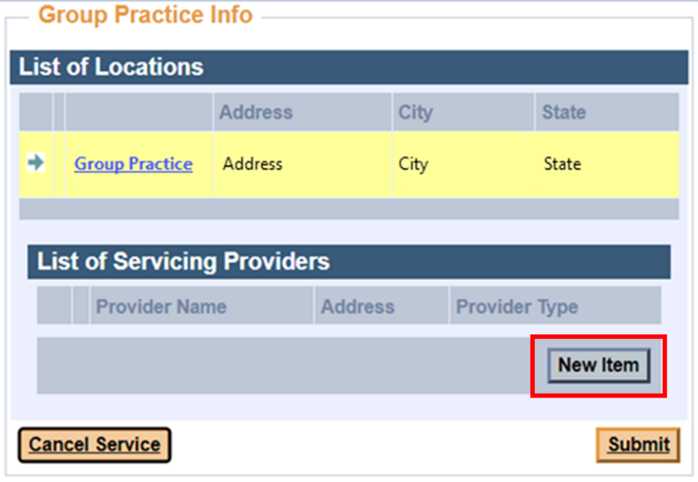
4. From the **Search for Existing Service Providers** panel, select the magnifying glass to open the **Search for Provider** panel.  
   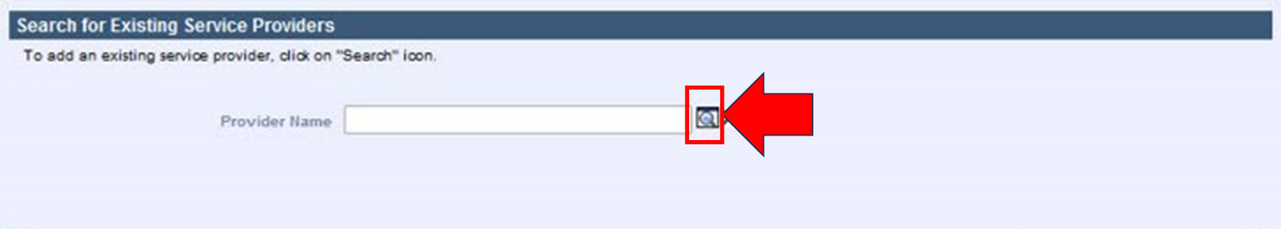
5. Enter the servicing provider’s Provider ID or NPI and select **Search**.  
   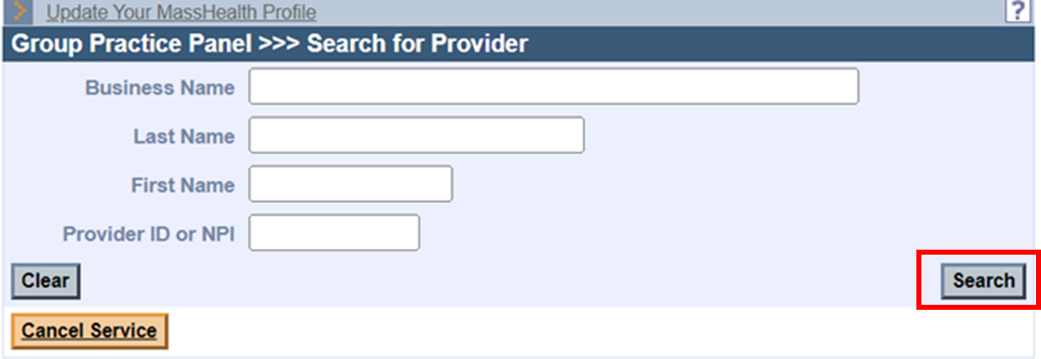  
   If the Provider ID or NPI are not readily available, you may search by name. Please note that that you don’t have to complete all fields. It’s possible to search with only partial information. Incorrect spelling will affect search results.
6. If the search is successful, the **List of Servicing Providers** panel will display the search results. Click the **Provider Name** to continue.  
   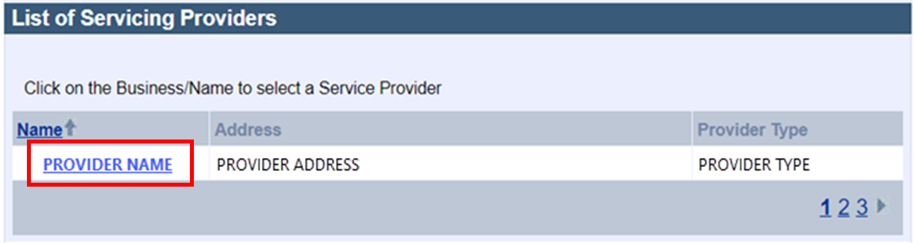
7. The **Service Provider Detail** panel will auto-populate the individual practitioner’s information. Verify the correct provider was identified. If correct, scroll down to the **Date Detail** panel. Enter the servicing provider’s effective date with the group practice in the **Effective Date** field. No end date is required.  
   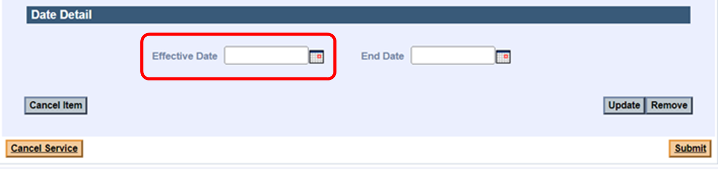  
   **Note:** Group practice organizations must notify MassHealth when an individual practitioner joins or leaves the group practice prior to or no later than the effective date of change. MassHealth will not backdate the effective date of a group link request. Claims submitted for rendering providers not linked to the group will be denied, so timely updates are important.
8. Click **Update** to save and return to the **List of Servicing Providers**.  
   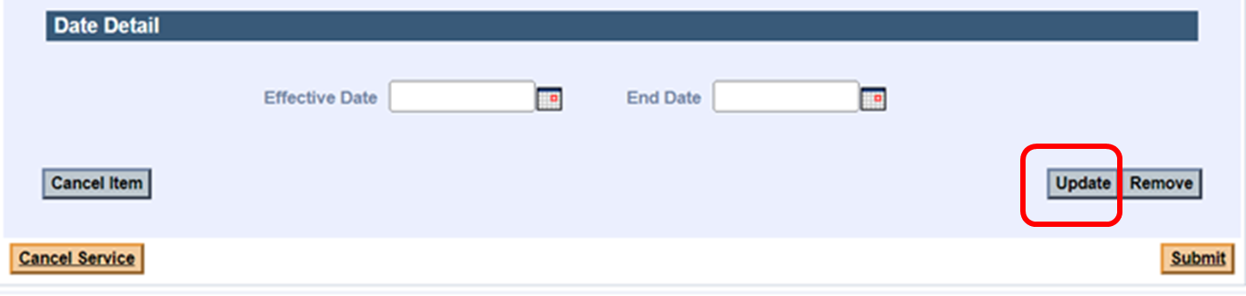
9. Select **Submit**.  
   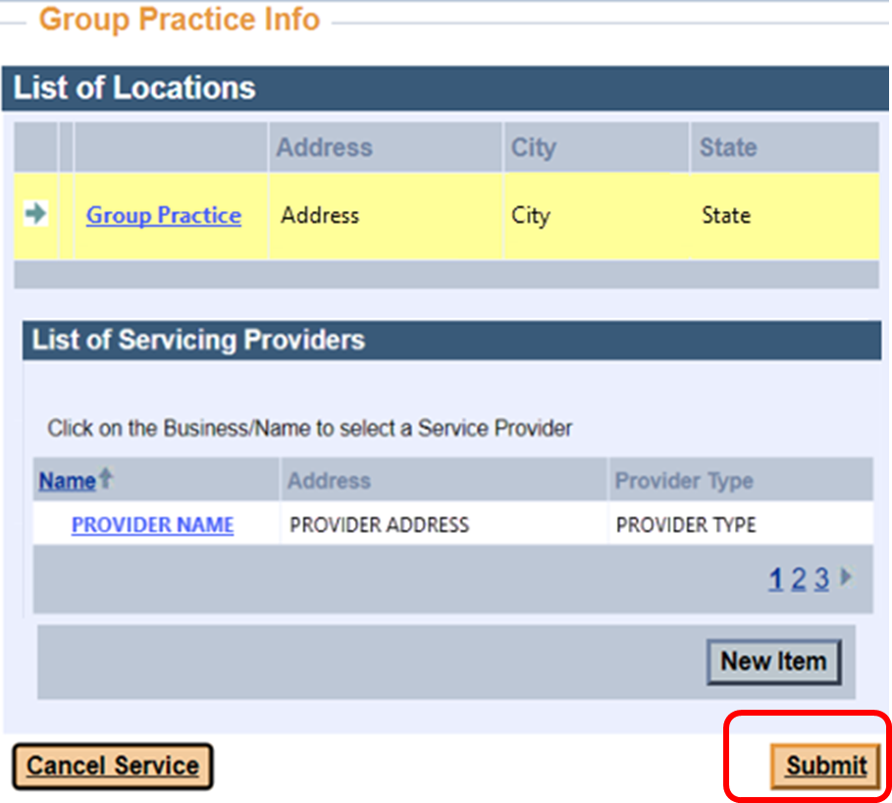

## Attestation

All update requests submitted via the POSC require a certification of agreement.

1. On the **Agreement** panel, click the indicated box to certify. Click **Submit** to submit the update request for processing.

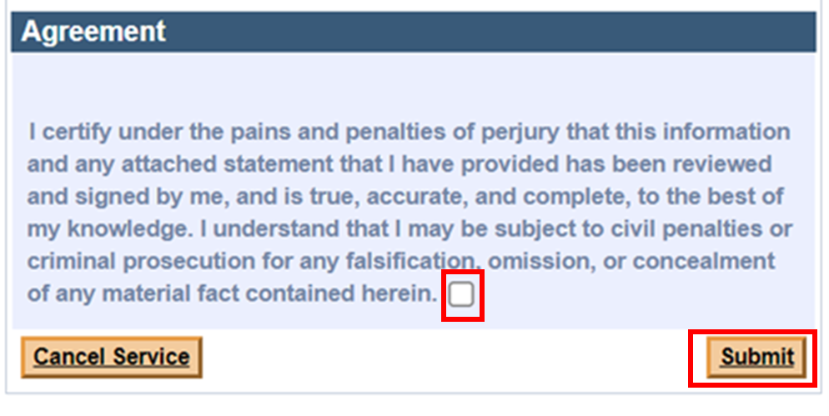

## Processing

All provider file update requests will be processed within 10 business days. A letter will be sent to the requesting provider’s DBA address once the change request is processed.