**Job Aid: Update a Referral**

A referring provider can change or modify an existing referral to a service provider as long as the referral is active and available. Please note that only the Primary Care Clinician (PCC) who originated the referral can update it.

This job aid describes how to

* use the **Search for Provider** function to locate referrals to a service provider; and
* modify a previously submitted referral.

**Inquire Referral**

From the **POSC** home page:

1. Click **Manage Service Authorizations**.

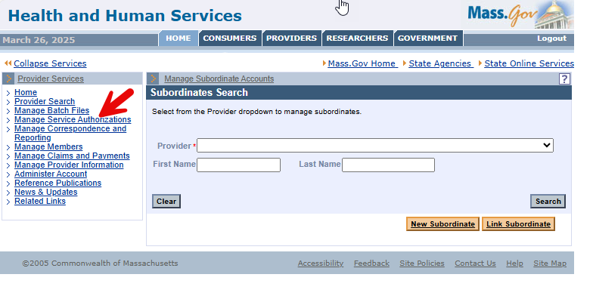

1. Click **Referrals**.

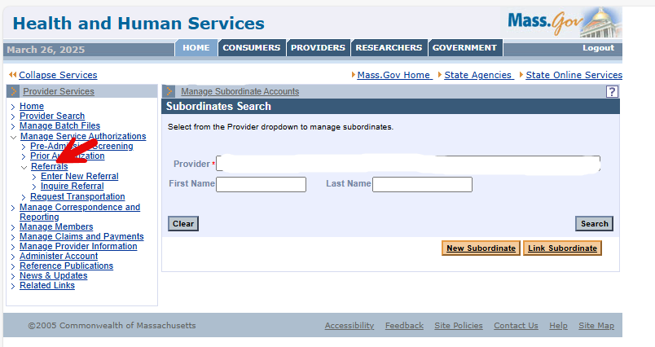

1. Click **Inquire Referral**. The **Referral Search** panel will display.

**Search for Referral**

On the **Referral Search** panel, the Referring Provider can search for referrals they submitted to a Service Provider. You can search by the Referral Number, Member and Service Provider Information, or by the Member and Service Provider issuing the referral.

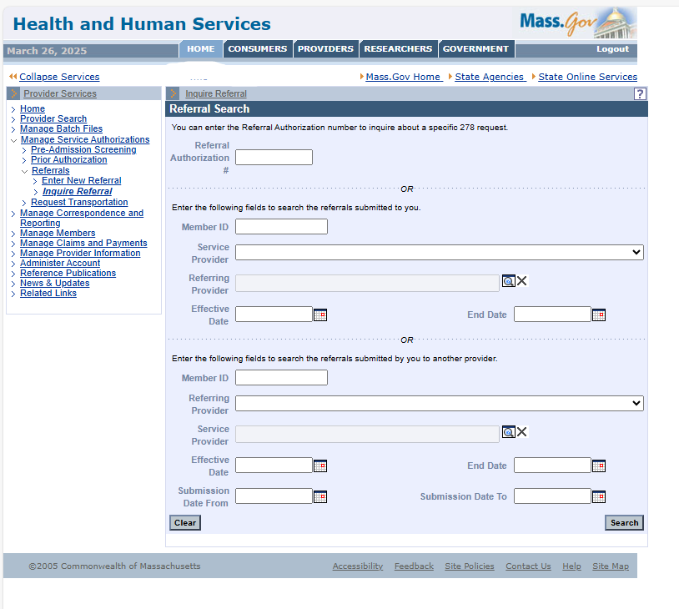

1. To search by referral number:
   * Enter the referral number in the **Referral Authorization Number** field.
   * Click **Search**.
   * Skip to Step 8.
2. If you don’t have the referral and want to find the referrals submitted by you (the Referring Provider):
   * Enter the Member ID.
   * Select the **Referring Provider** from the dropdown list. This is determined by your login to the POSC.
   * In the **Service Provider** field, click the **Field Search** button to display the **Search for Provider** panel, where you can perform a search for the service provider. Enter as much information in the search criteria as possible.
   * Click **Search**. A list of servicing providers will appear (there could be multiple pages).
   * Click the **Name** of the desired **Service Provider**.

**Complete Referral Search / Select Desired Referral**

1. On the **Referral Search** panel for referrals submitted by you (the Referring Provider):
   * Enter the date prior or equal to the **Effective Date** of the referral.
   * Enter an **End Date** the same as or after the end date for the referral.
   * Click **Search**. The **Referral Search Results** panel will display.
2. Click the **Referral Number** link of the desired referral. The **Referral Information** panel will display.

**Update Referral**

On the **Referral Information** panel:

1. Review the **Referral Information** to ensure you have selected the correct referral. When you have confirmed that you have the correct referral, you can complete the following steps.
2. Modify the number of **Visits** allowed for the referral.
   * The number of **Visits** can be reduced to a number equal to or greater than the number of **Visits** already processed. For example, if there were ten visits and six were used, the number of **Visits** could not be lower than six.
   * The number of **Visits** can be increased, if requested by the PCC.
3. Enter a new **End Date** for the referral.
   * The **End Date** can be set back to a date of service that is not before the **Service Provider’s** most recent date of service (previously paid claims are connected to the referral).
   * The **End Date** can be moved to a future date, if requested by the PCC.
4. Update and add text to the **Reason for Review** and the **Service Description** boxes.

When you have completed the desired changes to the referral:

1. Click **Update**. A **Referral Update Confirmation** panel will display, indicating the update was successful. Automatic notifications are not generated by the system for changes to an existing referral.

**Notes**

The referral can be updated by the originating PCC under the following conditions.

* The member is currently enrolled in the PCC Plan with the PCC who submitted the referral.
* The **Effective Date** and **End Date** range includes the current date.
* The number of visits has not been exhausted.
* The referral is active and available.

The referral will be automatically canceled under the following conditions.

* For any available referral, when the member leaves the PCC Plan, the **End Date** is changed to the close date.
* When a member changes enrollment to a different PCC, the **End Date** of the referral will
  + remain unchanged if the **End Date** on the referral is less than or equal to **30** days after the close date; or
  + be set to a grace period of **30** days after the close date, if the **End Date** on the referral is greater than **30** days after the close date.