Job Aid: Verify Member Eligibility

This MassHealth job aid describes how to check a member’s eligibility using the Provider Online Service Center (POSC).

How to Verify Member Eligibility
From the Provider Online Service Center home page:
- Click Manage Members.
- Click Eligibility.
- Click Verify Member Eligibility.
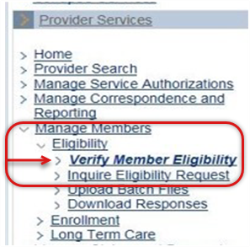

Eligibility Panel
On the Check Member Eligibility panel:
- Select the servicing provider from the dropdown list.
- Enter the Member ID.
There are three ways to perform an eligibility verification transaction for a member. You can enter:
- Member’s 12-digit Member ID;
- Member's SSN or Other Agency ID (DCF and DYS); or
- Member's first name, last name, DOB, and gender.
Should the system return a "Member Not Found" error message in the search results, you may wish to perform a second search using a different search method.
- In the From Date of Service and To Date of Service fields, enter the date range for the search.
Date range fields automatically default to the current date, but you can modify either field as desired. The maximum date span allowable for a search is 31 days. You cannot search for future dates of service.
- Click Submit.
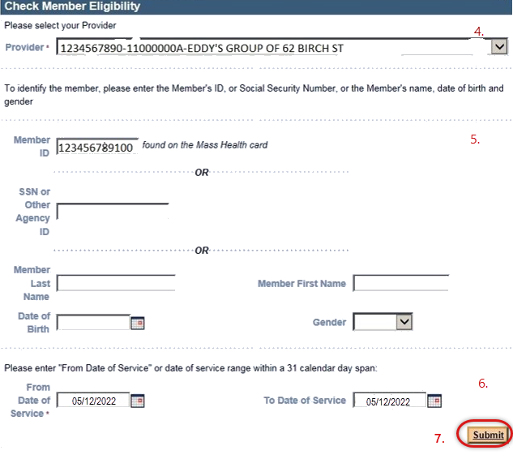

Confirm Member Information on the Member Information Tab
Confirm the member’s information, including:
- Provider ID;
- Member ID;
- Member Name; and
- Correct Date(s) of Service range.
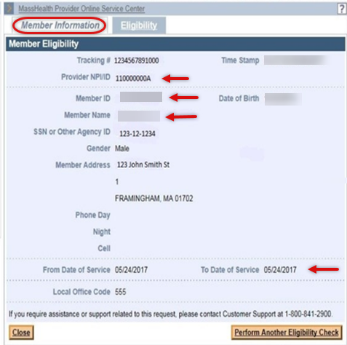

Check Eligibility
Once you have confirmed the member’s information:
- Click the Eligibility tab.
- Verify Eligibility Status on the Dates of Eligibility panel.
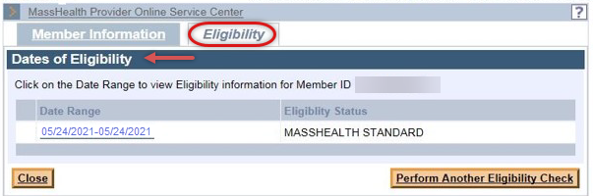

Multiple Benefit Program Listing
In some instances, multiple benefit programs may be listed for the date range requested. It is important to pay attention to the date ranges that are displayed beside the Eligibility Status.
The member may have an eligibility change over the selected date range or may have multiple overlapping benefit programs listed, as seen in the example below. This indicates that the member has eligiblity under multiple benefit programs over the selected date range. Coverage types will first be displayed in order of program eligiblity (richest program listed first), then by date.
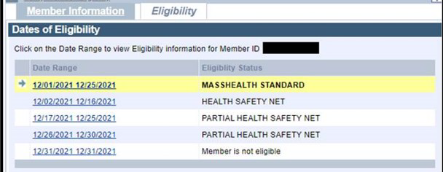
For list of MassHealth coverage types and covered services, please refer to 130 CMR 450.105: Coverage Types.

When ConnectorCare Is Listed
Sometimes you may see a ConnectorCare program indicated in connection with the Health Safety Net (HSN) program. This means that the member is eligible for a Health Connector product, but it does not mean that the member is necessarily enrolled in a ConnectorCare plan.
The provider must verify ConnectorCare plan enrollment separately with the member.
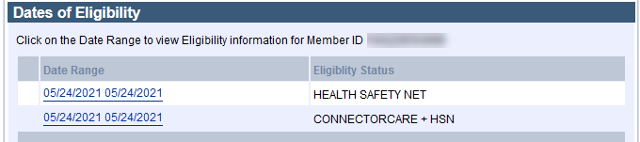
Click the date range to view the member’s eligibility details.
In general, you can click blue underlined text to get additional details.
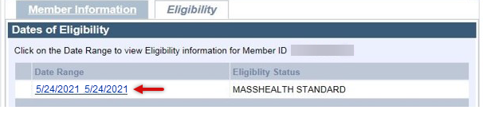

Eligibility Details
Details about the member’s program and eligibility will appear in panels.
You may see a panel listing Eligibility Restrictive Messages that will provide important information about the member’s benefits.
This example tells you that the member is eligible for Qualified Medicare Beneficiary (QMB), Medicare Part D, and certain HSN dental services at community health centers and hospital-based health centers.
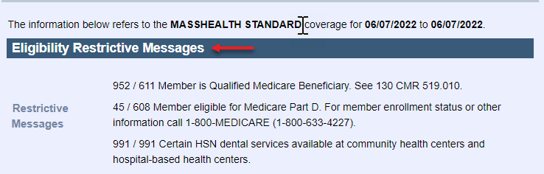
This example shows that the member is exempt from pharmacy and non-pharmacy copays.
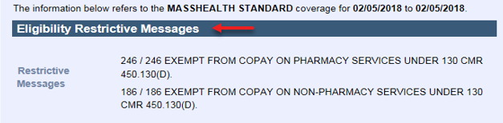
Consult your Provider Manual Appendix Y for the list of possible restrictive messages.

Member Enrolled in PCC plan or Primary Care ACO (ACO-B)
PCC plan and Primary Care ACO member panels include:
- List of Managed Care Data (for PCC/PCCB), indicating the member’s primary care provider information. Click the link to access additional information.
- List of Managed Care Data (for MCO/ACO), indicating the member’s managed care plan. Click the link to access additional information.
- List of Behavioral Health, indicating the member’s behavioral health care plan. Click the link to access additional information.
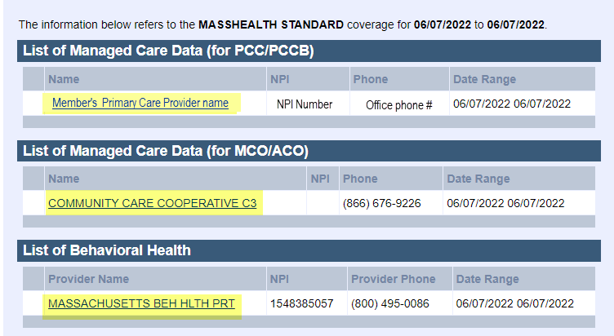
The Member Copay panel lists any co-payment requirements along with the current status for the month.
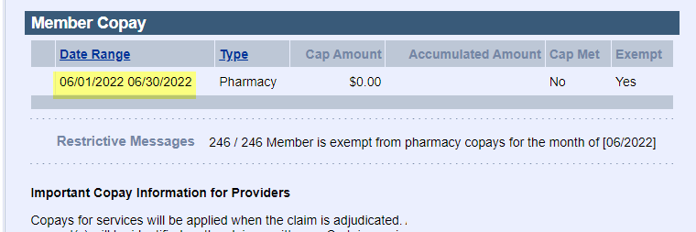
Additional Restrictive Messages within each panel might include co-pay notes; dental coverage restrictions; additional contact information for the program, plan, or primary care providers; or other important information when applicable.
For members enrolled in the PCC plan or one of the Primary Care ACOs, claims are submitted to MassHealth. If the member is enrolled in a managed care organization (MCO) or Accountable Care Partnership plan, billing information is provided in the restrictive messages of the Managed Care Data panel.

Member Enrolled in MCO and Accountable Care Partnership (ACO-A)
MCO and Accountable Care Partnership information will show the Member’s managed care data name listing along with contact information for the MCO/ACO-A.
The list of Managed Care Data (for MCO/ACO) indicates the member’s managed care plan. Click the link to access the Managed Care Data (for MCO/ACO) Details.
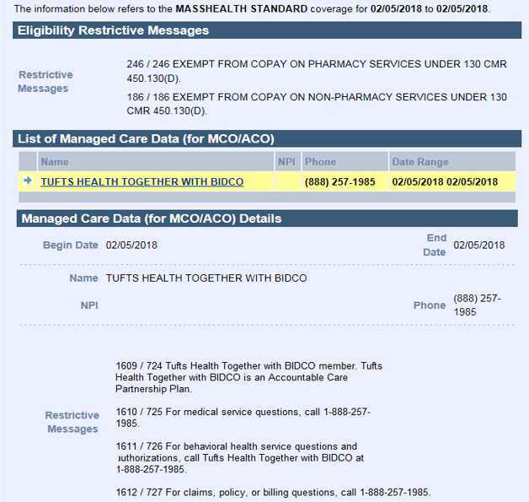
The Details for MCO and Accountable Care Partnership plans include:
- Who to call for medical questions;
- Who to call for behavioral health questions; and
- Who to call for policy or billing questions.

Member enrolled in MassHealth Community Partners Program
The MassHealth Community Partners Program coordinates person-centered, community-based supports that promote continuity of care and independence for MassHealth members with behavioral health (BH) or long-term services and supports (LTSS) needs. Enrollment in the community partners program can be seen in the Eligibility Verification System (EVS) under List of Managed Care Data (for Community Partners).
In the example below, the member’s managed care plan is BeHealthy Partnership Plan. Providers would bill and contact the MCO/ACO for any questions about the member’s eligibility and coverage. The member is also enrolled with a community partner to coordinate care and develop a plan of care in coordination with the member’s PCC. (Do not contact the community partner with billing questions.)
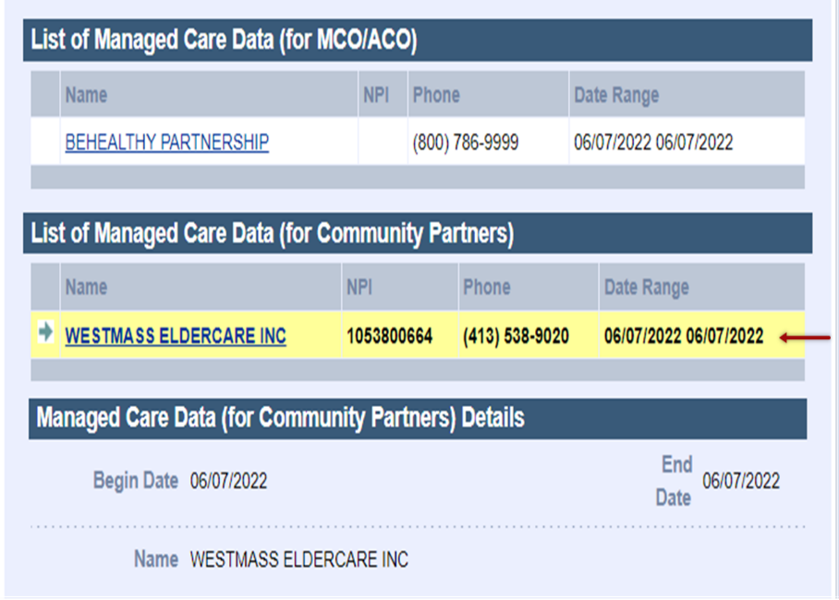

The Member Has MassHealth and Private Health Insurance, or Third-Party Liability (TPL)
If MassHealth is aware that a member has primary coverage through another carrier, EVS will show the TPL information. Click the Carrier Name to get additional information, such as the carrier code and contact information. The private health insurance is billed as the primary insurer and should be billed first. MassHealth is the secondary coverage.
If you become aware that a member has unreported TPL coverage, visit the Mass.gov MassHealth Third Party Liability Page for reporting instructions.
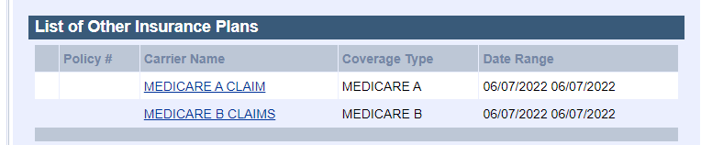
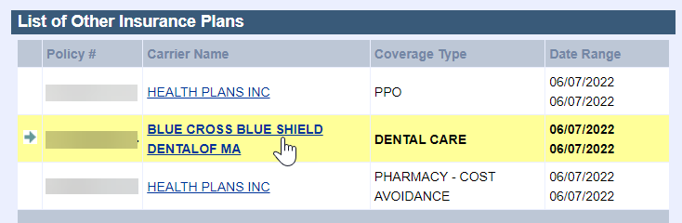
After verifying the member’s eligibility status, do one of the following:
- Click Close to end the process; or
- Click Perform Another Eligibility Check to verify another member’s eligibility.

