**Job Aid: View MDS 3.0 Reports for Nursing Facilities**

Nursing facilities can access their weekly Minimum Data Set (MDS) 3.0 reports in the Provider Online Service Center (POSC). This job aid describes how to do the following.

* Access MDS Submission and MDS Error reports
* Open and view metrics and reports
* Save a report

**Access View Claims Metrics/Reports**

From the **POSC** home page:

1. Click **Manage Correspondence and Reporting**.
2. Click **View Metrics/Reports**. The View/Metrics Reports panel will display.
3. Select the **Provider ID** from the dropdown list.
4. Click **Search**.

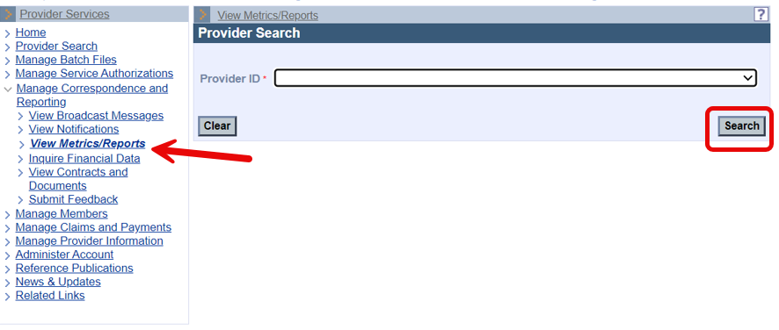

1. Check the **Reports** section to find the report by date.

**Note:** The MDS Submission report is ELG-402-W. The MDS Error Report is ELG-404-W.

1. Click the appropriate PDF link in the **File** column to open the file.

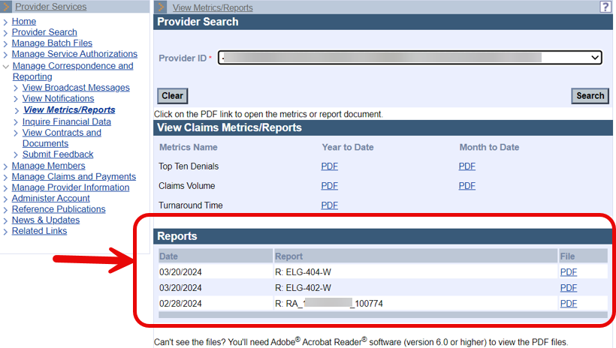

**View the Report PDF File**

After you click the PDF link, a pop-up window opens.

1. Click **Open**. The report will open in a new window.
2. View the report.

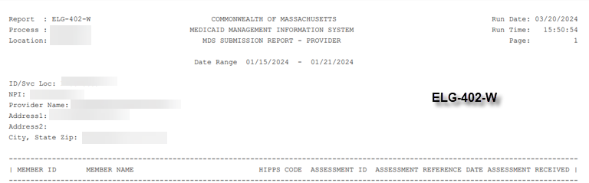

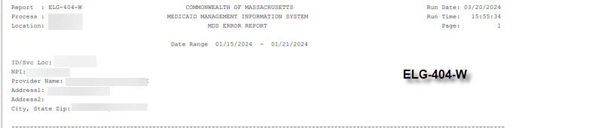

**Save a Copy**

From the **File** menu:

1. Select the appropriate menu option to save a copy (i.e., **Save a copy** or **Save as**).

**Note:** If you receive an Adobe Reader message, click OK.

1. Navigate to the desired location, enter a title in the **File name** field, and click **Save**.