**Job Aid: View Metrics Reports**

The POSC provides standard Claims Metrics and Reports data to all enrolled MassHealth providers.

This job aid describes how to do the following.

* Access metrics and reports (remittance advice)
* Open and view the metrics and reports

**Access View Claims Metrics/Reports**

From the **POSC** home page:

1. Click **Manage Correspondence and Reporting**.
2. Click **View Metrics/Reports**. The View/Metrics Reports panel will appear.
3. Select the **Provider ID** from the dropdown list.
4. Click **Search**.
5. Select the appropriate PDF link to open the appropriate file.

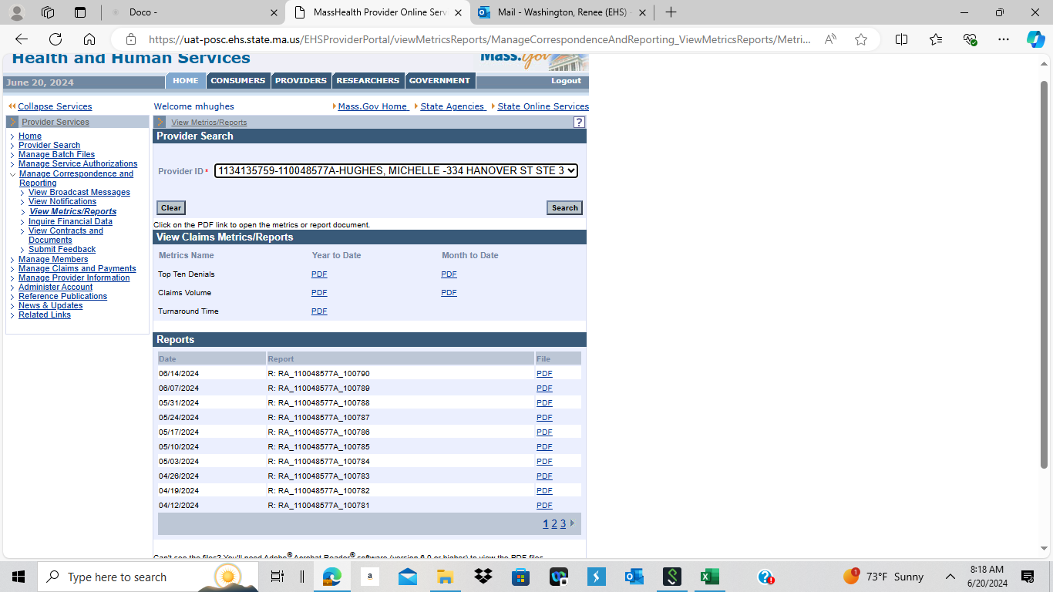

**View the Claims Metrics Reports**

Please select the appropriate claims metrics report and the report parameters. After you click the appropriate PDF link, a pop-up window opens.

1. Click **Open**. The report will open in a new window.
2. View the report.
3. Download the report.



**Reports – MassHealth Remittance Advice**

Please select the appropriate remittance advice to view. After you click the PDF link, a pop-up window opens.

1. Click **Open**. The report will open in a new window.
2. View the report.
3. Download the report.

