# MassHealth logo MMIS POSC Job Aid: Homeless Medical Respite Member Search

This job aid describes how to access the Homeless Medical Respite Member Search through the MassHealth Provider Online Service Center. This includes

* + how to navigate the panel
  + how to search the panel
  + how to review the field help
  + how to resolve an error message

## POSC Login

You can access the MassHealth POSC (Provider Online Service Center) home page by going to <https://mmis-portal.ehs.state.ma.us/EHSProviderPortal>. You can also navigate there by going to Mass.Gov, searching for MassHealth POSC, and then following the page navigation to login.

Once you access the home page, click the **Login** button. Once you log in, you can use the features displayed in the left navigation pane under “Provider Services.”

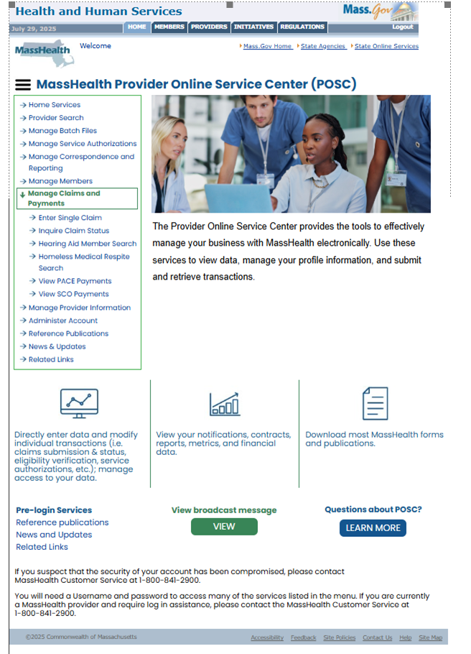

If you try to access a feature from the “Provider Services” menu without logging into the page, you will receive an error message.

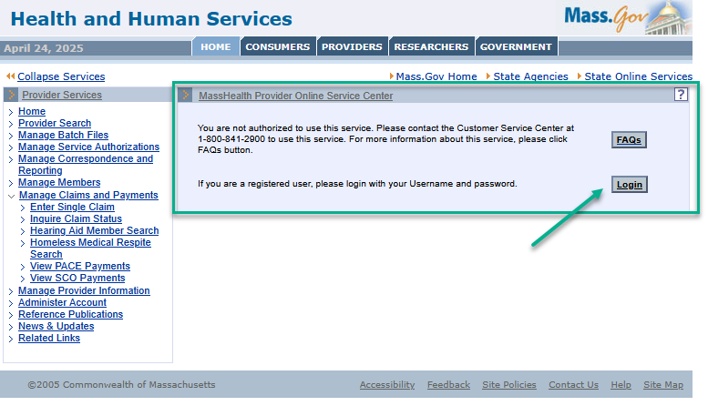

If you log into the POSC and your username is listed next to the welcome message display, but you don’t have access to the Homeless Medical Respite Member Search, you will get a message stating you are not authorized.

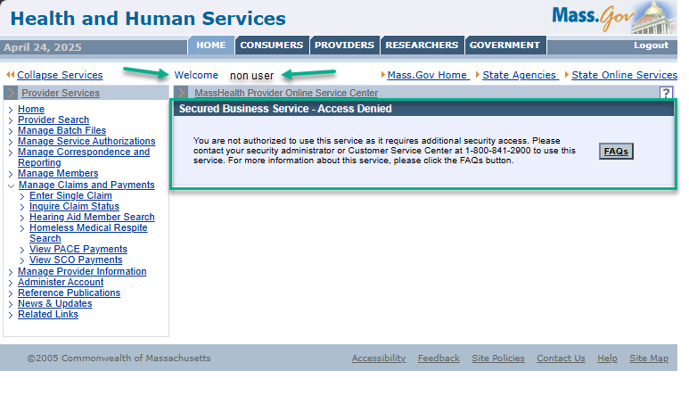

## Navigation

Once you’re logged in, you will find the new Homeless Medical Respite Member feature on the Provider Services pane under “Manage Claims and Payments.” Click on “Manage Claims and Payments.” You will see the service listed.

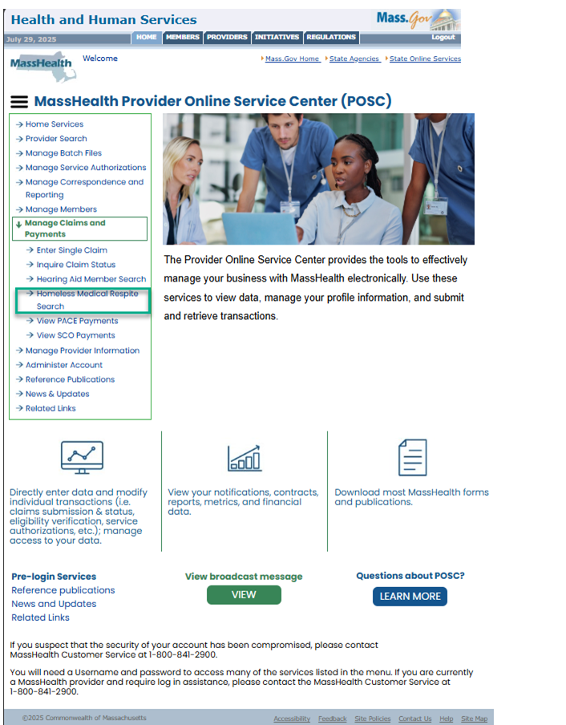

Click on **Homeless Medical Respite Member Search** to open the related search panel. 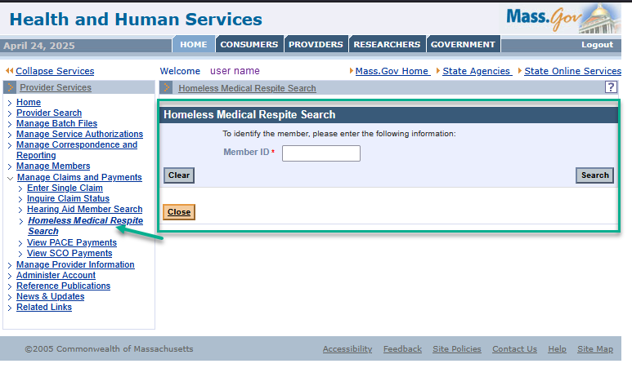

## Search

Type in the member’s 12-digit MassHealth identification number in the **Member ID** field and then click the **Search** button.

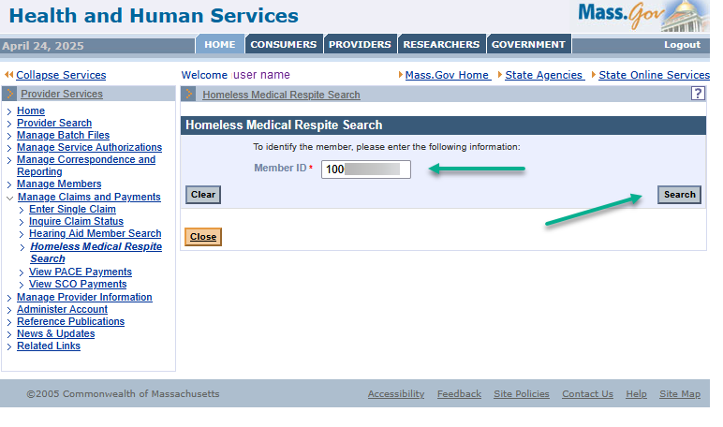

## Search Results

The search can yield several results:

* Member ID on File – Services Paid
* Member ID on File – No Services Paid
* Member ID Not on File – No Services Paid
* The search cans also show “No Records Found**.**”

### Member ID on File – Services Paid

You will see the search results display within the **Homeless Medical Respite Member Search Results** panel. The member’s name will show. If the member received Homeless Medical Respite Services, *as defined by having paid claims for the service,* the results will list the start date, end date, and the number of units (days) that have been paid. 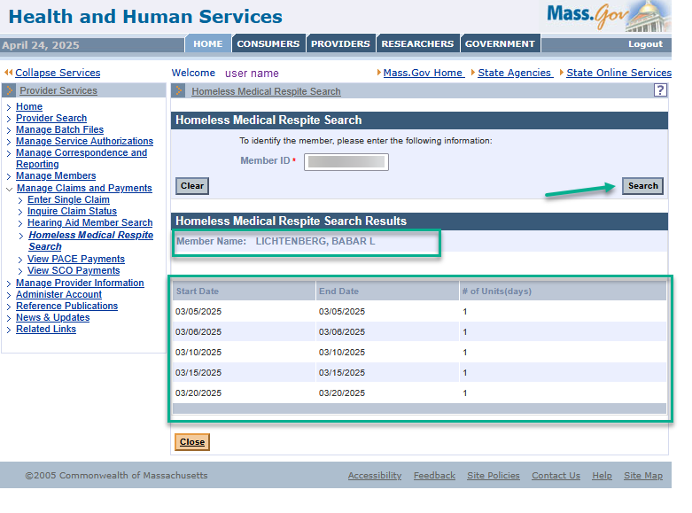

### Member ID on File – No Services Paid

When the member ID is on file but there are no Homeless Medical Respite Member Services to return, the display will show the member name with the results as “**No Records Found**”.

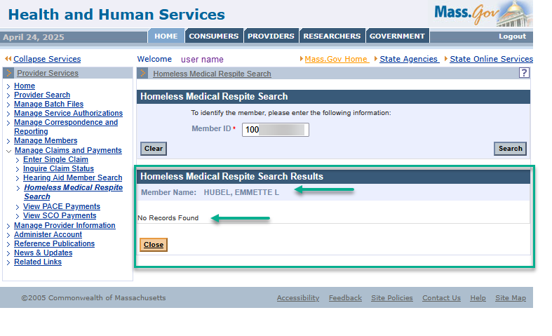

### Member ID Not on File – No Services Paid

When the member ID is not on file, the display will show “Member Name: **Not on File**” and the **Homeless Medical Respite Member Search** box will show “**No Records Found**”.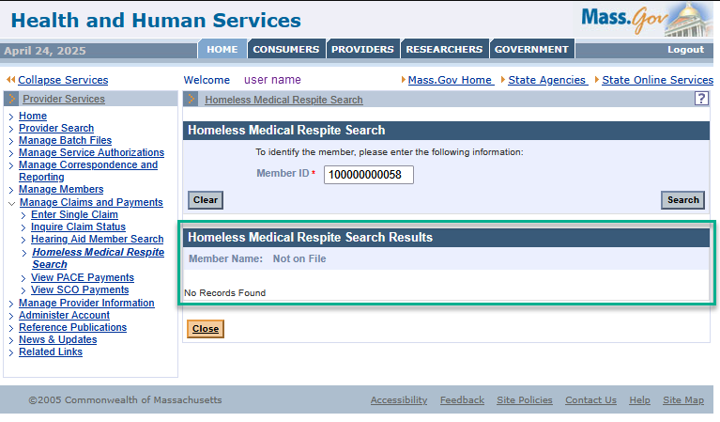

## Help

### Field Help

You can click on the field name **Member ID**\* to display Field Help.

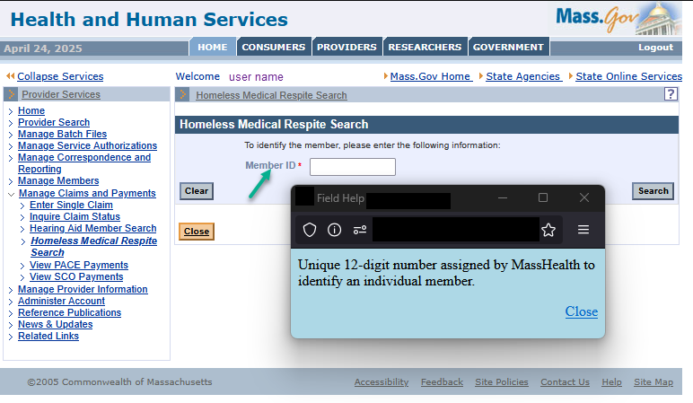

## Panel Help

You can click on the image of a questions mark to open the Help Panel.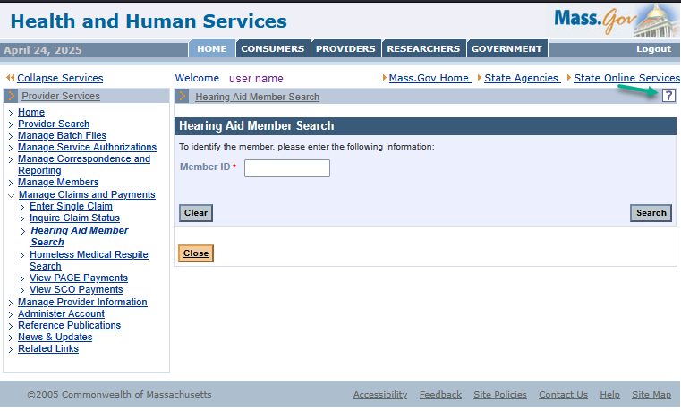

The page shows the description.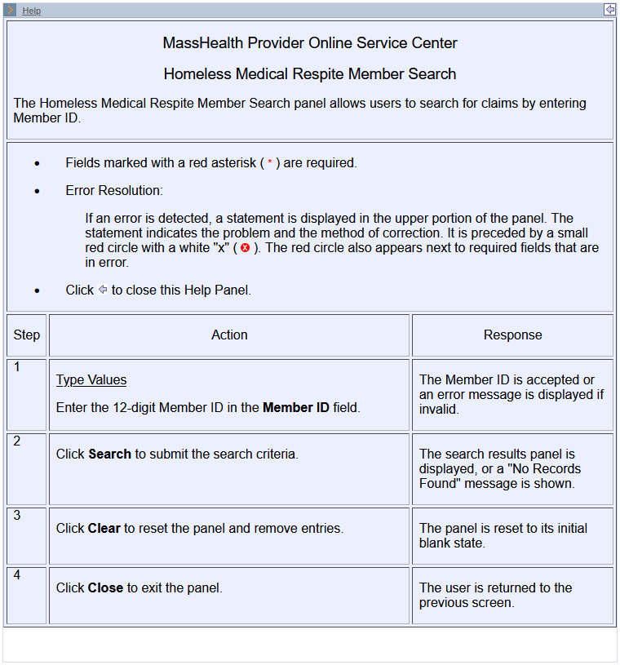

## Error Messages

The system will not accept a member ID with

* both number and letters
* special characters, or
* fewer than 12 digits.

If you use them, the system will show an error message.

