INDOOR AIR QUALITY ASSESSMENT

MassHealth
200 Theodore Rice Blvd
New Bedford, Massachusetts

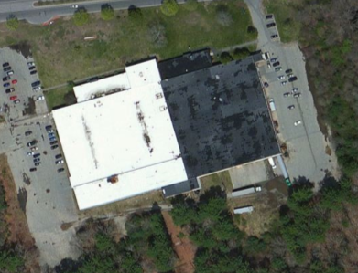

Prepared by:
Massachusetts Department of Public Health
Bureau of Environmental Health
Indoor Air Quality Program
November 2016

Background
Building: | MassHealth
Address: | 200 Theodore Rice Blvd, New Bedford, MA
Assessment Requested by: | Jamie Merrill Blood, Project Manager, Division of Capital Asset Management and Maintenance (DCAMM)
Reason for Request: | Post-occupancy
Date of Assessment: | September 30, 2016
Massachusetts Department of Public Health/Bureau of Environmental Health (MDPH/BEH) Staff Conducting Assessment: | Sharon Lee, Environmental Analyst, Indoor Air Quality (IAQ) Program
Building Description: | Single-story 1950s building; renovations prior to occupancy
Building Population: | Approximately 80 employees
Windows: | Not openable

Methods
Please refer to the IAQ Manual for methods, sampling procedures, and interpretation of results (MDPH, 2015).

IAQ Testing Results
The following is a summary of indoor air testing results (Table 1).
- Carbon dioxide levels were below 800 parts per million (ppm) in all areas assessed, indicating adequate fresh air in the space.
- Temperature was within the recommended range of 70°F to 78°F in all but one area assessed.
- Relative humidity was within the recommended range of 40% to 60% in all areas assessed.
- Carbon monoxide levels were non-detectable in all indoor areas assessed.
- Total volatile organic compounds (TVOCs) were either not detected or below background in the building at the time of assessment.
- Fine particulate matter (PM2.5) concentrations measured were below the National Ambient Air Quality Standard (NAAQS) level of 35 micrograms per cubic meter (μg/m³) in all areas assessed.

Ventilation
Heating, ventilation and air conditioning (HVAC) is provided by rooftop air-handling units (AHUs) ducted to supply and return vents. Conditioned air is delivered to occupied areas via louvered supply vents, and stale air is removed via ducted exhaust vents. Some larger areas also had plenum return vents. At the time of assessment, the HVAC system was operating. It should be noted that that thermostat fan settings were set to “auto” throughout the building. The thermostat in the scanning room was set to override (Picture 1); however, no air movement was detected. Thermostats should be set to “on” to provide for continuous air filtration and circulation throughout the space. Lack of air exchange/circulation can lead to the build-up of naturally occurring pollutants in the space, which can result in IAQ/comfort complaints.

Microbial/Moisture Concerns
A stained ceiling tile was observed in space 125 (Table 1). Water-damaged ceiling tiles can be indicate roof or plumbing leaks. Any leaks should be reported promptly to building maintenance staff to ensure they can be repaired and materials can be dried. The United States Environmental Protection Agency (US EPA) and the American Conference of Governmental Industrial Hygienists (ACGIH) recommend that porous materials be dried with fans and heating within 24 to 48 hours of becoming wet (US EPA, 2008; ACGIH, 1989). If porous materials are not dried within this time frame, mold growth may occur. Once mold has colonized porous materials, they are difficult to clean and should be removed and discarded.
Plants were observed in a few areas (Table 1). Plants can be a source of pollen and mold, which can be respiratory irritants to some individuals. Plants should be properly maintained and equipped with drip pans and should be located away from air diffusers to prevent the aerosolization of dirt, pollen, and mold.
Water coolers were observed in a few of areas (Picture 2). Plastic mats should be placed under these appliances to catch water that may leak or spill and prevent water damage to carpeting.

Other IAQ Evaluations

TVOCs
Exposure to low levels of TVOCs may produce eye, nose, throat, and/or respiratory irritation in some sensitive individuals. In addition to testing, BEH/IAQ staff examined spaces for products containing VOCs. BEH/IAQ staff noted air fresheners, hand sanitizers, cleaning products, and dry erase materials in a number of areas throughout the office space (Table 1; Picture 3). All of these products have the potential to be irritants to the eyes, nose, throat, and respiratory system of sensitive individuals.

Other Concerns
Standing fans were observed in both the scanner and records rooms, reportedly to facilitate air movement. Measures should be taken to ensure the thermostat is set with fan on to allow air movement, and ventilation equipment is adequate and functioning appropriately in these areas.
Floor and wall tile appeared stained in the bathroom due to soap dripping from the dispenser (Picture 4). Measures should be taken to prevent soap from collecting on tiles.

Conclusions/Recommendations
Based on observations at the time of assessment, the following is recommended:
- Operate supply and exhaust ventilation continuously in all areas during occupied periods. Ensure all HVAC equipment is maintained and supply and return vents are cleaned periodically to prevent dust re-aerosolization.
- Ensure thermostats are programed to allow fan “on” when the building is occupied.
- Ensure adequate ventilation in the scanner room to prevent accumulation of normally-occurring IAQ pollutants and provide occupants with a comfortable work environment.
- Ensure sure personal fans are cleaned periodically to prevent buildup and re-circulation of dust and debris.
- Replace water-damaged ceiling tile once source of leak is repaired.
- Keep plants in good condition, avoid overwatering, and remove from the airstream of heating and ventilation equipment.
- Measures should be taken to prevent soap from collecting on tiles in the bathroom.
- Reduce the use of cleaning products, sanitizers, and other items that contain VOCs.
- Remove air deodorizers and scented candles to prevent respiratory irritation.
- Install plastic mats below water coolers to prevent water damage to carpeting.
- Refer to resource manual and other related IAQ documents located on the MDPH’s website for further building-wide evaluations and advice on maintaining public buildings. These documents are available at: http://mass.gov/dph/iaq.

References
American Conference of Governmental Industrial Hygienists (ACGIH). 1989. Guidelines for the Assessment of Bioaerosols in the Indoor Environment. American Conference of Governmental Industrial Hygienists, Cincinnati, OH.
Massachusetts Department of Public Health (MDPH). 2015. Massachusetts Department of Public Health. Indoor Air Quality Manual: Chapters I-III. Available at: http://www.mass.gov/eohhs/gov/departments/dph/programs/environmental-health/exposure-topics/iaq/iaq-manual/.
United States Environmental Protection Agency (US EPA). 2008. “Mold Remediation in Schools and Commercial Buildings”. Office of Air and Radiation, Indoor Environments Division, Washington, DC. EPA 402-K-01-001. March 2001. Available at: https://www.epa.gov/mold/mold-remediation-schools-and-commercial-buildings-guide
Picture 1
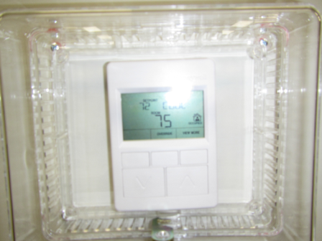
Thermostat in scanning room set to override

Picture 2
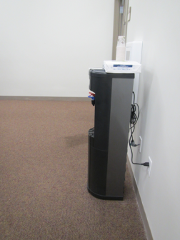
Water cooler on carpet
Picture 3
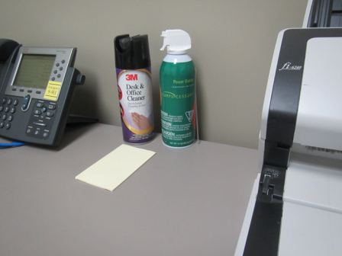
Cleaning products that are irritating to the eyes and respiratory system

Picture 4
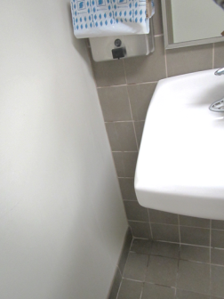
Stained floor tiles from soap dispenser
Location | Carbon  Dioxide  (ppm) | Carbon Monoxide  (ppm) | Temp  (°F) | Relative  Humidity  (%) | PM2.5  (µg/m³) | TVOCs  (ppm) | Occupants  in Room | Windows  Openable | Ventilation |  |  | Remarks
 |  |  |  |  |  |  |  |  | Intake | Exhaust
Background | 380 | ND | 63 | 69 | 3 | ND – 2
104 | 429 | ND | 70 | 60 | 4 | ND | 0 | N | Y |  | Y | DO
108/109 (Reception) | 409 | ND | 70 | 58 | 2 | ND | 1 | N | Y |  | Y | Thermostat set to auto
107 | 408 | ND | 70 | 58 | 2 | ND | 0 | N | Y |  | Y
105 | 425 | ND | 71 | 58 | 2 | ND | 4 | N | Y |  | Y
106 | 436 | ND | 70 | 57 | 2 | ND | 0 | N | Y |  | Y | Wall AC, DO
112 (server room) | 587 | ND | 69 | 54 | 3 | ND | 2 | N | Y |  | Y | Wall AC, DO, 1 AT
117/118 | 493 | ND | 70 | 57 | 3 | ND | 0 | N | Y |  | Y | Plants, lose carpet tile
116 | 473 | ND | 70 | 57 | 1 | ND | 0 | N | Y |  | Y | DO
115 | 495 | ND | 71 | 57 | 7 | ND | 0 | N | Y |  | Y | DO, AD (scented candle)
114 | 490 | ND | 71 | 56 | 3 | ND | 0 | N | Y |  | Y | AD (scented candle), thermostat set to auto
113 | 495 | ND | 70 | 56 | 3 | ND | 0 | N | Y |  | Y | DO
124/123 | 612 | ND | 71 | 56 | 3 | ND | 0 | N | Y |  | Y
122 | 691 | ND | 71 | 56 | 3 | ND | 0 | N | Y |  | Y | Thermostat set to auto, DO
121 | 611 | ND | 71 | 56 | 4 | ND | 0 | N | Y |  | N | DO
120 | 592 | ND | 71 | 56 | 3 | ND | 0 | N | Y |  | Y | DO
119 | 591 | ND | 71 | 56 | 3 | ND | 0 | N | Y |  | Y | DO
Cubicles 140-143 | 586 | ND | 72 | 56 | 6 | ND | 0 | N | Y |  | Y | Copier, thermostat set to auto
Cubicles 126-133 | 573 | ND | 72 | 55 | 3 | ND | 7 | N | Y |  | Y
Cubicles 156-160 | 585 | ND | 72 | 55 | 2 | ND | 2 | N | Y |  | Y
Cubicles 161-167 | 589 | ND | 73 | 54 | 3 | ND | 6 | N | Y |  | Y
Cubicles 170-173 | 712 | ND | 73 | 54 | 4 | ND | 1 | N | Y |  | Y
Cubicles 174-180 | 679 | ND | 73 | 54 | 4 | ND | 4 | N | Y |  | Y
Cubicles 200-205 | 627 | ND | 73 | 54 | 2 | ND | 5 | N | Y |  | Y | AD
Cubicles 195-199 | 721 | ND | 74 | 54 | 3 | ND | 5 | N | Y |  | Y | Thermostat set to auto
194 | 621 | ND | 73 | 53 | 4 | ND | 0 | N | Y |  | Y | DO, CPs
193 | 570 | ND | 74 | 54 | 4 | ND | 1 | N | Y |  | Y | DO, CPs
169 | 656 | ND | 74 | 53 | 3 | ND | 1 | N | Y |  | Y | CPs
145 | 623 | ND | 74 | 53 | 3 | ND | 0 | N | Y |  | Y | HS, plants
144 | 617 | ND | 73 | 53 | 3 | ND | 0 | N | Y |  | Y | DO
125 | 586 | ND | 74 | 53 | 3 | ND | 0 | N | Y |  | N | DO, WD-CT
Cubicles 212-216 | 649 | ND | 73 | 54 | 3 | ND | 3 | N | Y |  | Y | HS, food/storage
Cubicles 207-211 | 630 | ND | 74 | 53 | 3 | ND | 2 | N | Y |  | Y | Water cooler on carpet
Scanner room | 589 | ND | 75 | 50 | 13 | 1 | 4 | N | Y |  | Y | PF, CPs, thermostat in system override
Records room | 503 | ND | 74 | 50 | 3 | ND | 14 | N | Y |  | Y | Exterior DO, PF, thermostat set to auto

