Background/Introduction

INDOOR AIR QUALITY ASSESSMENT

Commonwealth of Massachusetts
MassHealth Office
21 Spring Street
Taunton, Massachusetts

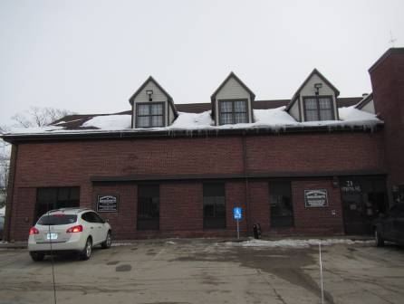

Prepared by:
Massachusetts Department of Public Health
Bureau of Environmental Health
Indoor Air Quality Program
April 2015

In response to a referral by Mary Dozois of the Massachusetts Department of Labor Standards (DLS), and in coordination with Erin McCabe, Field Operations Manager, Executive Offices of Health and Human Services (EOHHS), the MDPH Bureau of Environmental Health (BEH) provided assistance and consultation regarding indoor air quality (IAQ) at the MassHealth (MH) offices located at 21 Spring Street, Taunton, Massachusetts. The request was prompted by general IAQ concerns as well as specific conditions regarding previous water damage and lighting issues believed to be associated with migraines among staff.
On March 3, 2015 the MH office was visited by Ruth Alfasso, Environmental Engineer/Inspector and Cory Holmes Environmental Analyst/Regional Inspector in BEH’s IAQ Program to conduct an IAQ assessment. They were accompanied on the visit by Sharlene Sharif, Field Operations Unit EOHHS facilities.
The MH office occupies both floors of the northeastern section of a two-story office building located just outside Taunton Center. The space contains offices, modular workstations with cloth-covered dividers, reception/waiting area, interview rooms, training/conference rooms and kitchen/lounge areas. Ceilings consist of suspended ceiling tiles. Floors in the majority of areas are carpeted. Windows are openable on the first floor but are reported by MH staff to be kept closed to maintain central heating/cooling conditions. Other EOHHS offices occupy adjacent space in the building.

Methods
Air tests for carbon monoxide, carbon dioxide, temperature and relative humidity were conducted with the TSI, Q-Trak, IAQ Monitor, Model 7565. Air tests for airborne particle matter with a diameter less than 2.5 micrometers were taken with the TSI, DUSTTRAK™ Aerosol Monitor Model 8520. Light levels were measured using an EXTECH Instruments Foot Candle Meter. BEH/IAQ staff also performed a visual inspection of building materials for water damage and/or microbial growth.

Results
Approximately 80 employees work in the MH portion of the building and up to 100 members of the public may visit the space on a daily basis. The tests were taken during normal operations and appear in Table 1.

Discussion

Ventilation
It can be seen from Table 1 that carbon dioxide levels were above 800 parts per million (ppm) in 30 out of 47 areas tested, indicating a lack of air exchange in a little more than half the areas at the time of the assessment. Note that carbon dioxide results for the second floor were mainly below 800 ppm, while those for the first floor were all above 800 ppm (Table 1).
Fresh air is provided by rooftop air handling units (AHUs) ducted to ceiling-mounted supply diffusers (Picture 2). Return air is drawn back into wall (Picture 3) or ceiling vents (Picture 4) and returned to the AHUs. Additional exhaust ventilation in restrooms and some common areas (kitchen, conference room) is provided by switch-activated exhaust vents (Picture 5). It is important to note that due to low outside temperatures on the day of the assessment and over several previous weeks, fresh air supplies to buildings may be automatically or manually restricted in order to protect piping from freezing and enable comfortable temperatures to be maintained inside the building.
Thermostats were examined on each floor. On the first floor, thermostats were set to the “automatic” setting rather than the “on” setting (Picture 1). When the fan is set to on, the system provides a continuous source of air circulation and filtration. The automatic setting on the thermostat activates the HVAC system at a preset temperature. Once the preset temperature is reached, the HVAC system is deactivated. Therefore, no mechanical ventilation is provided until the thermostat re-activates the system. The MDPH typically recommends that thermostats be set to the fan on setting during occupied hours to provide continuous air circulation. Without a continuous source of fresh outside air and removal of stale air via the exhaust/return system, indoor environmental pollutants can build up and lead to indoor air quality/comfort complaints. The thermostats on the second floor were too old/worn for the settings to be determined.
To maximize air exchange, the MDPH recommends that both supply and exhaust ventilation operate continuously during periods of occupancy. In order to have proper ventilation with a mechanical supply and exhaust system, the systems must be balanced to provide an adequate amount of fresh air to the interior of a room while removing stale air from the room. It is recommended that HVAC systems be re-balanced every five years to ensure adequate air systems function (SMACNA, 1994).
Minimum design ventilation rates are mandated by the Massachusetts State Building Code (MSBC). Until 2011, the minimum ventilation rate in Massachusetts was higher for both occupied office spaces and general classrooms, with similar requirements for other occupied spaces (BOCA, 1993). The current version of the MSBC, promulgated in 2011 by the State Board of Building Regulations and Standards (SBBRS), adopted the 2009 International Mechanical Code (IMC) to set minimum ventilation rates. Please note that the MSBC is a minimum standard that is not health-based. At lower rates of cubic feet per minute (cfm) per occupant of fresh air, carbon dioxide levels would be expected to rise significantly. A ventilation rate of 20 cfm per occupant of fresh air provides optimal air exchange resulting in carbon dioxide levels at or below 800 ppm in the indoor environment in each area measured. MDPH recommends that carbon dioxide levels be maintained at 800 ppm or below. This is because most environmental and occupational health scientists involved with research on IAQ and health effects have documented significant increases in indoor air quality complaints and/or health effects when carbon dioxide levels rise above the MDPH guidelines of 800 ppm for schools, office buildings and other occupied spaces (Sundell et al., 2011). The ventilation must be on at all times that the room is occupied. Providing adequate fresh air ventilation with open windows and maintaining the temperature in the comfort range during the cold weather season is impractical. Mechanical ventilation is usually required to provide adequate fresh air ventilation.
Carbon dioxide is not a problem in and of itself. It is used as an indicator of the adequacy of the fresh air ventilation. As carbon dioxide levels rise, it indicates that the ventilating system is malfunctioning or the design occupancy of the room is being exceeded. When this happens, a buildup of common indoor air pollutants can occur, leading to discomfort or health complaints. The Occupational Safety and Health Administration (OSHA) standard for carbon dioxide is 5,000 parts per million parts of air (ppm). Workers may be exposed to this level for 40 hours/week, based on a time-weighted average (OSHA, 1997).
The MDPH uses a guideline of 800 ppm for publicly occupied buildings. A guideline of 600 ppm or less is preferred in schools due to the fact that the majority of occupants are young and considered to be a more sensitive population in the evaluation of environmental health status. Inadequate ventilation and/or elevated temperatures are major causes of complaints such as respiratory, eye, nose and throat irritation, lethargy and headaches. For more information concerning carbon dioxide, please see Appendix A.
Temperature readings during the assessment ranged from 71ºF to 75ºF (Table 1) which were within the MDPH recommended comfort guidelines. The MDPH recommends that indoor air temperatures be maintained in a range of 70ºF to 78ºF in order to provide for the comfort of building occupants. In many cases concerning indoor air quality, fluctuations of temperature in occupied spaces are typically experienced, even in a building with an adequate fresh air supply.
The relative humidity measured during the assessment ranged from 11 to 20 percent, all of which were below the MDPH recommended comfort range. The MDPH recommends a comfort range of 40 to 60 percent for indoor air relative humidity. Relative humidity levels in the building would be expected to drop during the winter months due to heating. The sensation of dryness and irritation is common in a low relative humidity environment. Low relative humidity is a very common problem during the heating season in the northeast part of the United States.

Microbial/Moisture Concerns
Concerns were reported regarding water intrusion that occurred in 2014. It was explained that water had entered the building due to collected rain/snowmelt along the exterior wall of the first floor. Intrusion was traced to cracks in the foundation that were repaired by a professional water-proofing firm in two stages. At the time of the water entry, building materials in the area had become moistened; occupants were relocated and the area was sealed off. Building staff reported that carpeting, wallboard and other building materials/items that had become wet were removed and replaced. It was reported that no further water intrusion issues have occurred over the past year in this area since the work was completed. Further, no water-damaged building materials were observed in this area during the assessment.
A few water-damaged ceiling tiles were observed in the office (Table 1). These appeared to be from historic roof or plumbing leaks. Water-damaged ceiling tiles should be removed and replaced once the source of water has been identified and remediated.
Plants were observed in several areas (Table 1). Plants, soil and drip pans can serve as sources of mold/bacterial growth. Plants should be properly maintained, over-watering of plants should be avoided and drip pans should be inspected periodically for mold growth. It was reported that the office has a “one plant” policy, which is enforced regularly. Employees are discouraged from bringing in plants and are not allowed to have more than one in a space.
Water coolers were observed in carpeted areas (Picture 6). Spills or leaks from these appliances can moisten carpeting. They should be located in a non-carpeted area or on waterproof mats.
The room housing data equipment was equipped with a ductless air conditioning unit to maintain proper temperature control. These units have condensation drains that are typically drained to the outside of the building. These units should be regularly inspected to insure that the condensation drains and pumps are working properly and are not clogged or leaking.

Other IAQ Evaluations
Indoor air quality can be negatively influenced by the presence of respiratory irritants, such as products of combustion. The process of combustion produces a number of pollutants. Common combustion emissions include carbon monoxide, carbon dioxide, water vapor, and smoke (fine airborne particle material). Of these materials, exposure to carbon monoxide and particulate matter with a diameter of 2.5 micrometers (μm) or less (PM2.5) can produce immediate, acute health effects upon exposure. To determine whether combustion products were present in the indoor environment, BEH/IAQ staff obtained measurements for carbon monoxide and PM2.5.

Carbon Monoxide
Carbon monoxide is a by-product of incomplete combustion of organic matter (e.g., gasoline, wood and tobacco). Exposure to carbon monoxide can produce immediate and acute health effects. Several air quality standards have been established to address carbon monoxide and prevent symptoms from exposure to these substances. The MDPH established a corrective action level concerning carbon monoxide in ice skating rinks that use fossil-fueled ice resurfacing equipment. If an operator of an indoor ice rink measures a carbon monoxide level over 30 ppm, taken 20 minutes after resurfacing within a rink, that operator must take actions to reduce carbon monoxide levels (MDPH, 1997).
The American Society of Heating Refrigeration and Air-Conditioning Engineers (ASHRAE) has adopted the National Ambient Air Quality Standards (NAAQS) as one set of criteria for assessing indoor air quality and monitoring of fresh air introduced by HVAC systems (ASHRAE, 1989). The NAAQS are standards established by the US EPA to protect the public health from six criteria pollutants, including carbon monoxide and particulate matter (US EPA, 2006). As recommended by ASHRAE, pollutant levels of fresh air introduced to a building should not exceed the NAAQS levels (ASHRAE, 1989). The NAAQS were adopted by reference in the Building Officials & Code Administrators (BOCA) National Mechanical Code of 1993 (BOCA, 1993), which is now an HVAC standard included in the Massachusetts State Building Code (SBBRS, 2011). According to the NAAQS, carbon monoxide levels in outdoor air should not exceed 9 ppm in an eight-hour average (US EPA, 2006).
Carbon monoxide should not be present in a typical, indoor environment. If it is present, indoor carbon monoxide levels should be less than or equal to outdoor levels. During the visit outdoor carbon monoxide concentrations were non-detect (ND). Indoor levels were ranged from ND to a slight level of 0.6 ppm (Table 1), which was likely due to idling vehicles in close proximity around the building.

Particulate Matter
The US EPA has established NAAQS limits for exposure to particulate matter. Particulate matter includes airborne solids that can be irritating to the eyes, nose and throat. The NAAQS originally established exposure limits to PM with a diameter of 10 μm or less (PM10). In 1997, US EPA established a more protective standard for fine airborne particulate matter with a diameter of 2.5 μm or less (PM2.5). This more stringent PM2.5 standard requires outdoor air particle levels be maintained below 35 μg/m³ over a 24-hour average (US EPA, 2006). Although both the ASHRAE standard and BOCA Code adopted the PM10 standard for evaluating air quality, MDPH uses the more protective PM2.5 standard for evaluating airborne PM concentrations in the indoor environment.
Outdoor PM2.5 concentrations were measured at 7 μg/m³ (Table 1). PM2.5 levels indoors ranged from ND to 46 μg/m³. All but one reading of 46 μg/m³, were below the NAAQS PM2.5 level of 35 μg/m³. The measurement of 46 μg/m³, which was taken in the waiting/main entrance area, was likely due to foot traffic and sand/salt debris from shoes and coats as well as idling vehicles in close proximity to the building.
Frequently, indoor air levels of particulate matter (including PM2.5) can be at higher levels than those measured outdoors. A number of activities that occur indoors and/or mechanical devices can generate particulate matter during normal operations. Sources of indoor airborne particulate matter may include but are not limited to particles generated during the operation of fan belts in the HVAC system, use of stoves and/or microwave ovens in kitchen areas; use of photocopiers, fax machines and computer printing devices; operation of an ordinary vacuum cleaner and heavy foot traffic indoors.

Volatile Organic Compounds
Indoor air concentrations can be greatly impacted by the use of products containing volatile organic compounds (VOCs). VOCs are carbon-containing substances that have the ability to evaporate at room temperature. Total volatile organic compounds (TVOCs) can result in eye and respiratory irritation if exposure occurs. For example chemicals evaporating from a paint can stored at room temperature would most likely contain VOCs.
Of note is the presence of copy machines within office areas directly adjacent to seating with no dedicated exhaust ventilation (Table 1). Photocopiers can be sources of pollutants such as VOCs, ozone, heat and odors, particularly if the equipment is older and in frequent use. Both VOCs and ozone are respiratory irritants (Schmidt Etkin, 1992). Photocopiers should be kept in well ventilated rooms and should be located near windows or exhaust vents.
Additional sources of TVOCs in the office area include dry erase boards and related materials (Table 1). Materials such as dry erase markers and dry erase board cleaners may contain VOCs, such as methyl isobutyl ketone, n-butyl acetate and butyl-cellusolve (Sanford, 1999), which can be irritating to the eyes, nose and throat.
Hand sanitizer was also observed in the space (Picture 7, Table 1); these products may contain ethyl alcohol and/or isopropyl alcohol, which are highly volatile and may be irritating to the eyes and nose. Sanitizing products may also contain fragrances to which some people may be sensitive.
Cleaning products, air freshening sprays and scented products were also found in the office (Pictures 7 and 8, Table 1). Plug-in air fresheners and other air deodorizers contain chemicals that can be irritating to the eyes, nose and throat of sensitive individuals. Many air fresheners contain 1,4-dichlorobenzene, a VOC which may cause reductions in lung function (NIH, 2006). Furthermore, deodorizing agents do not remove materials causing odors, but rather mask odors that may be present in the area. Many cleaning products contain chemicals that can be irritating to the eyes, nose and throat of sensitive individuals. Cleaning products should be properly labeled and stored in an appropriate area. In addition, a Material Safety Data Sheet (MSDS) should be available at a central location for each product in the event of an emergency.

Ambient Lighting Levels
As previously mentioned, one of the concerns reported for this office was lighting levels and possible exacerbation of migraine headaches. According to the Illuminating Engineers Society’s (IES) recommendations, light levels in offices are recommended to be between 50 and 100 foot-candles. Recommended light levels in hallways and for other uses vary (IES, 2011). Light levels brighter or less bright than desired can lead to eye strain, difficulty with tasks and/or exacerbate headaches.
Levels of ambient light in offices and workstations ranged from 19 to 79 foot-candles (FC) and most light levels measured in offices were below 50 FC (Table 1). However, prior to the BEH/IAQ visit, employees had reported that lights in the offices were too bright. In response, building management, working in conjunction with MH administrators and staff, had systematically removed the middle of three light ballasts in most light fixtures in workstations and offices (Picture 9). These levels of light are reportedly more comfortable for the majority of occupants. Note that workstations are also equipped with under-shelf task lights (Picture 9), which can be switched on and off to locally increase light levels to meet the needs of occupants and tasks. As an example, BEH/IAQ staff measured typical lighting conditions in workstation 215, a centrally located cubicle, which measured 28 FC. A second measurement was taken with the under-shelf task light on, which measured 51 FC.

Other Conditions
Other conditions that can affect IAQ were observed during the assessment. In some office areas, accumulations of items were seen on floors, windowsills, tabletops, counters, bookcases and desks, which provide a source for dusts to accumulate. These items (e.g., papers, folders, boxes) make it difficult for custodial staff to clean. Items should be relocated and/or be cleaned periodically to avoid excessive dust build up. Personal fans, supply and exhaust vents were found to be dusty in some areas. Regular cleaning of supply diffusers, exhaust vents and personal fans will reduce aerosolization of accumulated particulate matter on these surfaces.
It was reported that this office undergoes a twice-yearly “spring” and “fall” cleaning procedure during which time, staff are encouraged to discard/remove unneeded papers and items and are required to clear off flat surfaces so they can be thoroughly cleaned. At the time of the visit, it was reported that the “fall” cleaning had not occurred due to questions about timing of minor renovations that are planned to occur in the space. Regular cleaning of flat surfaces and removal of accumulated items is helpful in creating conditions for good IAQ.
Most areas of the office space were carpeted. The Institute of Inspection, Cleaning and Restoration Certification (IICRC) recommends that carpeting be cleaned annually (or semi-annually in soiled high traffic areas) (IICRC, 2012). Regular cleaning with a high efficiency particulate arrestance (HEPA) filtered vacuum in combination with an annual cleaning will help to reduce accumulation and potential aerosolization of materials from the carpeting. Carpeting in the office is also past its service life and much of it is scheduled for replacement during the planned renovations.
The data room is equipped with a fire suppression system to protect the area from fire as well as from water damage due to fire-fighting/sprinklers. This system uses nitrogen, argon and carbon dioxide to deprive a fire of oxygen (ANSUL, 2015). This system should be inspected in accordance with manufacturer’s recommendations in order to ensure it does not leak, because the gases released may displace oxygen and create a hazardous condition.

Conclusions/Recommendations
In view of the findings at the time of the visit, the following recommendations are made:
- Operate all ventilation systems throughout the building continuously during periods of occupancy to maximize air exchange. This would include leaving thermostat fan settings in the “on” mode (not auto) for continuous airflow.
- Consider upgrading old/malfunctioning thermostats with digital/programmable ones.
- Use the switch-activated exhaust systems in kitchens and conference/training rooms where available, to remove stale air and odors when these rooms are in heavy use.
- Consider adopting a balancing schedule of every 5 years for all mechanical ventilation systems, as recommended by ventilation industrial standards (SMACNA, 1994).
- For buildings in New England, periods of low relative humidity during the winter are often unavoidable. Therefore, scrupulous cleaning practices should be adopted to minimize common indoor air contaminants whose irritant effects can be enhanced when the relative humidity is low. To control for dusts, a high efficiency particulate arrestance (HEPA) filter equipped vacuum cleaner in conjunction with wet wiping of all surfaces is recommended. Avoid the use of feather dusters. Drinking water during the day can help ease some symptoms associated with a dry environment (throat and sinus irritations).
- Indoor plants should be properly maintained and equipped with drip pans to prevent water damage to porous building materials and be located away from ventilation sources to prevent the aerosolization of dirt, pollen or mold.
- Place water coolers/dispensers in areas without carpeting or place on a waterproof mat.
- Regularly inspect the ductless air conditioning units for proper condensation drainage.
- Continue to change filters for AHUs in accordance with the manufacturer’s instructions, or more frequently if needed.
- Consider installing local exhaust vents near photocopiers or relocating them to areas with local exhaust ventilation and away from occupants.
- Use dry erase markers only in well ventilated areas. Clean dry erase boards and trays to prevent accumulation of materials.
- Reduce the use of hand sanitizing products especially those containing fragrances.
- Avoid the use of air freshener sprays, solids and diffuser reeds to avoid exposure to VOCs and fragrance compounds.
- Use task lighting on workstations to adjust light levels for occupants and tasks as needed.
- Have the fire suppression system inspected/maintained in accordance with manufacturer’s instructions.
- Regularly clean supply diffusers, exhaust vents and personal fans to avoid re-aerosolizing any accumulated debris.
- Vacuum carpet with a high efficiency particulate arrestance (HEPA) filtered vacuum in combination with an annual cleaning to help to reduce accumulation and potential aerosolization of materials from the carpeting.
- If lease is renewed, continue with plans for interior renovations including replacement of old/worn carpeting.
- Refer to resource manuals and other related indoor air quality documents for further building-wide evaluations and advice on maintaining public buildings. Copies of these materials are located on the MDPH’s website: http://mass.gov/dph/iaq.

References
ANSUL. 2015. INERGEN Fire Suppression System. https://www.ansul.com/en/us/pages/ProductDetail.aspx?productdetail=INERGEN+Systems+-+Inert+Gases
ASHRAE. 1989. Ventilation for Acceptable Indoor Air Quality. American Society of Heating, Refrigeration and Air Conditioning Engineers. ANSI/ASHRAE 62-1989.
BOCA. 1993. The BOCA National Mechanical Code/1993. 8th ed. Building Officials & Code Administrators International, Inc., Country Club Hills, IL.
IICRC. 2012. Carpet Cleaning FAQ 4 Institute of Inspection, Cleaning and Restoration Certification. Institute of Inspection Cleaning and Restoration, Vancouver, WA.
IES. 2011. The IES Lighting Handbook, Tenth Edition, Illuminating Engineering Society. 2011.
MDPH. 1997. Requirements to Maintain Air Quality in Indoor Skating Rinks (State Sanitary Code, Chapter XI). 105 CMR 675.000. Massachusetts Department of Public Health, Boston, MA.
NIH. 2006. Chemical in Many Air Fresheners May Reduce Lung Function. NIH News. National Institute of Health. July 27, 2006. http://www.nih.gov/news/pr/jul2006/niehs-27.htm
OSHA. 1997. Limits for Air Contaminants. Occupational Safety and Health Administration. Code of Federal Regulations. 29 C.F.R 1910.1000 Table Z-1-A.
Sanford. 1999. Material Safety Data Sheet (MSDS No: 198-17). Expo® Dry Erase Markers Bullet, Chisel, and Ultra Fine Tip. Sanford Corporation. Bellwood, IL.
SBBRS. 2011. Mechanical Ventilation. State Board of Building Regulations and Standards. Code of Massachusetts Regulations, 8th edition. 780 CMR 1209.0.
Schmidt Etkin, D. 1992. Office Furnishings/Equipment & IAQ Health Impacts, Prevention & Mitigation. Cutter Information Corporation, Indoor Air Quality Update, Arlington, MA.
SMACNA. 1994. HVAC Systems Commissioning Manual. 1st ed. Sheet Metal and Air Conditioning Contractors’ National Association, Inc., Chantilly, VA.
Sundell. 2011. Sundell, J., H. Levin, W. W. Nazaroff, W. S. Cain, W. J. Fisk, D. T. Grimsrud, F. Gyntelberg, Y. Li, A. K. Persily, A. C. Pickering, J. M. Samet, J. D. Spengler, S. T. Taylor, and C. J. Weschler. Ventilation rates and health: multidisciplinary review of the scientific literature. Indoor Air, Volume 21: pp 191–204.
US EPA. 2006. National Ambient Air Quality Standards (NAAQS). US Environmental Protection Agency, Office of Air Quality Planning and Standards, Washington, DC. http://www.epa.gov/air/criteria.html.
Picture 1
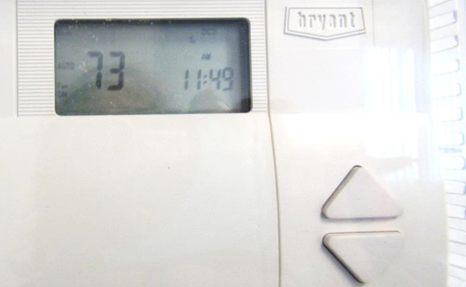
Thermostat with setting to “auto” rather than “on” (arrow)

Picture 2
Supply diffuser
Picture 3
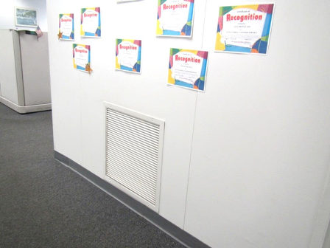
Wall-mounted exhaust/return vent

Picture 4
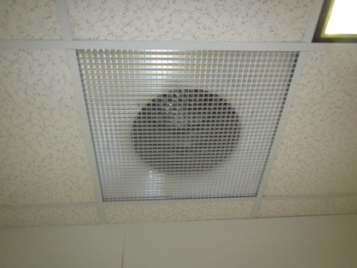
Ceiling-mounted exhaust/return vent
Picture 5
Switch-activated exhaust vent in lounge area

Picture 6
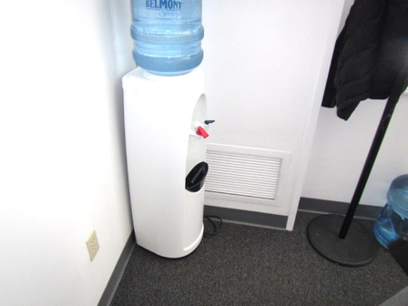
Water cooler on carpet
Picture 7
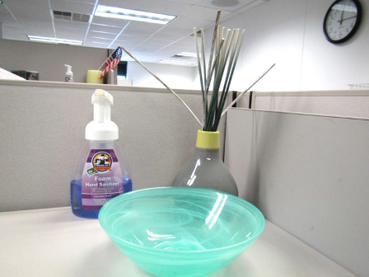
Hand sanitizer and air freshener reeds

Picture 8
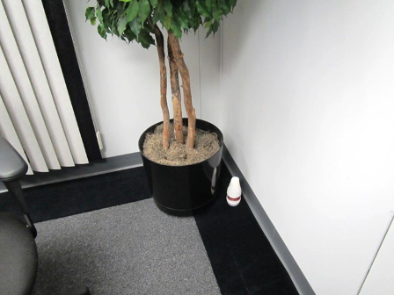
Air freshener in office
Picture 9
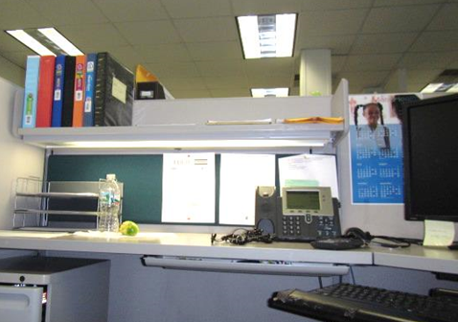
Light fixtures in workstation area, note middle of three ballasts is off/removed

Location | Carbon  Dioxide  (ppm) | Carbon Monoxide  (ppm) | Temp  (°F) | Relative  Humidity  (%) | PM2.5  (µg/m³) | Light Levels  (FC) | Occupants  in Room | Windows  Openable | Ventilation |  |  | Remarks
 |  |  |  |  |  |  |  |  | Intake | Exhaust
Background | 383 | ND | 36 | 12 | 7 |  |  |  |  |  |  | Cold, overcast
101 mail room | 991 | ND | 73 | 16 | 13 | 64 | 0 | N | Y |  |  | Mail equipment
102 lounge | 989 | ND | 73 | 16 | 2 | 40 | 0 | N | Y |  | Y | NC
104-107 | 1011 | ND | 74 | 16 | 9 | 25 | 3 | N | Y |  | N | HS, flowers, PF
109-110 | 979 | ND | 74 | 16 | 9 | 32-50 | 0 | N | Y |  | Y | HS
111-112 | 1035 | ND | 73 | 17 | 1 | 33 | 1 | N | Y |  |  | AF
113-115 | 1016 | ND | 73 | 15 | 1 | 42 | 2 | N | Y |  |  | Items
116 | 1022 | ND | 73 | 16 | 6 | 26 | 0 | N | Y
117-118 | 1051 | ND | 73 | 16 | 2 | 25 | 0 | N | Y |  |  | HS
120 training | 1059 | ND | 74 | 17 | 1 | 44 | 0 | Y | Y |  | Y | 8 computers
122 | 1032 | ND | 73 | 17 | 3 | 38 | 0 | N | Y |  |  | PF, HS
124-126, 135-137 | 1123 | ND | 74 | 17 | 3 | 36 | 3 | N | Y |  |  | HS, food
127-131 | 1062 | ND | 73 | 17 | 9 | 29 | 2 | Y | Y |  |  | Food
132-134 | 1112 | ND | 72 | 17 | 2 | 34 | 1 | Y | Y |  |  | 1 WD CT, PFs, HS
138-139 | 1030 | ND | 72 | 17 | 2 | 35 | 1 | N | Y |  | Y | HS, AF, PF- dusty, WC on carpet
140 data |  |  |  |  |  |  |  |  |  |  |  | ductless AC, Inergen fire suppression
141-142 | 1018 | ND | 72 | 17 | 2 | 32 | 0 | N | Y
143 | 1044 | ND | 74 | 17 | 3 | 49 | 2 | N | Y |  |  | HS, PF
144 | 1051 | ND | 74 | 16 | 1 | 29 | 0 | N | Y |  |  | HS
144 copy room | 940 | ND | 71 | 17 | 10 | 76 | 0 | N | Y |  | N | PC, papers
145 | 1011 | ND | 73 | 16 | 4 | 43 | 1 | N | Y |  | N | DO, DEM
146 | 977 | ND | 73 | 15 | 4 |  | 0 | N | Y |  |  | used for storage
147 | 1017 | ND | 74 | 16 | 8 | 26 | 1 | N | Y |  | N | DO, AF spray
148 | 1066 | 0.3 | 75 | 16 | 6 | 44 | 0 | N | Y |  | N
149 | 1056 | ND | 74 | 16 | 14 | 19 | 0 | N | Y |  |  | DO, HS
151 hallway
152 interview | 1005 | ND | 73 | 17 | 5 | 57 | 0 | N | Y |  | N | DO
153 interview | 1064 | ND | 73 | 17 | 20 | 35 | 0 (3 just left) | N | Y |  | N | HS
154 interview | 1098 | ND | 72 | 18 | 11 | 52 | 0 | N | Y |  | N
1st floor Public restroom
1st floor reception | 1035 | ND- 0.6 | 73 | 16 | 9 | 33 | 1 | N | Y |  | N | HS
1st floor staff women’s rest room |  |  |  |  |  |  |  | N | N |  | Y on/weak
1st floor waiting room | 1025 | ND | 72 | 18 | 46 | 28 | 7 | N (door) | Y |  | Y
200 | 690 | ND | 74 | 11 | 13 | 38 | 0 | Y | Y |  | Y | Boxes on floor
201 conference | 775 | ND | 74 | 13 | 4 | 54 | 0 | Y | Y
202 | 1206 | 0.6 | 75 | 20 | 8 | 54 | 5 | Y | Y |  | N | Fake plants, AF
203 | 711 | ND | 75 | 12 | 0 | 21 (lights were off) | 1 | Y | Y |  | N | 3 PF on, DO
205-206 | 706 | ND | 74 | 12 | 2 | 40 | 0 | Y | Y |  | Y | Boxes on floor, accumulated items, HS
207 | 675 | ND | 74 | 11 | 1 | 23 | 0 | Y | Y |  | N
208 storage |  |  |  |  |  |  |  |  |  |  |  | NC, AP – off and unplugged
210-212 | 697 | ND | 74 | 12 | 4 | 40-57 | 4 | Y | Y |  | Y | WD CT, PC, humidifier, HS, deodorizer, plant
213-216 | 675 | ND | 74 | 11 | 6 | 30 | 4 | Y | Y |  | Y | Food, items
215 |  |  |  |  |  | 28/51 |  |  |  |  |  | 28 = normal conditions  51 = with supplementary desk light on
227 files | 697 | ND | 74 | 11 | 2 | 52 | 0 | Y | Y |  | N | WD CT (3)
228-230 | 677 | ND | 74 | 12 | 1 | 26 | 1 | Y | Y |  | Y
234 | 698 | ND | 75 | 12 | 4 | 42 | 1 | Y | Y |  | N | DEM, DO
235-237 | 698 | ND | 75 | 11 | 2 | 28 | 2 | Y | Y |  | Y | Plants, HS
239-240, 247 | 709 | ND | 72 | 12 | 3 | 43 | 0 | Y | Y |  |  | HS
242 files | 690 | ND | 75 | 11 | 0 | 64 | 0 | N | Y |  | Y | Extra exhaust on switch, fake plants
243 | 690 | ND | 74 | 12 | 4 | 34 | 0 | Y | Y |  | Y | Fake plant
245 | 724 | ND | 73 | 13 | 3 | 51 | 1 | N | Y |  |  | Old copy machine, HS, plant
248 | 677 | ND | 75 | 12 | 1 | 79 | 0 | Y | Y |  |  | Solar gain, WD CT
250 lounge | 823 | ND | 75 | 11-15 | 3 |  | 2 | Y
251 | 713 | ND | 75 | 13 | 12 | 64 | 2 | Y | Y |  |  | PF, WC on carpet

