INDOOR AIR QUALITY ASSESSMENT

MassHealth Enrollment Center
333 Bridge Street
Springfield, Massachusetts

Prepared by:
Massachusetts Department of Public Health
Bureau of Environmental Health
Indoor Air Quality Program
August 2016

Background
Building: | MassHealth Enrollment Center (MEC)
Address: | 333 Bridge Street Springfield, Massachusetts
Assessment Requested by: | Erin McCabe, Executive Office of Health and Human Services (EOHHS)
Reason for Request: | General indoor air quality (IAQ) concerns
Date of Assessment: | June 10, 2016
Massachusetts Department of Public Health/Bureau of Environmental Health (MDPH/BEH) Staff Conducting Assessment: | Mike Feeney, Director , IAQ Program
Building Description: | Two-story, concrete building with flat, membrane roof
Building Population: | Approximately 60 employees and over one hundred visitors daily
Year of Construction: | 1911, renovated in 1999
Windows: | Openable

METHODS
Please refer to the IAQ Manual for methods, sampling procedures, and interpretation of results (MDPH, 2015).

IAQ Testing Results
The following is a summary of indoor air testing results (Table 1).
- Carbon dioxide levels were below 800 parts per million (ppm) in all areas tested, apart from the reception area.
- Temperature was within the recommended range of 70°F to 78°F in all areas tested.
- Relative humidity was within or close to the lower bound of the recommended range of 40% to 60% in most areas tested.
- Carbon monoxide levels were non-detectable in all indoor areas tested.
- Fine particulate matter (PM2.5) concentrations measured were below the National Ambient Air Quality Standard (NAAQS) level of 35 μg/m³ in all areas tested.

Ventilation

It can be seen from Table 1 that carbon dioxide levels were below 800 parts per million (ppm) in all but one area, indicating adequate air exchange at the time of the assessment. Mechanical ventilation is provided by rooftop air-handling units (AHUs). Fresh air is drawn into the AHUs and delivered to occupied areas via ductwork. Recirculated air is directed into the office space by ceiling-mounted fresh air diffusers. Return air is ducted back to the rooftop AHUs. To maximize air exchange, the MDPH recommends that both supply and exhaust ventilation operate continuously during periods of occupancy. In order to have proper ventilation with a mechanical supply and exhaust system, the systems must be balanced to provide an adequate amount of fresh air to the interior of a room while removing stale air from the room.

Microbial/Moisture Concerns
Water-damaged gypsum wall board (GW) was noted around an exterior door on the first floor (Picture 1). In addition, the splash guard behind the breakroom sink was warped and water-damaged (Picture 2). Water-damaged GW and wood can provide a source of mold and should be replaced after a water leak is discovered and repaired.
The US Environmental Protection Agency (US EPA) and the American Conference of Governmental Industrial Hygienists (ACGIH) recommend that porous materials be dried with fans and heating within 24 to 48 hours of becoming wet (US EPA, 2008; ACGIH, 1989). If not dried within this time frame, mold growth may occur. Once mold has colonized porous materials, they are difficult to clean and should be removed.
IAQ staff examined the second floor for sources of irritants. Of primary concern was the presence of an extensive number of potted plants, including flowering types (Pictures 3 and 4). Plants, soil, and drip pans can serve as sources of mold spores. Plants can also be a source of pollen. In addition, some plants were located directly on carpet, which can become moistened from overwatering. Plants should not be placed on porous materials, since water damage to porous materials may lead to microbial growth. In addition, plants should be kept away from sources of airflow, including supply and exhaust vents and fans which can distribute odors, pollen and mold around the building.

Conclusions/Recommendations
In view of the findings at the time of the visit, the following recommendations are made:

- Consider removing all flowers and other plants from the workplace.
- Remove any water-damaged GW and the damaged sink backsplash in a manner consistent with recommendations found in “Mold Remediation in Schools and Commercial Buildings” published by the US Environmental Protection Agency (US EPA, 2008).
- To maximize air exchange, the MDPH recommends that both supply and exhaust ventilation operate continuously during periods of occupancy.
- Have the HVAC system balanced every 5 years in accordance with SMACNA recommendations (SMACNA, 1994).
- For buildings in New England, periods of low relative humidity during the winter are often unavoidable. Therefore, scrupulous cleaning practices should be adopted to minimize common indoor air contaminants whose irritant effects can be enhanced when the relative humidity is low. To control for dusts, a high efficiency particulate arrestance (HEPA) filter equipped vacuum cleaner in conjunction with wet wiping of all surfaces is recommended. Drinking water during the day can help ease some symptoms associated with a dry environment (throat and sinus irritations).
- Refer to resource manuals and other related indoor air quality documents for further building-wide evaluations and advice on maintaining public buildings. Copies of these materials are located on the MDPH’s website: http://mass.gov/dph/iaq.

References
ACGIH. 1989. Guidelines for the Assessment of Bioaerosols in the Indoor Environment. American Conference of Governmental Industrial Hygienists, Cincinnati, OH.
Massachusetts Department of Public Health (MDPH). 2015. Indoor Air Quality Manual: Chapters I-III. Available at: http://www.mass.gov/eohhs/gov/departments/dph/programs/environmental-health/exposure-topics/iaq/iaq-manual/.
SMACNA. 1994. HVAC Systems Commissioning Manual. 1st ed. Sheet Metal and Air Conditioning Contractors’ National Association, Inc., Chantilly, VA.
US EPA. 2008. “Mold Remediation in Schools and Commercial Buildings”. Office of Air and Radiation, Indoor Environments Division, Washington, DC. EPA 402-K-01-001. September 2008. Available at: http://www.epa.gov/mold/mold-remediation-schools-and-commercial-buildings-guide.

Picture 1
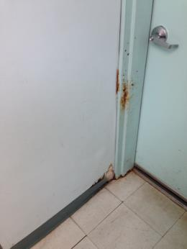
Water-damaged GW around exterior door on first floor
Picture 2
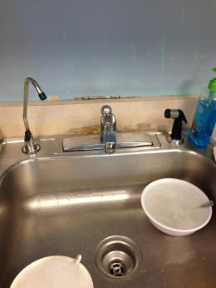
Water-damaged sink backsplash in break room
Picture 3
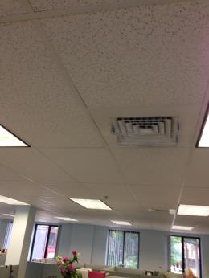
Flowering plants in office on second floor
Picture 4
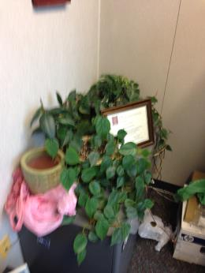
Example of plants on second floor
Location | Carbon  Dioxide  (ppm) | Carbon Monoxide  (ppm) | Temp  (°F) | Relative  Humidity  (%) | PM2.5  (µg/m3) | Occupants  in Room | Windows  Openable | Ventilation |  | Remarks
 |  |  |  |  |  |  |  | Supply | Exhaust
Background (outdoors) | 434 | ND | 72 | 35 | 2
Waiting room | 784 | ND | 73 | 37 | 4 | 5 | N | Y | Y
Hall | 783 | ND | 73 | 38 | 3 | 5 | N | Y | Y
Reception | 813 | ND | 73 | 35 | 4 | 1 | N | Y | N
110 | 721 | ND | 74 | 36 | 3 | 2 | N | Y | N | Plants
112 | 735 | ND | 73 | 37 | 3 | 4 | N | Y | Y | Water-damaged gypsum wallboard.
117 | 770 | ND | 75 | 37 | 3 | 3 | N | Y | Y
121 | 775 | ND | 75 | 37 | 3 | 2 | N | Y | Y
150 | 754 | ND | 73 | 38 | 3 | 1 | N | Y | N
151 | 755 | ND | 73 | 38 | 3 | 1 | N | Y | N | Plants
153 | 762 | ND | 73 | 38 | 4 | 1 | N | Y | Y | Plants, door open
156 | 679 | ND | 72 | 37 | 2 | 0 | N | Y | N
157 | 741 | ND | 72 | 38 | 3 | 0 | N | Y | N
204 | 675 | ND | 74 | 39 | 1 | 3 | Y | Y | Y | Plants
214 | 642 | ND | 73 | 39 | 1 | 2 | Y | Y | Y | Plants, flowers
215 | 676 | ND | 73 | 39 | 1 | 2 | Y | Y | Y | Plants
219 | 680 | ND | 73 | 39 | 1 | 2 | Y | Y | Y | Plants
224 | 654 | ND | 75 | 36 | 2 | 1 | Y | Y | Y | Plants
230 | 647 | ND | 75 | 37 | 2 | 2 | Y | Y | Y | Plants
235 | 667 | ND | 75 | 37 | 1 | 1 | Y | Y | Y | Plants
241 | 660 | ND | 74 | 39 | 1 | 0 | N | Y | N | Water-damaged sink backsplash
242 | 654 | ND | 73 | 41 | 1 | 0 | N | Y | Y
250 | 723 | ND | 73 | 42 | 2 | 0 | Y | Y | N
251 | 691 | ND | 75 | 37 | 2 | 2 | N | Y | N
252 | 720 | ND | 75 | 37 | 2 | 0 | Y | Y | Y | Door open
253 | 713 | ND | 75 | 37 | 2 | 2 | Y | Y | N | Plants, flowers, door open
255 | 604 | ND | 73 | 39 | 1 | 0 | Y | Y | N
256 | 638 | ND | 74 | 38 | 3 | 0 | Y | Y | N
263 | 653 | ND | 75 | 39 | 3 | 2 | Y | Y | N | Plants

