Background/Introduction

INDOOR AIR QUALITY ASSESSMENT

Commonwealth of Massachusetts
MassHealth Office
45 Spruce Street
Chelsea, Massachusetts

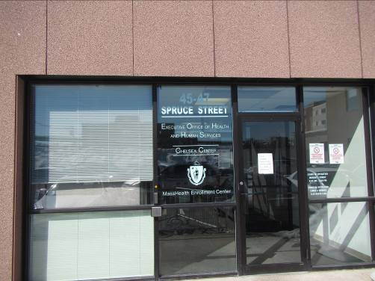

Prepared by:
Massachusetts Department of Public Health
Bureau of Environmental Health
Indoor Air Quality Program
April 2015

In response to a request by Erin McCabe, Field Operations Manager, Executive Office of Health and Human Services (EOHHS), the Massachusetts Department of Public Health (MDPH), Bureau of Environmental Health (BEH) provided assistance and consultation regarding indoor air quality (IAQ) at the MassHealth Offices (MH) located at 45 Spruce Street, Chelsea, Massachusetts. The request was prompted by employee complaints concerning general IAQ.
On March 6, 2015 the MH office was visited by Ruth Alfasso, Environmental Engineer/Inspector and Jason Dustin Environmental Analyst/Inspector in BEH’s IAQ Program to conduct an IAQ assessment. BEH staff were accompanied on the visit by Cory Thomas, Field Operations Unit, EOHHS, Dixon Iyawe, Director of the MH Chelsea office and Diane Pixley, Deputy Director of the MH office.
MH occupies areas on the first and second floor of a two-story building located in Chelsea, MA. The building has a flat roof and appears to be clad in Exterior Foam Insulation System (EFIS) panels. Ceilings consist of suspended ceiling tiles. Floors in the majority of areas are covered with carpet squares. Windows are not openable in the building. The building is located on a busy street in a neighborhood containing restaurants, warehouse/industrial buildings and other office buildings.

Methods
Air tests for carbon monoxide, carbon dioxide, temperature, and relative humidity were conducted with the TSI, Q-Trak, IAQ Monitor, Model 7565. Air tests for airborne particle matter with a diameter less than 2.5 micrometers were taken with the TSI, DUSTTRAK™ Aerosol Monitor Model 8520. BEH/IAQ staff also performed a visual inspection of building materials for water damage and/or microbial growth.

Results
Approximately 65 employees work in the MH portion of the building and up to 100 members of the public may visit the space on a daily basis. The tests were taken during normal operations and appear in Table 1. Tables are sorted by room/cubicle number where available and by name or location otherwise.

Discussion

Ventilation
It can be seen from Table 1 that carbon dioxide levels were above 800 parts per million (ppm) in 26 out of 43 areas tested indicating a lack of air exchange in more than half of the areas sampled at the time of the assessment. Of note is that 15 out of 16 of the carbon dioxide results for the second floor were below 800 ppm, while 25 out of 27 results for the first floor were above 800 ppm (Table 1).
Fresh air is provided by rooftop air handling units (AHU) ducted to ceiling-mounted supply diffusers (Picture 1). Return air is drawn back into ceiling vents (Picture 2) and returned to the AHUs. In a few locations, the exhaust appeared to be vented into ducts which may exhaust directly to the roof. The BEH/IAQ program recommends that direct venting be used in areas where pollutants may be generated such as kitchens, copy areas and high-use areas.
Note that due to low outside temperatures on the day of the assessment, and over the several previous weeks, fresh air supplies to buildings may be automatically or manually restricted in order to protect piping from freezing and enable comfortable temperatures to be maintained inside the building.
Thermostats were examined on each floor. It appeared that thermostat fans were set to the “on” setting on both floors. When the thermostat is set to on, the system provides a continuous source of air circulation and filtration. The automatic setting on the thermostat activates the HVAC system at a preset temperature. Once the preset temperature is reached, the HVAC system is deactivated. No mechanical ventilation is provided until the thermostat re-activates the system. The MDPH typically recommends that thermostats be set to the fan on setting during occupied hours to provide continuous air circulation. Without a continuous source of fresh outside air and removal of stale air via the exhaust/return system, indoor environmental pollutants can build up and lead to indoor air quality/comfort complaints.
To maximize air exchange, the MDPH recommends that both supply and exhaust ventilation operate continuously during periods of occupancy. In order to have proper ventilation with a mechanical supply and exhaust system, the systems must be balanced to provide an adequate amount of fresh air to the interior of a room while removing stale air from the room. It is recommended that HVAC systems be re-balanced every five years to ensure adequate air systems function (SMACNA, 1994). It was reported that the systems were last balanced at the time of the renovation, approximately three years previous.
Minimum design ventilation rates are mandated by the Massachusetts State Building Code (MSBC). Until 2011, the minimum ventilation rate in Massachusetts was higher for both occupied office spaces and general classrooms, with similar requirements for other occupied spaces (BOCA, 1993). The current version of the MSBC, promulgated in 2011 by the State Board of Building Regulations and Standards (SBBRS), adopted the 2009 International Mechanical Code (IMC) to set minimum ventilation rates. Please note that the MSBC is a minimum standard that is not health-based. At lower rates of cubic feet per minute (cfm) per occupant of fresh air, carbon dioxide levels would be expected to rise significantly. A ventilation rate of 20 cfm per occupant of fresh air provides optimal air exchange resulting in carbon dioxide levels at or below 800 ppm in the indoor environment in each area measured. MDPH recommends that carbon dioxide levels be maintained at 800 ppm or below. This is because most environmental and occupational health scientists involved with research on IAQ and health effects have documented significant increases in indoor air quality complaints and/or health effects when carbon dioxide levels rise above the MDPH guidelines of 800 ppm for schools, office buildings and other occupied spaces (Sundell et al., 2011). The ventilation must be on at all times that the room is occupied. Providing adequate fresh air ventilation with open windows and maintaining the temperature in the comfort range during the cold weather season is impractical. Mechanical ventilation is usually required to provide adequate fresh air ventilation.
Carbon dioxide is not a problem in and of itself. It is used as an indicator of the adequacy of the fresh air ventilation. As carbon dioxide levels rise, it indicates that the ventilating system is malfunctioning or the design occupancy of the room is being exceeded. When this happens, a buildup of common indoor air pollutants can occur, leading to discomfort or health complaints. The Occupational Safety and Health Administration (OSHA) standard for carbon dioxide is 5,000 parts per million parts of air (ppm). Workers may be exposed to this level for 40 hours/week, based on a time-weighted average (OSHA, 1997).
The MDPH uses a guideline of 800 ppm for publicly occupied buildings. A guideline of 600 ppm or less is preferred in schools due to the fact that the majority of occupants are young and considered to be a more sensitive population in the evaluation of environmental health status. Inadequate ventilation and/or elevated temperatures are major causes of complaints such as respiratory, eye, nose and throat irritation, lethargy and headaches. For more information concerning carbon dioxide, please see Appendix A.
Temperature readings during the assessment ranged from 71ºF to 78ºF (Table 1) which were within the MDPH recommended comfort guidelines. The MDPH recommends that indoor air temperatures be maintained in a range of 70ºF to 78ºF in order to provide for the comfort of building occupants. In many cases concerning indoor air quality, fluctuations of temperature in occupied spaces are typically experienced, even in a building with an adequate fresh air supply.
The relative humidity measured during the assessment ranged from 7 to 18 percent, all measurements were below the MDPH recommended comfort range. The MDPH recommends a comfort range of 40 to 60 percent for indoor air relative humidity. Relative humidity levels in the building would be expected to drop during the winter months due to heating. The sensation of dryness and irritation is common in a low relative humidity environment. Low relative humidity is a very common problem during the heating season in the northeast part of the United States.

Microbial/Moisture Concerns
Water-damaged ceiling tiles were observed in several areas of the building (Pictures 1 and 3, Table 1) which appeared to be the result of historic roof or plumbing leaks. Water-damaged ceiling tiles should be removed and replaced once the source of water has been identified and remediated.
Plants were observed in several areas (Table 1). Some of these plants appeared to be poorly maintained, overwatered, and inappropriately placed on porous materials (Pictures 4 and 5). Plants, soil and drip pans can serve as sources of mold/bacterial growth. Plants should be properly maintained, over-watering of plants should be avoided and drip pans should be inspected periodically for mold growth. Water-damaged windowsills were observed in a few areas that appeared to be due to plants or other items that had been placed there in the past (Pictures 4 and 6).
An area of water-damaged plaster/paint was observed in one room on the first floor next to a window (Picture 7). This may indicate a leak from outside, or chronic condensation in this area. The water-damaged materials should be removed and the wall cavity should be monitored for leaks. Items should not be stored on this windowsill on order to prevent the build-up of condensation in this location and to avoid moistening of materials.
Water-damaged carpeting was observed in a storeroom under stairs (Picture 8). If this area is subject to periodic water infiltration or condensation, it should not be used for storage of porous items. In addition, in this room and in others, boxes were found stored on the floor. Items in contact with floors may be subject to moistening from condensation, which can damage porous materials such as cardboard, and may lead to microbial growth.
Water coolers were observed in carpeted areas (Picture 9). Spills or leaks from these appliances can moisten carpeting. They should be located in a non-carpeted area or on waterproof mats.
The room housing data equipment was equipped with a ductless air conditioning unit to maintain proper temperature control. These units have condensation drains that are pumped to the outside of the building. These units should be regularly inspected to insure that the condensation drains and pumps are working properly and are not clogged or leaking.
The exterior of the building was examined for conditions that might lead to indoor air quality concerns. Doors to the exterior were seen to be missing weather stripping (Picture 10), which can allow unconditioned air, moisture and pests into the building. In addition, a hole was noted in the EFIS siding on one area (Picture 11). This should be repaired to prevent infiltration of water into the building and to allow the drainage plane to function properly.

Other IAQ Evaluations
Indoor air quality can be negatively influenced by the presence of respiratory irritants, such as products of combustion. The process of combustion produces a number of pollutants. Common combustion emissions include carbon monoxide, carbon dioxide, water vapor, and smoke (fine airborne particle material). Of these materials, exposure to carbon monoxide and particulate matter with a diameter of 2.5 micrometers (μm) or less (PM2.5) can produce immediate, acute health effects upon exposure. To determine whether combustion products were present in the indoor environment, BEH/IAQ staff obtained measurements for carbon monoxide and PM2.5.

Carbon Monoxide
Carbon monoxide is a by-product of incomplete combustion of organic matter (e.g., gasoline, wood and tobacco). Exposure to carbon monoxide can produce immediate and acute health effects. Several air quality standards have been established to address carbon monoxide and prevent symptoms from exposure to these substances. The MDPH established a corrective action level concerning carbon monoxide in ice skating rinks that use fossil-fueled ice resurfacing equipment. If an operator of an indoor ice rink measures a carbon monoxide level over 30 ppm, taken 20 minutes after resurfacing within a rink, that operator must take actions to reduce carbon monoxide levels (MDPH, 1997).
The American Society of Heating Refrigeration and Air-Conditioning Engineers (ASHRAE) has adopted the National Ambient Air Quality Standards (NAAQS) as one set of criteria for assessing indoor air quality and monitoring of fresh air introduced by HVAC systems (ASHRAE, 1989). The NAAQS are standards established by the US EPA to protect the public health from six criteria pollutants, including carbon monoxide and particulate matter (US EPA, 2006). As recommended by ASHRAE, pollutant levels of fresh air introduced to a building should not exceed the NAAQS levels (ASHRAE, 1989). The NAAQS were adopted by reference in the Building Officials & Code Administrators (BOCA) National Mechanical Code of 1993 (BOCA, 1993), which is now an HVAC standard included in the Massachusetts State Building Code (SBBRS, 2011). According to the NAAQS, carbon monoxide levels in outdoor air should not exceed 9 ppm in an eight-hour average (US EPA, 2006).
Carbon monoxide should not be present in a typical, indoor environment. If it is present, indoor carbon monoxide levels should be less than or equal to outdoor levels. During the visit outdoor carbon monoxide concentrations were 0.5 to 1.0 ppm. No measurable levels of carbon monoxide were detected inside the building during the assessment (Table 1).

Particulate Matter
The US EPA has established NAAQS limits for exposure to particulate matter. Particulate matter includes airborne solids that can be irritating to the eyes, nose and throat. The NAAQS originally established exposure limits to PM with a diameter of 10 μm or less (PM10). In 1997, US EPA established a more protective standard for fine airborne particulate matter with a diameter of 2.5 μm or less (PM2.5). This more stringent PM2.5 standard requires outdoor air particle levels be maintained below 35 μg/m³ over a 24-hour average (US EPA, 2006). Although both the ASHRAE standard and BOCA Code adopted the PM10 standard for evaluating air quality, MDPH uses the more protective PM2.5 standard for evaluating airborne PM concentrations in the indoor environment.
Outdoor PM2.5 concentrations were measured at ND to 19 μg/m³ (Table 1). PM2.5 levels indoors ranged from ND to 24 μg/m³. All readings were below the NAAQS PM2.5 level of 35 μg/m³. Frequently, indoor air levels of particulate matter (including PM2.5) can be at higher levels than those measured outdoors. A number of activities that occur indoors and/or mechanical devices can generate particulate matter during normal operations. Sources of indoor airborne particulate matter may include but are not limited to particles generated during the operation of fan belts in the HVAC system, use of stoves and/or microwave ovens in kitchen areas; use of photocopiers, fax machines and computer printing devices; operation of an ordinary vacuum cleaner and heavy foot traffic indoors.

Volatile Organic Compounds
Indoor air concentrations can be greatly impacted by the use of products containing volatile organic compounds (VOCs). VOCs are carbon-containing substances that have the ability to evaporate at room temperature. Total volatile organic compounds (TVOCs) can result in eye and respiratory irritation if exposure occurs. For example chemicals evaporating from a paint can stored at room temperature would most likely contain VOCs.
Of note is the presence of copy machines within office areas directly adjacent to seating with no dedicated exhaust ventilation (Table 1). Photocopiers can be sources of pollutants such as VOCs, ozone, heat and odors, particularly if the equipment is older and in frequent use. Both VOCs and ozone are respiratory irritants (Schmidt Etkin, 1992). Photocopiers should be kept in well ventilated rooms, and should be located near windows or exhaust vents.
Additional sources of TVOCs in the office area include dry erase boards and related materials (Table 1). Materials such as dry erase markers and dry erase board cleaners may contain VOCs, such as methyl isobutyl ketone, n-butyl acetate and butyl-cellusolve (Sanford, 1999), which can be irritating to the eyes, nose and throat.
Hand sanitizer was also observed in the space (Table 1); these products may contain ethyl alcohol and/or isopropyl alcohol, which are highly volatile and may be irritating to the eyes and nose. Sanitizing products may also contain fragrances to which some people may be sensitive.
Cleaning products, air freshening sprays and scented products were also found in the office (Table 1). Air fresheners and air deodorizers contain chemicals that can be irritating to the eyes, nose and throat of sensitive individuals. Many air fresheners contain 1,4-dichlorobenzene, a VOC which may cause reductions in lung function (NIH, 2006). Furthermore, deodorizing agents do not remove materials causing odors, but rather mask odors that may be present in the area. Many cleaning products contain chemicals that can be irritating to the eyes, nose and throat of sensitive individuals. Cleaning products should be properly labeled and stored in an appropriate area. In addition, a Material Safety Data Sheet (MSDS) should be available at a central location for each product in the event of an emergency.

Other Conditions
Evidence of rodent activity was observed in the form of mouse traps in several areas (Picture 9). Building staff reported rodents in the building in the past. Rodent infestation can result in indoor air quality related symptoms due to materials in their wastes. Mouse urine contains a protein that is a known sensitizer (US EPA, 1992). A sensitizer is a material that can produce symptoms (e.g., running nose or skin rashes) in sensitive individuals after repeated exposure. A three-step approach is necessary to eliminate rodent infestation:
- removal of the rodents;
- cleaning of waste products from the interior of the building; and
- reduction/elimination of pathways/food sources that are attracting rodents.
To eliminate exposure to allergens, rodents must be removed from the building. Please note that removal, even after cleaning, may not provide immediate relief since allergens can exist in the interior for several months after rodents are eliminated (Burge, 1995). Once the infestation is eliminated, a combination of cleaning and increased ventilation and filtration should serve to reduce allergens associated with rodents.
Note that in the kitchen area, debris was observed on toasters and other equipment (Picture 12). This debris can be attractive to pests. It can also lead to smoke and odors when the appliances are used/heated.
Kitchen odors (e.g., bacon) were noted in several areas of the office at the time of the assessment. The penetration/strength of these odors as well as the appearance of the kitchen’s exhaust vent suggest that this vent is a part of the general building return system and is therefore entraining cooking pollutants and distributing odors to the rest of the zone serviced by this AHU. It is recommended that kitchen areas directly vent to the outdoors.
In some office areas, accumulations of items were on floors, windowsills, tabletops, counters, bookcases and desks, which provide a source for dusts to accumulate (Picture 13). These items (e.g., papers, folders, boxes) make it difficult for custodial staff to clean. Items should be relocated and/or be cleaned periodically to avoid excessive dust build up. Pencil shavings were observed in one office (Picture 14). These materials can also be aerosolized by air movement from the ventilation system or opening/closing of doors; aerosolized materials may present an eye or respiratory irritant. Personal fans, and supply and exhaust vents were found to be dusty in some areas (Picture 15). Regular cleaning of supply diffusers, exhaust vents and personal fans will reduce aerosolizing any accumulated particulate matter on these surfaces.
Most areas of the office space were carpeted. The Institute of Inspection, Cleaning and Restoration Certification (IICRC) recommends that carpeting be cleaned annually (or semi-annually in soiled high traffic areas) (IICRC, 2012). Regular cleaning with a high efficiency particulate arrestance (HEPA) filtered vacuum in combination with an annual cleaning will help to reduce accumulation and potential aerosolization of materials from the carpeting.

Conclusions/Recommendations
In view of the findings at the time of the visit, the following recommendations are made:
- Operate all ventilation systems throughout the building continuously during periods of occupancy to maximize air exchange. This would include leaving thermostat fan settings in the “on” mode (not auto) for continuous airflow.
- Consider connecting the exhaust vent in the kitchen to a direct vent fan to exhaust kitchen odors, particulate matter and moisture outside the building.
- Consider adopting a balancing schedule of every 5 years for all mechanical ventilation systems, as recommended by ventilation industrial standards (SMACNA, 1994).
- For buildings in New England, periods of low relative humidity during the winter are often unavoidable. Therefore, scrupulous cleaning practices should be adopted to minimize common indoor air contaminants whose irritant effects can be enhanced when the relative humidity is low. To control for dusts, a high efficiency particulate arrestance (HEPA) filter equipped vacuum cleaner in conjunction with wet wiping of all surfaces is recommended. Avoid the use of feather dusters. Drinking water during the day can help ease some symptoms associated with a dry environment (throat and sinus irritations).
- Examine areas of leakage and ensure any water-damaged ceiling tiles are repaired and/or replaced. Examine the area above ceiling tiles for mold growth. Disinfect areas of water leaks with an appropriate antimicrobial, as needed.
- Indoor plants should be properly maintained and equipped with drip pans to prevent water damage to porous building materials and be located away from ventilation sources to prevent the aerosolization of dirt, pollen or mold.
- Inspect the damaged plaster shown in Picture 7 for sources of water and repair. Do not store materials on this windowsill until the source of water has been repaired.
- Place water coolers/dispensers in areas without carpeting or place on a waterproof mat.
- Regularly inspect the ductless air conditioning units for proper condensation drainage.
- Repair/install weather-stripping on doors to the outside to prevent infiltration of unconditioned air, moisture and pests.
- Repair the siding shown in Picture 11.
- Consider relocating photocopiers to areas with local exhaust ventilation and away from occupants.
- Use dry erase markers only in well ventilated areas. Clean dry erase boards and trays to prevent accumulation of materials.
- Reduce the use of hand sanitizing products especially those containing fragrances.
- Avoid the use of air freshener sprays, solids and diffuser reeds to avoid exposure to VOCs and fragrance compounds.
- Use the principles of integrated pest management (IPM) to rid this building of pests.
Activities that can be used to eliminate pest infestation may include the following:
  - Keep list/inventory of location of all rodent bait/sticky traps, monitor on a regular basis and replace as needed to prevent odors from rodent die off. Do not place rodent traps in the airstream of ventilation equipment;
  - Do not use recycled food containers for other purposes. Seal containers to be recycled in a container with a tight fitting lid to prevent rodent access;
  - Remove non-food items that rodents are consuming or using as bedding;
  - Store foods in tight fitting containers;
  - Avoid eating at workstations. In areas were food is consumed, vacuum periodically to remove crumbs;
  - Regularly clean crumbs and other food residues from toasters, toaster ovens, microwave ovens coffee pots and other food preparation equipment;
  - Examine each room and the exterior walls of the building for means of rodent egress and seal appropriately. Holes as small as ¼” is enough space for rodents to enter an area. If doors do not seal at the bottom, install a weather strip as a barrier to rodents;
  - Reduce harborages (cardboard boxes, paper) where rodents may reside; and
  - Refer to the IPM Guide, which can be obtained at the following Internet address: http://www.mass.gov/eea/docs/agr/pesticides/publications/ipm-kit-for-bldg-mgrs.pdf.
- Continue to change filters for AHUs in accordance with the manufacturer’s instructions, or more frequently if needed.
- Regularly clean supply diffusers, exhaust vents and personal fans to avoid re-aerosolizing any accumulated debris.
- Vacuum carpet with a high efficiency particulate arrestance (HEPA) filtered vacuum in combination with an annual cleaning to help to reduce accumulation and potential aerosolization of materials from the carpeting.
- Refer to resource manuals and other related indoor air quality documents for further building-wide evaluations and advice on maintaining public buildings. Copies of these materials are located on the MDPH’s website: http://mass.gov/dph/iaq.

References
ASHRAE. 1989. Ventilation for Acceptable Indoor Air Quality. American Society of Heating, Refrigeration and Air Conditioning Engineers. ANSI/ASHRAE 62-1989.
BOCA. 1993. The BOCA National Mechanical Code/1993. 8th ed. Building Officials & Code Administrators International, Inc., Country Club Hills, IL.
Burge, H.A. 1995. Bioaerosols. Lewis Publishing Company, Boca Raton, FL.
IICRC. 2012. Carpet Cleaning FAQ 4 Institute of Inspection, Cleaning and Restoration Certification. Institute of Inspection Cleaning and Restoration, Vancouver, WA.
MDPH. 1997. Requirements to Maintain Air Quality in Indoor Skating Rinks (State Sanitary Code, Chapter XI). 105 CMR 675.000. Massachusetts Department of Public Health, Boston, MA.
NIH. 2006. Chemical in Many Air Fresheners May Reduce Lung Function. NIH News. National Institute of Health. July 27, 2006. http://www.nih.gov/news/pr/jul2006/niehs-27.htm
OSHA. 1997. Limits for Air Contaminants. Occupational Safety and Health Administration. Code of Federal Regulations. 29 C.F.R 1910.1000 Table Z-1-A.
Sanford. 1999. Material Safety Data Sheet (MSDS No: 198-17). Expo® Dry Erase Markers Bullet, Chisel, and Ultra Fine Tip. Sanford Corporation. Bellwood, IL.
SBBRS. 2011. Mechanical Ventilation. State Board of Building Regulations and Standards. Code of Massachusetts Regulations, 8th edition. 780 CMR 1209.0.
Schmidt Etkin, D. 1992. Office Furnishings/Equipment & IAQ Health Impacts, Prevention & Mitigation. Cutter Information Corporation, Indoor Air Quality Update, Arlington, MA.
SMACNA. 1994. HVAC Systems Commissioning Manual. 1st ed. Sheet Metal and Air Conditioning Contractors’ National Association, Inc., Chantilly, VA.
Sundell. 2011. Sundell, J., H. Levin, W. W. Nazaroff, W. S. Cain, W. J. Fisk, D. T. Grimsrud, F. Gyntelberg, Y. Li, A. K. Persily, A. C. Pickering, J. M. Samet, J. D. Spengler, S. T. Taylor, and C. J. Weschler. Ventilation rates and health: multidisciplinary review of the scientific literature. Indoor Air, Volume 21: pp 191–204.
US EPA. 1992. Indoor Biological Pollutants. US Environmental Protection Agency, Environmental Criteria and Assessment Office, Office of Health and Environmental Assessment, research Triangle Park, NC. EPA 600/8-91/202. January 1992.
US EPA. 2006. National Ambient Air Quality Standards (NAAQS). US Environmental Protection Agency, Office of Air Quality Planning and Standards, Washington, DC. http://www.epa.gov/air/criteria.html.
Picture 1
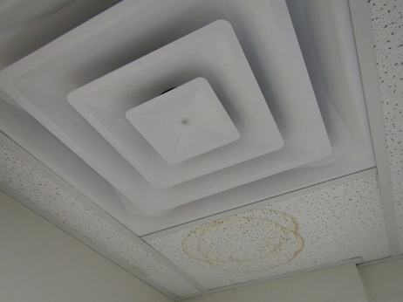
Ceiling-mounted supply vent (note water-damaged ceiling tile)
Picture 2
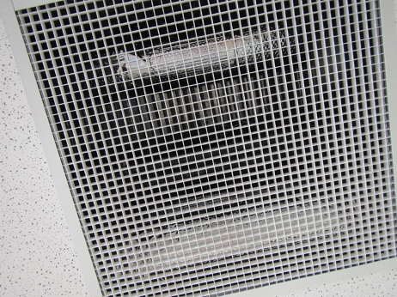
Ceiling-mounted return vent
Picture 3
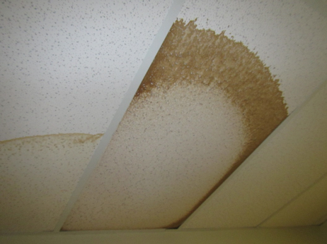
Water-damaged ceiling tiles in a storage room
Picture 4
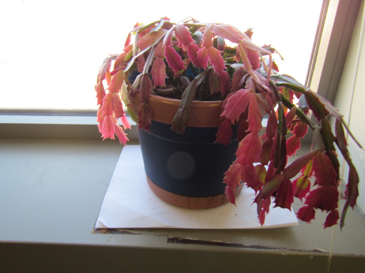
Plant on cardboard, note damage to windowsill
Picture 5
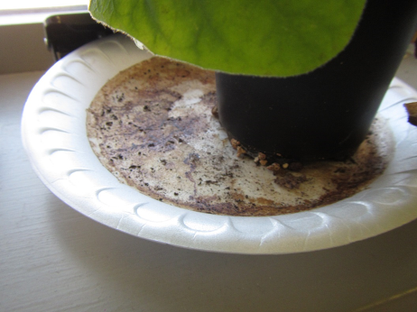
Debris in plant drip pan
Picture 6
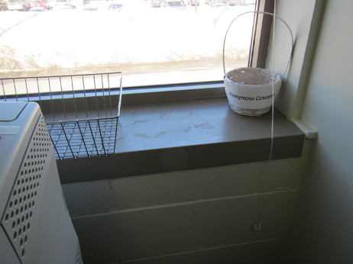
Water stains/damage on windowsill
Picture 7
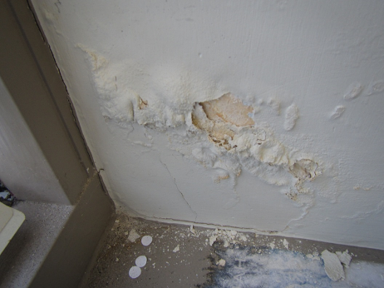
Water-damaged plaster
Picture 8
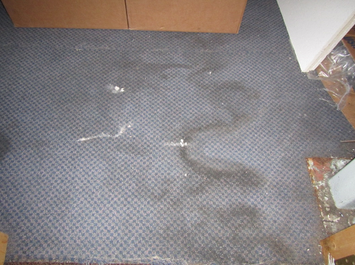
Water-damaged carpeting in storage area
Picture 9
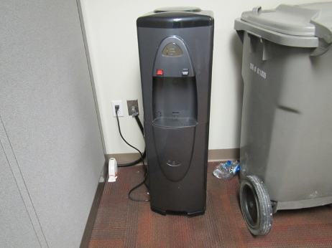
Water cooler on carpet, also note mousetrap to the left
Picture 10
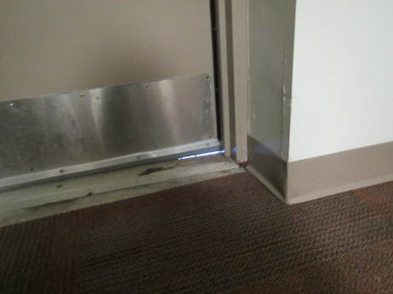
Gap under door (light penetration)
Picture 11
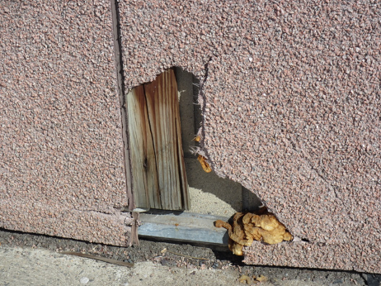
Hole in siding
Picture 12
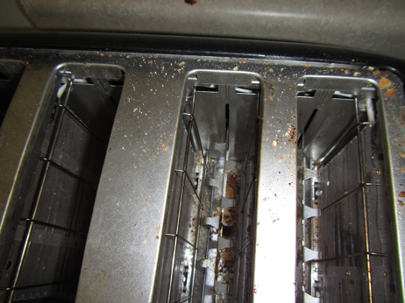
Toaster in kitchen area with crumbs
Picture 13
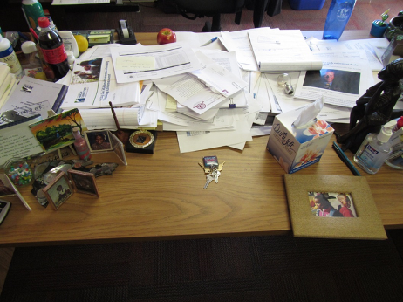
Papers and items on desk
Picture 14
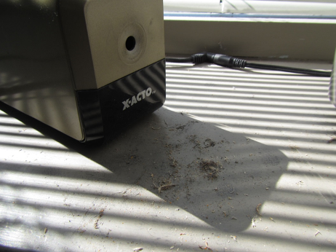
Pencil shavings
Picture 15
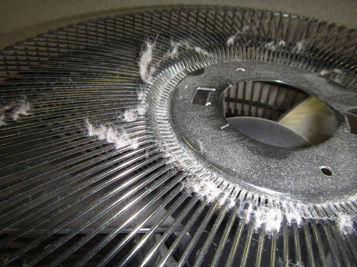
Debris on personal fan

Location | Carbon  Dioxide  (ppm) | Carbon Monoxide  (ppm) | Temp  (°F) | Relative  Humidity  (%) | PM2.5  (µg/m³) | Occupants  in Room | Windows  Openable | Ventilation |  |  | Remarks
 |  |  |  |  |  |  |  | Intake | Exhaust
Background | 403 | 0.5-1.0 | 32 | 4 | ND-19 |  |  |  |  |  | Cold, sunny, traffic nearby
First floor
“Penthouse” cubicle area | 1015 | ND | 72 | 13 | 3 | 9 | N | Y |  | Y | Items hanging from ceiling, AI, plants, PC
116 office | 846 | ND | 73 | 11 | 6 | 0 | N | Y |  | Y | 2 WD CT, boxes on floor, DEM
134 cube area | 922 | ND | 76 | 11 | 3 | 5 | N | Y |  | Y | CP, plants, PF, HS
137 office | 865 | ND | 77 | 9 | 4 | 1 | N | Y |  | Y | DO
140 cube area | 865 | ND | 75 | 11 | 16 | 1 | N | Y |  | Y | AI
160 cube area | 925 | ND | 76 | 10 | 2 | 3 | N | Y |  | Y | Plants, AI, HS
161 cube area | 902 | ND | 75 | 11 | 4 | 1 | N | Y |  | N | Printers
1st floor conference room | 1144 | ND | 71 | 17 | 24 | 6 | N | Y |  | Y
Baratz cube area | 937 | ND | 76 | 11 | 20 | 3 | N | Y |  | Y | CP, HS
Beaudry office | 855 | ND | 76 | 10 | 1 | 0 | N | Y |  | N | DO
Espinal cube area | 946 | ND | 75 | 10 | 5 | 2 | N | Y |  | Y | PC
Guirola, soft office | 862 | ND | 76 | 17 | 2 | 0 | N | Y |  | N | DO, HS, food, AF, plants, WD paint/plaster by window
Hearing 7 | 1070 | ND | 72 | 13 | 7 | 1 | N | Y |  | N | WD CT
Interview 1 | 1118 | ND | 74 | 16 | 4 | 0 | N | Y |  | Y | HS
Interview 2 | 1110 | ND | 73 | 13 | ND | 4 | N | Y |  | Y | CP/AF
Interview 3 | 1155 | ND | 72 | 12 | ND | 1 | N | Y |  | Y | CP
Interview 4 | 1095 | ND | 72 | 12 | ND | 3 | N | Y |  | Y | CP
Interview 5 | 1065 | ND | 72 | 12 | ND | 2 | N | Y |  | Y
Interview 6 | 1277 | ND | 73 | 18 | 5 | 1 | N | y |  | Y
Landrau, office | 898 | ND | 74 | 11 | 2 | 1 | N | Y |  | N | PF, DO
Lewis, soft office | 900 | ND | 74 | 11 | 4 | 0 | N | Y |  | N | DO, HS, CP
Lunch room | 663 | ND | 74 | 9 | 5 | 0 | N | Y |  | Y | NC, bacon odors, vending machines, plants, refrigerators, exhaust not separately ducted outside- return only
Mail room | 704 | ND | 74 | 9 | 3 | 0 | N | Y |  | Y
Reception/staff side | 880 | ND | 72 | 12 | 5 | 2 | N | Y |  | Y | PF, PC, plant
Staff ladies room |  |  |  |  |  |  | N | Y |  | Y | 2 WD CT, CP, AF
Storage room | 803 | ND | 73 | 10 | 3 | 0 | N | Y |  | y | 2 WD CT, NC, boxes on floor, glitter on floor
Training Room | 836 | ND | 72 | 11 | 3 | 0 | N | Y |  | Y | 16 computers, dusty windowsills
Waiting room | 1039 | ND | 73 | 13 | 1 | 15 | N door | Y |  | Y
Second Floor
145 cube area | 634 | ND | 75 | 7 | 2 | 2 | N | Y |  |  | Items on floor, WD windowsill
200 | 651 | ND | 74 | 8 | 2 | 0 | N | Y |  | N | DO, plants, AI, DEM
201 Hotel | 658 | ND | 75 | 8 | 2 | 0 | N | Y |  | N | DO, mousetrap
204 | 670 | ND | 78 | 8 | 4 | 1 | N | Y |  | N | DO, plant, HS, CP
214 | 679 | ND | 78 | 8 | 9 | 0 | N | Y |  | N | Soft office, HS, DO
223 cube area | 684 | ND | 77 | 8 | 2 | 4 | N | Y |  |  | CP, items on ceiling, plants, PFs
229 cube area | 682 | ND | 77 | 7 | 4 | 3 | N | Y |  | Y | Plants, AI, PC, PF, HS
Braun soft office | 644 | ND | 74 | 8 | 1 | 0 | N | Y |  | N | DO, vacuum cleaner
Director | 651 | ND | 75 | 8 | 2 | 0 | N | Y |  | N | DO, CP, PF, HS, plant
Executive meeting room | 883 | ND | 73 | 7 | 5 | 0 | N | Y |  | N | DO
Executive suite main area | 696 | ND | 74 | 8 | 1 | 1 | N | Y |  | Y | PC, AI under desk
Executive suite vacant office | 785 | ND | 74 | 7 | 1 | 0 | N | Y |  | N | DO
Ladies room |  |  |  |  |  |  | N | Y |  | Y | AF odors, HS
Lewis office | 687 | ND | 78 | 13 | ND | 1 | N | Y |  | N | DO, items on windowsill, plants
Murph office | 668 | ND | 74 | 8 | 1 | 0 | N | Y |  | N | DO, WD windowsill
Office next to 204 | 646 | ND | 78 | 7 | 0 | 0 | N | Y |  | N | DO, items on floor
Soft office next to door | 650 | ND | 77 | 8 | 1 | 0 | N | Y |  | N | PF, stored cardboard, boxes and paper

