INDOOR AIR QUALITY ASSESSMENT

MassHealth Enrollment Center
21 Spring Street
Taunton, MA

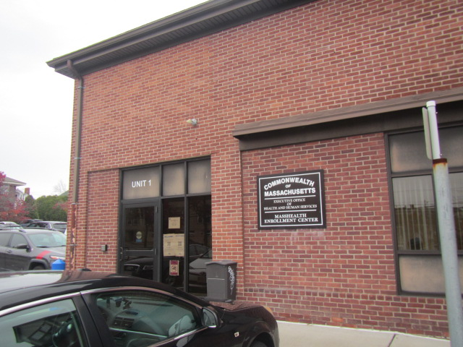

Prepared by:
Massachusetts Department of Public Health
Bureau of Climate and Environmental Health
Division of Environmental Health Regulations and Standards
November 2025

Executive Summary:
At the request of Local 509 SEIU, the Massachusetts Department of Public Health’s (MDPH), Division of Environmental Health Regulations and Standards (EHRS), Indoor Air Quality (IAQ) Outreach and Education Unit, conducted an IAQ assessment on November 12th at the Taunton MassHealth Enrollment Center’s walk in areas, due to an occupant’s report of headaches, with a specific request to conduct “temperature checks in all areas listed above with the door open and then again with the door shut for a fifteen minute time period.” Although this request was fulfilled, testing results were not significantly different with the doors shut rather than open.
Therefore, the IAQ Unit recommends a more detailed/data-driven approach to investigating these concerns, consisting of the following:
- EOHHS Facilities representatives should work with the Building Owner to download and obtain real-time temperature measurements for one week (or longer if needed) from the electronic heating, ventilating, and air conditioning (HVAC) management system, should be available via a phone/app or computer, and
- For the same time period, Local 509 SEIU should have MassHealth staff maintain a detailed log, recording:
  - time of day,
  - whether doors are open/shut,
  - number of occupants in the room,
  - any other pertinent info (comfort issues, odors, perceived lack of airflow, etc.)
- Once this time period is complete, the data/information should be shared between EOHHS, Local 509 SEIU, and DPH IAQ for analysis to identify any trends, issues/discrepancies and if found, evaluated for corrections/adjustments to the HVAC system.
In addition to temperature testing, IAQ staff tested for a number of other IAQ contaminants and comfort parameters including, relative humidity, carbon dioxide, carbon monoxide, airborne particulate matter, and total volatile organic compounds.
Finally, EOHHS representatives asked DPH IAQ staff to test additional areas on the first floor, that were not requested by Local 509 SEIU, which are included in Table 1, however the times of these tests were not recorded as they were not part of the above request, although they occurred at similar times as the requested testing, the morning of November 12th.

BACKGROUND
Building: | MassHealth Enrollment Center
Address: | 21 Spring Street, Taunton, MA
Assessment Requested by: | Local 509 SEIU
Reason for Request: | Headaches reported by an occupant
Date of Assessment: | November 12, 2025
Massachusetts Department of Public Health/Bureau of Climate and Environmental Health (MDPH/BCEH) Staff Conducting Assessment: | Cory Holmes, Senior Advisor for IAQ Inspections, Audits, Outreach and Education, Division of Environmental Health Regulations and Standards
Building Description: | The MassHealth Enrollment Center occupies two stories of a red brick building, which is also occupied by several other EOHHS offices. The  space contains carpet squares, gypsum wallboard walls, and suspended ceiling tiles.
Windows: | Not openable
The space has been visited by IAQ staff in the past, including several full assessments of the entire building. Most of these reports are available on DEP’s website: https://www.mass.gov/info-details/indoor-air-quality-reports-cities-and-towns-t#taunton. The current assessment focused on complaint areas on the first floor.

METHODS
Please refer to the IAQ Manual for methods, sampling procedures, and interpretation of results (MDPH, 2015).

RESULTS AND DISCUSSION
Measurements for IAQ parameters are shown in Table 1 and summarized below:
- Carbon dioxide (CO₂) | a measure of the adequacy of ventilation | Levels were below the MDPH guideline of 800 parts per million (ppm) in all areas, indicating adequate air exchange at the time of assessment.
- Temperature | a measure of comfort | Was within or close to the MDPH recommended range of 70°F to 78°F in areas tested.
- Relative humidity | a measure of comfort and, when in excess for an extended period, a way to reflect the potential for mold and fungal growth | Was below the MDPH recommended range of 40 to 60% in all areas tested. This is reflective of outdoor conditions. Low relative humidity is common indoors during the heating season. Relative humidity would be expected to be higher during hot, humid weather.
- Carbon monoxide  (CO) | a product of combustion that can result in acute and long term cardiovascular, respiratory, and neurological symptoms | Levels were non-detectible (ND) in all indoor areas assessed.
- Particulate matter (PM2.5) | a way to measure inhalable particle distribution in the air | Concentrations were below the National Ambient Air Quality Standard (NAAQS) of 35 micrograms per cubic meter (μg/m³) in all areas tested, with most ND.
- Total Volatile Organic Compounds (TVOCs) | VOCs are carbon-containing substances that can evaporate at room temperature. Frequently, exposure to low levels of total VOCs (TVOCs) may produce eye, nose, throat and/or respiratory irritation in some sensitive individuals. | Levels were ND in all areas assessed.

Ventilation
A heating, ventilating, and air conditioning (HVAC) system has several functions. First, it provides heating and, if equipped, cooling. Second, it is a source of fresh air. Finally, an HVAC system will dilute and remove normally occurring indoor environmental pollutants by not only introducing fresh air but also filtering the airstream and ejecting stale air to the outdoors via exhaust ventilation. Even if an HVAC system is operating as designed, point sources of respiratory irritation may exist and affect symptoms in sensitive individuals.
Fresh air is provided by air handling units (AHUs) located on the roof of the building. Supply air from the AHUs is filtered, heated/cooled, and delivered to rooms via ducted supply vents (Picture 1). Exhaust air is drawn through ceiling or wall-mounted grills (Picture 1 and 2) to be removed from the building.
The ventilation system should be on and operational to supply fresh air continuously during occupied periods. Without adequate fresh air supply and removal of stale air, common indoor air pollutants can build up and cause irritation. The system was on and appeared to be operating normally at the time of assessment. It was reported that previously, one of the flexible ducts was not connected to the supply vent in one of the offices. IAQ staff checked above the ceiling (Picture 3) as well as each of the vents to ensure proper airflow, which was confirmed.
The IAQ Unit recommends that AHU filters be changed 2-4 times a year (or per the manufacturer’s recommendations) and be at least a minimum efficiency reporting value (MERV) 8, or higher if the equipment can handle them without a degradation in airflow, as these are adequate to filter out pollen, mold, and similar particulates (ASHRAE, 2012). Filters in use at the MassHealth Enrollment Center are pleated MERV 11 (Pictures 4 and 5) and are reportedly changed four times a year.
Most areas are covered with carpet squares. Carpets should be cleaned annually (or semi-annually in soiled/high traffic areas) in accordance with Institute of Inspection, Cleaning and Restoration Certification (IICRC) recommendations, (IICRC, 2012). All carpeting should be routinely vacuumed and cleaned to ensure proper removal of dirt, dust, and debris. Regular cleaning with a high efficiency particulate air (HEPA) filtered vacuum in combination with an annual cleaning will help to reduce accumulation and potential aerosolization of materials from carpeting.
Finally, it was noted that a number of portable air cleaning units were in use in the area of concern (Pictures 6 and 7). These appear to be units which use high efficiency particulate arrestance (HEPA) filters which are good choices for use in occupied areas. Air purifiers that may produce ozone should not be used (US EPA, 2003). All air purifiers should be cleaned and maintained in accordance with manufacturers’ instructions.

CONCLUSIONS/RECOMMENDATIONS
The following recommendations are made to improve IAQ:
- As stated in the Executive Summary, EOHHS Facilities’ representatives should work with the Building Owner to download and obtain real-time temperature measurements for one week (or longer if needed) from the electronic HVAC management system, which is available via a phone/app or computer.
- Concurrent to this time period Local 509 SEIU should have MassHealth staff maintain a detailed log, recording:
      - time of day,
      - whether doors are open/shut,
      - number of occupants in the room,
      - any other pertinent info (comfort issues, odors, perceived lack of airflow, etc.)
- Once this time period is complete the data/information should be shared between EOHHS, Local 509 SEIU, and DPH IAQ to identify any trends, issues/discrepancies and if found, evaluated for corrections/adjustments to the HVAC system.
- Continue to operate supply and exhaust ventilation in all areas continuously during occupied periods.
- Have the HVAC system balanced every 5 years in accordance with SMACNA recommendations (SMACNA, 1994).
- Continue to change filters for HVAC units at least two to four times a year or as per the manufacturers’ recommendations using filters with a Minimum Efficiency Rating Value (MERV) of 8 or better.
- Ensure thermostats building-wide are set in a consistent manner, including any nighttime or weekend setbacks.
- Inform occupants about how to request temperature control changes.
- Periodically clean dust from supply and return vents and fans.
- Clean carpeting in accordance with IICRC recommendations (IICRC, 2012).
- For buildings in New England, periods of low relative humidity during the winter are often unavoidable. Therefore, scrupulous cleaning practices should be adopted to minimize common indoor air contaminants whose irritant effects can be enhanced when the relative humidity is low. To control dust, a high efficiency particulate arrestance (HEPA) filter equipped vacuum cleaner in conjunction with wet wiping of all surfaces is recommended. Avoid the use of feather dusters. Drinking water during the day can help ease some symptoms associated with a dry environment (throat and sinus irritations).
- Air purifiers that use HEPA filters, with or without carbon filters, are good choices for occupied areas. Units that may produce ozone should not be used. Maintain all in accordance with manufacturers’ instructions including cleaning and filter changes.
- Refer to resource manual and other related IAQ documents located on the MDPH’s website for further building-wide evaluations and advice on maintaining public buildings. These documents are available at: http://mass.gov/dph/iaq.

REFERENCES
ASHRAE. 2012. American Society of Heating, Refrigeration and Air Conditioning Engineers (ASHRAE) Standard 52.2-2012 -- Method of Testing General Ventilation Air-Cleaning Devices for Removal Efficiency by Particle Size (ANSI Approved).
IICRC. 2012. Institute of Inspection, Cleaning and Restoration Certification. Carpet Cleaning: FAQ.
MDPH. 2015. Massachusetts Department of Public Health. Indoor Air Quality Manual: Chapters I-III. Available at: https://www.mass.gov/lists/indoor-air-quality-manual-and-appendices.
SMACNA. 1994. HVAC Systems Commissioning Manual. 1st ed. Sheet Metal and Air Conditioning Contractors’ National Association, Inc., Chantilly, VA.
US EPA. 2003. “Ozone Generators that are Sold as Air Cleaners: An Assessment of Effectiveness and Health Consequences”. United States Environmental Protection Agency, Office of Air and Radiation, Indoor Environments Division, Washington, DC. Last updated September, 2018. https://www.epa.gov/indoor-air-quality-iaq/ozone-generators-are-sold-air-cleaners.

Picture 1
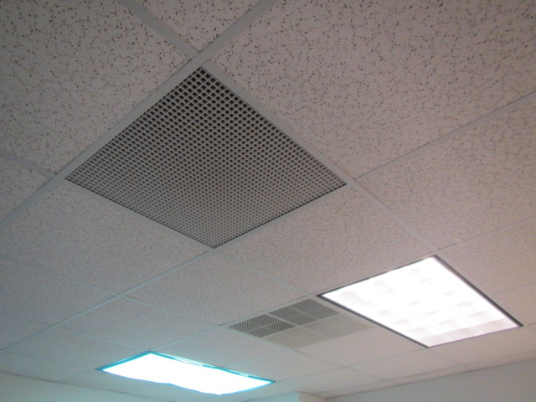
Ceiling-mounted supply and return vents
Picture 2
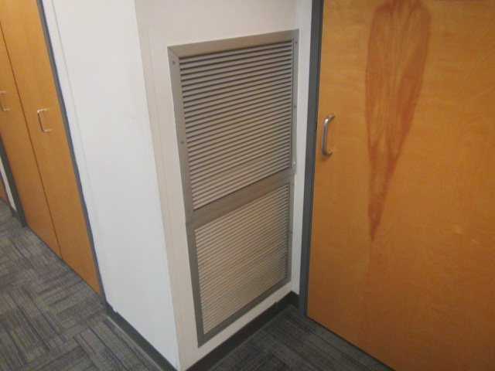
Wall-mounted return vent
Picture 3
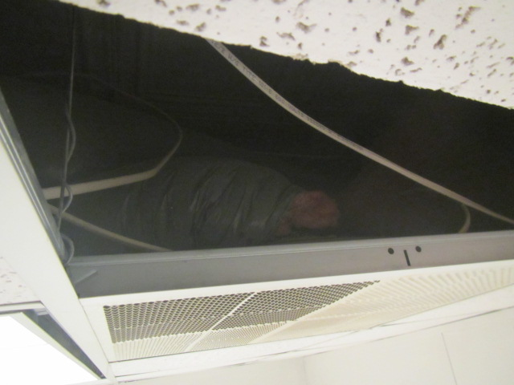
Insulated flex duct connected to supply vent in office
Picture 4
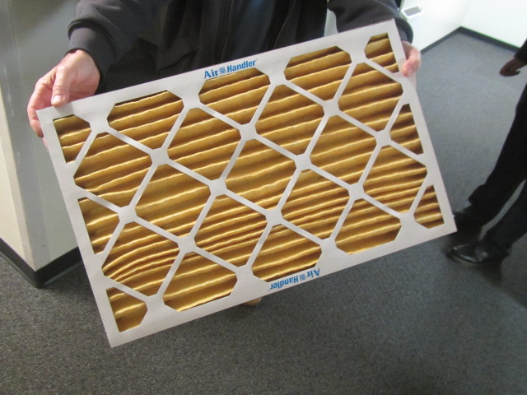
Pleated MERV 11 filter for HVAC system
Picture 5
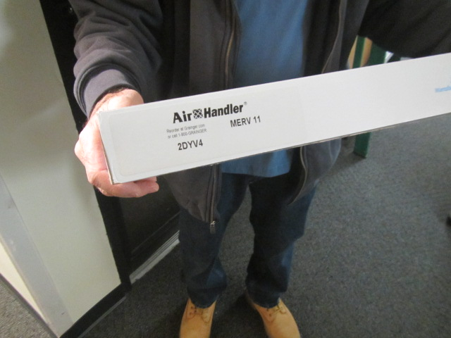
Pleated MERV 11 filter for HVAC system
Picture 6
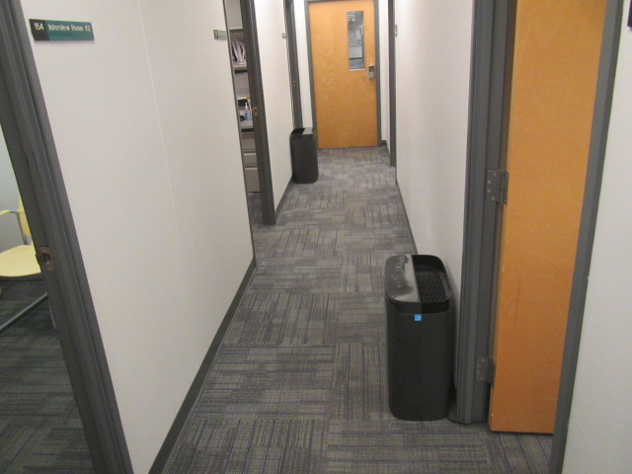
Two of three portable air cleaning units in area
Picture 7
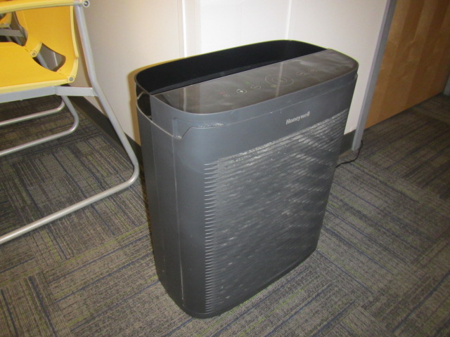
Third portable air cleaning unit in area

Location | Carbon  Dioxide  (ppm) | Carbon Monoxide  (ppm) | Temp  (°F) | Relative  Humidity  (%) | PM2.5  (µg/m³) | TVOC  (ppm) | Occupants  in Room | Windows  Openable | Ventilation |  | Time/Remarks
 |  |  |  |  |  |  |  |  | Supply | Exhaust | Time/Remarks
Background | 419 | 1.0 | 43 | 49 | 10 | ND |  |  |  |  | 8:00 AM Cool, overcast conditions
First Round of Testing with Doors open |  |  |  |  |  |  |  |  |  |  | Return vents for most offices are in hallways
Main Waiting Area | 527 | ND | 70 | 26 | ND | ND | 0 | N | Y | N | 8:13 AM, no interior doors
156 | 529 | ND | 70 | 25 | ND | ND | 0 | N | Y | Y | 8:14 AM door open
1B | 612 | ND | 70 | 24 | ND | ND | 0 | N | Y | Y | 8:15 AM door open
154 | 524 | ND | 70 | 24 | ND | ND | 0 | N | Y | N | 8:16 AM door open
153 | 639 | ND | 70 | 22 | ND | ND | 0 | N | Y | N | 8:17 AM door open
150 | 524 | ND | 70 | 22 | ND | ND | 0 | N | Y | N | 8:18 AM door open
151 | 544 | ND | 70 | 23 | ND | ND | 0 | N | Y | N | 8:19 AM door open
Second Round of Testing with Doors shut
156 | 566 | ND | 70 | 23 | ND | ND | 1 | N | Y | Y | 8:49 AM door closed 15 + mins
Main Waiting Area | 637 | ND | 69 | 25 | ND | ND | 9 | N | Y | Y | 8:50 AM, no interior doors
1B | 697 | ND | 69 | 23 | ND | ND | 1 | N | Y | Y | 8:51 AM 15 + mins
151 | 563 | ND | 70 | 23 | ND | ND | 0 | N | Y | N | 8:52 AM 15 + mins
150 | 629 | ND | 70 | 22 | ND | ND | 0 | N | Y | N | 8:53 AM 15 + mins
152 | 564 | ND | 71 | 21 | ND | ND | 0 | N | Y | N | 8:54 AM 15 + mins
153 | 666 | ND | 71 | 22 | ND | ND | 0 | N | Y | N | 8:55 AM 15 + mins
154 | 584 | ND | 71 | 21 | 1 | ND | 0 | N | Y | N | 8:56 AM 15 + mins
Additional Areas Tested |  |  |  |  |  |  |  |  |  |  | Note: these areas were not requested by the Local SEIU – therefore times not recorded
147 | 574 | ND | 70 | 22 | ND | ND | 0 | N | Y | N
145 | 521 | ND | 70 | 23 | ND | ND | 0 | N | Y | N
143 | 512 | ND | 71 | 24 | ND | ND | 0 | N | Y | N
137-139 | 547 | ND | 71 | 23 | ND | ND | 2 | N | Y | Y
123-133 | 628 | ND | 71 | 24 | ND | ND | 2 | N | Y | Y
126-139 | 549 | ND | 71 | 22 | ND | ND | 2 | N | Y | Y
122-130 | 506 | ND | 71 | 22 | ND | ND | 1 | N | Y | Y
120 | 545 | ND | 71 | 22 | ND | ND | 0 | N | Y | Y
109-111 | 595 | ND | 70 | 23 | ND | ND | 2 | N | Y | Y
113-117 | 539 | ND | 70 | 23 | ND | ND | 0 | N | Y | Y
105-108 | 544 | ND | 70 | 23 | ND | ND | 2 | N | Y | Y
Mail Room | 540 | ND | 70 | 22 | ND | ND | 0 | N | Y | N
102 | 580 | ND | 70 | 22 | ND | ND | 0 | N | Y | Y

