INDOOR AIR QUALITY ASSESSMENT

MassHealth Office of Payment and Care Delivery Innovation
Executive Office of Health and Human Services
One Ashburton Place, 2nd Floor
Boston

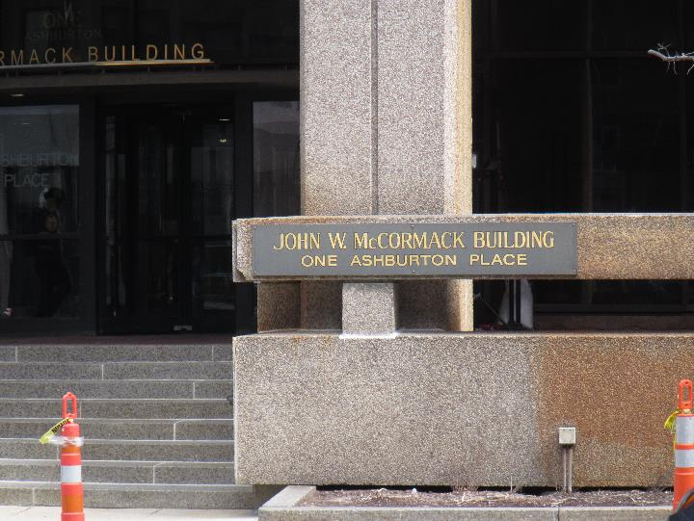

Prepared by:
Massachusetts Department of Public Health
Bureau of Environmental Health
Indoor Air Quality Program
December 2019

Background
Building: | MassHealth Office of Payment and Care Delivery Innovation,  Executive Office of Health and Human Services (EOHHS)
Address: | One Ashburton Place, 2nd Floor, Boston, MA
Assessment Requested by: | Gary Sing, Director of Delivery System Investment and Social Services Integration
Reason for Request: | General indoor air quality (IAQ) concerns
Date of Assessment: | December 11, 2019
Massachusetts Department of Public Health/Bureau of Environmental Health (MDPH/BEH) Staff Conducting Assessment: | Ruth Alfasso, Environmental Engineer, IAQ Program
Building Description: | One Ashburton Place, also known as The McCormack Building, is a large state office building constructed in the 1970s. A small area located off the escalator on the second floor was examined during this assessment. This area has cubicle workstations and an open area.
Number of Occupants: | Up to 20 people
Windows: | Not openable

Methods
Please refer to the IAQ Manual for methods, sampling procedures, and interpretation of results (MDPH, 2015).

IAQ Testing Results
The following is a summary of indoor air testing results (Table 1).
- Carbon dioxide levels were below MDPH guideline of 800 parts per million (ppm) in all areas surveyed, indicating adequate air exchange.
- Temperature was within the recommended range of 70°F to 78°F in all areas tested, however occupants reported temperature control issues in the space.
- Relative humidity was below the recommended range of 40 to 60% in all areas tested which is typical of the heating season.
- Carbon monoxide levels were non-detectable (ND) in all areas tested.
- Fine particulate matter (PM2.5) concentrations measured were below the NAAQS limit of 35 μg/m³ in all areas tested.

Other areas of this building have been assessed by this program and reports from those visits can be found at https://www.mass.gov/service-details/indoor-air-quality-reports-cities-and-towns-b.

Ventilation
A heating, ventilating, and air conditioning (HVAC) system has several functions. First it provides heating and, if equipped, cooling. Second, it is a source of fresh air. Finally, an HVAC system will dilute and remove normally-occurring indoor environmental pollutants by not only introducing fresh air, but by filtering the airstream and ejecting stale air to the outdoors via exhaust ventilation. Even if an HVAC system is operating as designed, point sources of respiratory irritation may exist and cause symptoms in sensitive individuals.
Fresh air appears to be supplied by vents located in the ceiling at the outside edge of the building (Picture 1). Return air is drawn through ceiling-mounted vents using ducted returns (Picture 2). Additional heating is supplied by radiators next to the windows (Picture 3). Facility staff reported that HVAC equipment serving this area was recently replaced.
Temperature control issues were reported by occupants, including both low and high temperatures, since they moved in earlier in 2019. Although the temperatures measured at the time of the visit were within MDPH comfort parameters, several characteristics of the space may make temperature control difficult:
- The space is small and has a high occupancy for the square footage. Use of computer/office equipment in the space also increases the heat load.
- The space has windows on three sides. Some of the windows overlook the interior, including the entryway and some overlook the outside.
- The exterior windows are poorly insulated. At the time of the visit, both the glass and window frame were cold to the touch. During the summer, these windows would be expected to transmit heat to the interior as well.

Microbial/Moisture Concerns
No water-damaged materials or musty odors were observed during this visit. Note that the lack of insulation on windows/frames means these areas may be subject to condensation during periods of high humidity and low outdoor temperatures. Although there were no signs of window leaks in this office, windows in other parts of the building have been known to leak. If moisture from condensation or leaks is noted near windows, porous items should be kept away from these areas to avoid moistening.
A plant was noted in one area (Table 1). Plants can be a source of pollen and mold, which can be respiratory irritants to some individuals. Plants should be properly maintained and equipped with drip pans and should be located away from induction units to prevent the aerosolization of dirt, pollen, and mold.
A refrigerator and water dispenser were located on carpet (Picture 4). Refrigerators and water dispensing equipment should be located in a non-carpeted area or on a waterproof mat to prevent damage to carpet and subsequent odors. Refrigerators should be kept clean to avoid microbial growth and odors.

Other Concerns
Exposure to low levels of total volatile organic compounds (TVOCs) may produce eye, nose, throat, and/or respiratory irritation in some sensitive individuals. In addition to testing, BEH/IAQ staff examined spaces for products containing VOCs. BEH/IAQ staff noted hand sanitizers and dry erase materials in the office space. All of these products have the potential to be irritants to the eyes, nose, throat, and respiratory system of sensitive individuals.
Items were observed on flat surfaces, such as windowsills, tabletops, counters, bookcases, and desks. Items stored in offices provide a source for dusts to accumulate and make it difficult for custodial staff to clean. Items should be relocated and/or be cleaned periodically to avoid excessive dust build up. The heating units along the windows were visibly dusty (Picture 3); dust can cause odors when heated.
The offices were carpeted. Carpets should be cleaned annually (or semi-annually in soiled/high traffic areas) in accordance with Institute of Inspection, Cleaning and Restoration Certification (IICRC) recommendations, (IICRC, 2012).

Conclusions/Recommendations
Based on observations at the time of assessment, the following is recommended:
- Operate supply and exhaust ventilation continuously in all areas during occupied periods. Ensure all HVAC equipment is cleaned/maintained in accordance with manufacturer’s instructions.
- Balance the HVAC system every 5 years in accordance with Sheet Metal and Air Conditioning Contractors’ National Association (SMACNA) recommendations (SMACNA, 1994).
- Continue to work with building facility management to address temperature control issues.
- Consider installation of draft/heat-blocking curtains on exterior windows if feasible. If installed, ensure they are cleaned periodically.
- Regularly clean HVAC equipment including supply and return vents and heating units to remove dust that may be heated or reaerosolized.
- Avoid storing porous items in areas where leaks or condensation may occur. Ensure building management is aware of any leaks or water damage.
- Keep plants in good condition, avoid overwatering, and remove from the airstream of heating and ventilation equipment.
- Consider the use of waterproof mats underneath refrigerators and water dispensers to protect carpet from leaks and spills.
- Clean refrigerators, microwaves and cooking/eating areas frequently.
- For buildings in New England, periods of low relative humidity during the winter are often unavoidable. Therefore, scrupulous cleaning practices should be adopted to minimize common indoor air contaminants whose irritant effects can be enhanced when the relative humidity is low. To control for dusts, a high efficiency particulate arrestance (HEPA) filter equipped vacuum cleaner in conjunction with wet wiping of all surfaces is recommended. Avoid the use of feather dusters. Drinking water during the day can help ease some symptoms associated with a dry environment (throat and sinus irritations).
- Reduce the amount of items stored on flat surfaces to allow regular cleaning.
- Clean carpeting in accordance with IICRC recommendations (IICRC, 2012). Consider the use of plastic chair mats under desks to protect carpeting.
- Refer to resource manual and other related IAQ documents located on the MDPH’s website for further building-wide evaluations and advice on maintaining public buildings. These documents are available at: http://mass.gov/dph/iaq.

References
IICRC. 2012. Institute of Inspection, Cleaning and Restoration Certification. Carpet Cleaning: FAQ.
MDPH. 2015. Massachusetts Department of Public Health. Indoor Air Quality Manual: Chapters I-III. Available at: http://www.mass.gov/eohhs/gov/departments/dph/programs/environmental-health/exposure-topics/iaq/iaq-manual/.
SMACNA. 1994. HVAC Systems Commissioning Manual. 1st ed. Sheet Metal and Air Conditioning Contractors’ National Association, Inc., Chantilly, VA.
Picture 1
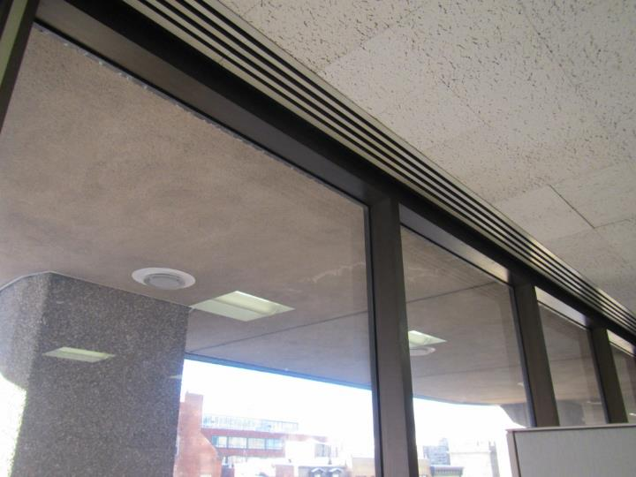
Fresh air supply vents next to exterior windows
Picture 2
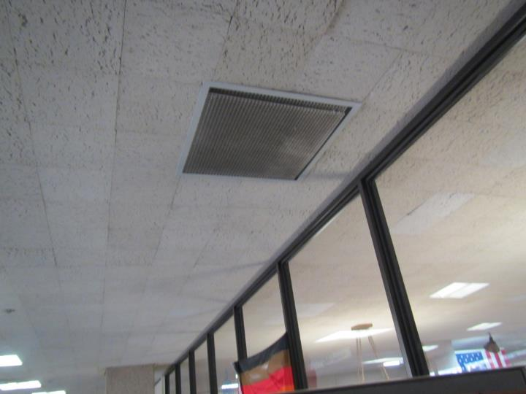
Return vent, note dust
Picture 3
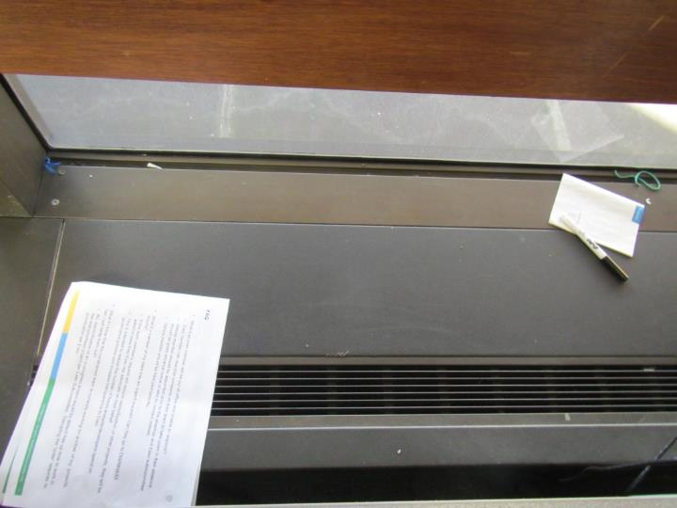
Radiator next to exterior windows, note dust and items
Picture 4
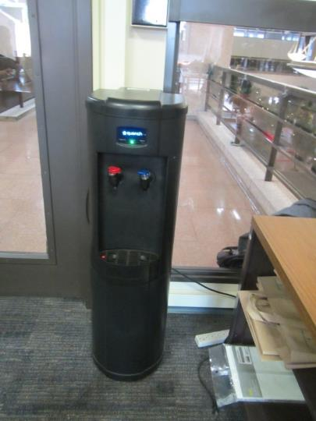
Water cooler on carpet
Location | Carbon  Dioxide  (ppm) | Carbon Monoxide  (ppm) | Temp  (°F) | Relative  Humidity  (%) | PM2.5  (µg/m³) | Occupants  in Room | Windows  Openable | Ventilation |  |  | Remarks
 |  |  |  |  |  |  |  | Intake | Exhaust
5A and 5B | 445 | ND | 73 | 26 | 1 | 1 | N | Y |  | Y
4 A and B | 609 | ND | 73 | 24 | 2 | 2 | N | Y |  | Y | Plant
3A | 555 | ND | 74 | 24 | 1 | 0 | N | Y |  | Y
1 and 2 | 539 | ND | 74 | 25 | 1 | 3 | N | Y |  | Y
Open area | 462 | ND | 75 | 22 | 2 | 4 | N | Y |  | Y | DEM, fridge and microwave (microwave has crumbs), fridge and water cooler on carpet

