BACKGROUND

INDOOR AIR QUALITY/WATER DAMAGE ASSESSMENT

Commonwealth of Massachusetts
MassHealth Enrollment Center
21 Spring Street
Taunton, MA

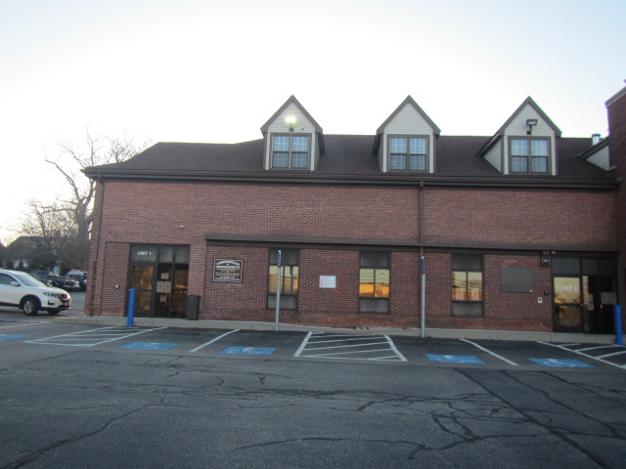

Prepared by:
Massachusetts Department of Public Health
Bureau of Climate and Environmental Health
Indoor Air Quality Program
December 2023
Building: | Commonwealth of Massachusetts,  MassHealth Enrollment Center
Address: | 21 Spring Street, Taunton, MA
Assessment Requested by: | Kyle A. Marshall, Deputy Facilities Director for Leasing, Executive Office of Health and Human Services
Reason for Request: | Referral from the Department of Labor Standards (DLS) in response to indoor air quality (IAQ) and mold concerns.
Date of Assessment: | December 21, 2023
Massachusetts Department of Public Health/Bureau of Climate and Environmental Health (MDPH/BCEH) Staff Conducting Assessment: | Cory Holmes, Assistant Director, Indoor Air  Quality (IAQ) Program
Building Description: | The MassHealth Enrollment Center occupies two-stories of the red brick building, which is also occupied by several other EOHHS offices. The space contains wall to wall carpet, carpet squares, gypsum wallboard walls, and suspended ceiling tiles.
Windows: | There are no openable windows in the space.

The complaint focused on concerns regarding mold exposure in air and underneath carpet in workstation area 109-110. At the time of assessment, no visible mold was observed in the space or on carpeting in the area. A section of the carpet in this area was recently removed for inspection, cleaned, and replaced by a professional carpet company hired by the Landlord (Picture 1).

METHODS
MDPH IAQ staff performed a visual assessment for mold growth and conducted moisture sampling of carpeting to ensure dry at the time of assessment. Air tests for carbon monoxide, temperature, relative humidity, and airborne particle matter with a diameter less than 2.5 micrometers were taken with the TSI, Q-Trak XP.

AIR TESTING RESULTS
Media sampled |  | MDPH Guideline/  Comparison Value |  | Measured Range |  |  | Comments
 |  |  |  | Outdoors/  Background |  | Indoors
Carbon Dioxide (CO₂) |  | < 800 parts per million (ppm) is preferred |  | 437 |  | 789
Total Volatile Organic Compounds (TVOCs) |  | Equal to or below background level measured |  | ND |  | ND
Carbon Monoxide (CO) |  | Non-detectable (ND) or equal to or below background level measured |  | ND |  | ND
Particulate Matter 2.5 (PM2.5) |  | US EPA National Ambient Air Quality Standards (NAAQS) 35 μg/m³ or less |  | 10 |  | 1
Temperature |  | 70 to 78ºF |  | 47 |  | 70 | Within MDPH comfort guidelines
Relative Humidity (RH) |  | 40% to 60% |  | 47 |  | 37 | Below MDPH comfort guidelines, which is typical during the heating season in New England
Moisture Testing |  | Normal = Dry |  | Dry-no rain or elevated RH |  | Carpet dry | No visible mold, moisture, or associated odors in area 109-110, 3 water-damaged ceiling tiles in area 148A
ppm = parts per million | µg/m³ = microgram per cubic meter |  | ND = non-detectable

Microbial/Moisture Concerns
At the time of assessment, all moisture measurements of carpeting in area 109-110 were normal (i.e., dry). In addition, MDPH IAQ staff removed carpet in the affected area for inspection and the area underneath was found to be dry with no visible mold growth or associated odors (Picture 2).
No visible mold growth was observed in the space; however, three water-damaged ceiling tiles were observed in work area 148A (Picture 3). Water-damaged ceiling tiles indicate leaks from either the roof or plumbing system and should be replaced after a water leak is discovered and repaired to prevent mold growth.
It is recommended that porous material be dried with fans and heating within 24 to 48 hours of becoming wet (US EPA, 2008, ACGIH, 1989). If porous materials are not dried within this time frame, mold growth may occur. Water-damaged porous materials cannot be adequately cleaned to remove mold growth.
The MDPH IAQ Program recommends using filters with a minimum efficiency rating value (MERV) rated 8 filter (or higher) in the building ventilation system. These are adequate to filter out pollen and mold spores (ASHRAE, 2012). The filters in use at the MassHealth Enrollment Center have a MERV rating of 8 (Pictures 4 and 5).

Other Issues
As a general rule, carpets should be cleaned annually (or semi-annually in soiled/high traffic areas) in accordance with Institute of Inspection, Cleaning and Restoration Certification (IICRC) recommendations, (IICRC, 2012). The service life of carpeting is approximately 10-11 years (IICRC, 2002). Carpeting of this age and condition becomes increasingly difficult to clean and maintain and may be a source of particulate matter to the indoor environment. Regular cleaning with a high efficiency particulate air (HEPA) filtered vacuum in combination with an annual cleaning will help to reduce accumulation and potential aerosolization of materials from carpeting.

RECOMMENDATIONS
In view of the findings at the time of the visit, the following recommendations are made:

Water Damage Recommendations
- Monitor ceiling tiles for further leaks, and report to building management for investigation/remediation.
- Continue to use MERV 8-rated filters (or higher), which are adequate to filter out pollen and mold spores. Filters should be changed 2-4 times a year, or as per the manufactures’ recommendations.

Other Recommendations
- Operate HVAC system/ventilation continuously during occupied periods to provide circulation and filtration.
- Clean carpeting annually or semi-annually in soiled high traffic areas as per the recommendations of the Institute of Inspection, Cleaning and Restoration Certification (IICRC, 2012).
- Replace carpeting past its useful life (> 10-11 years).
- Refer to the resource manual and other related indoor air quality documents located on the MDPH’s website for further building-wide evaluations and advice on maintaining public buildings. These documents are available at http://mass.gov/dph/iaq.

REFERENCES
ACGIH. 1989. Guidelines for the Assessment of Bioaerosols in the Indoor Environment. American Conference of Governmental Industrial Hygienists, Cincinnati, OH.
ASHRAE. 2012. American Society of Heating, Refrigeration and Air Conditioning Engineers (ASHRAE) Standard 52.2-2012 -- Method of Testing General Ventilation Air-Cleaning Devices for Removal Efficiency by Particle Size (ANSI Approved).
IICRC. 2002. Institute of Inspection, Cleaning and Restoration Certification. A Life-Cycle Cost Analysis for Floor Coverings in School Facilities.
IICRC. 2012. Institute of Inspection, Cleaning and Restoration Certification. Carpet Cleaning: FAQ.
US EPA. 2008. “Mold Remediation in Schools and Commercial Buildings”. Office of Air and Radiation, Indoor Environments Division, Washington, DC. EPA 402-K-01-001. September 2008. Available at: http://www.epa.gov/mold/mold-remediation-schools-and-commercial-buildings-guide.
Picture 1
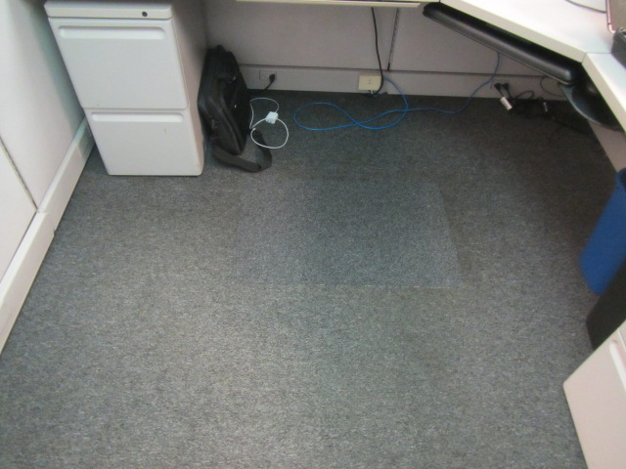
Patched carpet in work area 109-110
Picture 2
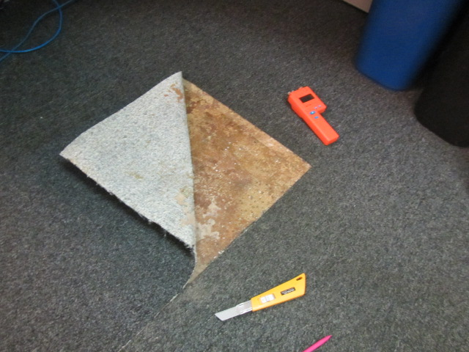
Carpet patch removed to observe conditions below
Picture 3
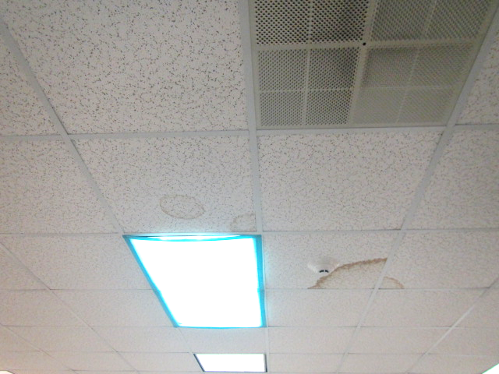
Water-damaged ceiling tiles in area 148A
Picture 4
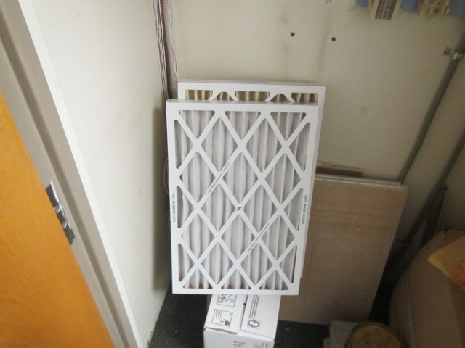
Pleated MERV 8 filters for HVAC system
Picture 5
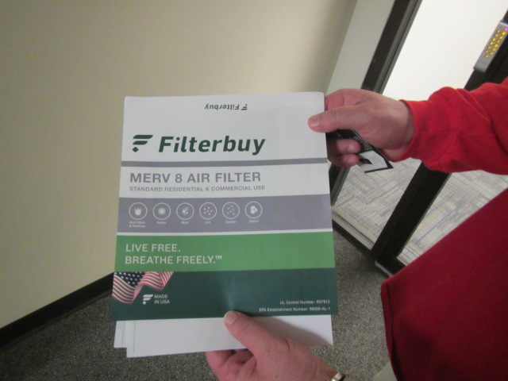
Spec sheets for pleated MERV 8 filters

