INDOOR AIR QUALITY ASSESSMENT

**MassHealth Offices**

**Floors 7 and 9**

**100 Hancock Street**

**Quincy, MA**

**August 2025**



Prepared by:

Massachusetts Department of Public Health

Bureau of Climate and Environmental Health

Division of Environmental Health Regulations and Standards

# CONTENTS

CONTENTS 2

BACKGROUND 3

RESULTS AND DISCUSSION 3

Ventilation 4

HVAC System Maintenance 4

Water Damage and Moisture Concerns 5

Sources of Respiratory Irritants/Possible Asthma Triggers 7

CONCLUSIONS AND RECOMMENDATIONS 8

REFERENCES 11

PICTURES 12

Ventilation Pictures 12

Water Damage Pictures 13

Respiratory Irritants Pictures 20

Table 1 24

Table 2A 29

Table 2B 30

Table 2C 31

Table 3 32

Table 4 34

# BACKGROUND

|  |  |
| --- | --- |
| Building: | MassHealth Offices |
| Address: | 100 Hancock Street, Quincy, MA, 7th and 9th floor offices |
| Coordinated Via: | Pedro Batista, Project Coordinator, Executive Office of Health and Human Services (EOHHS) |
| Reason for Request: | General indoor air quality (IAQ) issues |
| Date of Assessment: | August 25, 2025 |
| Massachusetts Department of Public Health/Bureau of Climate and Environmental Health/**Division of Environmental Health Regulations and Standards** (MDPH/BCEH/EHRS) Staff Conducting Assessment: | Ruth Alfasso, Indoor Air Quality (IAQ) Outreach and Education Unit, EHRS |
| Building Description: | |  | | --- | | MassHealth occupies several floors in the 10-story building at 100 Hancock Street, Quincy. The building was originally built in the 1980s and renovated in the 2000s. According to marketing materials on the building, 100 Hancock Street is LEED Silver Certified with an upgraded HVAC system and energy management system. | |
| Windows: | Windows in the areas assessed are not openable. |
| **Building Population:** | The building is occupied by state employees on a hybrid work schedule. |

# 

# RESULTS AND DISCUSSION

The following is a summary of indoor air testing results (Table 1)

|  |  |  |
| --- | --- | --- |
| * ***Carbon dioxide (CO2)*** | *a measure of the adequacy of ventilation* | Levels were below the MDPH guideline of 800 parts per million (ppm) in all areas surveyed, indicating adequate air exchange at the time of assessment. |
| * ***Temperature*** | *a measure of comfort* | It was within the MDPH recommended comfort range of 70°F to 78°F in all occupied areas. |
| * ***Relative humidity*** | *a measure of comfort and, when in excess for an extended period, a way to reflect the potential for mold and fungal growth* | It was within or above the upper level of the MDPH recommended comfort range of 40 to 60% in areas tested. This was reflective of outside conditions. |
| * ***Carbon monoxide***   ***(CO)*** | *a product of combustion that can result in acute and long term cardiovascular, respiratory, and neurological symptoms* | Levels were non-detect (ND) in all areas tested. |
| * ***Particulate matter (PM2.5)*** | *a way to measure inhalable particle distribution in the air* | Concentrations were below the National Ambient Air Quality Standard (NAAQS) of 35 micrograms per cubic meter (μg/m3) in all areas tested. |

## Ventilation

Ventilation refers to both the supply of fresh air and the removal of stale air from a room. The introduction of fresh air into an occupied space will dilute normally occurring pollutants that are generated by occupancy and other activities. In addition, a heating, ventilation and air conditioning (HVAC) system will remove pollutants from a building if operating appropriately. All ventilation systems throughout the building should operate continuously during periods of occupancy.

Fresh air is provided by air handling units (AHUs) which may be located on the roof. No access to the AHUs was available on the day of the assessment. Air from the AHUs is filtered, heated/cooled, and delivered to rooms via ducted supply diffusers (Pictures 1 and 2). While it is highly likely that return vents exist, all the vents appeared to be supply-type vents. When possible, every room should have supply and return ventilation. It is recommended that HVAC systems be re-balanced every five years to ensure adequate air systems function (SMACNA, 1994). It is not known when the last time these systems were balanced.

The various types of ventilation components as well as devices that can move/redirect airflow that were identified in the building are listed in Table 2A, Table 2B and Table 2C. (see Ventilation pictures)

**Balancing**

To have proper ventilation with a mechanical supply and exhaust system, a system must be balanced to provide an adequate amount of fresh air to the interior of a room while also removing stale air from the room. It is recommended that HVAC systems be re-balanced every five years to ensure adequate air systems function (SMACNA, 1994).

### HVAC System Maintenance

It is recommended that AHUs be outfitted with pleated filters of a Minimum Efficiency Reporting Value (MERV) of 8 or higher, which are adequate in filtering out pollen and mold spores (ASHRAE, 2012). In addition, filters should be changed 2-4 times a year or in accordance with the manufacturer’s recommendations. Note that when periods of high pollution such as wildfire smoke occur, filters may need to be changed more frequently.

## Water Damage and Moisture Concerns

Please note that the MDPH does not recommend conducting mold testing in a typical water damage remediation. For details, please consult [Guidance Regarding Testing for Mold in Water-Damaged Public Buildings](https://www.mass.gov/info-details/guidance-regarding-testing-for-mold-in-water-damaged-public-buildings) | Mass.gov

The application of a mildewcide to moldy porous materials is not recommended.

Molds are found naturally in our environment both indoors and outdoors. Inside, mold growth may occur when items, particularly porous products such as paper or gypsum wallboard, are exposed to moisture. Typical water sources include leaks, floods, and condensation. To avoid mold growth, dry all water-damaged items and affected areas within 24-48 hours and reduce indoor humidity. Some people with chronic respiratory conditions, such as asthma, are more likely to experience health symptoms associated with molds, including allergic reactions and respiratory irritation. Controlling moisture is the key to preventing mold growth and potential health symptoms. [Climate fact sheet: mold growth | Mass.gov](https://www.mass.gov/info-details/climate-fact-sheet-mold-growth)

Hot, humid summers are becoming more frequent due to climate change. Massachusetts has experienced hot, humid, and rainy summers in 2018, 2021, and 2023. July of 2021 was the wettest ever recorded in Massachusetts, and the three-month period from June through August, known as the meteorological summer, was the fourth wettest on record, according to the National Oceanic and Atmospheric Administration’s (NOAA) Centers for Environmental Information (NOAA, 2021). The summers of 2023 and 2024 were also hot, and wet, with 2023 being measured as the second rainiest on record (WBUR, 2023). Several heat waves with temperatures above 90°F have happened in 2025. These conditions are challenging for buildings, particularly those without central air conditioning.

During these hot and wet summers, extended periods of outdoor relative humidity above 70% occurred. Under this weather, public buildings experienced extended periods of water vapor exposure from high relative humidity. When exposed to these conditions, porous materials such as gypsum wallboard, cardboard, and other materials may become prone to developing mold colonization, particularly if located in areas that are prone to developing condensation on floors and walls (e.g., below grade space).

**Mold Growth**

Porous materials (e.g., gypsum wallboard, ceiling tiles and carpeting) can be dried with fans and heating within 24 to 48 hours of becoming wet (US EPA, 2008).

If porous materials are not dried within this time frame, mold growth may occur.

Moldy materials should be cleaned following the guidance in EPA’s Mold Remediation in Schools and Commercial Building (US EPA, 2008).

In order to remove mold from buildings, of primary importance is to identify, repair and/or limit the moisture source causing damage in the building. Once the moisture source is remediated, then discarding and/or cleaning of mold contaminated materials can be completed.

All areas examined were assessed for the presence of mold, moisture, or visible water damage.

* **Water-damaged ceiling tiles were noted along some exterior walls, particularly at corners (Pictures 3 through 5; Table 1).** These should be replaced after a water leak is discovered and repaired. All materials appeared dry at the time of assessment and no mold was noted.
  + Because the building has a 10th floor, water damage is not related to roof leaks. Water-damaged ceiling tiles may be caused by condensation from the HVAC system. However, the locations of most water-damaged ceiling tiles were along the edges of the building and in corners, suggesting that water may be entering the building envelope during heavy or wind-driven rain events.
  + The exterior of the building is clad in panels (Picture 6). Joints or flashing between panels and windows, or between panels at corners, may no longer be tight as designed, or panels may be damaged and allow infiltration of rain. Damage to panels at the level of the 7th or 9th floor would be difficult to see from the ground level.
* An episode of water damage had occurred in the past in the 9th floor breakroom. **The base coving along the walls had been removed, likely to assist with drying the walls and had not been replaced (Picture 7).** The timing of this incident was not known at the time of the assessment. This room is not carpeted, and no moldy odors or stains were noted.
* **Several cloth workstation dividers were found with stains due to damage from water or other liquids (Picture 8).** These should be cleaned, and any that have musty or moldy odors should be replaced.
* **Several refrigerators in the areas examined were dirty inside, and had gaskets that were stained with mold (Pictures 9 through 11).** A set of small refrigerators was located along an exterior wall on the 7th floor (Picture 12) and one of them was dirty inside and had an odor. These and other refrigerators were also located on carpet. Spills/leaks from appliances can stain carpet (Picture 13). and lead to microbial growth and odors.
* Other appliances such as **toasters, toaster ovens, and microwaves were found dirty** or with accumulated crumbs (Picture 14). Dirty appliances can cause smoke and odors when used, and crumbs can attract pests.
* **Food was noted in several areas** including breakrooms and offices (Table 1). Food can be attractive to pests and should be kept in pest-proof containers.
* **Plants were noted in several areas**, including draped over cubicle walls (Pictures 15 and 16). Plants can be a source of mold or odors, especially if overwatered or in poor condition. Plants should be well-maintained and placed on non-porous drip pans that are cleaned periodically.

(see Water Damage Pictures)

## Sources of Respiratory Irritants/Possible Asthma Triggers

Asthma is a lung disease that can make breathing difficult. Without careful management of asthma, some people can have symptoms, like a tight feeling in the chest, shortness of breath, coughing, or wheezing. Although there is no cure for asthma, people with asthma can live healthy, active lives. A safe and healthy environment helps to reduce asthma symptoms.

* **Dust, a common respiratory and eye irritant, can collect on surfaces and items.** Although janitorial and maintenance staff perform routine cleaning, they may not be able to clean as effectively if accumulated items are not picked up or surfaces are cluttered.
* Even with a properly functioning ventilation system, it is necessary to **reduce the use of materials that can be a source of respiratory irritants** to prevent symptoms in individuals who have sensitivity to such pollutants.

Possible asthma triggers and/or airborne pollutants exist in the building. These are listed below as well as in (Table 4).

(see Sources of Respiratory Irritant Pictures)

* **Most areas had carpet tiles.** Carpets should be vacuumed regularly with a high efficiency particulate arrestance (HEPA) filter-equipped vacuum cleaner and cleaned annually (or semi-annually in soiled/high traffic areas) in accordance with Institute of Inspection, Cleaning and Restoration Certification (IICRC) recommendations, (IICRC, 2012).
* **In a few areas, dust and debris were seen accumulating on vents.** This dust can be aerosolized under certain conditions and can also be a medium for mold growth. While a buildup of dust is normal because of the action of the vents, vents should be cleaned periodically. Personal fans were also found to be dusty (Picture 17).
* **Exposure to low levels of total volatile organic compounds (TVOCs) may produce eye, nose, throat, and/or respiratory irritation in some sensitive individuals.** To determine if VOCs were present, EHRS staff examined rooms for products containing VOCs. and noted cleaners (Picture 18), hand sanitizers, dry erase materials, and other products in use within the building. All of these products have the potential to be irritants to the eyes, nose, throat, and respiratory system of sensitive individuals.
* **Issues with clutter and storage were found in the areas assessed.** Boxes in several storage areas were found on the floor and disorganized (Pictures 19 and 20). Storage areas should be organized, with most items off the floor on shelving or in cabinets (e.g. Picture 21). Clutter was also found in some offices and workstations (Table 1). Excess items and items stored improperly make thorough cleaning difficult, can attract dust, and may provide harborage for pests.
* **The construction of some workstation walls leaves a gap between them and the building walls** which can be difficult to clean and may collect dust, debris, and items (Picture 22). In some cases, these locations were used for storage (Picture 23). Items like potting soil should not be kept in an office, particularly in an area that is difficult to clean and may be a runway for rodents.

# CONCLUSIONS AND RECOMMENDATIONS

|  |  |  |  |
| --- | --- | --- | --- |
|  | **HVAC System** | | **Helpful Links** |
| 1. If | Ensure all AHUs and restroom exhaust vents are on and operating continuously during occupied periods. |  | |
|  | Check building plans to ensure that every occupied area has access to supply and return or exhaust ventilation. Add or move vents if possible and necessary to improve circulation. |  | |
|  | Change HVAC filters 2-4 times a year, or per the manufacturers’ recommendations, using MERV 8 or the best MERV-rating that can work with current equipment. | [ANSI/ASHRAE Standard 52.2-2017](https://www.ashrae.org/File%20Library/Technical%20Resources/COVID-19/52_2_2017_COVID-19_20200401.pdf) | |
|  | During filter changes, clean dust and debris from the inside of HVAC cabinets. |  | |
|  | Clean dust and debris from vents, ceiling fans, and personal fans periodically. |  | |
|  | Have the HVAC system balanced if it has been more than 5 years since the last balancing. |  | |
|  | **Water damage** | | |
|  | Replace water-damaged ceiling tiles |  | |
|  | Ensure there is a system for reporting and monitoring leaks. Building occupants should ensure they report active leaks to building management for investigation and repairs. |  | |
|  | Consider having the exterior of the building examined for gaps around panels and missing/damaged flashing that may allow water infiltration during heavy wind-driven rain. |  | |
|  | Replace the base coving in the 9th floor breakroom. |  | |
|  | Clean or replace water-damaged/stained cloth workstation dividers. |  | |
|  | Ensure all refrigerators are cleaned out regularly, and that spills are cleaned promptly when they occur. |  | |
| 1. Cl | Inspect and clean refrigerator/freezer gaskets periodically, if they cannot be adequately cleaned, replace. |  | |
|  | Remove any refrigerators that are not working or not needed. |  | |
|  | Ensure refrigerators and water coolers are placed on a non-porous surface such as tile or plastic mat to prevent mold growth on carpeting. |  | |
|  | Keep all food preparation equipment clean and free of crumbs. |  | |
|  | Store food in pest-proof containers |  | |
|  | Maintain plants to avoid odors and mold growth. |  | |
|  | **Respiratory Irritants/Possible Asthma Triggers** | | |
|  | Organize storage areas so that most items are off the floor on shelves or in cabinets. Remove items that are not needed. |  | |
|  | Reduce clutter in offices to allow for thorough cleaning. |  | |
|  | Reduce use of products and equipment that create irritating volatile organic compounds (VOCs) and only use in well-ventilated areas. Minimize the use of air fresheners, deodorizers, and scented products. | [Clean Air Is Odor Free](https://www.mass.gov/doc/clean-air-is-odor-free-removing-fragrances-to-improve-indoor-air-quality-in-schools-and-offices-0/download) | |
|  | Ensure that areas behind workstation walls can be cleaned periodically. Avoid using these areas for storage, particularly of porous materials. |  | |
|  | Clean carpeting annually (or semi-annually in soiled high traffic areas) as per recommendations of the Institute of Inspection, Cleaning and Restoration Certification (IICRC, 2012). |  | |

# REFERENCES

ASHRAE. 2012. American Society of Heating, Refrigeration and Air Conditioning Engineers (ASHRAE) Standard 52.2-2012 – Method of Testing General Ventilation Air-Cleaning Devices for Removal Efficiency by Particle Size (ANSI Approved).

IICRC. 2012. Institute of Inspection Cleaning and Restoration Certification. Institute of Inspection, Cleaning and Restoration Certification. Carpet Cleaning: FAQ.

NOAA. 2021. Summer 2021 neck and neck with Dust Bowl summer for hottest on record. National Oceanic and Atmospheric Administration, 1401 Constitution Avenue NW, Room 5128, Washington, DC 20230 <https://www.noaa.gov/news/summer-2021-neck-and-neck-with-dust-bowl-summer-for-hottest-on-record>

SMACNA. 1994. HVAC Systems Commissioning Manual. 1st ed. Sheet Metal and Air Conditioning Contractors’ National Association, Inc., Chantilly, VA.

US EPA. 2008. Mold Remediation in Schools and Commercial Buildings. US Environmental Protection Agency, Office of Air and Radiation, Indoor Environments Division, Washington, D.C. EPA 402-K-01-001. <http://www.epa.gov/mold/mold-remediation-schools-and-commercial-buildings-guide>.

WBUR. 2023. “It’s been a summer of rain and flooding misery in Mass.” WBUR local news. September 12, 2023. <https://www.wbur.org/news/2023/09/12/summer-flooding-rain-massachusetts>

(Click to link back to report)

# PICTURES

## Ventilation Pictures

Picture 1

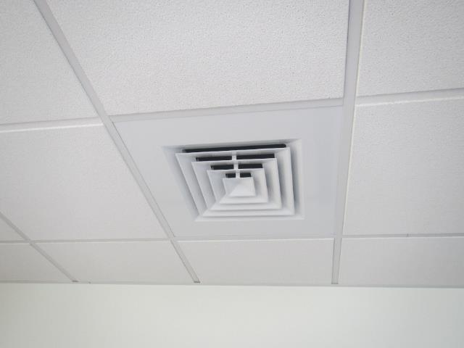

Supply-style vent

Picture 2

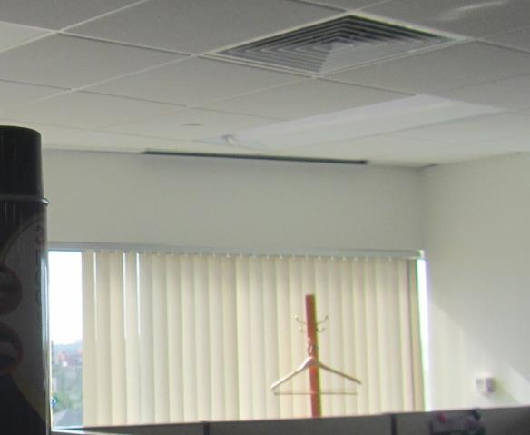

Supply-style vent along windows and in ceiling

## Water Damage Pictures

Picture 3

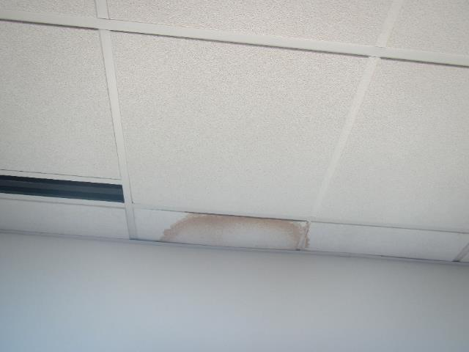

Water-damaged ceiling tile

Picture 4

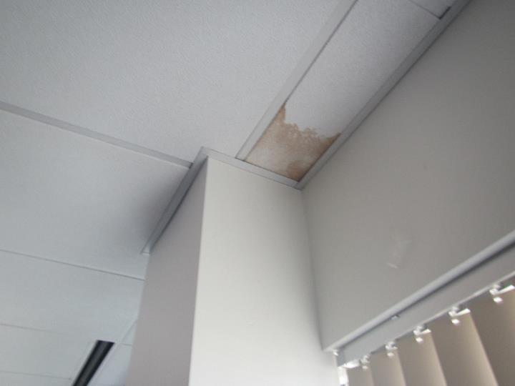

Water-damaged ceiling tile

Picture 5

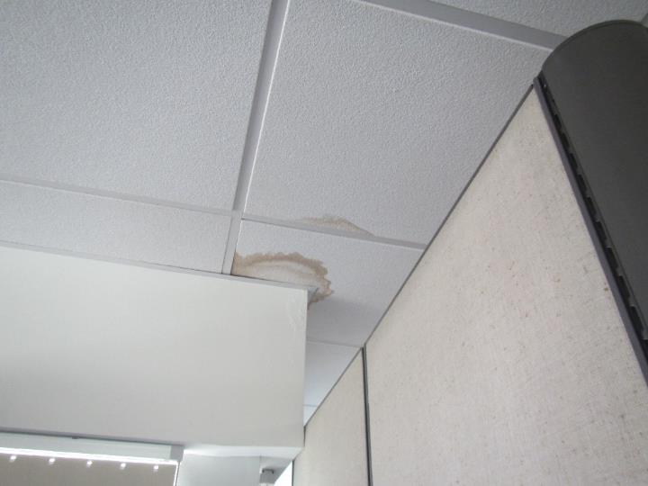

Water-damaged ceiling tile at an interior corner wall

Picture 6



Panel and window construction of the building exterior

Picture 7

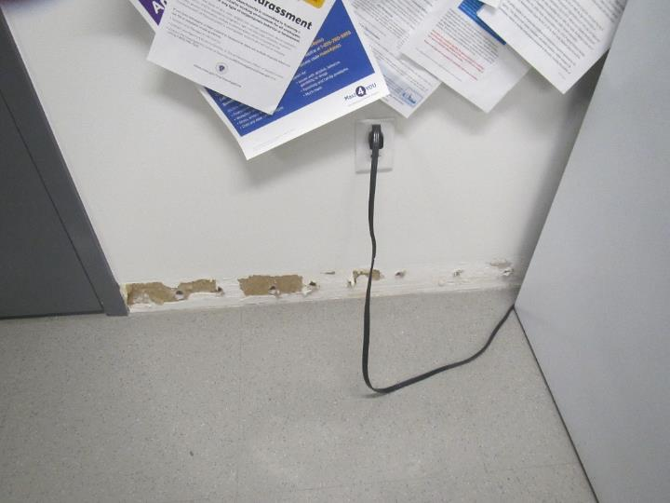

Missing base coving in 9th floor kitchen area

Picture 8

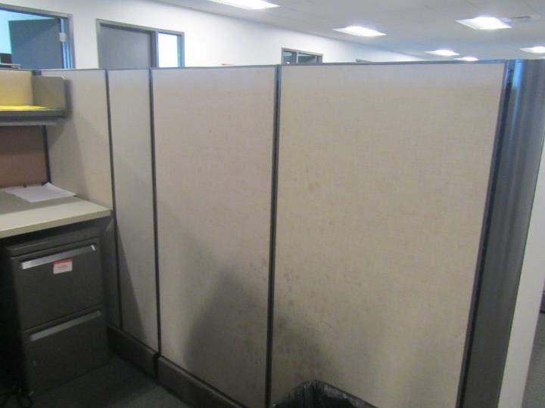

Water-damaged workstation wall

Picture 9

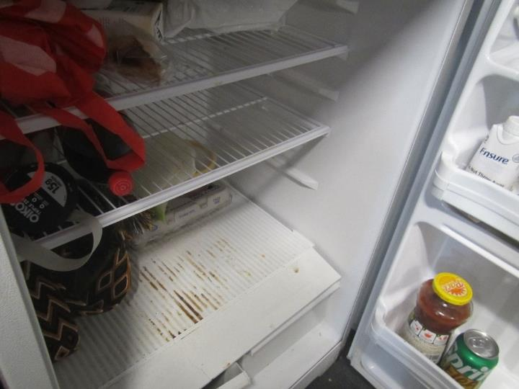

Dirty refrigerator in the 7th floor breakroom

Picture 10

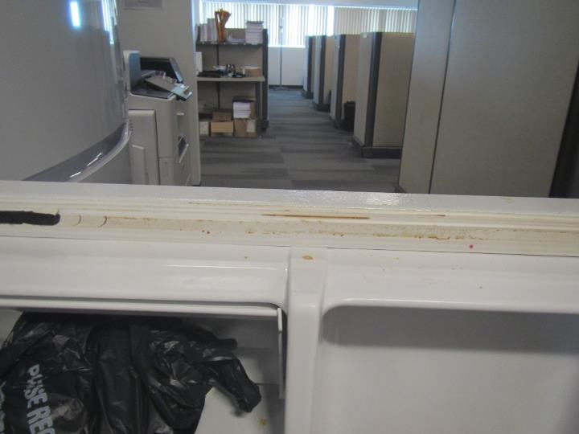  
Dirty refrigerator gasket

Picture 11

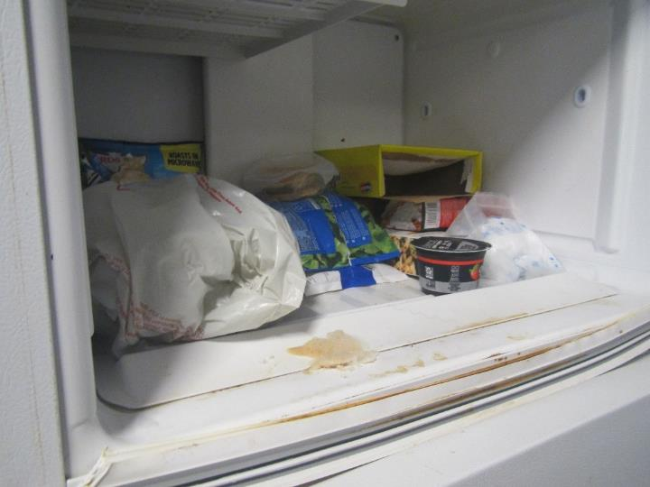

Dirty freezer

Picture 12

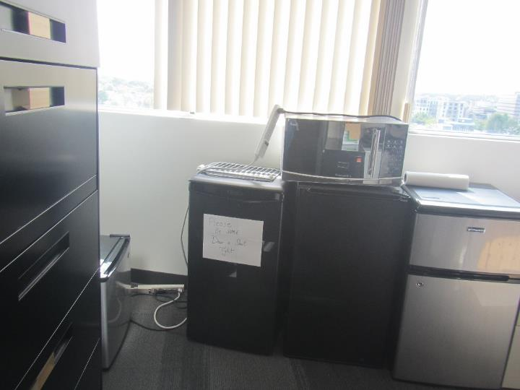

Group of small refrigerators on carpet on the 7th floor

Picture 13

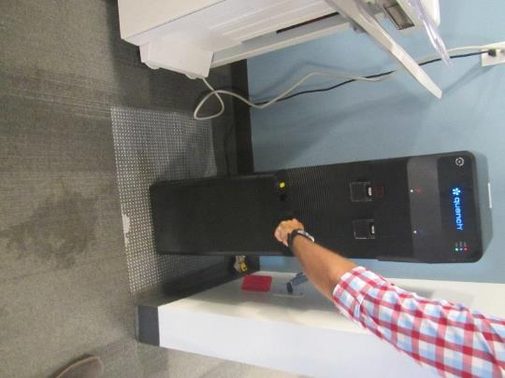

Water-damaged carpet next to water dispenser

Picture 14

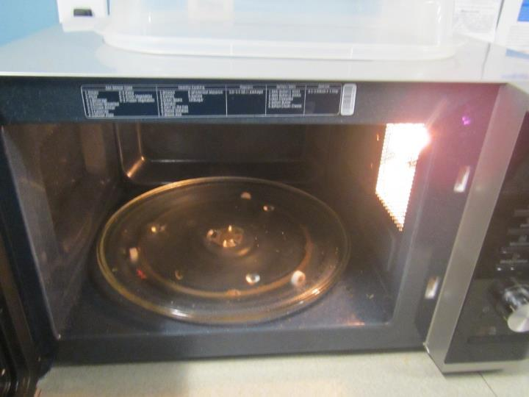

Dirty microwave

Picture 15

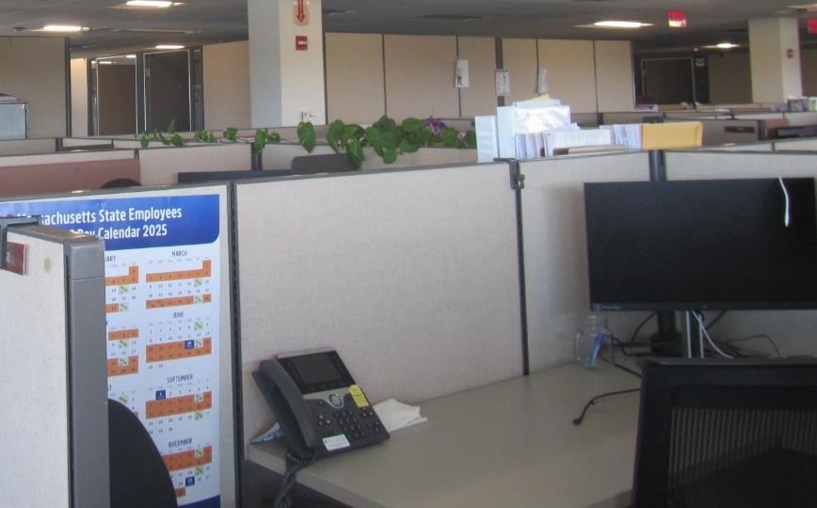

Plant draped over cubicle walls

Picture 16

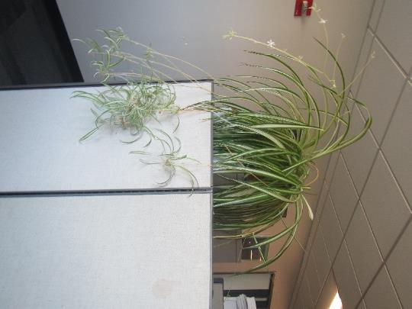

Large plant in a cubicle

## 

## Respiratory Irritants Pictures

Picture 17

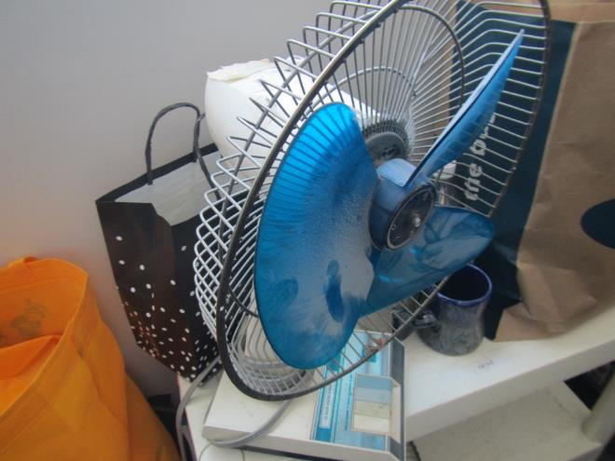

Dust/debris on fan blades, fan may be broken or grill opened for cleaning

Picture 18

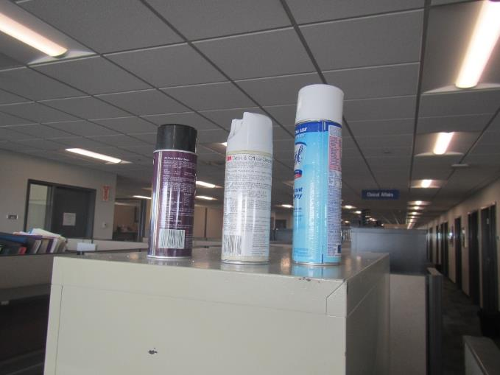

Cleaning products

Picture 19

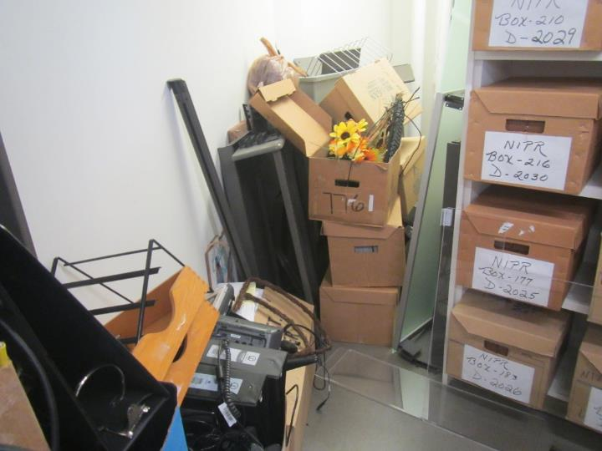

Disorganized storage with boxes on floor

Picture 20

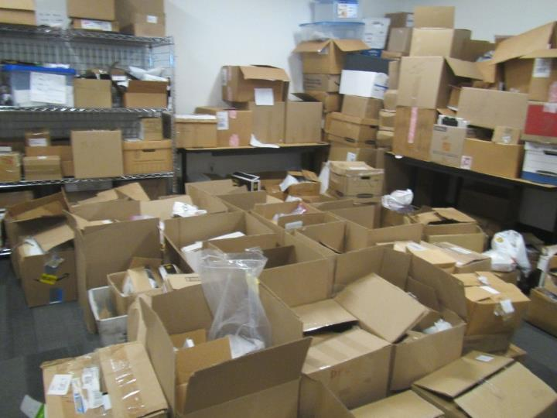

Cluttered storage area with boxes on the floor

Picture 21

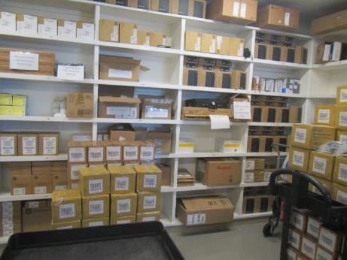

Example of an organized storage area in the MassHealth space

Picture 22

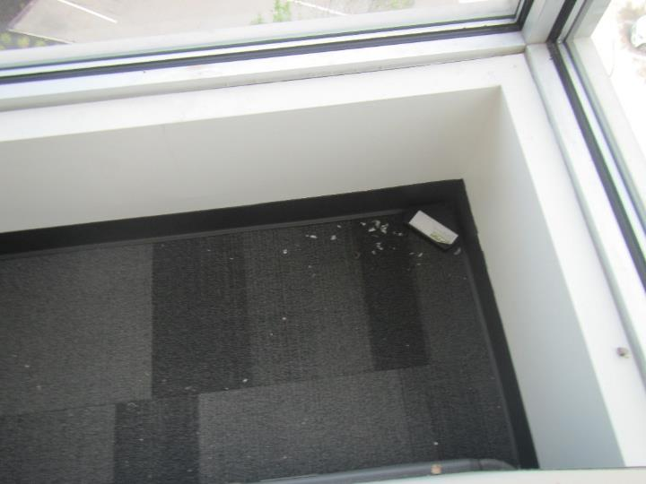

Debris between workstation wall and room wall

Picture 23

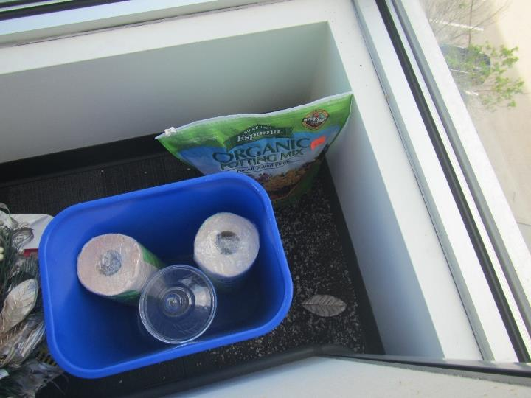

Potting soil and other stored items behind workstation wall

Click to link back to report

# Table 1

| **Location** | **Carbon**  **Dioxide**  **(ppm)** | **Carbon Monoxide**  **(ppm)** | **Temp**  **(°F)** | **Relative**  **Humidity**  **(%)** | **PM2.5**  **(g/m3)** | **Occupants**  **in Room** | **Windows**  **Openable** | **Ventilation** | | **Remarks** |
| --- | --- | --- | --- | --- | --- | --- | --- | --- | --- | --- |
| **Supply** | **Exhaust** |
| Background | 387 | ND | 76 | 71 | 3 |  |  |  |  | Cloudy |
| 7th floor | | | | | | | | | | |
| 7018 | 530 | ND | 75 | 60 | ND | 0 | N | Y |  |  |
| Break area | 593 | ND | 75 | 59 | ND | 0 | N | Y |  | Several small refrigerators on carpet, one has an odor and is empty (broken?), CP |
| 7103 | 559 | ND | 76 | 58 | ND | 1 | N | Y |  |  |
| 7105 | 601 | ND | 75 | 60 | ND | 1 | N | Y |  | CP |
| 7029 cubes | 563 | ND | 74 | 59 | ND | 2 | N | Y |  |  |
| 7021 | 584 | ND | 75 | 60 | ND | 1 | N | Y |  |  |
| 7019 | 554 | ND | 74 | 60 | ND | 0 | N | Y |  | Files, HS |
| 7018 | 582 | ND | 74 | 60 | ND | 0 | N | Y |  | Heater |
| 7017 | 583 | ND | 74 | 61 | ND | 0 | N | Y |  | DEM |
| 7037 cubes | 565 | ND | 74 | 61 | ND | 0 | N | Y |  |  |
| 7016 | 559 | ND | 74 | 60 | ND | 0 | N | Y |  | WD CT |
| 7040 cubes | 567 | ND | 74 | 60 | ND | 0 | N | Y |  |  |
| 7015 | 686 | ND | 74 | 61 | ND | 1 | N | Y |  | HS |
| 7014 | 578 | ND | 73 | 61 | ND | 0 | N | Y |  | HS, boxes on floor |
| 7013 | 571 | ND | 74 | 61 | ND | 0 | N | Y |  | DEM |
| 7047 cubes | 588 | ND | 74 | 62 | ND | 3 | N | Y |  | HS |
| 7012 | 580 | ND | 74 | 61 | ND | 0 | N | Y |  | CP, HS |
| 7011 | 571 | ND | 74 | 62 | ND | 1 | N | Y |  | HS |
| 7010 | 540 | ND | 73 | 62 | ND | 0 | N | Y |  |  |
| 7009 | 560 | ND | 73 | 62 | ND | 0 | N | Y |  |  |
| 7059 cubes | 568 | ND | 73 | 62 | ND | 0 | N | Y |  |  |
| 7007 | 558 | ND | 73 | 63 | ND | 0 | N | Y |  | DEM |
| 7005 | 556 | ND | 73 | 63 | ND | 0 | N | Y |  | Ajar ceiling tile, DEM |
| 7071 cubes | 560 | ND | 73 | 63 | ND | 0 | N | Y |  |  |
| 7003 and 7002 |  |  |  |  |  |  | N | Y |  | Plants |
| 7075 cubes |  |  |  |  |  |  | N | Y |  | Plants |
| 7140 (part wall) | 549 | ND | 73 | 63 | ND | 0 | N | Y |  |  |
| 7081 cubes | 562 | ND | 73 | 63 | ND | 1 | N | Y |  |  |
| 7089 cubes | 559 | ND | 73 | 62 | Nd | 1 | N | Y |  | WD cloth workstation dividers |
| 7092 cubes | 563 | ND | 73 | 62 | ND | 0 | N | Y |  |  |
| 7111 | 574 | ND | 73 | 62 | ND | 2 | N | Y |  | Items, food |
| 7207 | 554 | ND | 74 | 61 | ND | 1 | N | Y |  |  |
| 7233 cubes | 555 | ND | 74 | 61 | ND | 1 | N | Y |  | WD CT |
| 7115 (part wall) | 565 | ND | 74 | 62 | ND | 1 | N | Y |  | Items on floor |
| 7222 cubes | 557 | ND | 74 | 62 | ND | 0 | N | Y |  | WD CT |
| 7205 | 551 | ND | 74 | 63 | ND | 0 | N | Y |  |  |
| File/copy area | 544 | ND | 73 | 63 | ND | 0 | N | Y |  | Not carpeted, photocopier, boxes on floor |
| 7189 cubes | 542 | ND | 73 | 63 | ND | 0 | N | Y |  | HS |
| 7171 cubes | 567 | ND | 72 | 64 | ND | 2 | N | Y |  | Items |
| 7156 cubes | 575 | ND | 73 | 64 | ND | 1 | N | Y |  | WD CT |
| 7151 cubes | 584 | ND | 73 | 64 | ND | 2 | N | Y |  | Plants |
| 7144 (part wall) | 572 | ND | 73 | 64 | ND | 1 | N | Y |  | Items behind workstation wall, WD CT in area outside room, PF |
| 7141 | 560 | ND | 73 | 63 | ND | 0 | N | Y |  | Food |
| Big 7th floor breakroom | 567 | ND | 73 | 63 | ND | 0 | N | Y |  | Dirty microwave, dirty toaster, refrigerators, food (one fridge dirty) |
| 7th floor men’s and women’s rooms |  |  |  |  |  |  |  |  |  | no water damage |
| 9th floor | | | | | | | | | | |
| 9005 | 530 | ND | 72 | 66 | ND | 0 | N | Y |  | DEM |
| 9007 | 540 | ND | 72 | 67 | ND | 0 | N | Y |  | Food (in jar) |
| 9009 | 528 | ND | 72 | 67 | ND | 0 | N | Y |  | Food, DEM |
| 9012 | 525 | ND | 72 | 67 | ND | 0 | N | Y |  | DEM, WD CT, HS |
| 9141 cubes | 537 | ND | 72 | 67 | ND | 0 | N | Y |  |  |
| 9015 | 532 | ND | 72 | 67 | ND | 0 | N | Y |  |  |
| 9056 cubes | 523 | ND | 73 | 66 | ND | 0 | N | Y |  | Broken, dusty fan, CP, items |
| 9061 cubes | 525 | ND | 73 | 66 | ND | 2 | N | Y |  | 1 WD CT |
| 9906 cubes | 528 | ND | 73 | 66 | ND | 1 | N | Y |  |  |
| 9075 cubes | 521 | ND | 73 | 66 | ND | 1 | N | Y |  | Perfume odors |
| 9200 | 563 | ND | 73 | 65 | ND | 0 | N | Y |  |  |
| 9202 (part wall) | 524 | ND | 73 | 65 | ND | 0 | N | Y |  |  |
| 9251 cubes | 538 | ND | 74 | 64 | ND | 0 | N | Y |  |  |
| 9248 | 522 | ND | 74 | 63 | ND | 0 | N | Y |  |  |
| 9205 (part wall) | 531 | ND | 74 | 64 | ND | 0 | N | Y |  | Drinks, food, DEM, HS |
| 9206 (part wall) | 526 | ND | 74 | 64 | ND | 0 | N | Y |  | PF |
| 9246 cubes | 526 | ND | 74 | 64 | ND | 0 | N | Y |  |  |
| 9220 cubes | 528 | ND | 74 | 64 | ND | 0 | N | Y |  |  |
| 9244 | 536 | ND | 74 | 64 | ND | 0 | N | Y |  | PF on |
| 9036 breakroom |  |  |  |  |  | 1 | N | Y |  | NC, coffee maker, 2 fridges, microwave, and toaster |
| 9232 conference/storage |  |  |  |  |  | 0 | N | Y |  | Items on floor, WD CT |
| 9235 | 564 | ND | 74 | 64 | ND | 1 | N | Y |  | HS |

(Click to link back to report)

# Table 2A

|  |  |  |  |  |  |
| --- | --- | --- | --- | --- | --- |
| **Equipment Present in Building**  **(X = Yes)** | **Type of Heating/Cooling Ventilation**  **Equipment** | **Fresh**  **Air**  **Supply**  **(X = Yes)** | **Type of Location(s)** | **Air Filters Installed**  **MERV Rating**  **(1-15, U*)**  **(X = Yes)** | **Comments** |
|  | Univents |  |  |  |  |
| X | Rooftop Air Handling Units | X |  |  |  |
|  | Outdoor, Ground-Installed Air Handling Units |  |  |  |  |
|  | Attic/Crawlspace Air Handling Units |  |  |  |  |
| X | Ceiling-Mounted Air Handling Units (including inside plenum) |  |  |  |  |
|  | Basement/Crawlspace-Installed Air Handling Units |  |  |  |  |
|  | Mechanical Room-installed Air Handling Units |  |  |  |  |
|  | Fan Coil Units |  |  |  |  |
|  | Window-Mounted Air Conditioners |  |  |  |  |
|  | Portable air conditioners |  |  |  |  |
|  | Wall Louver-Controlled Gravity Air Supply |  |  |  |  |
|  | Windows |  |  |  |  |
|  | Fan in window (blowing in) |  |  |  |  |
|  | Built in wall fan (switched) |  |  |  |  |
|  | Heat recovery ventilator unit |  |  |  |  |
|  | Energy recovery ventilator unit |  |  |  |  |
|  | Chilled Beam |  |  |  |  |
|  | Passive combustion supply vent in basement/boiler room |  |  |  |  |

*U = Filter Rating underdetermined due to inaccessibility during building visit

# Table 2B

|  |  |  |  |  |
| --- | --- | --- | --- | --- |
| **Equipment Present in Building**  **(X = Yes)** | **Type of Exhaust Ventilation**  **Equipment** | **Ducted**  **To Outdoors**  **(X = Yes)** | **Type of Location(s)** | **Comments** |
| X | Rooftop Motors/Fans | X | Offices and common areas |  |
|  | Unit Exhaust |  |  |  |
| unknown | Ceiling Return Vent |  |  |  |
|  | Ceiling Return Vent, Plenum |  |  |  |
|  | Wall Return Vent |  |  |  |
|  | Ceiling fan |  |  |  |
|  | Kitchen Stove Hood |  |  |  |
| X | Restroom Exhaust Vent | X |  |  |
|  | Photocopier Exhaust Vent |  |  |  |
|  | Garage |  |  |  |
|  | Chemical Hood(s) |  |  |  |
|  | Locker Rooms |  |  |  |
|  | Showers |  |  |  |
|  | Clothes Dryers |  |  |  |
|  | Gas Water Heaters |  |  |  |
|  | Furnace-Flue to Chimney |  |  |  |
|  | Furnace/Boiler direct vent or power vent (no combustion air supply) |  |  |  |
|  | Kiln, Pottery |  |  |  |
|  | Dark Room |  |  |  |
|  | Generator Room |  |  |  |
|  | Wood Shop Dust Collector |  |  |  |
|  | Spray Paint Booths |  |  |  |
|  | Fan in window (blowing out) |  |  |  |

# Table 2C

|  |  |  |  |
| --- | --- | --- | --- |
| **Equipment Present in Building**  **(X = Yes)** | **Type of Equipment** | **Type of Location(s)** | **Comments** |
| X | Floor Fans, pedestal | Offices and cubicles |  |
| X | Floor Fans, portable | Offices and cubicles | Some dusty |
|  | Air Purifier (HEPA, other) |  |  |
|  | Floor heaters, portable |  |  |
| X | Refrigerators, Cold Beverage Vending Machines | Kitchen, breakrooms, offices |  |
|  | Radiator, wall-mounted |  |  |
|  | Radiator, floor-mounted |  |  |
|  | Passive Vents (Wall/Door) |  |  |

(Click to link back to report)

# Table 3

| **Found in Building**  **X = Yes** | **Water-Damaged Materials, Building Components or Stored Materials** | **Location** | **Visible Microbial Growth?**  **X = Yes** | **Musty odor detected?**  **X = Yes** | **Comments** |
| --- | --- | --- | --- | --- | --- |
|  | Books-other bound materials |  |  |  |  |
|  | Brick walls – broken, missing mortar |  |  |  |  |
|  | Brick walls – blocked weep holes |  |  |  |  |
|  | Cardboard boxes |  |  |  |  |
|  | Carpet tiles |  |  |  |  |
|  | Carpet - area rugs |  |  |  |  |
|  | Carpet wall-to-wall |  |  |  |  |
|  | Ceiling tiles - affixed directly to ceiling surface |  |  |  |  |
|  | Ceiling tiles - bowing-in suspended ceiling |  |  |  |  |
|  | Ceiling tiles - water-stained in splined ceiling |  |  |  |  |
| X | Ceiling tiles - water-stains in suspended ceiling | Near some exterior walls | N | N |  |
|  | Chairs - laminated |  |  |  |  |
|  | Cloth |  |  |  |  |
|  | Countertops (around sinks) |  |  |  |  |
|  | Curtains |  |  |  |  |
|  | Dust/debris within AHU, uninvent, HVAC, chilled beam units, etc. (WD through condensation, humidity, or leaks) |  |  |  |  |
|  | Efflorescence (i.e., mineral deposits) |  |  |  |  |
|  | Engineered woods - particleboard, plywood, Masonite |  |  |  |  |
|  | Flooring – loosened tiles |  |  |  |  |
|  | Flooring - wooden |  |  |  |  |
|  | Furniture - laminated |  |  |  |  |
| X | Furniture - upholstered | Cloth covered dividers | N | N |  |
|  | Gypsum wallboard - ceiling |  |  |  |  |
|  | Gypsum wallboard - restroom wall |  |  |  |  |
|  | Gypsum wallboard - interior wall |  |  |  |  |
|  | Gypsum wallboard – located on exterior wall |  |  |  |  |
|  | HVAC drain pan – lack of draining |  |  |  |  |
|  | HVAC filters |  |  |  |  |
|  | Insulation- attic (paper-backed) |  |  |  |  |
|  | Insulation - inside air handling unit |  |  |  |  |
|  | Insulation - on pipe(s) fiberglass |  |  |  |  |
|  | Insulation - on pipe(s) other/plaster-like material |  |  |  |  |
|  | Insulation - wall cavity |  |  |  |  |
|  | Insulation – ceiling plenum |  |  |  |  |
|  | Modular furniture – walls/cloth partitions |  |  |  |  |
|  | Musical instrument cases |  |  |  |  |
|  | Plaster ceilings |  |  |  |  |
|  | Records/files |  |  |  |  |
| X | Refrigerator - door gasket | Break room | X |  |  |
|  | Refrigerator - drip pan |  |  |  |  |
|  | Refrigerator - Interior surfaces |  |  |  |  |
|  | Room divider - ceiling-mounted, sliding |  |  |  |  |
|  | Sink backsplash |  |  |  |  |
|  | Tables – laminated |  |  |  |  |
|  | Wallpaper |  |  |  |  |
|  | Wood - attic/roof materials |  |  |  |  |
|  | Wood - floor joists in basement ceiling |  |  |  |  |
|  | Wood - wall framing |  |  |  |  |
|  | Wood - window sills |  |  |  |  |
|  | Wood - window-mounted air conditioner framing |  |  |  |  |
|  | OTHER |  |  |  |  |

WHAT ARE ENVIRONMENTAL ASTHMA TRIGGERS?

Asthma triggers are any chemical, pollutant, or allergen that can make your asthma worse. Asthma triggers can also be strong chemical smells, dust, or pets. Your asthma triggers may be different from those of other people. Not all asthma triggers affect people the same way. Environmental asthma triggers are found both indoors and outdoors. DPH link: [Asthma and Your Environment (mass.gov)](https://www.mass.gov/doc/asthma-and-your-environment-english/download)

(click to link back to report)

# Table 4

| **Condition Present**  **X = Yes** | **Possible asthma symptom-inducing environmental pollutant** | **Recommendation to reduce or eliminate the pollutant** |
| --- | --- | --- |
| X | Water Damage and/or Mold  (allergen) | Identify water source and repair to eliminate.  Clean non-porous materials.  Remove and replace porous materials susceptible to mold growth.  Perform regular water damage assessments as a tool to ensure timely mitigation as needed.  Use NIOSH water damage assessment protocol as a guide: [NIOSH water damage assessment guideline](https://www.cdc.gov/niosh/docs/2019-115/pdfs/2019-115.pdf?id=10.26616/NIOSHPUB2019115&inf_contact_key=241b5c2ed98c27d94b530dedc36f1623f651f238aa2edbb9c8b7cff03e0b16a0). |
|  | Moistening of building components during hot, humid weather (>2 days in length) (mold, allergen) | Remove materials not dried in <2 days in a manner consistent with [US EPA Mold Removal in Commercial Buildings guideline](https://www.epa.gov/mold/pdf-version-checklist-mold-remediation-mold-remediation-schools-and-commercial-buildings).  Use dehumidification in occupied basement areas and other areas with chronic dampness. |
|  | Vegetation against exterior of building (water damage-mold) | Remove all vegetation preventing building exterior drying.  Remove all vegetation capable of falling onto a building or depositing debris onto the roof. |
|  | Personal humidifiers (lack of proper maintenance)  (pollutant and allergen) | Clean and maintain properly.  Use distilled water to eliminate metal and water treatment odors.  Maintain hydration by increasing water consumption. |
|  | Drains: Floor drains, Sink drains (abandoned use)  Water bubblers (abandoned use) | If in use, pour water into drain at least twice a week.  If not in use, seal the drain with appropriate material in accordance with the Massachusetts Plumbing Code (248 CMR 10.00). |
|  | Live Animals (turtles, gerbils, birds, rabbits, etc.) | Ensure cleanliness or remove animals from the location. |
|  | Improperly maintained aquariums and terrariums (allergen) | Maintain such equipment properly to eliminate odor.  Discontinue use. |
| X | Plants and flowers  (allergen and mold) | Keep indoor plants well maintained and not overwatered. Monitor for signs of mold and pests.  Ensure water for cut flowers does not become stagnant.  Ensure dried plant material is free of odors, mold, and pests and handled carefully  If asthma risks are high, eliminate plants and flowers. |
|  | HVAC system moisture issues  (mold, allergen) | Consult ASHRAE’s minimum standards for HVAC maintenance and inspection of commercial HVAC systems (<https://www.ashrae.org/technical-resources/bookstore/standards-180-and-211>). |
|  | HVAC system contaminant issues (allergen) | Consult ASHRAE’s minimum standards for HVAC maintenance and inspection of commercial HVAC systems (<https://www.ashrae.org/technical-resources/bookstore/standards-180-and-211>). |
|  | Indoor swimming pool odors outside of swimming pool (mold, chemical) | Maintain and operate pool HVAC systems to vent odors from building.  Ensure locker room exhaust vents operate during building hours.  All doors leading to the pool should be rendered airtight and be closed. |
|  | Pollen (allergen) | Recommend installation of MERV 8 or better filters if HVAC engineer confirms HVAC system can be so equipped without adversely affecting function.  Cut grass after hours.  Cut grass in a pattern to direct clippings away from exterior wall.  Remove trees and shrubs from in front of windows and air intakes. |
|  | Dry air | Maintain hydration.  Avoid overheating of air. |
|  | Dust mites  (allergen) | Recommendation to remove non-official upholstered furniture, area rugs, pillows, cushions, etc.  Cleaning with use of HEPA-filtered vacuum cleaner.  Eliminating clutter, storing items in dust and moisture-proof containers, and regularly removing dust through wet wiping. |
|  | Pests, including rodents and cockroaches  (allergen) | Use of integrated pest management guidelines, including:   * Proper disposal of food containers * Proper storage of food products in airtight containers * Elimination of use of food as art projects * Remove pest harborages/clutter * Regular monitoring for pests   [EPA IPM guideline link](https://www.epa.gov/ipm/introduction-integrated-pest-management) |
|  | Latex-containing materials | Remove tennis balls from furniture legs. |
|  | Fragrances  (chemical) | Eliminate point sources, such as:   * Plug-in air fresheners * Aroma/oil reed diffusers * Scented sprays * Discontinue use of other scented materials * Consult DPH fragrance guideline: [*Clean air is odor-free*](https://www.mass.gov/doc/clean-air-is-odor-free-removing-fragrances-to-improve-indoor-air-quality-in-schools-and-0/download) |
|  | Strong smells from /use of Chemicals (such as cleaning products)  (chemical) | Use building-issued cleaning products.  Use products in accordance with manufacturer’s instructions including dilution, application, and ventilation.  Avoid using products that are stronger than needed for the situation. |
|  | Strong odors from new building materials (carpeting/furniture)  (chemical) | Use low VOC-emitting materials.  Air out materials (outside or in an unoccupied area) prior to installation. |
|  | Tobacco smoke  Secondhand Smoke  (pollutant) | Eliminate tobacco smoking.  Seal all shared wall penetrations. |
| X | Products with strong odor such as paint, perfume, hairspray, air fresheners, bug-spray, laminators, candles, wax melters, dry erase markers and other VOC-containing products  (chemical) | If essential:   * Provide proper exhaust ventilation to eject aerosolized products directly outdoors. * Avoid/reduce use during occupied hours.   If not necessary, remove and eliminate. |
|  | Vehicle exhaust  (pollutant) | Enforce anti-idling regulations and post signs to give notice.  Relocate vehicles away from fresh air intakes.  Require cars to park face-in at building walls.  [MA anti-idling law FAQs](https://www.mass.gov/files/documents/2018/02/20/idling-faq.pdf#:~:text=The%20Massachusetts%20Anti-Idling%20Law%20The%20goal%20of%20the,sometime%20wonder%20when%20idling%20might%20be%20considered%20necessary.) |
|  | Vapors and or fumes from gas, oil, or kerosene stoves  (pollutant) | Operate stove hood when stove is in use.  Install stove hood if not present.  Ensure the equipment is in good working order. |
|  | Ozone (pollutant) | Eliminate use of ozone generating equipment. |
|  | Window Air Conditioners (if not properly maintained) (allergen) | Equip with proper filter and clean periodically.  Clean drip pans.  Install in window with weathertight, non-mold-growth sustaining material. |
|  | Pottery (pollutant) | Do not operate kiln during occupied hours.  Operate kiln with exhaust system activated.  Seal all seams and holes in kiln vent.  Ensure kiln exhaust discharge terminates outdoors. |
| X | Carpeting (allergen) | Clean carpeting in a manner consistent with IICRC standards, including regular vacuuming with a high efficiency particulate air (HEPA) filtered vacuum in combination with annual cleaning or semi-annual cleaning in soiled high traffic areas. |
|  | Sweeping/dusting vs HEPA vacuuming/wet wiping  (allergen or pollutant) | Refrain from using feather dusters or brooms.  Utilize HEPA vacuums and wet wiping to minimize aerosolizing particulate matter. |
|  | Lack of adequate air exchange/mechanical ventilation | Make repairs as necessary and ensure all HVAC system components are operating continuously when building is occupied. |
|  | Lack of local exhaust at source of pollution (vocational shop activities, kitchen exhaust hood) (all) | Recommend installation of exhaust ventilation to direct pollutants directly outdoors. |
|  | Renovating buildings while occupied  (chemical) | Use all SMACNA guidelines for Renovation While Buildings Are Occupied. For information, visit <https://www.mass.gov/service-details/construction-and-renovation-generated-pollutants-in-occupied-buildings>. |
|  | Chemistry program chemical storage  (chemical) | Repair (if needed) and operate chemical storeroom vents appropriately.  Reduce or eliminate unneeded or overstocked chemicals.  Store all chemicals in a manner to separate incompatible chemicals.  Keep chemical storerooms clean. |
| X | Photocopiers/duplicating machines | All machines should have dedicated exhaust vents. |