Slide 1

MassHealth Payment and Care

Delivery Innovation (PCDI)
January 1, 2020 Updates
Provider Presentation

Executive Office of Health & Human Services
Slide 2

Agenda
- Payment and Care Delivery Innovation (PCDI) background
- Managed Care Health Plan Options
- MassHealth health plan options for 2020
- Primary Care Exclusivity
- Updates for 2020- new primary care practices joining ACO plans
- Impacted Member Notifications and Timeline
- Continuity of Care (CoC) for impacted members
- MassHealth Choices
- Provider Reminders
- Provider Resources
Slide 3

Payment and Care Delivery Innovation (PCDI) Background

Background
- The Executive Office of Health and Human Services (EOHHS) is committed to a sustainable, robust MassHealth program for its 1.8 million members
- On March 1, 2018, MassHealth’s PCDI initiative offered new health plan options to MassHealth members eligible for managed care. These managed care options include Accountable Care Organizations (ACOs) plans in addition to re-procured managed care organizations (MCOs) plans and the Primary Care Clinician (PCC) Plan
Slide 4

Managed Care Health Plan Options
Accountable Care Organizations (ACOs):
An ACO is a provider-led health plan that holds participating providers financially accountable for both cost and quality of care for members. ACOs are composed of groups of primary care providers (PCPs) to whom members are attributed. In an ACO, the PCP and their team are responsible for working with the member and the ACO’s network of providers to help coordinate care and connect the member with available services and supports
  - Accountable Care Partnership Plans
  - Primary Care ACOs

Managed Care Organizations (MCOs):
health plans run by insurance companies that provide care through their own provider network that includes PCPs, specialists, behavioral health providers, and hospitals. Care coordinators are employed by the MCO
- Primary Care Clinician (PCC) Plan : The primary care providers are called primary care clinicians (PCCs). The MassHealth network of PCCs, specialists, and hospitals delivers services. The Massachusetts Behavioral Health Partnership (MBHP) provides behavioral health services
Slide 5

Accountable Care Partnership Plans
Be Healthy Partnership - Baystate Health Care Alliance with Health New England
Berkshire Fallon Health Collaborative - Health Collaborative of the Berkshires with Fallon Health
BMC HealthNet Plan Signature Alliance - Signature Healthcare with BMC HealthNet Plan
BMC HealthNet Plan Community Alliance - Boston Accountable Care Organization with BMC HealthNet Plan
BMC HealthNet Plan Mercy Alliance - Mercy Medical Center with BMC HealthNet Plan
BMC HealthNet Plan Southcoast Alliance - Southcoast Health with BMC HealthNet Plan
Fallon 365 Care - Reliant Medical Group with Fallon Health
My Care Family - Merrimack Valley ACO with Allways Health Partners
Tufts Health Together with Atrius Health - Atrius Health with Tufts Health Plan (THP)
Tufts Health Together with BIDCO - Beth Israel Deaconess Care Organization (BIDCO) with Tufts Health Plan (THP)
Tufts Health Together with Boston Children's ACO – Boston Children’s ACO with Tufts Health Plan (THP)
Tufts Health Together with CHA - Cambridge Health Alliance (CHA) with Tufts Health Plan (THP)
Wellforce Care Plan - Wellforce with Fallon Health

Primary Care ACO Plans
Community Care Cooperative (C3)
Partners HealthCare Choice
Steward Health Choice

Managed Care Organizations
Boston Medical Center (BMC) HealthNet Plan
Tufts Health Together

Primary Care Clinician (PCC) Plan
Primary care Providers in the MassHealth Network
Slide 6

Primary Care Exclusivity
A primary care practice entity that contracts with an ACO may only empanel managed care members who are also enrolled in that same ACO
  - They may not empanel MassHealth managed care members enrolled in an MCO, the Primary Care Clinician (PCC) Plan, or any other ACO
  - They may only provide primary care services to managed care members who are also enrolled in that same ACO (outside of the exceptions listed on the next slides )
Primary care exclusivity is applied at the site level because the member is assigned to the primary care practice entity site rather than to the individual PCPs performing the primary care functions and services at the site
Slide 7

Primary Care Exclusivity – Exceptions
Primary Care Exclusivity does not apply in the following situations:
- PCPs serving members in the Special Kids Special Care Program
- PCPs that also provide medication assisted treatment (MAT) services may provide MAT services to members enrolled in any ACO, MCO, or the PCC Plan, without regard to limitations related to primary care exclusivity
- School-Based Health Centers (SBHCs) operated through CHCs can serve all MassHealth members and must submit claims for services delivered at SBHCs directly to MassHealth
- Other MassHealth programs*, such as:
- MassHealth Fee-for-service (FFS) (including those over age 65 or with third-party coverage)
- OneCare
- Senior Care Options (SCO)
- Program of All-inclusive Care for the Elderly (PACE)

*Providers who contract with an ACO may continue to provide services to members enrolled in the above programs regardless of their contracts with ACOs.
Slide 8

Primary Care Exclusivity – Exclusions

Specialists, Hospitals, and Other Providers*
- Primary care exclusivity requirements neither apply to nor impact specialists, hospitals, and other providers—including behavioral health providers. Specialists, hospitals, and other providers may continue to provide specialty services across MassHealth managed care options. Such providers may contract with multiple health plans at the same time and may provide services to members in any of the health plans with which the providers have contracts.
- Primary Care ACOs and the PCC Plan use the MassHealth fee-for-service network of specialists and hospitals. Specialists, hospitals, and other providers may see MassHealth members enrolled in a Primary Care ACO or the PCC Plan if the provider is a MassHealth participating provider contracted to provide medical services.
*Please refer to All Provider Bulletin 279 for more information (https://www.mass.gov/files/documents/2018/11/05/all-provider-bulletin-279.pdf )

Slide 9

Updates for 2020 - new primary care practices joining ACO plans

Opportunity for Existing ACOs to Add Participating PCPs
To support and further the goals of the ACO Program, MassHealth offered an opportunity for existing ACOs to request the addition of new participating PCPs effective January 1, 2020.
ACOs were required to submit such request for MassHealth review in May 2019.
Each request was evaluated by MassHealth against criteria that included, but were not limited to;
- Impact on members;
- Impact on network adequacy;
- The ACO’s proposed approach to ensuring Continuity of Care;
- The demonstrated commitment by the PCP to participate in the ACO
Slide 10

Updates for 2020 - new primary care practices joining ACO plans Primary Care Provider Changes for January 1, 2020
MassHealth is excited to announce 56 primary care sites will be joining MassHealth ACOs effective January 1, 2020. These include several providers who are changing from one ACO to another ACO.
The total 58 new sites are across the following ACOs:
- 29 providers to Partners HealthCare Choice
- 8 providers to Steward Health Choice
- 5 providers to Tufts Health Together with Boston Children’s ACO
- 5 providers to BMC HealthNet Plan Community Alliance
- 4 providers to Wellforce Care Plan
- 3 providers to Tufts Health Together with BIDCO
- 2 providers to Community Care Cooperative

A full list of new primary care providers joining ACO plans, can be found at
https://www.mass.gov/info-details/primary-care-providers-joining-new-masshealth-acos-starting-january-1-2020

Slide 11

Updates for 2020
- New providers are joining ACOs effective January 1, 2020
- MassHealth intends to keep members with their existing Primary Care Provider (PCP) when possible. As a result, a number of members (~37,000) will be following their PCP into the same health plan their PCP has joined effective January 1, 2020
- Members will receive a letter letting them know of their new health plan
- Service area and region updates effective for January 1, 2020
- Changes to time and distance standards - Martha’s Vineyard (Oak Bluffs service area) and Nantucket only
Slide 12

Impacted Member Notifications
Late October, 2019 , impacted members will begin to receive notices informing them of changes to their MassHealth health plan. Notices will inform the member that their PCP will be joining an ACO, or changing ACOs on January 1, 2020 and they will be moving with their PCP into this ACO.
Member actions following assignment:
- members should confirm that other doctors, specialists, behavioral health providers, and hospitals that are most important to them are part of their new plan. Members can do so by:
    - Checking their new MassHealth health plan’s website
    - Calling their new MassHealth health plan
    - Contact your doctors, specialist, behavioral health providers, or other providers and hospitals and ask them if they participate in the ACO
    - Checking www.MassHealthChoices.com
- If members are satisfied with their plan assignment, they do not need to do anything. On January 1, 2020 they will be enrolled in their new MassHealth health plan.
- Members who want to switch MassHealth health plans from their plan assignment can do so by visiting www.MassHealthChoices.com and completing an Online Enrollment Form, or calling MassHealth Customer Service 1-800-841-2900 TTY: 1-800-497-4648.
Slide 13

Impacted Member Notifications Timeline
10/31/19 Notices will be mailed by 10/31 to members (~37,000 members)
1/1/20
Start of 90 day Plan Selection Period
Members will follow their PCP into a new ACO and be enrolled in a new health plan.
1/1/20 – 3/31/20
Plan Selection Period. Members can change health plans for any reason
4/1/19
Start of Fixed Enrollment Period
Members enrolled in an ACO or MCO can only change their health plans for certain reasons
Important: The Plan Selection and Fixed Enrollment Period dates are member specific and depend on the date of their health plan enrollment. The dates above do not apply to all MassHealth members, only those that receive a MassHealth Health Plan notice in October
Slide 14

Impacted Member Notice
Example:
The member’s current PCP has joined an ACO.
The member will be enrolled in the ACO their PCP is affiliated with and continue receiving care from their PCP.
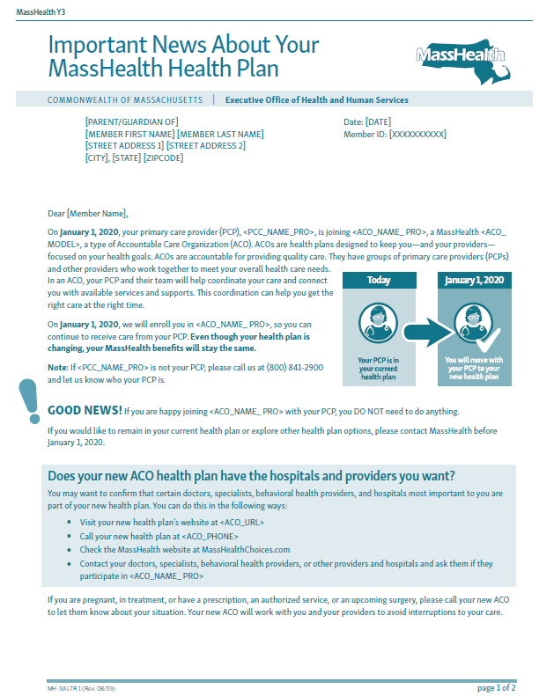

Slide 15

Continuity of Care (CoC) for Impacted Members
MassHealth is committed to working with all relevant parties to promote continuity of care for members who move into new plans. To support a successful transition, members have a 90 day continuity of care period to help prevent interruptions to care as members transition health plans.
- In most cases, members can continue to see their existing providers for 90 days, even if those providers are not in their new plan’s network
- Providers who are not in the new plan’s network can contact the new plan to make appropriate payment arrangements
- In some cases, the continuity of care period may be extended. For example, members who are pregnant can continue seeing their existing OB/GYN providers throughout their pregnancy and up to six weeks postpartum
- Focused efforts will be made for members with needs requiring specialized care, including but not limited to members who are pregnant, have autism spectrum disorder and receiving ABA services, receiving ongoing services such as dialysis, home health, chemotherapy, and/or radiation, receiving treatment for behavioral health or substance use, including Medication for Addiction Treatment (MAT) services
- We are asking all plans, providers, and assisters to reinforce this message and to ensure that members continue to receive all needed health care services during this transition
- Members can contact their new plan now to let them know of any ongoing treatments or scheduled appointments
- Providers will be able to see new plan information in the MassHealth Eligibility Verification System (EVS) starting January 1, 2020. They can contact the new plan at that time for new authorization requests, or with any questions or concerns
- While ACOs are ultimately responsible for coordinating member’s transition and service coordination into their new health plan, both MassHealth and ACOs will ensure protocols are in place for continuity of care issues that may arise
Slide 16

MassHealthChoices.com
MassHealthChoices.com is an online provider directory used to help members learn, compare, and enroll in a new MassHealth health plan
Image of MassHealthChoices’ home page
Slide 17

Provider Reminders

Identify the Member
Use EVS to verify eligibility and current Plan*
Determine if you participate in the Member’s Plan and if applicable you have a referral from that Plan *Member enrollment selection information available 1.1.20

Contact the Plan
- Contact the member’s Plan if you need a referral or if you do not participate in that Plan
- Work with the Plan to understand claims submission
- Work with the Plan and the Primary Care Provider to coordinate the care plan

Provider Care and Services
- Impacted Members have an extended 90 day continuity of care
- Before refusing to see a Member or canceling appointments contact the MassHealth Customer Service Center at 1-800-841-2900
Slide 18
Provider Reminders

MassHealth eligibility verification system (EVS) and claims submission reminders
The MassHealth Eligibility Verification System (EVS) is designed to display the status of a member’s health care coverage for the date(s) of service requested (please note EVS does not display eligibility for future dates). This includes the identification of the health plan and the type of plan that the member is enrolled if applicable. If you are using EVS via the Provider Online Service Center (POSC), or through third party software, please ensure that you review all of the EVS messages associated with the eligibility response.
For providers that are looking to identify where claims should be submitted based on the EVS messages, please use the information below to ensure the proper location to submit your claims. Claims submission to the incorrect health plan will result in delayed processing and payment.
- For Primary Care ACO and PCC Plan members, please submit electronic only claims directly to MassHealth except for behavioral health (BH). BH claims should be submitted directly to MBHP.
- For Accountable Care Partnership Plan members, please refer directly to the applicable Accountable Care Partnership Plan submission instructions for medical and behavioral health claims
- For MCO members, please refer to the MCO for medical and behavioral health claims submission.
If you have any questions, please contact the MassHealth Customer Service Center via email at providersupport@mahealth.net or call 1-800-841-2900.
Slide 19

Provider Resources
Payment and Care Delivery (PCDI) for Providers:
https://www.mass.gov/payment-care-delivery-innovation-pcdi-for-providers
- Information for providers about the MassHealth PCDI initiative
Mass.Gov/MassHealth
https://www.mass.gov/topics/masshealth
- General information regarding the MassHealth program and other resources
MassHealthChoices.com
http://www.masshealthchoices.com/
- Online Provider directory where members can learn, compare, and enroll in health plans.
MassHealth Enrollment Guide:
https://www.masshealthchoices.com/member-materials
- Printed enrollment guide for members to view health plans, service areas, and extra benefits.
MassHealth Enrollment Centers:
https://www.mass.gov/service-details/masshealth-enrollment-centers-mecs
- A list of the MassHealth enrollment centers for in-person eligibility assistance.
MassHealth Customer Service:
  - 1-800-841-2900 (Monday- Friday 8:00am-5:00pm)
  - TTY: 1-800-497-4648
Slide 20

Questions

