Medical Care Advisory Committee (MCAC) and Payment Policy Advisory Board (PPAB) Meeting
  - Executive Office of Health and Human Services
  - September 6, 2023

Table of Contents
- MassHealth’s 1115 Demonstration: Update
- MassHealth Redeterminations: Update

MassHealth’s 1115 Demonstration: Update

MassHealth's 1115 demonstration extension represents a five-year $67.2 billion agreement supporting MassHealth reforms

On September 28th, 2022, CMS approved a five-year extension of the MassHealth Section 1115 demonstration. Since 1997, the 1115 demonstration has been a critical tool in enabling Massachusetts to achieve and maintain near-universal coverage, sustain the Commonwealth’s safety net, expand critical behavioral health services, and implement reforms in the way that care is delivered.

The extended 1115 demonstration (2022-2027) builds on these reforms by continuing to support integrated, outcomes-based care for MassHealth members and bringing a new focus on advancing health equity by closing disparities in quality and access. Goals for this demonstration include:
  - Continuing the path of restructuring and reaffirming accountable, value-based care
  - Making reforms and investments in primary care, behavioral health and pediatric care
  - Advancing health equity, with a focus on initiatives addressing health-related social needs and specific disparities
  - Sustainably supporting the Commonwealth’s safety net, including level, predictable funding for safety net providers, with a continued linkage to accountable care
  - Maintaining near-universal coverage, making updates to eligibility policies to support coverage and equity

MassHealth smoothly transitioned ~1.3M members to new ACOs and Community Partner organizations in April 2023

- ~1.3M members are now being served by one of 17 new Accountable Care Organizations (ACOs), and 35k members are now being served by 20 new Community Partners (CPs)
- Every major health system and all FQHCs in the Commonwealth now participate in the program
- Program launch went generally smoothly, with positive experience by MassHealth members, health plans, providers, and stakeholders

  - Continuity of Care
- 90-day Continuity of Care period
- Strong focus on transitions of care for members entering new plans, and/or transitioning from out of network providers
- Positive experience with limited member experience disruption

  - Primary care payment reform
- ~1,000 practices now receiving sub-capitation payments for primary care services
- Supports providers to focus on team-based integrated care and moves off fee-for-service
- Key focus on implementing new payment approach to ensure consistent, reliable revenue for practices

  - Enhanced Program and Contract Management
- New ACO and CP contracts include enhanced expectations, including improved:
  - Network management
  - Care coordination and care management
  - Clinical quality

  - Focus on HRSN and health equity
- Expanded investment and supports for health-related social needs, including housing and nutrition supports
- Health Quality & Equity Incentive program with >$2B incentives for RELDSOGI data collection, measure stratification, and disparities reduction

MassHealth’s Health Quality and Equity Incentive Program will hold ACOs/MCOs and acute care hospitals accountable for improving clinical quality and advancing equity

  - Demographic and HRSN Data
Completeness of patient-reported demographic data:
- Race, Ethnicity, Language, Disability, Sexual Orientation, and Gender Identify (RELDSOGI)
- Health Related Social Needs (HRSN)

Year 1 goals:
- Report baseline RELD SOGI completeness
- Train staff to collect RELD SOGI data
- Identify plan for HRSN screening in year 2, including documenting using z-codes
- Identify strategies to provide resources to members who screen positive for HRSNs

  - Equitable Quality and Access Performance improvements on access and quality metrics + reductions in disparities
Performance improvements on access and quality metrics + reductions in disparities
  - Access for members with disability
  - Access for limited English proficiency
  - Disparities reduction in preventive, perinatal, and pediatric care, care for chronic diseases and behavioral health, and care coordination

Year 1 goals:
- Plan for identifying disparities using stratified data
- Submit quarterly deliverables for PIPs, including on care coordination and maternal morbidity
- Submit organizational self-assessment of capacity for providing high-quality language services
- Submit assessment of staff disability competency
- Submit report describing screening for accommodation needs, how / whether needs met

  - Capacity and Collaboration Improvements in metrics such as
Improvements in metrics such as
- Provider and workforce capacity
- Cultural Competency
- Collaboration between partners to improve quality and reduce disparities.

Year 1 goals:
- Hospitals apply for Joint Commission standards for health equity; ACOs for NCQA:
  - Leadership to promote efforts
  - Develop written plan to reduce disparities
  - Inform stakeholders of progress towards reducing disparities
- Build capacity to report member experience related to cultural competency

MassHealth’s 1115 expands authorities and investment in HRSN services
- CMS reauthorized and expanded both the Community Supports Program and the Flexible Services Program, improving nutrition and housing supports for MassHealth members

 | Flexible Services Program | Specialized Community Support Program (CSP)
HRSN Services | - Case management, outreach, and education  - Housing supports (includes pre-tenancy and tenancy sustaining support, transition services, one-time transition/moving costs and housing deposits, medically necessary devices like A/C units and asthma remediation, and home modifications)  - Nutrition supports (incl. counseling, meal delivery, medically-tailored food prescriptions, food vouchers, household nutrition support, and cooking supplies)  - when member is a high-risk child or pregnant individual, meals may be provided at household level  - Transportation to nutrition/housing supports | Specialized CSP services, which are outreach and supportive services to enable beneficiaries with behavioral health needs to use clinical treatment services and other supports, including:  - For Homeless Individuals (CSP-HI): Assistance in finding, transitioning to, and maintaining housing  - For Individuals with Justice Involvement (CSP-JI): Assistance in transitioning back to the community  - For Tenancy Preservation Program (CSP-TPP): Specialized services for individuals with BH needs who are being evicted due to behavior or a disability
Eligible Members | ACO-enrolled individuals aged 0-64 who have a health needs-based criteria (e.g., BH needs, complex physical health needs, frequent ED utilization, high-risk pregnancy) and one risk factor (e.g., at risk for nutritional deficiency) | Managed care and FFS members in CSPs due to homelessness (CSP-HI), who are justice-involved (CSP-JI) or have BH needs and are facing eviction as a result of behavior or a disability (CSP-TPP)

MassHealth Redeterminations: Update

  - MassHealth began redetermining all 2.4M members on April 1, 2023 in alignment with federal requirements

- In March 2020, the federal government declared a public health emergency (PHE) due to COVID-19.
- In response to the PHE and consistent with federal requirements, MassHealth put protections in place that generally prevented members’ MassHealth coverage from.
- On April 1, 2023, these continuous coverage protections ended and MassHealth began the year-long process to redetermine all members’ eligibility, as required by CMS.
- MassHealth is focused on maintaining coverage for eligible individuals

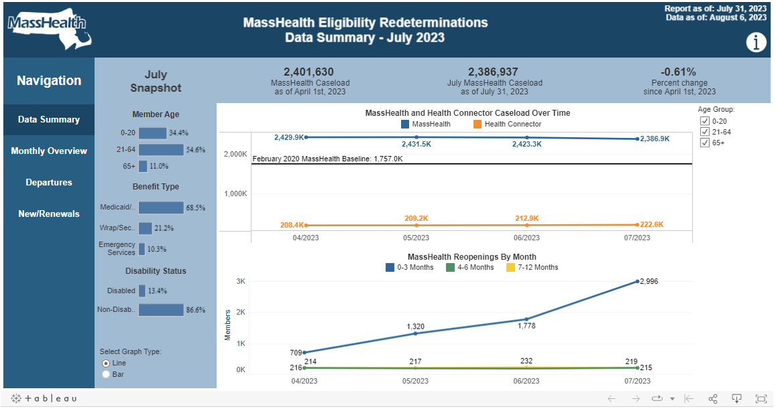
MassHealth is publishing a monthly dashboard that provides data on caseload changes.

MassHealth has used federal flexibilities to increase the number of individuals who are renewed without requiring them to take action

- Whenever possible, MassHealth will autorenew an individual’s coverage by validating data on file with state and federal data sources.
- For the redetermination process, MassHealth received federal approval to make temporary enhancements to its systems, enabling it to automatically renew (“auto-renew”) more members who are under age 65 (MAGI population).
    - These enhancements resulted in a ~75% autorenewal rate for individuals under age 65 who did not have their coverage protected during the Maintenance of Effort (MOE) period
    - The autorenewal rate for individuals under age 65 who did have their coverage protected during the MOE period is significantly lower (less than 10%) as there is less up to date information for this cohort.
- MassHealth has also requested federal approval to enhance the autorenewal process for individuals over 65 or individuals with disabilities (the non-MAGI population).
- Individuals who are not able to have their coverage autorenewed will receive a blue envelope with their renewal form.

MassHealth is continuing its outreach efforts to make sure members know what action to take to receive the best health coverage they are eligible for.

Outreach highlights include…
- Through EOHHS’s partnership with Health Care For All, canvassers have knocked on over 350K doors and community-based organizations have held over 1,000 events in the 15 communities with the most members at risk of coverage loss.
- MassHealth Accountable Care Organizations and other health plans have made nearly 400K outreach attempts via phone call, text message, and letter, to members selected for renewal since April 2023.
- Additionally, MassHealth has continued to expand member outreach efforts, including new member awareness efforts at 50+ Market Baskets, ~600 libraries, ~1,800 schools, and additional statewide organizations such as the YMCA, Boys & Girls Club, etc.
- EOHHS held trainings specifically for eligibility specialists supporting members over age 65.
- EOHHS executed an additional $1M grant in collaboration with the Health Connector to hire a team of ‘Mobile Community Specialists’ to conduct renewal assistance in the community.
You can learn more about MassHealth’s renewal process at mass.gov/masshealthrenew

Appendix

MassHealth’s Health Quality and Equity Incentive Program: Annual Investment

- Substantial annual funding for ACO and Hospital equity performance over five years, in addition to comparable funding for aggregate quality performance

Table 1: Annual Investment in Hospitals (in millions)

Incentive Type | 2023 | 2024 | 2025 | 2026 | 2027
Equity Incentives | $350 | $350 | $350 | $350 | $350
Quality Incentives | $250 | $250 | $250 | $250 | $250

Table 2: Annual Investment in ACOS (% of TCOC*)
* TCOC – Total Cost of Care, or total projected cost of caring for an attributed ACO population

Incentive Type | 2023 | 2024 | 2025 | 2026 | 2027
Equity Incentives | 0.75% | 0.75% | 0.75% | 0.75% | 0.75%
Quality Incentives | 0.75% | 0.75% | 0.75% | 0.75% | 0.75%

MassHealth’s Health Quality and Equity Incentive Program: Program Outcomes

  - By Waiver Year 5 (2027), ACO/MCOs and Hospitals will be:
- Submitting complete and accurate self-reported RELDSOGI and HRSN data according to minimum standards
- Achieving 80% completeness on RELD/SOGI data to identify & monitor health disparities
- Using an effective HRSN screening tool and improving referral and linkage to appropriate resources

- Having complete and accurate data on health care disparities on measures identified by MassHealth
- Implementing Performance Improvement Plans (Maternal Mortality and Care Coordination)
- Implementing plans to enhance screening for preferred language and achieving gap closure for language access measure
- Routinely training staff on disability competency
- Analyzing data on member experience and implementing a plan to address gaps in meeting accommodation needs

- Reporting health equity strategic plans
- Patient-facing staff and leadership receiving training related to disability competent care
- Screening members for accommodation needs met and achieving gap closure
- Entities achieving health equity accreditation/certification by TJC or NCQA (or equivalent)
- Achieving gap closure in cultural competence item set performance

